PROJECT PROPOSAL
Reading Resistance
An Interpretable Machine-Learning Classifier for Predicting Antibiotic Resistance from Bacterial Genomes, with an Honest Benchmark

Category: Artificial Intelligence applied to Life Sciences / Microbial Genomics
Type: Two-person computational research project (no wet-lab required)
Team: Software engineer (ML & pipeline) + M.Sc. Microbiology (domain & validation)
Timeline: Four-week sprint
Authors: ____________________________
Date: ____________________________

Contents

Executive Summary
Antibiotic resistance is one of the defining global-health threats of the century; on current trends, drug-resistant infections are projected to become a leading cause of death worldwide. Deciding whether a bacterial strain will resist a given antibiotic normally requires days of laboratory culturing. Because a strain’s genome already carries the determinants of its resistance, that decision can, in principle, be read directly from sequence.
This project builds an interpretable machine-learning classifier that predicts, from a bacterial genome, whether a strain is resistant or susceptible to each of several antibiotics — and, unlike a black box, names the genes and mutations behind every call. Its defining commitment is an honest benchmark: the model is validated with a phylogeny-aware split (so it must generalize to unseen bacterial lineages, not memorize clones) and compared head-to-head against a transparent known-resistance-gene baseline and against published methods.
The work is fully computational, uses only public datasets, runs on a laptop, and is scoped to a four-week sprint. It is delivered by a two-person team whose skills are complementary by design: a software engineer owning the pipeline and the machine learning, and a microbiology M.Sc. owning organism and drug selection, label quality, and the biological validation that makes the results defensible.

1 Background & Problem Statement

1.1 Why this matters
Bacteria acquire resistance by carrying specific genes (for example enzymes that destroy an antibiotic) or by point mutations in the drug’s target. Standard phenotypic testing — growing the strain against the drug — is accurate but slow. Genome-based prediction promises a far faster route, and whole-genome sequencing of clinical isolates is now routine, which is why large public collections of genomes paired with laboratory resistance phenotypes already exist.

1.2 The gap this project fills
Genome-to-resistance prediction is an active field, but two things separate a credible project from a naive one, and both are central here. First, bacterial genomes are clonal, so a careless random train/test split lets the model memorize a resistant lineage and be rewarded for recognizing its near-twins — inflating accuracy dramatically. Second, if a model simply detects a known resistance gene, it is a database lookup, not a contribution; the value comes from rigorous, honest evaluation of what the model adds over that baseline.

2 Research Question & Hypothesis
Research question. Can an interpretable model predict antibiotic resistance (resistant vs. susceptible) for a chosen pathogen directly from genomic features, generalize to bacterial lineages it has never seen, and be honestly benchmarked against a transparent known-gene baseline and published methods?
Hypothesis. A gradient-boosted model trained on resistance-determinant features, evaluated under a phylogeny-aware split, will (a) achieve strong per-drug discrimination on unseen lineages, (b) match or exceed a known-gene rules baseline — especially by reducing clinically dangerous very-major errors — and (c) surface top features that correspond to established resistance mechanisms.

3 Objectives
Primary objective: deliver a validated, interpretable classifier that predicts resistant/susceptible per antibiotic for the chosen organism.
Secondary objectives:
- Assemble a clean, versioned, lineage-annotated genome–feature dataset from public sources.
- Implement a phylogeny-aware split and prove no lineage leakage between train and test.
- Benchmark honestly against a known-gene rules baseline and published performance, using clinical error rates (very-major and major errors) alongside AUC.
- Produce SHAP explanations per drug and validate the top determinants against known biology.
- Ship a demo: input a genome, receive per-drug resistant/susceptible calls with the determinants behind each.

4 Novelty & Competitive Positioning
Four choices separate this from a lookup script or a leaky notebook:
- Honest benchmark. The known-gene rules classifier is treated as a first-class baseline; the claim is about measured added value, not a headline accuracy number.
- Phylogeny-aware evaluation. Testing on unseen lineages is the bacterial analog of preventing data leakage, and is what proves the model generalizes.
- Interpretability. Every prediction ships with the genes and mutations that drove it, biologically validated by a microbiologist.
- Clinically honest metrics. Reporting very-major and major error rates — not just accuracy — shows the project understands what a wrong call costs.
This directly complements the wet-lab antimicrobial-resistance projects that already succeed in this competition — it is the computational twin of that proven theme.

5 Data Sources
All public, all downloadable, no laboratory work.
Role | Source | What it provides
Genomes + labels | BV-BRC (formerly PATRIC) | Assembled bacterial genomes paired with laboratory resistant / susceptible phenotypes across many antibiotics.
Reference determinants | CARD  AMRFinderPlus / RGI | Catalog of known resistance genes and point mutations, and the tools to annotate each genome into a feature matrix.
Validation reference | Published AMR-ML studies | Reported performance on the same organism, for an honest external comparison of results.
The specific organism and antibiotics are chosen in Week 1, data-driven, favoring those with abundant, balanced resistant/susceptible genomes.

6 Methodology

6.1 Organism & drug selection (Week 1, data-driven)
The microbiologist and engineer jointly select one pathogen and a handful of antibiotics with enough well-labeled, class-balanced genomes to train and test honestly. Choosing from the data — rather than committing blind — removes the single largest scheduling risk in a short sprint.

6.2 Feature extraction
Each genome is annotated with AMRFinderPlus / RGI into a compact, interpretable feature matrix: presence or absence of known resistance genes, plus established resistance-conferring point mutations (for example gyrA for fluoroquinolones, rpoB for rifampicin). This determinant-based representation is fast to build and biologically meaningful — the right choice for a four-week timeline. Whole-genome k-mer features are noted as an out-of-scope extension.

6.3 Phylogeny-aware evaluation (the decisive choice)
Because bacteria are clonal, a random split leaks lineage identity and inflates every metric. Train and test sets are therefore separated by lineage (for example by multi-locus sequence type or phylogenetic cluster), so the model is forced to generalize to bacterial populations it has never seen. This is the project’s central rigor signal; demonstrating awareness of population-structure leakage is what a knowledgeable judge looks for.

6.4 Modeling
One model per antibiotic. A logistic-regression baseline sets a transparent floor; the primary model is gradient boosting (XGBoost / LightGBM), well suited to sparse determinant features and paired cleanly with SHAP. Output probabilities are calibrated.

6.5 Evaluation & the honest benchmark
Per drug, the model reports ROC-AUC and PR-AUC, and — critically — very-major error rate (a resistant strain wrongly called susceptible, the dangerous mistake) and major error rate. It is then compared against two references: a transparent rules baseline that predicts resistance whenever a known resistance gene is present, and published performance on the same organism. The story is not “we beat everyone”; it is “here, honestly measured, is what the model adds.”

6.6 Interpretability & biological validation
Global SHAP identifies the determinants driving each drug’s predictions. The microbiologist then checks them against known mechanisms: do the top features match the biology the field already understands? Agreement is strong evidence the model learned real signal; any surprise is either an artifact to fix or a genuinely interesting lead.

7 System Architecture
The system is an eight-layer pipeline: public genomes and phenotypes feed ingestion and quality control; a feature layer annotates each genome into resistance-determinant features; the matrix is split by lineage; per-drug models are trained and calibrated; evaluation benchmarks against the rules baseline with clinical error rates; interpretability attaches determinants to every call; and an application layer exposes it as a demo.
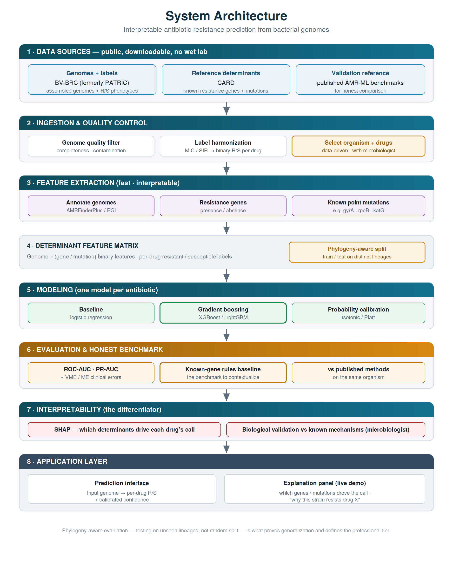
Figure 1 — Layered system architecture. The phylogeny-aware split (Layer 4) is the rigor differentiator.

8 End-to-End Workflow
The workflow runs from raw genomes to an explained, benchmarked prediction, with two decision gates that protect the result: a check that each drug has enough resistant and susceptible genomes to model honestly, and a generalization gate that, if the model fails to hold up on unseen lineages, loops back to revisit the split rather than publish an inflated number.
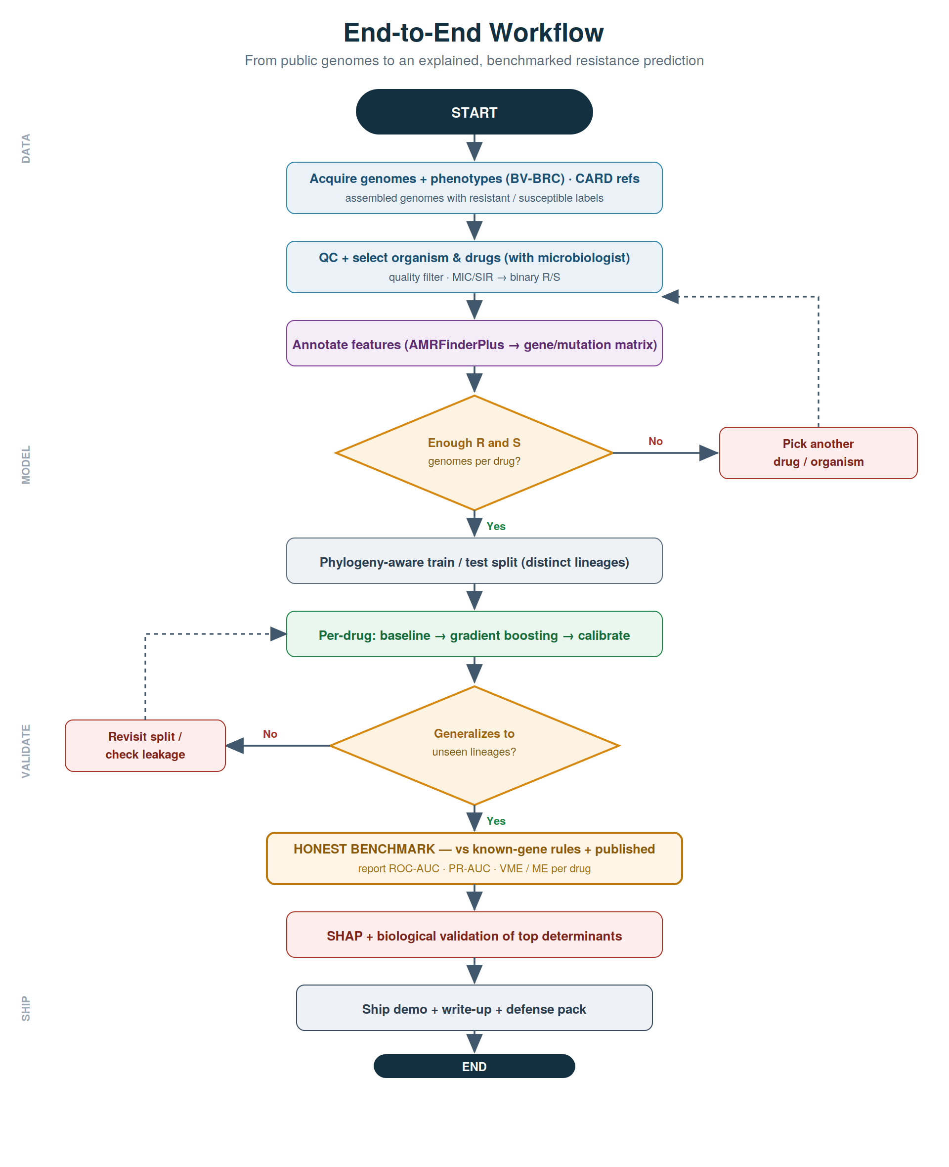
Figure 2 — End-to-end workflow with decision gates and feedback loops.

9 Four-Week Sprint Roadmap
Delivery is compressed into four weeks and organized around a single principle: build a thin, ugly-but-complete pipeline for one drug in Week 1, then broaden and polish. Each week ends with a defensible artifact, and Week 1 carries an explicit go/no-go.
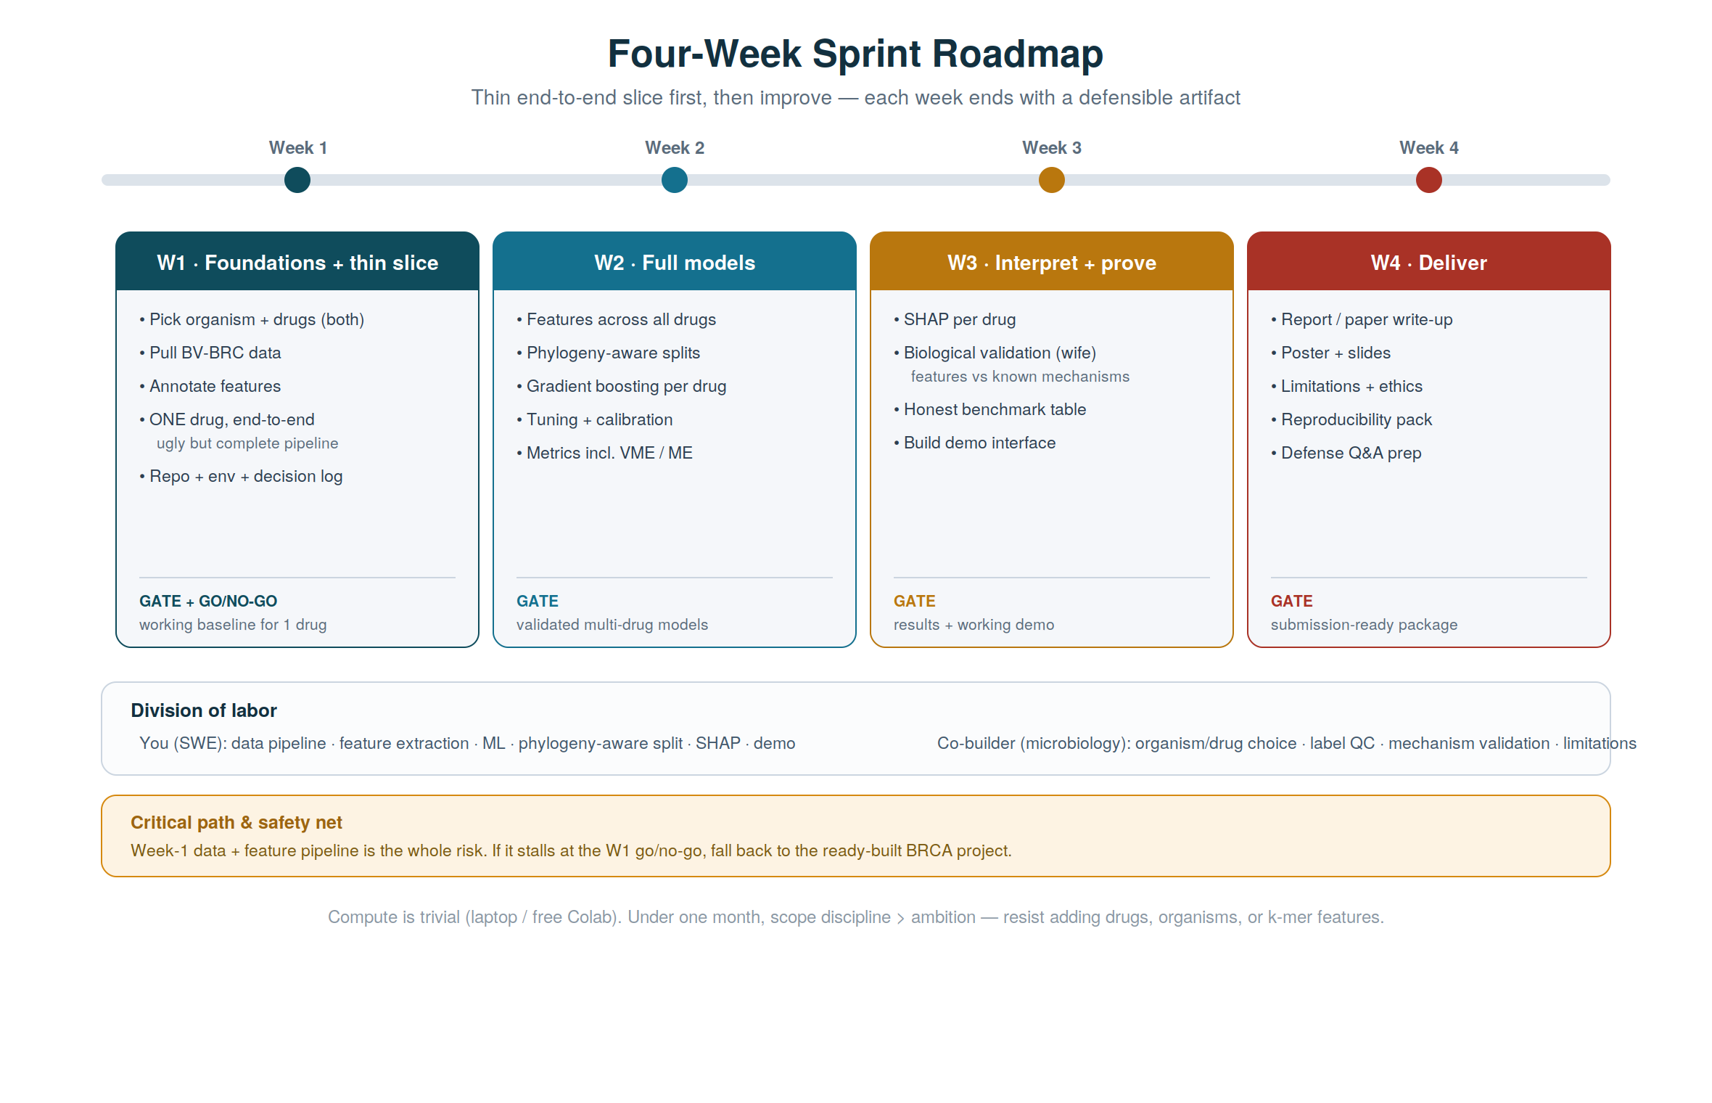
Figure 3 — Four-week sprint roadmap with team lanes and the Week-1 go/no-go.
Week | Focus | Exit artifact
W1 · Foundations | Select organism & drugs; acquire BV-BRC data; annotate features; build ONE drug end-to-end; repo + decision log. | Working baseline for one drug + go/no-go decision.
W2 · Full models | Features across all chosen drugs; phylogeny-aware splits; gradient boosting; tuning; calibration; VME/ME metrics. | Validated multi-drug models.
W3 · Interpret + prove | SHAP per drug; biological validation; honest benchmark table; demo interface. | Results + working demo.
W4 · Deliver | Write-up; poster; limitations & ethics; reproducibility; defense prep. | Submission-ready package.

10 Evaluation Metrics & Success Criteria
Per drug: ROC-AUC and PR-AUC for discrimination, reliability curves for calibration, and very-major and major error rates for clinical safety — all reported under the phylogeny-aware split, never a random one.
Success is defined honestly. The target is strong per-drug discrimination on unseen lineages, a measured comparison against the known-gene baseline (ideally fewer very-major errors), and SHAP determinants that agree with known biology. “State-of-the-art on every drug” is explicitly not the goal; a smaller, honestly-validated result is worth more than a large leaky one.

11 Risks & Limitations
Risk / limitation | Mitigation
One-month timeline is tight for genomics. | Thin end-to-end slice in Week 1; ruthless scope discipline; determinant features (not k-mers); a Week-1 go/no-go with the ready-built BRCA project as fallback.
Population-structure leakage (the primary scientific threat). | Phylogeny-aware splits by lineage; prove no shared lineages across train/test.
“Just a database lookup” critique. | Frame the known-gene rules classifier as the explicit baseline; report what the model adds, especially reduced very-major errors.
Class imbalance / sparse phenotypes per drug. | Select balanced drugs in Week 1; report PR-AUC; drop drugs with too few labels rather than overclaim.
Label and metadata noise in public data. | Quality-filter genomes; microbiologist audits phenotype labels; pin dataset versions in a manifest.

12 Team & Division of Labor
Software engineer: data pipeline, feature extraction, phylogeny-aware splitting, modeling, calibration, SHAP tooling, and the demo. Microbiologist (M.Sc.): organism and drug selection, phenotype-label quality control, biological validation of SHAP determinants, interpretation of clinical error trade-offs, and the limitations and defense narrative. Both must be able to explain the parts they present; scientific decisions are shared and logged.

13 Ethical Considerations
The tool is a research and decision-support aid, not a diagnostic device; genotype-based prediction complements but does not replace phenotypic susceptibility testing, and a missed resistant call has real clinical cost — hence the emphasis on very-major error rates. Only public, de-identified genomic data are used. Reference databases are geographically biased toward well-sequenced regions and pathogens, which limits generalization; this is stated plainly as a limitation. Interpretability is itself an ethical safeguard, keeping the model auditable rather than opaque.

14 Expected Outcomes & Deliverables
- Per-drug interpretable resistant/susceptible classifiers for the chosen organism.
- A phylogeny-aware evaluation with per-drug ROC-AUC, PR-AUC, and very-major / major error rates.
- An honest benchmark table versus the known-gene baseline and published methods.
- SHAP determinant rankings validated against known resistance mechanisms.
- A working demo: genome in, per-drug calls plus the determinants behind them.
- A written report / paper, a poster, and a reproducible code + data-versioning package.

15 Selected References
[1] Nguyen, M. et al. Using machine learning to predict antimicrobial minimum inhibitory concentrations and associated genomic features for nontyphoidal Salmonella. Journal of Clinical Microbiology (2019).
[2] Moradigaravand, D. et al. Prediction of antibiotic resistance in Escherichia coli from large-scale pan-genome data. PLoS Computational Biology (2018).
[3] Hicks, A. L. et al. Evaluating the reliability of machine learning for antimicrobial-resistance prediction: the role of population structure. PLoS Computational Biology (2019).
[4] Olson, R. et al. / Davis, J. J. et al. The BV-BRC (formerly PATRIC) Bioinformatics Resource Center. Nucleic Acids Research.
[5] Alcock, B. P. et al. CARD 2023: expanded curation and the Comprehensive Antibiotic Resistance Database. Nucleic Acids Research (2023).
[6] Feldgarden, M. et al. AMRFinderPlus and the Reference Gene Catalog. Scientific Reports (2021).
[7] Lundberg, S. M. & Lee, S.-I. A unified approach to interpreting model predictions (SHAP). NeurIPS (2017).
[8] O’Neill, J. Tackling Drug-Resistant Infections Globally: Review on Antimicrobial Resistance (2016).
[9] World Health Organization. Global Antimicrobial Resistance and Use Surveillance System (GLASS) report.
Reference metadata should be verified and expanded in Week 1.

