WEB DEVELOPMENT
ACTIVITY BASED LEARNING
HTML, CSS Source Code and Output Screenshots

Name: KAPPAGANTHU V S DURGA PRASAD
Roll No: 26001153
Section: CSM-05

This document presents the three web development practicals, their HTML source code, the shared CSS stylesheet, and browser output screenshots.

1. Personal Portfolio Website
A personal portfolio webpage with Home, About, Education, Skills, Projects, Achievements and Contact sections.

HTML Code
<!DOCTYPE html>
<html lang="en">

<head>
<meta charset="UTF-8">
<meta name="viewport" content="width=device-width, initial-scale=1.0">
<title>My Personal Portfolio</title>
<link rel="stylesheet" href="style.css">
</head>

<body>

<header>
<h2>MyPortfolio</h2>
<nav aria-label="Main navigation">
<a href="#home">Home</a>
<a href="#about">About</a>
<a href="#education">Education</a>
<a href="#skills">Skills</a>
<a href="#projects">Projects</a>
<a href="#achievements">Achievements</a>
<a href="#contact">Contact</a>
</nav>
</header>

<main>
<section class="hero" id="home">
<div>
<h1>Hello, I'm <span>KAPPAGANTHU V S DURGA PRASAD</span></h1>
<h3>B.Tech Student | Web Developer | Tech Enthusiast</h3>
<p>Welcome to my personal portfolio website!</p>
<a href="#projects" class="button">View My Projects</a>
<a href="#contact" class="button">Contact Me</a>
</div>
</section>

<section id="about">
<h2 class="section-title">About Me</h2>
<div class="card">
<p>
I am a B.Tech student interested in programming,
web development, and emerging technologies.
I enjoy learning new skills, solving problems,
and creating useful projects.
</p>
<p><strong>Hobbies:</strong> Reading, coding, listening to music,
and exploring technology.</p>
</div>
</section>

<section id="education">
<h2 class="section-title">Educational Qualifications</h2>
<div class="card-container">
<div class="card">
<h3>B.Tech</h3>
<p>College: DR.RVR NRI UNIVERSITY</p>
<p>Branch: CSE / AI & ML</p>
<p>Year: 2026–Present</p>
</div>
<div class="card">
<h3>Intermediate</h3>
<p>College: NARAYANA JR COLLEGE</p>
<p>Year: 2026</p>
<p>Marks: 72%</p>
</div>
<div class="card">
<h3>SSC</h3>
<p>School: K.C HIGH SCHOOL</p>
<p>Year: 2024</p>
<p>GPA: 8.4</p>
</div>
</div>
</section>

<section id="skills">
<h2 class="section-title">Technical Skills</h2>
<div class="skills">
<span>HTML</span>
<span>CSS</span>
<span>JavaScript</span>
<span>Python</span>
<span>C Programming</span>
<span>SQL</span>
<span>Problem Solving</span>
</div>
</section>

<section id="projects">
<h2 class="section-title">My Projects</h2>
<div class="card-container">
<div class="card">
<h3>Personal Portfolio</h3>
<p>A responsive website to showcase my skills,
education, and projects.</p>
</div>
<div class="card">
<h3>Student Management System</h3>
<p>A simple project for maintaining student
details and academic records.</p>
</div>
<div class="card">
<h3>Calculator</h3>
<p>A basic calculator built using HTML,
CSS, and JavaScript.</p>
</div>
</div>
</section>

<section id="achievements">
<h2 class="section-title">Achievements & Resume</h2>
<div class="card-container">
<div class="card">
<h3>Achievements</h3>
<ul>
<li>Participated in technical workshops.</li>
<li>Completed programming exercises.</li>
<li>Developed academic mini-projects.</li>
</ul>
</div>
<div class="card">
<h3>My Resume</h3>
<p>Add your resume PDF in the same folder
and name it <strong>resume.pdf</strong>.</p>
<a href="resume.pdf" class="button" target="_blank">
View Resume
</a>
<a href="resume.pdf" class="button" download>
Download Resume
</a>
</div>
</div>
</section>

<section id="contact">
<h2 class="section-title">Contact Me</h2>
<div class="card">
<p>Email: your.email@example.com</p>
<p>Phone: +91 XXXXXXXXXX</p>
<p>Location: Your City, India</p>
<p>LinkedIn: Add your LinkedIn profile URL</p>
<p>GitHub: Add your GitHub profile URL</p>
</div>

<form id="contactForm">
<h3>Send Me a Message</h3>
<input type="text" id="name" placeholder="Your Name" required>
<input type="email" id="email" placeholder="Your Email" required>
<textarea id="message" rows="5" placeholder="Your Message" required></textarea>
<button type="submit" class="button">Send Message</button>
<p id="formStatus" role="status" aria-live="polite"></p>
</form>
</section>
</main>

<footer>
<p>&copy; <span id="year"></span> KAPPAGANTHU V S DURGA PRASAD.
All Rights Reserved.</p>
</footer>

</body>

</html>

Output
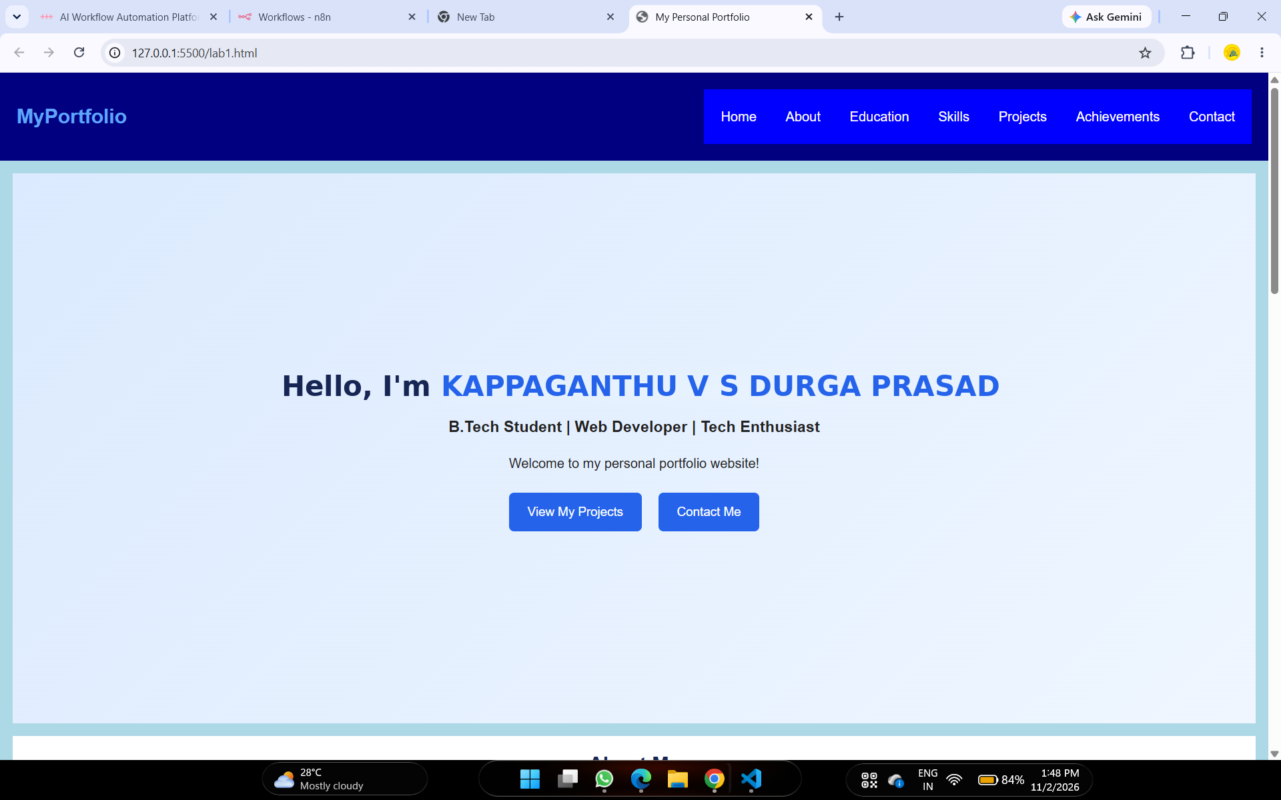
1. Personal Portfolio Website – Output screenshot 1
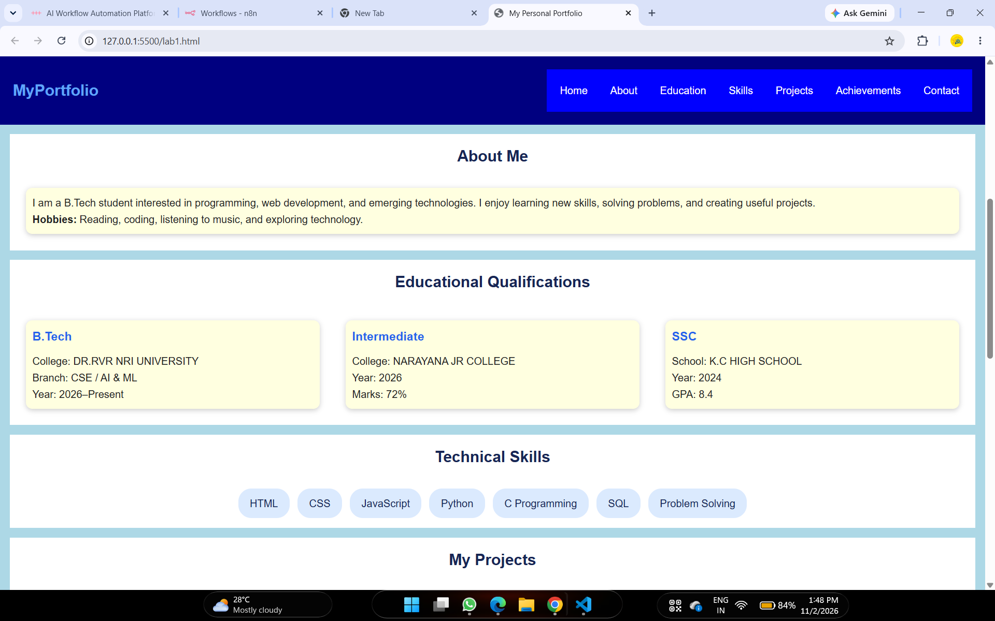
1. Personal Portfolio Website – Output screenshot 2
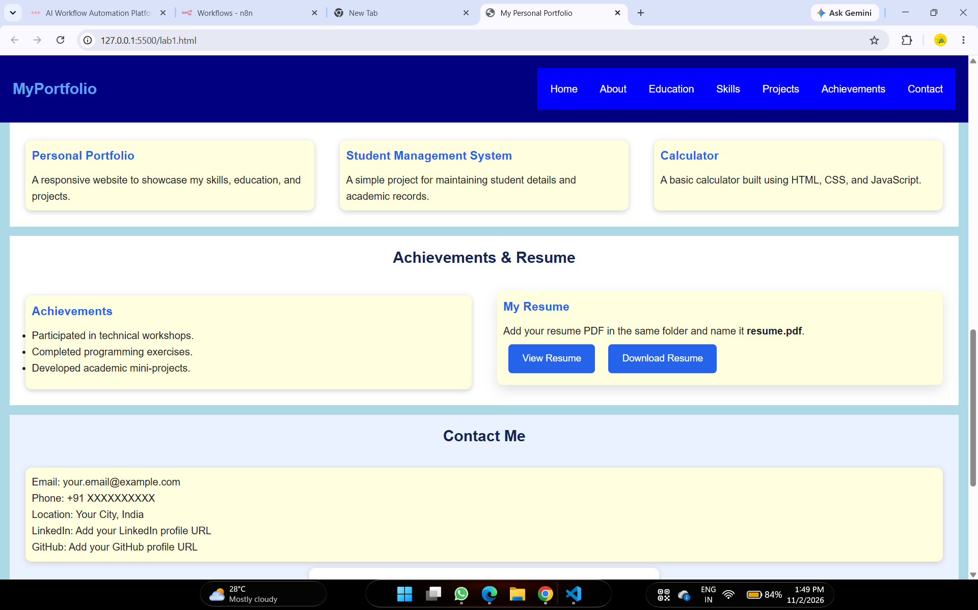
1. Personal Portfolio Website – Output screenshot 3
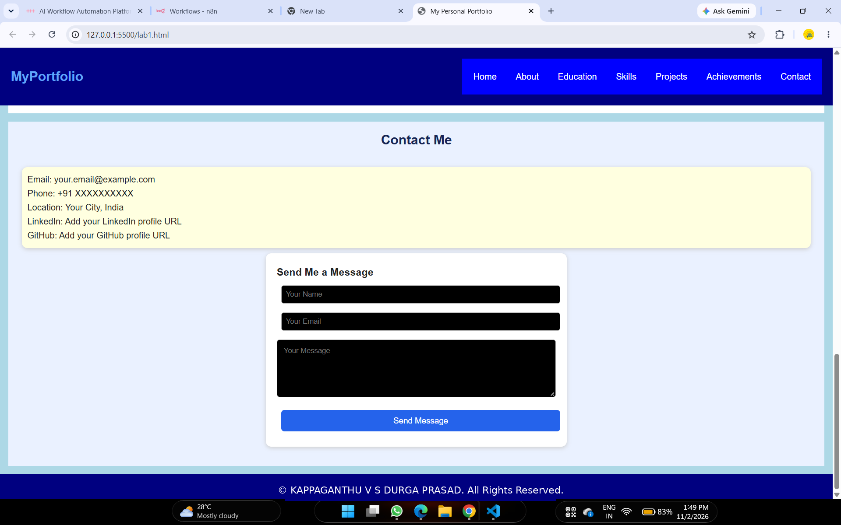
1. Personal Portfolio Website – Output screenshot 4

2. Travel Booking Website
A travel booking interface with journey search fields, available bus services, passenger details, seat selection and fare information.

HTML Code
<!DOCTYPE html>
<html lang="en">

<head>
<meta charset="UTF-8">
<meta name="viewport" content="width=device-width, initial-scale=1.0">
<title>Travel Booking</title>
<LINK rel="stylesheet" href="style.css">
</head>

<body>
<header>
<h1>Travel Booking</h1>
<p>Book your journey easily!</p>
</header>

<div class="container">
<form>
<h2>Search Your Journey</h2>
<div class="fields">
<div>
<label>Source</label>
<input type="text" placeholder="Enter source city" required>
</div>
<div>
<label>Destination</label>
<input type="text" placeholder="Enter destination" required>
</div>
<div>
<label>Travel Date</label>
<input type="date" required>
</div>
<div>
<label>Passengers</label>
<select>
<option>1 Passenger</option>
<option>2 Passengers</option>
<option>3 Passengers</option>
<option>4 Passengers</option>
</select>
</div>
</div>
<button type="button">Search Buses</button>
</form>

<h2>Available Services</h2>
<div class="card">
<h3>Express Travels</h3>
<p>Service: AC Sleeper Bus</p>
<p>Departure: 09:00 PM | Arrival: 06:00 AM</p>
<p><b>Fare: ₹900 per passenger</b></p>
<button type="button">Select Bus</button>
</div>

<div class="card">
<h3>Super Luxury Travels</h3>
<p>Service: Non-AC Seater Bus</p>
<p>Departure: 08:00 PM | Arrival: 05:00 AM</p>
<p><b>Fare: ₹600 per passenger</b></p>
<button type="button">Select Bus</button>
</div>

<form>
<h2>Passenger Details</h2>
<div class="fields">
<div>
<label>Full Name</label>
<input type="text" placeholder="Enter your name" required>
</div>
<div>
<label>Age</label>
<input type="number" min="1" placeholder="Enter age" required>
</div>
<div>
<label>Gender</label>
<select>
<option>Male</option>
<option>Female</option>
<option>Other</option>
</select>
</div>
</div>

<h3>Select Your Seat</h3>
<div class="seats">
<label><input type="checkbox"> A1</label>
<label><input type="checkbox"> A2</label>
<label><input type="checkbox"> A3</label>
<label><input type="checkbox"> A4</label>
<label><input type="checkbox"> B1</label>
<label><input type="checkbox"> B2</label>
<label><input type="checkbox"> B3</label>
<label><input type="checkbox"> B4</label>
</div>

<h3>Fare Information</h3>
<table>
<tr>
<th>Service</th>
<th>Fare</th>
</tr>
<tr>
<td>AC Sleeper</td>
<td>₹900</td>
</tr>
<tr>
<td>Non-AC Seater</td>
<td>₹600</td>
</tr>
</table>
<br>
<button type="submit">Book Ticket</button>
</form>
</div>

<footer>
<p>© 2026 Travel Booking Website</p>
</footer>
</body>

</html>

Output
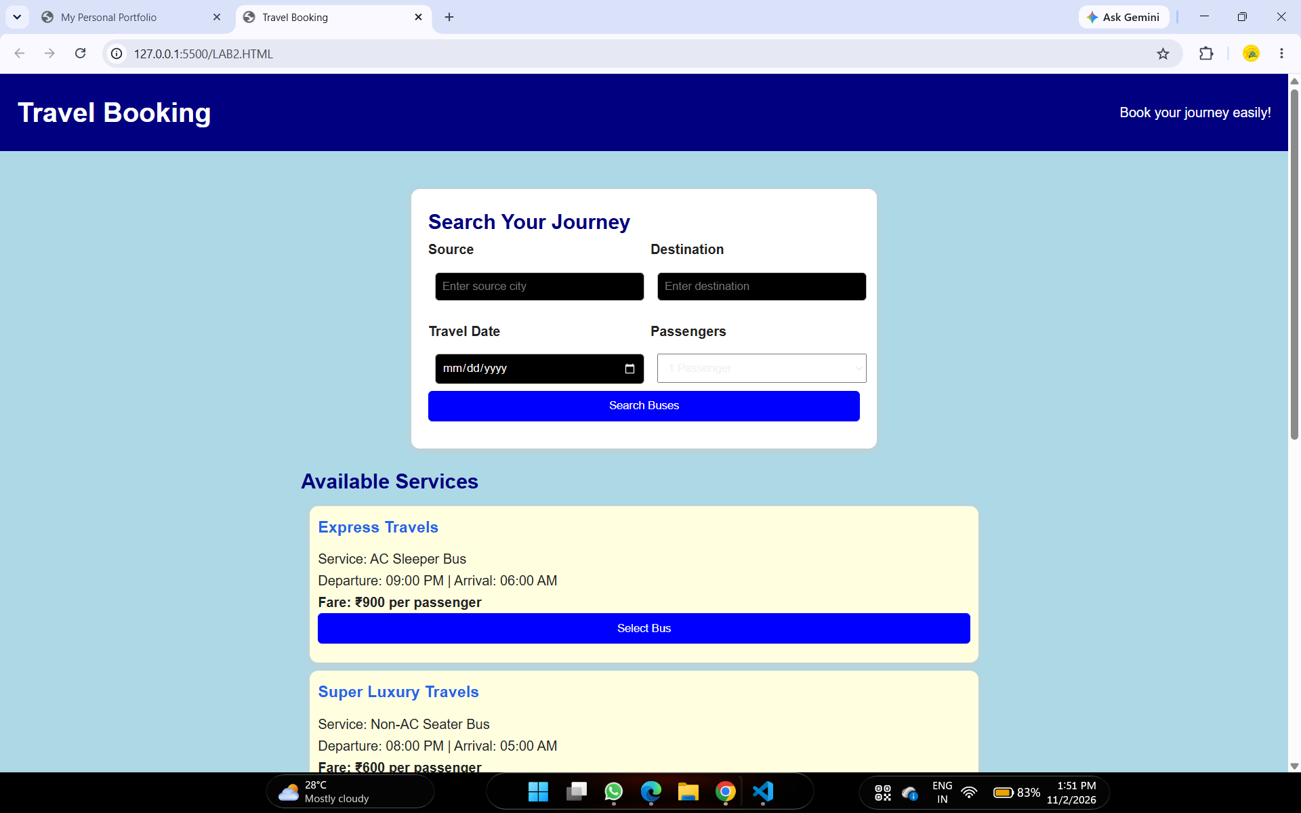
2. Travel Booking Website – Output screenshot 1
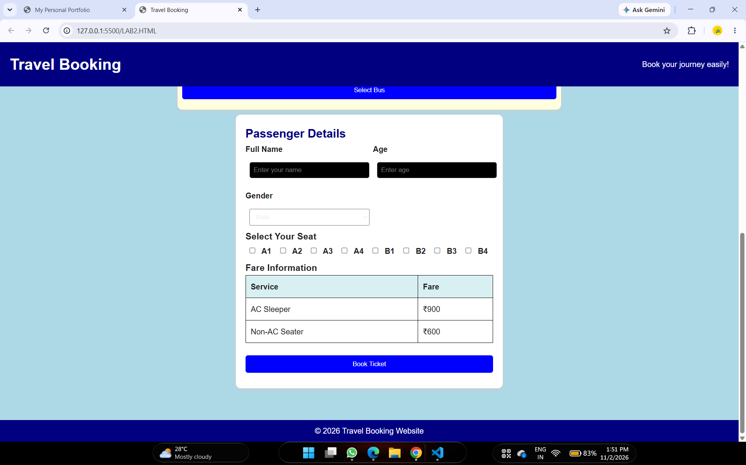
2. Travel Booking Website – Output screenshot 2

3. College Event Website
A Tech Fest 2026 event page containing event themes, keynote speakers, schedule, venue details, participation guidelines and a registration form.

HTML Code
<!DOCTYPE html>
<html>

<head>
<title>College Event</title>
<link rel="stylesheet" href="style.css">>
</head>

<body>

<header>
<h1>TECH FEST 2026</h1>
<p>Explore Technology and Innovation</p>
<p>Date: December 15, 2026</p>
</header>

<nav>
<a href="#themes">Themes</a>
<a href="#speakers">Speakers</a>
<a href="#schedule">Schedule</a>
<a href="#register">Register</a>
</nav>

<section id="themes">
<h2>Event Themes</h2>
<div class="card">Artificial Intelligence</div>
<div class="card">Robotics</div>
<div class="card">Web Development</div>
</section>

<section id="speakers">
<h2>Keynote Speakers</h2>
<div class="card">
<h3>Dr. Anil Kumar</h3>
<p>Topic: Artificial Intelligence</p>
</div>
<div class="card">
<h3>Ms. Priya Sharma</h3>
<p>Topic: Web Development</p>
</div>
</section>

<section id="schedule">
<h2>Event Schedule</h2>
<table>
<tr>
<th>Time</th>
<th>Activity</th>
</tr>
<tr>
<td>9:00 AM</td>
<td>Welcome Speech</td>
</tr>
<tr>
<td>10:00 AM</td>
<td>Keynote Session</td>
</tr>
<tr>
<td>12:00 PM</td>
<td>Lunch Break</td>
</tr>
<tr>
<td>2:00 PM</td>
<td>Technical Workshop</td>
</tr>
<tr>
<td>4:00 PM</td>
<td>Closing Ceremony</td>
</tr>
</table>
</section>

<section>
<h2>Venue Information</h2>
<p>Venue: College Main Auditorium</p>
<p>Date: December 15, 2026</p>
</section>

<section>
<h2>Participation Guidelines</h2>
<ul>
<li>Bring your college ID card.</li>
<li>Register before attending.</li>
<li>Arrive on time.</li>
<li>Maintain discipline.</li>
</ul>
</section>

<section id="register">
<h2>Registration Form</h2>
<form>
<label>Name:</label><br>
<input type="text" placeholder="Enter your name" required><br>
<label>Email:</label><br>
<input type="email" placeholder="Enter your email" required><br>
<label>Choose Theme:</label><br>
<select>
<option>Artificial Intelligence</option>
<option>Robotics</option>
<option>Web Development</option>
</select><br><br>
<button type="submit">Register</button>
</form>
</section>

<footer>
<p>© 2026 Tech Fest</p>
<p>Contact: techfest@example.com</p>
</footer>

</body>

</html>

Output
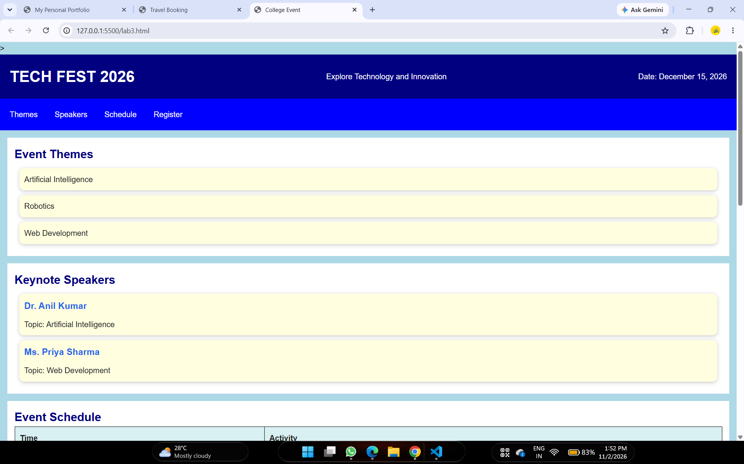
3. College Event Website – Output screenshot 1
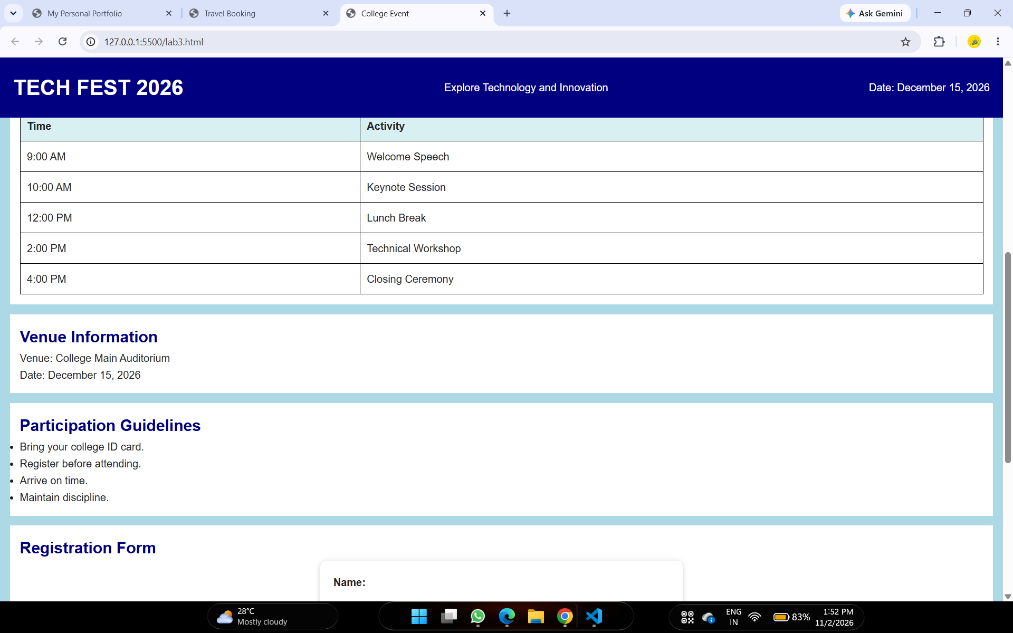
3. College Event Website – Output screenshot 2
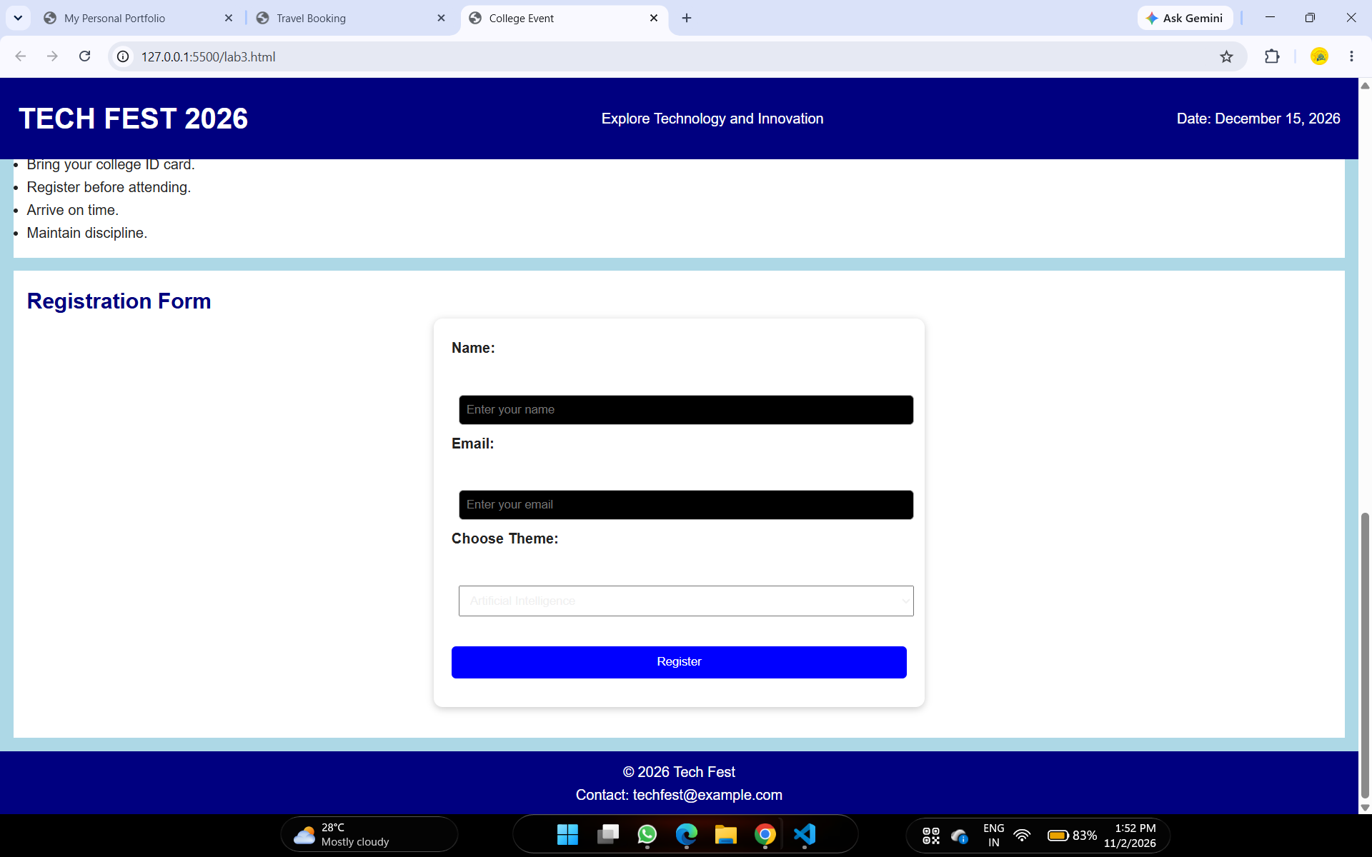
3. College Event Website – Output screenshot 3

4. Shared CSS Stylesheet
The three HTML pages link to a stylesheet named style.css. The supplied stylesheet contains the CSS rules for the portfolio, travel booking and college event pages.

CSS Code (style.css)
* {
margin: 0;
padding: 0;
box-sizing: border-box;
scroll-behavior: smooth;
}

body {
font-family: Arial, sans-serif;
background: #f4f7fb;
color: #222;
line-height: 1.6;
}

header {
background: #172554;
color: white;
padding: 18px 8%;
display: flex;
justify-content: space-between;
align-items: center;
flex-wrap: wrap;
position: sticky;
top: 0;
z-index: 100;
}

header h2 {
color: #60a5fa;
}

nav {
display: flex;
flex-wrap: wrap;
gap: 15px;
}

nav a {
color: white;
text-decoration: none;
transition: color 0.3s;
}

nav a:hover {
color: #60a5fa;
}

section {
padding: 60px 8%;
scroll-margin-top: 80px;
animation: fadeIn 0.8s ease;
}

.hero {
min-height: 80vh;
display: flex;
justify-content: center;
align-items: center;
text-align: center;
background: linear-gradient(135deg, #dbeafe, #eff6ff);
}

.hero h1 {
font-size: 42px;
color: #172554;
}

.hero span {
color: #2563eb;
}

.hero p {
margin: 15px 0;
}

.button {
display: inline-block;
padding: 11px 22px;
margin: 8px;
background: #2563eb;
color: white;
text-decoration: none;
border-radius: 6px;
transition: transform 0.3s, background 0.3s;
border: none;
cursor: pointer;
font-size: 15px;
}

.button:hover {
background: #172554;
transform: translateY(-3px);
}

h2.section-title {
text-align: center;
margin-bottom: 30px;
color: #172554;
}

.card-container {
display: grid;
grid-template-columns: repeat(auto-fit, minmax(220px, 1fr));
gap: 20px;
}

.card {
background: white;
padding: 22px;
border-radius: 10px;
box-shadow: 0 4px 12px #00000012;
transition: transform 0.3s, box-shadow 0.3s;
}

.card:hover {
transform: translateY(-7px);
box-shadow: 0 8px 20px #00000020;
}

.card h3 {
color: #2563eb;
margin-bottom: 10px;
}

.skills {
display: flex;
flex-wrap: wrap;
justify-content: center;
gap: 12px;
}

.skills span {
background: #dbeafe;
color: #172554;
padding: 10px 18px;
border-radius: 20px;
transition: background 0.3s, color 0.3s;
}

.skills span:hover {
background: #2563eb;
color: white;
}

#contact {
background: #eaf1ff;
}

form {
max-width: 550px;
margin: auto;
}

input,
textarea {
width: 100%;
padding: 12px;
margin: 8px 0;
border: 1px solid #bbb;
border-radius: 5px;
font-family: inherit;
}

input:focus,
textarea:focus {
outline: 2px solid #60a5fa;
}

footer {
text-align: center;
background: #172554;
color: white;
padding: 18px;
}

@keyframes fadeIn {
from {
opacity: 0;
transform: translateY(15px);
}

to {
opacity: 1;
transform: translateY(0);
}
}

@media (max-width: 650px) {
header {
justify-content: center;
gap: 12px;
}

nav {
justify-content: center;
gap: 10px;
}

.hero h1 {
font-size: 30px;
}

section {
padding: 45px 5%;
}
}

body {
font-family: Arial, sans-serif;
background: #eef4f8;
margin: 0;
}

header {
background: #087e8b;
color: white;
text-align: center;
padding: 20px;
}

.container {
max-width: 850px;
margin: 25px auto;
padding: 20px;
}

form,
.card {
background: white;
padding: 20px;
margin-bottom: 20px;
border-radius: 10px;
box-shadow: 0 2px 8px #ccc;
}

.fields {
display: grid;
grid-template-columns: repeat(auto-fit, minmax(180px, 1fr));
gap: 15px;
}

label {
display: block;
margin-bottom: 6px;
font-weight: bold;
}

input,
select,
button {
width: 100%;
padding: 10px;
margin-bottom: 12px;
box-sizing: border-box;
}

button {
background: #087e8b;
color: white;
border: none;
cursor: pointer;
border-radius: 5px;
}

.seats {
display: flex;
gap: 10px;
flex-wrap: wrap;
}

.seats input {
width: auto;
}

table {
width: 100%;
border-collapse: collapse;
}

th,
td {
padding: 10px;
border: 1px solid #ddd;
text-align: left;
}

th {
background: #d8f0f2;
}

footer {
text-align: center;
background: #087e8b;
color: white;
padding: 12px;
}

body {
font-family: Arial;
margin: 0;
background-color: lightblue;
}

header {
background-color: navy;
color: white;
text-align: center;
padding: 20px;
}

nav {
background-color: blue;
padding: 10px;
text-align: center;
}

nav a {
color: white;
margin: 10px;
}

section {
background-color: white;
margin: 15px;
padding: 15px;
}

h2 {
color: navy;
}

.card {
background-color: lightyellow;
padding: 10px;
margin: 10px;
}

table {
width: 100%;
}

th,
td {
padding: 10px;
border: 1px solid black;
}

input,
select {
padding: 8px;
margin: 8px;
}

button {
background-color: blue;
color: white;
padding: 10px;
}

footer {
background-color: navy;
color: white;
text-align: center;
padding: 10px;
}

Technologies Used
HTML5 – webpage structure, content, forms, navigation and tables.
CSS3 – page styling, layout, colors, spacing, responsive behavior and visual presentation.

Conclusion
The three practical webpages demonstrate the use of HTML and CSS to create a personal portfolio, a travel booking interface and a college event website. The screenshots show the rendered browser outputs of the supplied source files.

