Strong Compression
1. Introduction

We try to investigate causal relationships between applications of rule.
2. Definitions

Atomic event (AEvent) is a change in site state (linkState, internalState) or agent. Stores state before and after. Atomic events are displayed as Nodes (circles) on diagrams. White filled circle means Node which is tested, Black Node means change of state and Grey Node means change without testing.

Wire is a set of atomic events occurred with concrete wire during simulation. Each Wire has a unique identifier, WireHashKey, which consists of:
- Agent Id
- Site Id
  - wire type
- internalState
- linkState(FREE/BOUND)
- linkState(FREE/connected with ..)
- check agent

Event (CEvent) stores information about a specific Rule application at some point in time. It is HashMap, where keys are WireHashKey and objects are Atomic Events.

ObsEvent (or observableEvent) is the last event, the goal of the story.

State of CEvent:
  - KEPT – the marked event is significant
  - DELETED — the marked event is not significant
  - UNRESOLVED — the event is in undefined state (we don't know whether it is significant or not)
3. Input Data

Number of Events is stored in the following set:
HashMap<WireHashKey, TreeMap<Long, CEvent>>
Long is the event id.
CEvent is an Event

4. Output Data

We have to build tree (story), which shows the trace of rules and species leading to observable rule application.

5. Goal

The goal is to rebuild the tree (story) to be able to apply Weak Compression and thus reduce the story size.
6. Solution

We will swap agents of the same type and perform weak compression after each swap, which can lead to the Goal.
7. Algorithm

- Perform simulation and weak compression.
- For each event, build set of perturbations (swaps).
- For each perturbation in the set:
  - Apply perturbation;
  - Perform weak compression;
  - If weak compression is successful:
* if not successful, continue with the next perturbation (step 3.а)
    - Check new structure:
      - If new “storage” is better, take it and continue with the next event (step 2)
* if there are no more events to process, this is the end of strong compression.

      - If new storage is not better, continue with the next perturbation (step 3.а);
* if there are no more perturbations, the next event (step 2);

Storage comparison

If some new storage (story tree) depth is not more than that of the previous one and the size is less than of the previous one, this new storage is better.
We can measure depth for each event. After each perturbation, the depth for every event must not increase.

How to build a set of perturbations

- Find similar agents for the current event;
- Build all possible perturbations for these agents;
- Build all possible perturbations for all agents from the above set.
- To increase performance: Discard “similar” perturbations (perturbation “to itself” and “reverse” perturbation, if we have 1 => 2 and 2 => 1, then we can discard one of them);

Applying perturbation

Move «nodes» from one wire to another. Conditions of states before/after may be broken.
8. Examples

Example 1:
After weak compression, we have the following story:
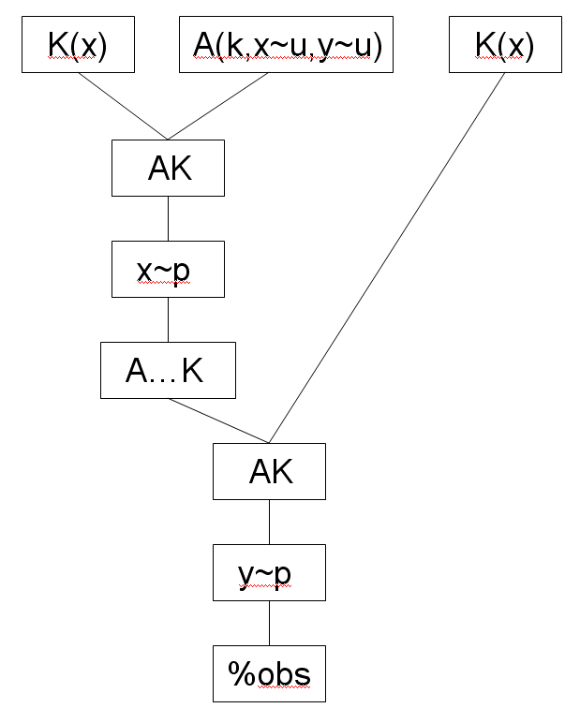
During strong compression, we perform swapping of agents:
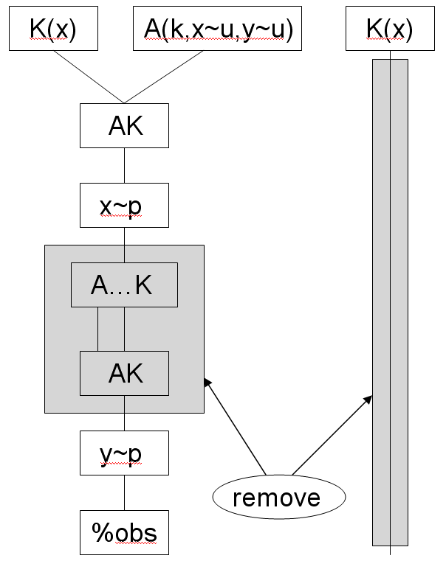
Blocks which we can remove are marked with «remove».

Having performed weak compression again, we get the following story:
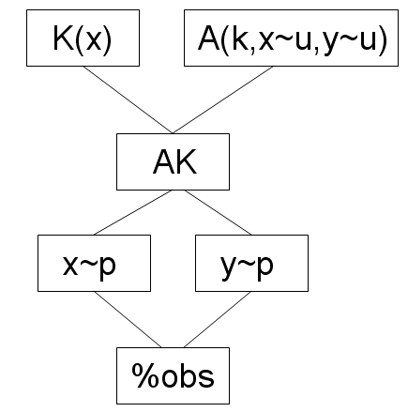

Example 2

Consider story
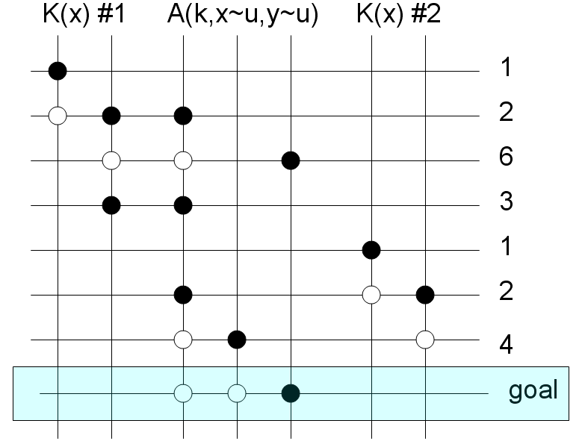

Go through events (take event 1, the one marked with an arrow)
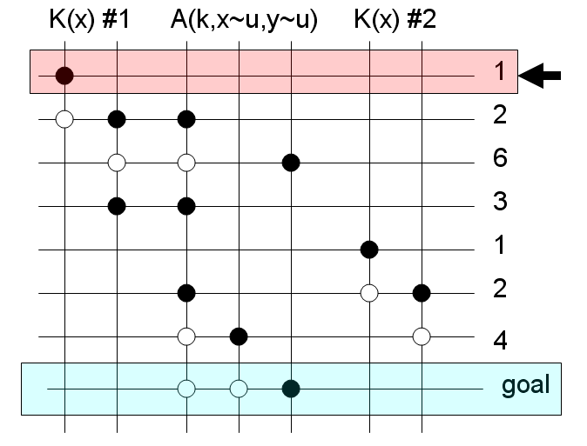
Similar agents: K(x)
Possible perturbations: (#1 → #1), (#1 → #2), (#2 → #2), (#2 → #1).
Perturbations (#1 → #1) and (#2 → #2) – change nothing.
Perturbations (#1 → #2) and (#2 → #1) – are identical.
So, there is the only one perturbation left: (#1 → #2)
Applying it, we get the following story:
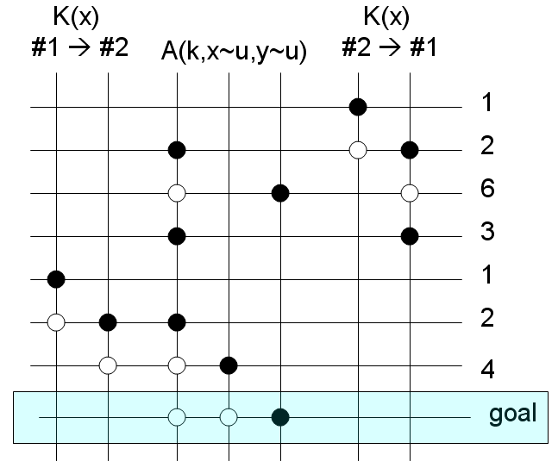

Perform weak compression.
Story has not been changed.
Return to the story (storage) we had before perturbation.
There are no more perturbations for the event 1, so we have to choose the next one:

Event 2.
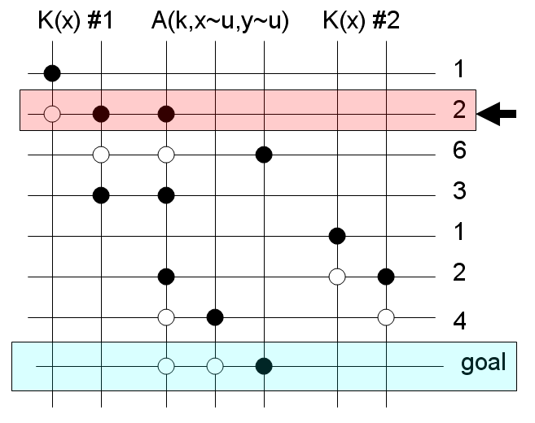

Similar agents: K(x)
Possible perturbations: (#1 → #1), (#1 → #2), (#2 → #2), (#2 → #1).
Perturbations (#1 →#1) and (#2 → #2) – doesn't change anything.
Perturbations: (#1 → #2) and (#2 → #1) – are identical.
So, there is the only one perturbation left: (#1 → #2)
Applying it, we get the following story:

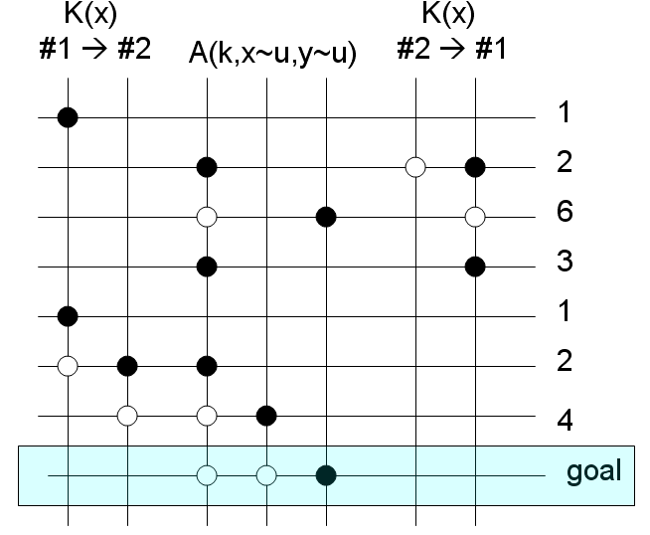
Perform weak compression.
Story has not been changed.
Return to the story (storage) we had before perturbation.
There are no more perturbations for the event #2, so we have to choose the next one:
Event #6.
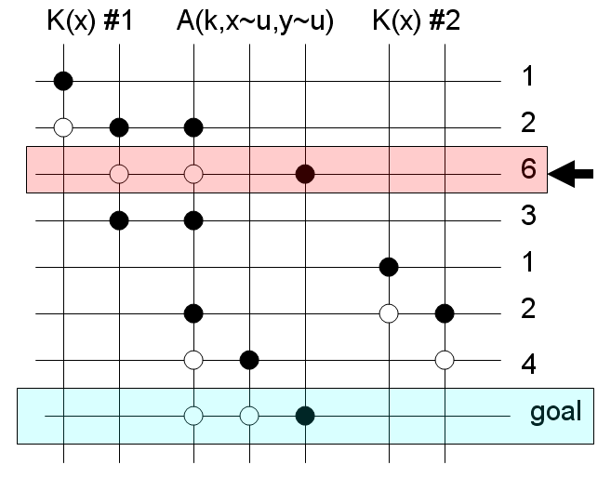
Similar agents: K(x)
Possible perturbations: (#1 → #1), (#1 → #2), (#2 → #2), (#2 → #1).
Perturbations (#1 → #1) and (#2 → #2) – change nothing.
Perturbations: (#1 → #2) and (#2 → #1) – are identical.
So, there is the only one perturbation left: (#1 → #2)
Applying it, we get the following story:

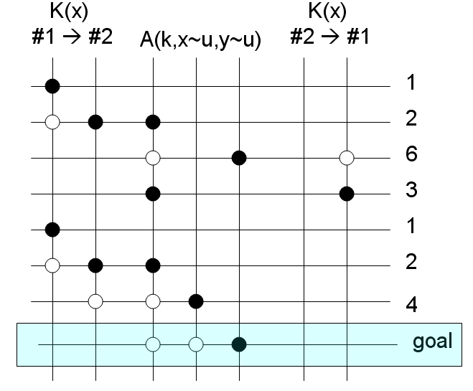

Perform weak compression.
Story has not been changed.
Return to the story (storage) we had before perturbation.
There are no more perturbations for the event #6, so we have to choose the next one:

Event #3.
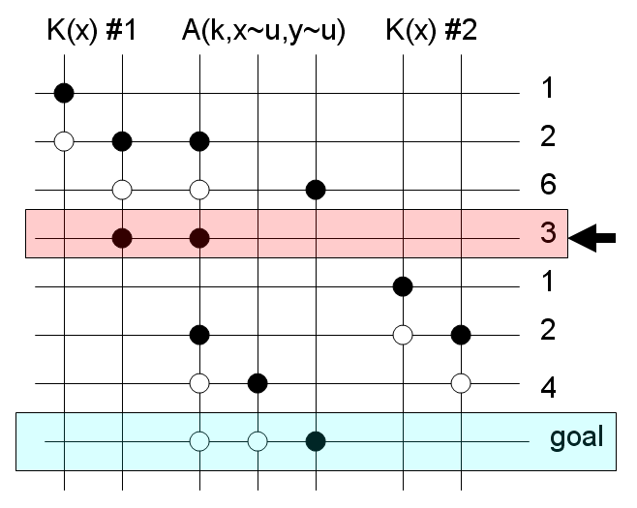

Similar agents: K(x)
Possible perturbations: (#1 → #1), (#1 → #2), (#2 → #2), (#2 → #1).
Perturbations (#1 → #1) and (#2 → #2) – change nothing.
Perturbations: (#1 → #2) and (#2 → #1) – are identical.
So, there is the only one perturbation left: (#1 → #2)
Applying it, we get the following story:

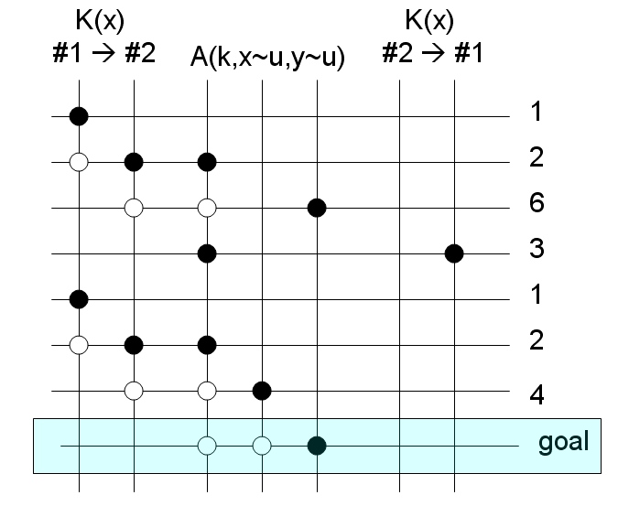

Perform weak compression.
Story has not been changed.
Return to the story (storage) we had before perturbation.
There are no more perturbations for the event #3, so we have to choose the next one:

Event #1.
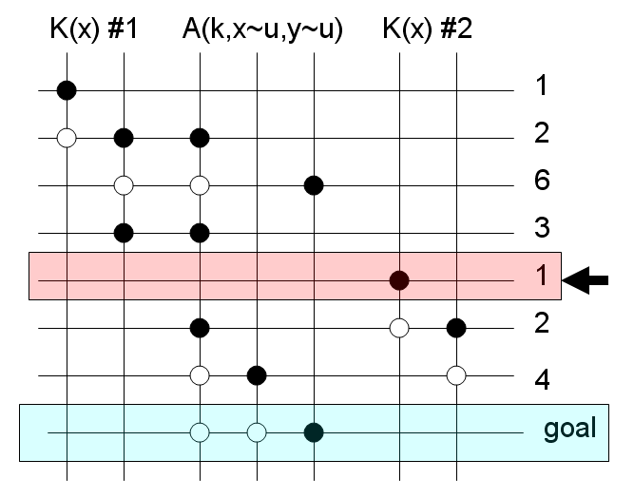

Similar agents: K(x)
Possible perturbations: (#1 → #1), (#1 → #2), (#2 → #2), (#2 → #1).
Perturbations (#1 → #1) and (#2 → #2) – change nothing.
Perturbations (#1 → #2) and (#2 → #1) – are identical.
So, there is the only one perturbation left: (#1 → #2)
Applying it, we get the following story:

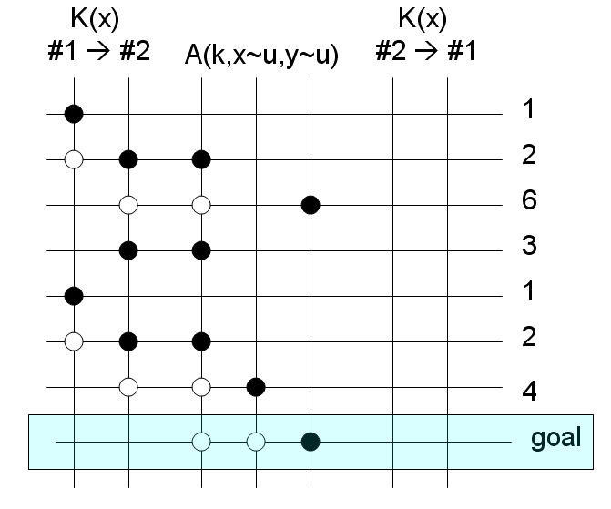
Apply weak compression.
We can remove block:
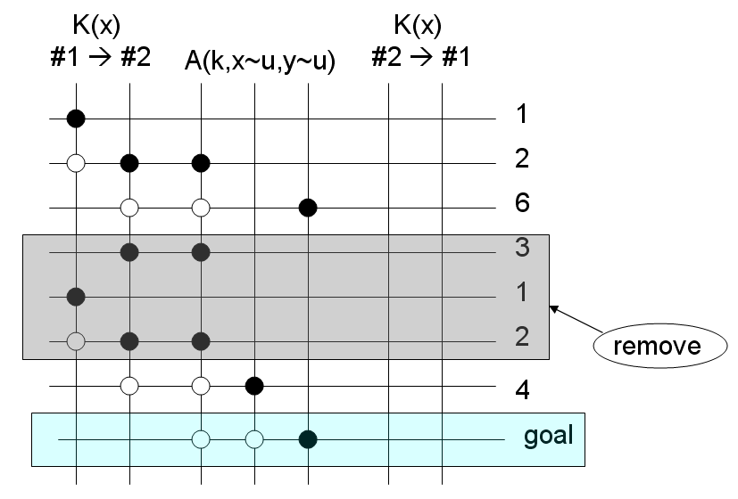
Story has changed.
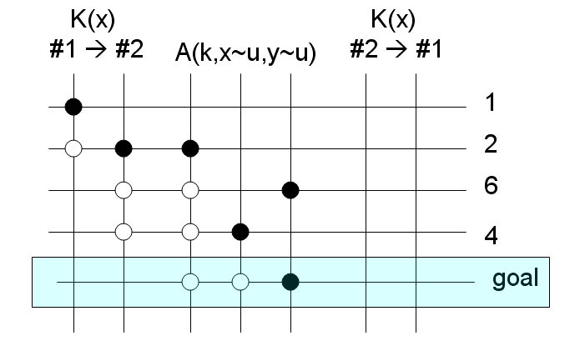

Take this new story as base.
Start from the very first event, etc.

9. Flowchart

10. Supplements

NB In our opinion, we can, depending on the manner we do the swapping, arrive at different results.

The agent power id defined as the sum of its wire powers.
It is reasonable to swap
A) two agents with small powers (with hope to cancel one later)
B) an agent with small power and an agent with high power.

