Strong Compression

Introduction
Here we investigate the causal relationships between application of the rules.

Definitions
The Atomic event (AEvent) is a change in the site state (linkState, internalState) or agent. It stores the wire states before and after the rule application. Atomic events are displayed as Nodes (circles) on the diagrams. The Node that is tested is displayed as a white filled circle, the Node that changes the state is displayed as a black circle, and the Node that changes without testing is displayed as a gray circle.

The Wire is a set of atomic events that occurred with the specific state during simulation. Each Wire has a unique identifier, WireHashKey, which consists of:
- Agent Id;
- Site Id;
- wire type :
  - internalState;
  - linkState(FREE/BOUND);
  - linkState(FREE/connected with ..);
  - check agent.

The Event (Event class) stores the information about the specific Rule application at some instant. The Event contains the HashMap, where WireHashKey is the key, and the Atomic Events are the objects.

The ObsEvent (or observableEvent) is the last event in the story.

The possible Event states:
- KEPT – the marked event is significant;
- DELETED — the marked event is not significant;
- UNRESOLVED — the event is in undefined state (we don't know whether it is significant or not).

Input Data
The Input Data consists of the events which are stored in the following collection:
HashMap<WireHashKey, TreeMap<Long, Event>>, where
Long is the event id, CEvent is the Event.

Output Data
The Output Data is a tree (story), which shows the trace of rules and species leading to observable rule application.

Goal
The goal is to rebuild the tree (story) to be able to apply Weak Compression and thus reduce the story size.

Solution
We swap the agents of the same type and perform the Weak Compression after each swap, which can lead to the Goal.

Algorithm
- Perform simulation and weak compression.
- For each event, build set of permutations (swaps).
- For each permutation in the set:
  - Apply permutation;
  - Perform weak compression;
  - If weak compression is successful:
* if not successful, continue with the next permutation (step 3.1)
    - Check new structure:
      - If the new storage is better, take it and continue with the next event (step 2)
* if there are no more events to process, this is the end of strong compression.
      - If the new storage is not better, continue with the next permutation (step 3.1);
*if there are no more permutations, continue with the next event (step 2);

Notes:
- Extension by continuity. For example, suppose that we have a(x~u!1),b(x!1...), a(x~p!1),b(x!1...). Try to swap a(x~u) and a(x~p). It is clear that we have to swap the agents b too. If b is linked with some other agents we have to try to swap them too, and so on.
- Sewing cut. After swapping the agent we may have some incorrect wires, but the weak compression may remove these contradictions. Therefore, we perform swap disregarding wire correctness.

Storage comparison:
If the new storage (story tree) depth is not more than the depth of the previous one and the size is less than the size of the previous one, this new storage is better. We can measure the depth for each event. After each permutation, the depth for each event should not increase.

How to build a set of permutations:
- Find similar agents for the current event;
- Build all possible permutations for these agents;
- Build all possible permutations for all agents from the above set;
- To increase performance: Discard “similar” perturbations, that is, the perturbation “to itself” and the “reverse” perturbation, if we have 1 => 2 and 2 => 1, then we can discard one of them.

Applying perturbation:
Move the nodes from one wire to another. Conditions of states before/after may be broken.

Examples
Example 1:
After the weak compression, we have the following story:
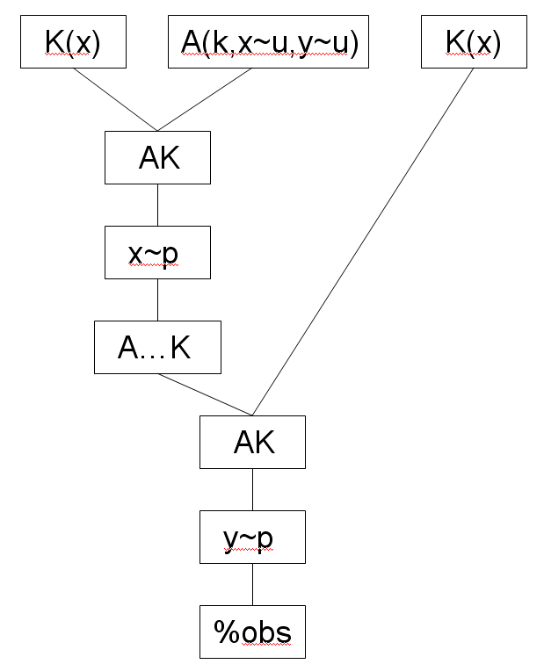
During the strong compression, we perform the agents swapping:
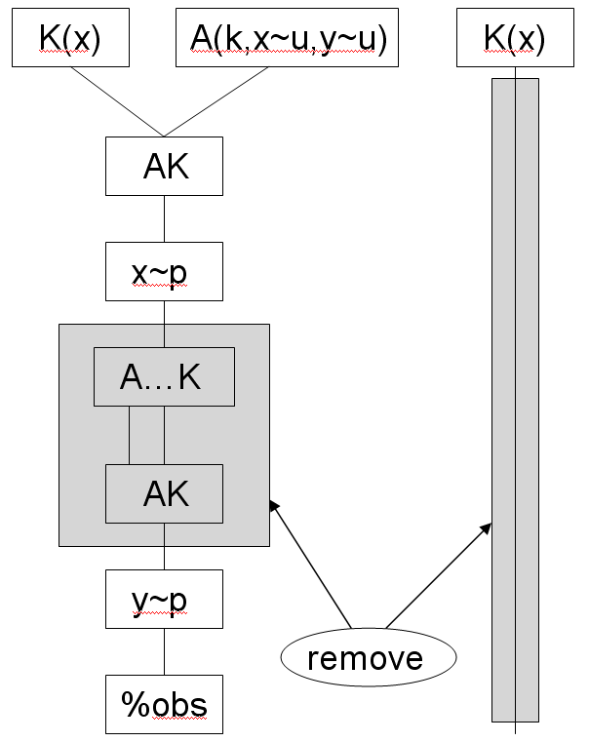
The blocks to remove are marked as «remove».

Having performed the weak compression again, we get the following story:
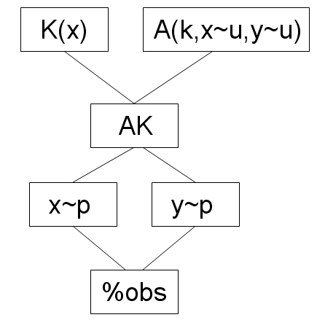

Example 2:

Consider the story
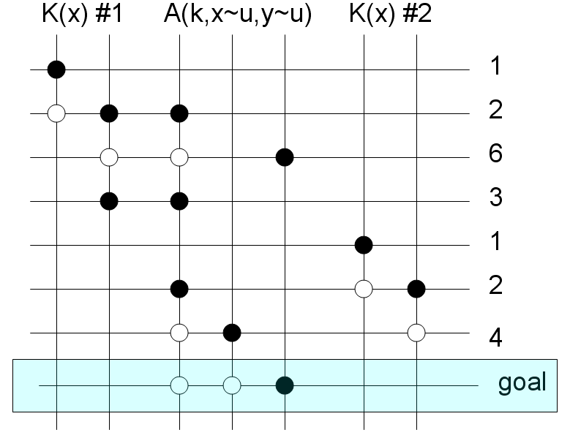

Go through events (take the event 1, the one marked with an arrow)
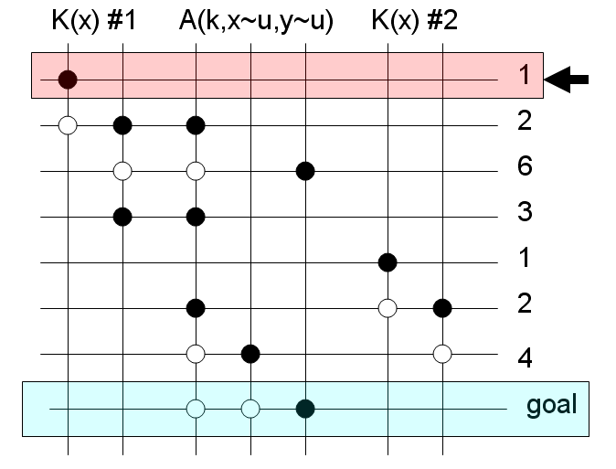
Similar agents: K(x)
Possible permutations: (#1 → #1), (#1 → #2), (#2 → #2), (#2 → #1).
Permutations (#1 → #1) and (#2 → #2) change nothing.
Permutations (#1 → #2) and (#2 → #1) are identical.
So, there is the only one permutation left: (#1 → #2)
Applying it, we get the following story:
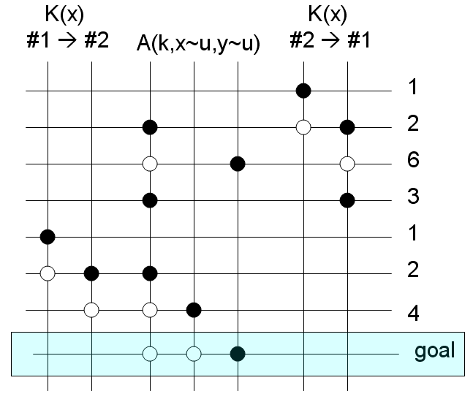

Perform weak compression. Story does not change. Return to the story (storage) we had before permutation.
There are no more permutations for the event 1, so we have to choose the next one:

Event 2.
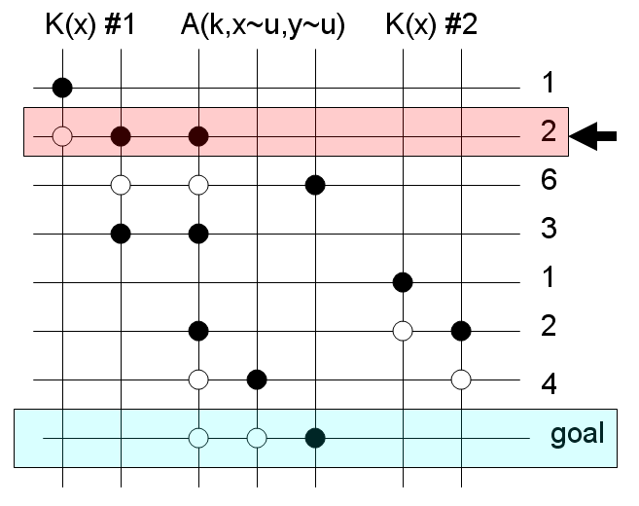

Similar agents: K(x)
Possible permutations: (#1 → #1), (#1 → #2), (#2 → #2), (#2 → #1).
Permutations (#1 →#1) and (#2 → #2) change nothing.
Permutations (#1 → #2) and (#2 → #1) are identical.
So, there is the only one perturbation left: (#1 → #2)
Applying it, we get the following story:

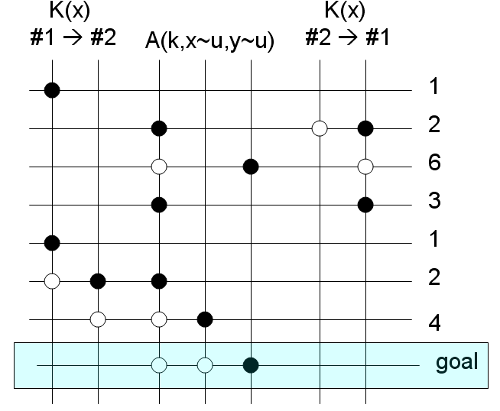
Perform weak compression. Story does not change. Return to the story (storage) we had before permutation.
There are no more permutations for the event 2, so we have to choose the next one:
Event 6.
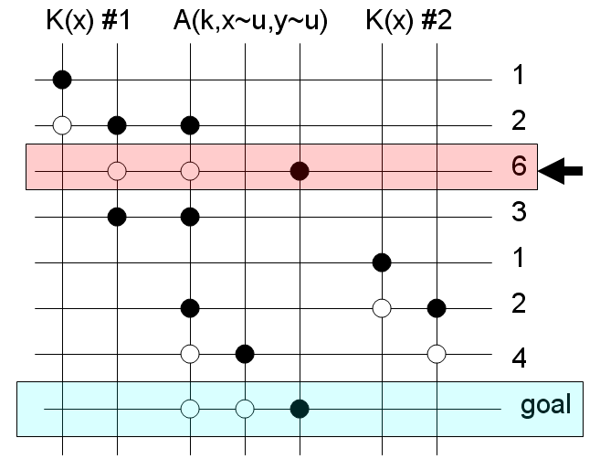
Similar agents: K(x)
Possible permutations: (#1 → #1), (#1 → #2), (#2 → #2), (#2 → #1).
Permutations (#1 → #1) and (#2 → #2) change nothing.
Permutations (#1 → #2) and (#2 → #1) are identical.
So, there is the only one permutation left: (#1 → #2)
Applying it, we get the following story:

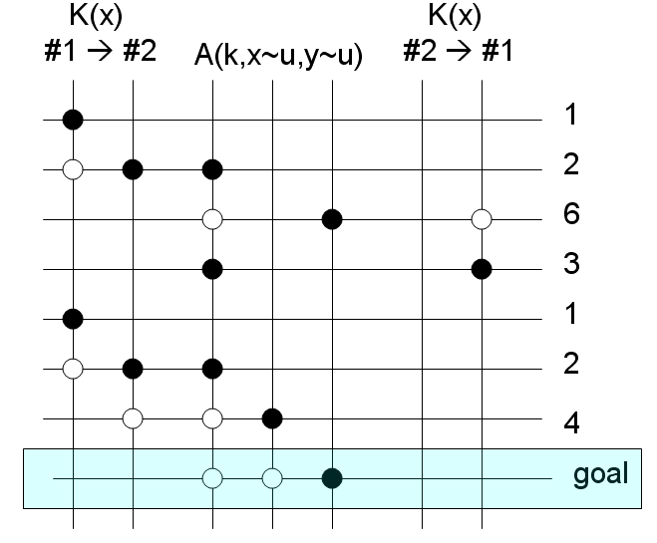

Perform weak compression. Story does not change. Return to the story (storage) we had before permutation.
There are no more permutations for the event 6, so we have to choose the next one:

Event 3.
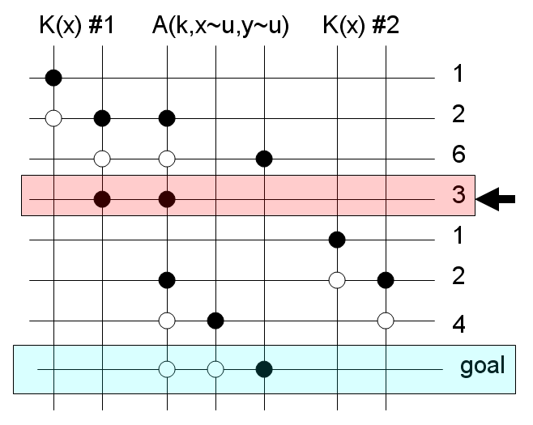

Similar agents: K(x)
Possible permutations: (#1 → #1), (#1 → #2), (#2 → #2), (#2 → #1).
Permutations (#1 → #1) and (#2 → #2) change nothing.
Permutations (#1 → #2) and (#2 → #1) are identical.
So, there is the only one permutation left: (#1 → #2)
Applying it, we get the following story:

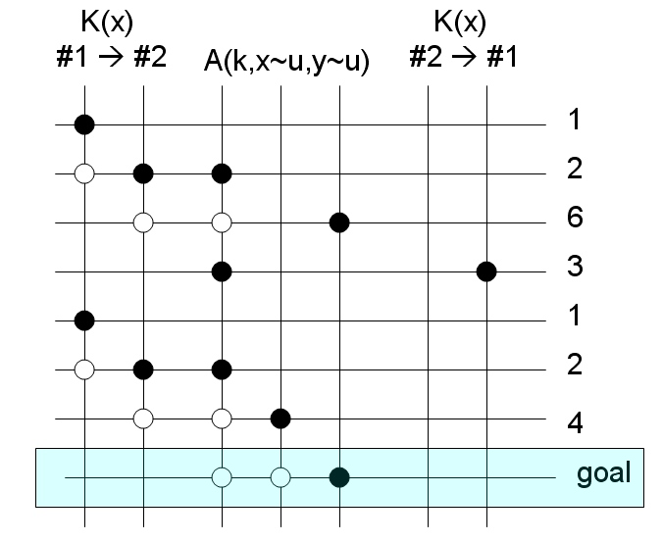

Perform weak compression. Story does not change. Return to the story (storage) we had before permutation.
There are no more permutations for the event 3, so we have to choose the next one:

Event 1.
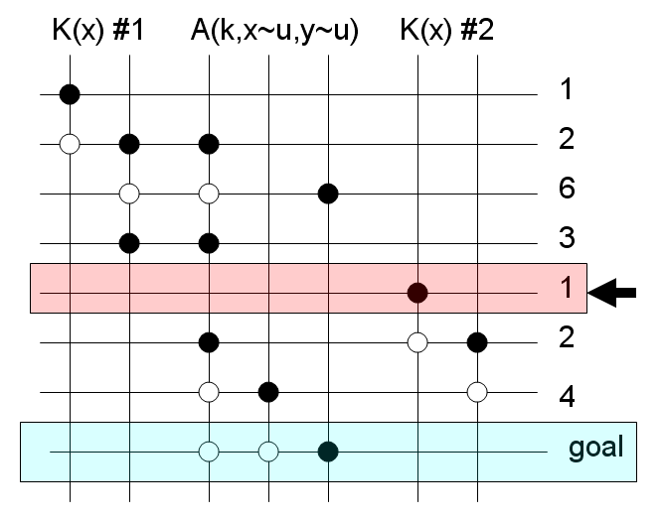

Similar agents: K(x)
Possible permutations: (#1 → #1), (#1 → #2), (#2 → #2), (#2 → #1).
Permutations (#1 → #1) and (#2 → #2) change nothing.
Permutations (#1 → #2) and (#2 → #1) are identical.
So, there is the only one permutation left: (#1 → #2)
Applying it, we get the following story:

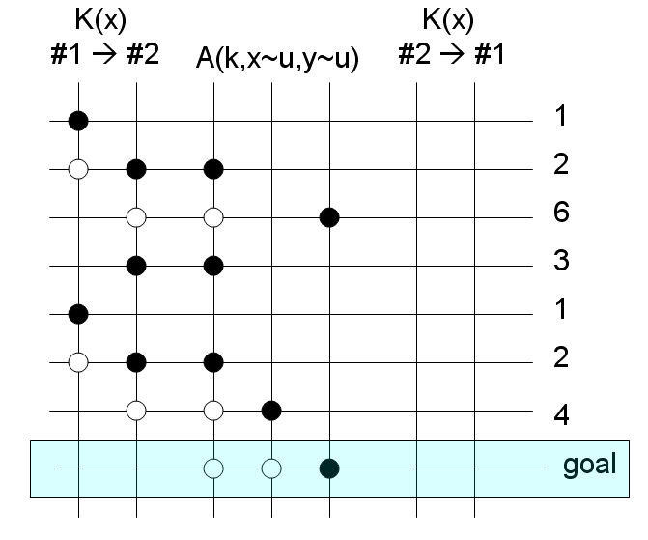
Apply weak compression. We can remove a block:
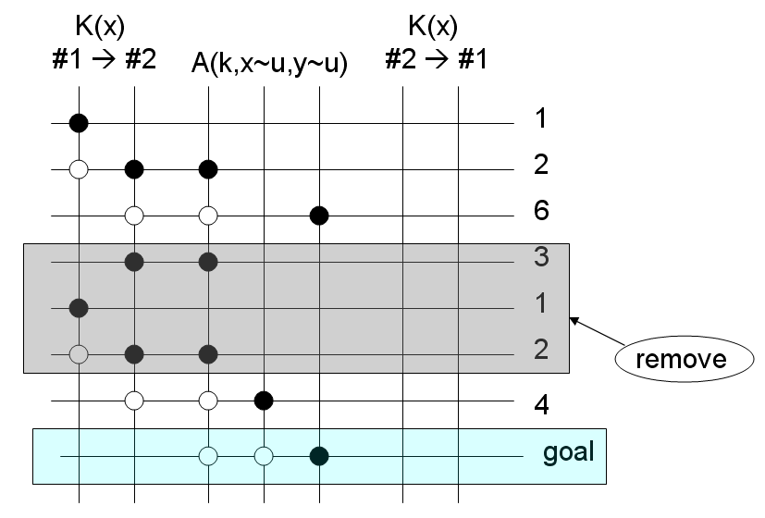
The story changed.
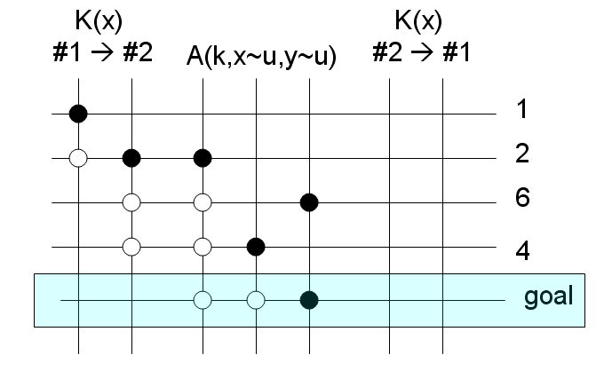

Take this new story as base. Start from the very first event, etc.

Flowchart

