Before doing anything with Rpi3, I recommend installing the fan or cooler to the raspberry pi because it gets hotter while installing and doing make operation which leads to slower performance.

***Hapticomm version***

***Log in the raspberry PI 3***

$ mkdir ~/hapticomm_efficacy (or any other dedicated location and folder will be fine)

$ cd ~/hapticomm_efficacy

$ git clone

$ https://github.com/bas1l/hapticomm-efficacy-psychophysics.git

$ cd hapticommlib/

$ sudo ./configure.sh

| **cmake**  After this command: here is the problem with the old **CMake** version in Rpi3, the default version is 3.16.3, but we need 3.18 and higher. Use this tutorial to install the newest version [OSDevLab: How to install latest Cmake for Raspberry Pi](http://osdevlab.blogspot.com/2015/12/how-to-install-latest-cmake-for.html) . The version I installed is [Index of /files/v3.18 (cmake.org)](https://cmake.org/files/v3.18/)  *First uninstall the previous version of CMake*:  $ sudo apt update  $ sudo apt install build-essential libtool autoconf unzip wget  $ sudo apt remove --purge --auto-remove cmake  *Then* Go to the [official CMake webpage](https://www.cmake.org/download), then download and extract the latest version. Update the version and build variables in the following command to get the desired version:  $ version=3.23  $ build=2 ## don't modify from here  $ mkdir ~/temp  $ cd ~/temp  (wget https://cmake.org/files/v$version/cmake-$version.$build.tar.gz  tar -xzvf cmake-$version.$build.tar.gz)  $ wget https://cmake.org/files/v3.18/cmake-3.18.4.tar.gz  (tar -xzvf cmake-$version.$build.tar.gz)  $ tar -xzvf cmake-3.18.4.tar.gz  cd cmake-$version.$build/  $ cd cmake-3.18.4/  $ ./bootstrap ## It will take some time :)   | I had errors here with openSSl:  $ sudo apt-get install libssl-dev  $ ./bootstrap ## again | | --- |   $ sudo make ## It will also take lot time ~ 1 - 1.5 hour  (there is a way (in theory) to make it faster by command $ make -j$(nproc) instead of $ sudo make )  $ sudo make install  Cmake is installed successfully! Run : “$ cmake --version” to check |
| --- | --- |

$ cd

$ pip install pyzmq

$ cd ~/hapticomm_efficacy/hapticommlib/

$ sudo ./configure.sh ## giving errors with cppzmq

| **libzmq**  Installation via command `./autogen.sh`: from([libzmq/INSTALL at master · zeromq/libzmq · GitHub](https://github.com/zeromq/libzmq/blob/master/INSTALL))    $ mkdir zeromq  $ cd zeromq  $ git clone <https://github.com/zeromq/libzmq>  $ cd libzmq  $ ./autogen.sh  $ mkdir build  $ cd build  $ cmake ..  $ sudo make -j4 install  **cppmzq**  Build cppzmq via cmake. This does an out of source build and installs the build files   * + download and unzip the lib, cd to directory   + mkdir build   + cd build   + cd   + sudo make -j4 install   $ cd  $ mkdir zeromq_next  $ cd zeromq_next  $ git clone <https://github.com/zeromq/cppzmq>  $ cd cppzmq  $ mkdir build  $ cd build  $ cmake ..  $ sudo make -j4 install |
| --- |

$ cd ~/hapticomm_efficacy/hapticomm-efficacy-psychophysics/hapticommlib$ sudo ./configure.sh

$ cd ../build

$ sudo make

$ cd ..

| Update CMakeLists.txt and add these lines:  $ nano CMakeLists.txt  #find cppzmq wrapper, installed by make of cppzmq  # B. External libraries  find_package(cppzmq)  target_link_libraries(libhapticomm cppzmq) |
| --- |

Examples to run the code:

$ python hapticomm-efficacy-main.py

$ python3 hapticomm-efficacy-main.py

Some Dependencies to run the code, if errors happen:

$ pip install pynput

$ pip3 install pyzmq

$ pip3 install pynput

Output:

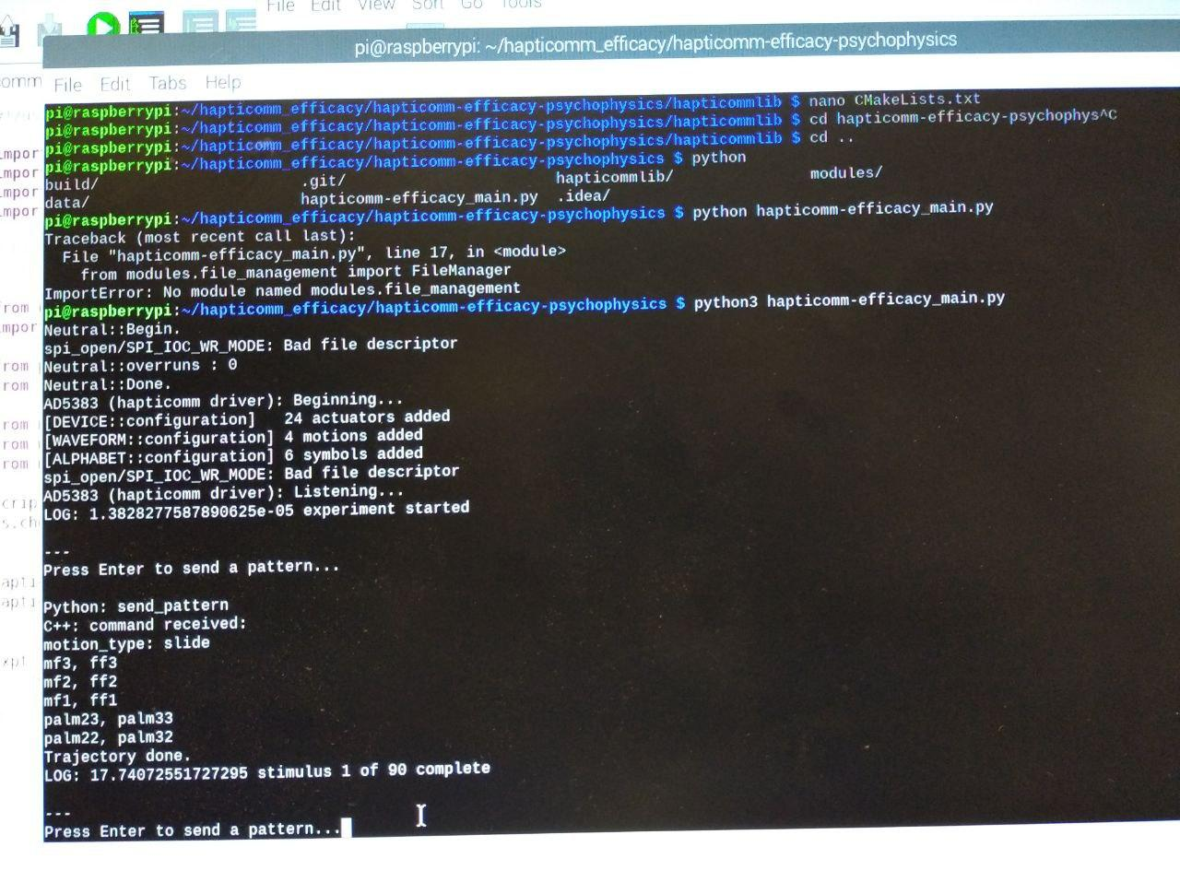

Figure 1. Output of *haptiomm-efficacy_main.py*

| **Install Python 3.6 and higher**  Please, follow the steps:  <https://installvirtual.com/install-python-3-on-raspberry-pi-raspbian/amp/> |
| --- |

| **Change default python**  $ "sudo update-alternatives --config python"  And then enter "1" or "2" depending which python2 or python3 is numerated there.  Then check by entering "python" command, it will automatically open the default python version:  $ python |
| --- |

| **If SPI does not work**  **1) Method:**  sudo raspi-config  <https://www.mathworks.com/help/supportpkg/raspberrypiio/ref/enablespi.html>  Motor winding by default is different  git clone <https://github.com/bas1l/hapticomm-efficacy-psychophysics.git>  git checkout dev_forZhanat  sudo pip3 install keyboard  elif c == "i":  stim = {  'type': "tap",  'nb_actuators': 1,  'width': 1,  'length': 1,  'actuators': ["ff1"]  }  tap, tap-and-hold, slide  **2) Method:**  On the left up corner click on the Raspberry pi icon to open the menu:    Choose "Preferences" -> "Raspberry Pi Configuration". You should see this new window:    Please, choose "Interfaces".    In SPI press "Enable". |
| --- |