

**Name: Kofi Appiah**

**Roll Number: 10022300106**

**Project Report on Forage Internship.**

***The 1st Part: Digital Technology Internship at GE Aerospace***

*Vue.js Interface Task*During my internship, I was tasked with creating a simple user interface in Vue.js. My goal was to build an interface that included a heading, an image, two variables, and a computer button that would display the product of the two numbers when clicked. I successfully delivered this by building the interface in Vue SFC Playground, adding a "Compute Product" heading, embedding a representative image, and declaring two numeric variables that were displayed. I'm particularly proud of implementing the Compute button functionality - it disappears after being clicked and displays the computed product, which works exactly as intended.

**Technical Requirements Draft - Supply Chain Feature**  
I worked on drafting technical requirements for a supply chain feature that would determine the optimal time to order plane parts. My challenge was to balance avoiding shortages while reducing costs. I identified key inputs needed: Part ID, Last Replacement Date, Average Time Between Replacements, and Estimated Shipping Lead Time. For the logic, I proposed using predictive analytics with historical failure data and maintenance logs, combined with lead time integration to generate reorder windows. The outputs I designed include a Recommended Order Date and Risk Assessment Score. I made sure to account for integration with existing inventory databases and procurement software in my proposal.

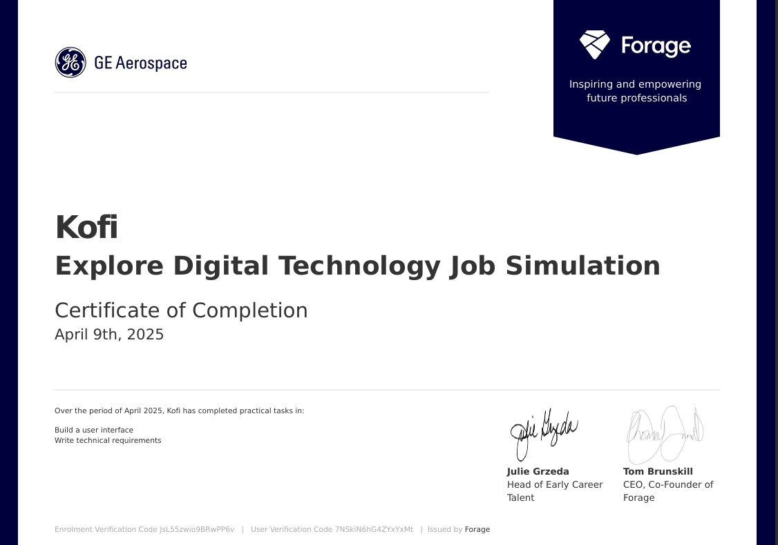

**The Second Part: Software Engineering Project - College Football Game Feature**

*Dynamic Player Development System Proposal*  
I conceived and proposed a Dynamic Player Development System to enhance our college football game. My vision was to create a system where players could train and upgrade athletes over time, focusing on attributes like speed, strength, and awareness. I wanted to make these developments influenced by coaches, training facilities, and resources to add depth to the gameplay. I believe this system would significantly increase player engagement by allowing them to manage not just recruitment but long-term athlete development.

In designing the solution, I built upon existing mechanics by adding skill growth curves, weekly training focus options, coach effectiveness ratings, and facility quality multipliers. While excited about the strategic depth this would add, I recognized it might overwhelm new players. That's why I proposed including an optional toggle or automation feature - I wanted to ensure the game remained accessible to all players while offering deeper mechanics for those who want them.

***Class Diagram Summary***  
For this feature, I designed a comprehensive class structure. My core classes included Player to track skills and development, Coach to impact training, and Team to manage groups of players. I created specialized classes like Training Session for scheduling and Performance Review for tracking progress. The relationships I established - like Teams containing Players and Coaches training Players during Sessions - form the backbone of the system. I'm especially pleased with how Training Facilities and Resources work together to boost effectiveness. To visualize this, I created and included a UML diagram in my submission.

* Looking back at these projects, I'm proud of what I accomplished during my GE Aerospace internship, particularly how I applied Vue.js to create functional interfaces and approached complex supply chain problems analytically. My college football game feature represents my ability to design engaging, player-focused systems that balance depth with accessibility. Both experiences have strengthened my technical skills and my understanding of user-centered design. All in all, it was a good project.



**FIGMA PROJECT**

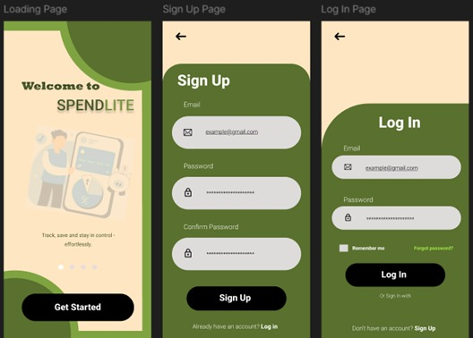

LinkedIn link- <https://www.linkedin.com/in/kofi-appiah-11a597352?utm_source=share&utm_campaign=share_via&utm_content=profile&utm_medium=ios_app>

Certification- <https://forage-uploads-prod.s3.amazonaws.com/completion-certificates/ay2tsYxaTif7Nt6z7/fjk7MFbQbedPXb3ws_ay2tsYxaTif7Nt6z7_7NSkiN6hG4ZYxYxMt_1744241486416_completion_certificate.pdf>