1.

2.

3.

4.

5.

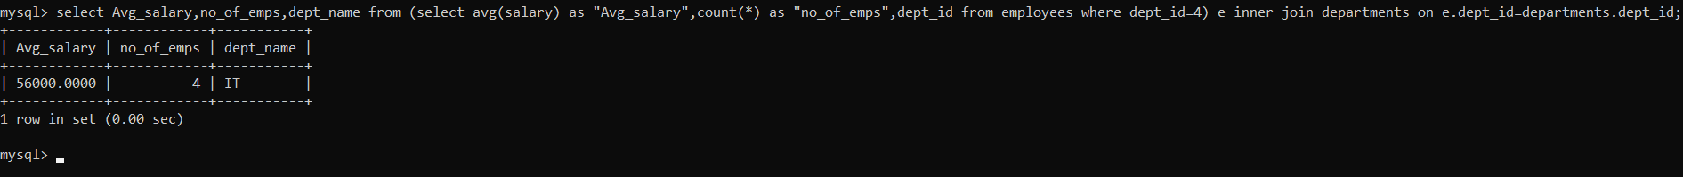

6.

7.

8.

9.

