**Blink button**

<?xml version="1.0" encoding="utf-8"?>

<alpha xmlns:android="http://schemas.android.com/apk/res/android"

android:fromAlpha="1.0"

android:toAlpha="0.1"

android:duration="500"

android:repeatMode="reverse"

android:repeatCount="infinite"/>

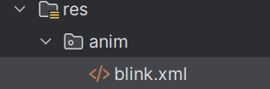**blink burtton path**