Lab 13 Wheel-of-Fortune Game

Objective
In this lab, you will combine techniques learned in previous labs with new concepts—such as shift registers and counters—to design an electronic Wheel of Fortune on the DE10-Lite board.

Introduction
The Wheel of Fortune you are designing operates as follows: At startup, the LEDs rotate continuously in a circular pattern using the bit pattern “00000001,” while the seven-segment display rapidly increments from 00 to FF in hexadecimal and loops back. When the user presses the stop button, the LED rotation halts, and the seven-segment display freezes to show the number captured at the rising edge of the button press. Upon releasing the button, the system restarts—the LEDs resume rotating, and the display begins incrementing the hexadecimal value again at high speed. The LED rotation should be slow enough to be visually noticeable, while the display should update quickly enough to make the numbers difficult to read during motion, creating a sense of randomness. To achieve this behavior, you will need to implement the following modules:
- A ring counter (or shift register) to rotate LEDs
- A counter to increment/decrement number
- A clock divider to generate slower clock
- Two seven segment decoders to display counter values

The diagram of the system is shown below:
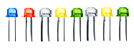

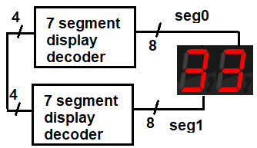
data_in
(0-15)
leds
4
4-bit
Bidirectional Counter
8
count
up_down (0/1)
4
8-bit
Ring Counter

load

clk
system_clock
(50MHz)
reset
stop
clock divider

- Build an 8-bit ring counter
A ring counter is a type of shift register—a cascade connection of flip-flops—where the output of the last flip-flop is fed back to the input of the first. It is initialized so that only one flip-flop has an output of 1, while the rest are 0. This single '1' bit circulates through the register, resulting in a repeating pattern with a period of 8 clock cycles. Below is the circuit diagram for an 8-bit ring counter. A skeleton Verilog description is provided with some details omitted. Your task is to complete the missing parts.
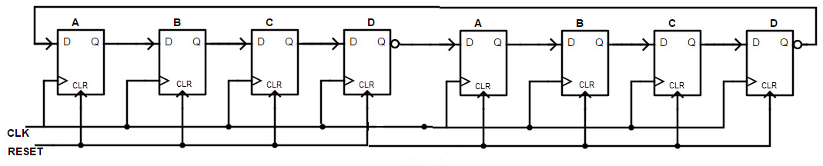

module ring_counter(clk, reset, stop, Q);
input clk, reset, stop;
output [7:0] Q;

reg [7:0] Qtemp = 8'b00000001;

always @(posedge clk)
begin
if (reset)
Qtemp = 8'b00000001;
else if (stop)
Qtemp = ______;
else
Qtemp = {_______, ______};
end
assign Q = Qtemp;
endmodule

- Build a bidirectional (up/down) counter
Bidirectional counters, also known as up/down counters, can count in either direction—incrementing or decrementing—through a given sequence. The counting direction can be reversed at any point using an additional control input, as shown below. This counter should also support loading an initial 4-bit value and include a control to stop counting. A skeleton Verilog description of the counter is provided below, with some details omitted. Your task is to complete the missing parts.

module counter(clk, load, stop, data_in, up_down, count);
input clk, up_down; // clock, count up or down
input load, stop; // load counter with the number in dataIn
input [3:0] data_in; //starting number
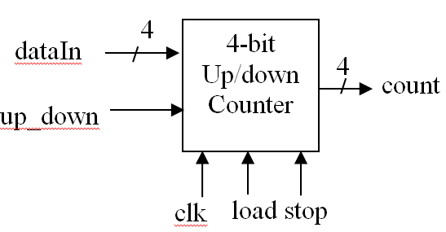
output reg [3:0] count = 0;
data_in
always @(posedge clk)
begin
if (load)
count = ______;
else if (stop)
count = ______;
else if (up_down)
count = ____________;
else
count = ____________;
end
endmodule

- Build top-level wheel of fortune game
Based on the diagram on the first page, write Verilog code to implement the Wheel of Fortune circuit. A skeleton of the Verilog description is provided with some details omitted. Your task is to fill in the blanks so that your Verilog code matches the circuit exactly as shown in the diagram.

module wof(system_clock, reset, stop, leds, seg0, seg1);
input system_clock, reset, stop;
output [7:0] leds;
output [7:0] seg0, seg1;

wire clk;
wire [3:0] count;

clkDiv2 U1(system_clock, clk); // produce slower clock
ring_counter U2(___, ____, ____, ____); //ring counter
counter U3(____, _____, _____, _____, ___, ___); // bidirectional counter
seg_decoder U4(_____, ____); // the first 7 segment display
seg_decoder U5(_____, ____); // the second 7 segment display

endmodule

- Edit, synthesize and simulate the design using Intel Quartus and Program DE-10 Lite board

Step 1: Add/Edit code:
- Download three files from the Brightspace: wof.v, seg_decoder.v and clkDiv2.v.
- Open Intel Quartus Prime Lite and Click the New Project Wizard and select Next.
- Directory, Name, Top-Level Entity: Change the directory to your user folder C:\users\firstname.lastname\Lab13 and name the project as “wof”. When prompted to create the directory, choose Yes.
- Project Type: Select Empty Project, and then click Next.
- Add Files: You can add files later. Click Next.
- Family, Device, and Board Settings: Click Board tab, select MAX 10 DE-10 Lite and uncheck “Create top-level design file”. Click Next.
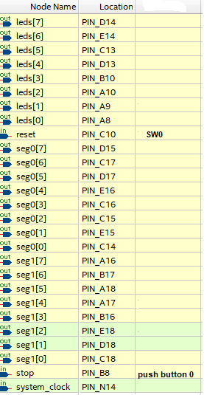
- EDA Tool Settings: Set Simulation to ModelSim from the dropdown menu. Click Next.
- Click Finish.
- Copy the three downloaded files, wof.v, seg_decoder.v and clkDiv2.v, from the Downloads folder to your Lab13 project folder (C:\users\firstname.lastname\Lab13). Then, add these three files to the project by going to the menu: Project > Add/Remove Files in Project > Click on the three dots "..." at the end of the row that begins with "File name" > Change the directory to your project folder > Select the three files > Add > OK.
- Change Project Navigator (top-left) view from Hierarchy to Files from the drop-down menu. Then, click on wof.v to open it and complete the code for the ring_counter, counter, and wof modules.
Step 2: Analysis & Synthesize: check syntax error
Run Analysis & Synthesis by right-clicking on it in the Tasks panel and selecting Start, or by double clicking on it. This will perform a syntax check on your Verilog code. If the process completes successfully, a green check mark will appear next to Analysis & Synthesis. If you there are errors, review your syntax, fix the issues, and run the process again until no errors remain.
Step 3: Pin Assignment: Map signals to appropriate DE10-Lite pins
- In the top menu, select Assignments > Pin Planner. The inputs and outputs will be listed under Node Name because you have already run Analysis & Synthesis. If you don’t see the inputs and outputs, run Analysis & Synthesis again.
- Type or select the pin numbers in the Location column according to the table in the last page. The rest of the columns will auto populate with data.
- Close the Pin Planner.
Step 4: Compile the Design: generate SRAM Object File (.sof) for configuring FPGA chip
Right-click Compile Design in the Tasks panel, then click Start. If the process completes successfully, green check marks will appear next to the items under Compile Design.

Step 5: Program Device: Download the project into the DE10-Lite board
- Use the USB cable in the box to connect DE10-Lite FPGA board to the computer. Warning: DO NOT touch the back of the board. Put the board on the desk or hold its edges only.
- Go to Tools > Programmer to open the programmer.
- If the Start button is enabled, click it to download the design to the board. After a brief pause, you should see the message 100% (Successful) and your design will now be running on the board.
- If the Start button is disabled, check if hardware setup ensure USB-Blaster [USB-0] is displayed. If the field next to "Hardware Setup" reads "No Hardware", click the Hardware Setup button and select USB-Blaster under the drop-down for Currently selected hardware.

Step 6: Verify the Design:
Test and verify your design on the DE10-Lite board. Note that stop/start => push button 0, reset => Switch 0. Press the push button to start the game and release it to stop.

Optional Extensions (Time Permitting):
- Currently, the two seven-segment displays show identical numbers. Modify your code to display two different numbers by adding a second counter.
- Change the game difficulty by adjusting the clock divider: You can modify the line parameter DivVal = 1000000; in clkDiv2.v to set a different value. A smaller value increases the clock speed and raises the difficulty level—but not to set it too small.

Lab checkout
Have your work checked by the lab instructor/assistant before you leave the lab. Take a picture of your working circuit. Then, disconnect the USB cable, place the DE-10 board and cable back in the box, and return the box.

Lab work submission (Due today)
Submit the picture of your working circuit to Brightspace using the "Lab 13" submission link.

No lab report is required for this lab.

