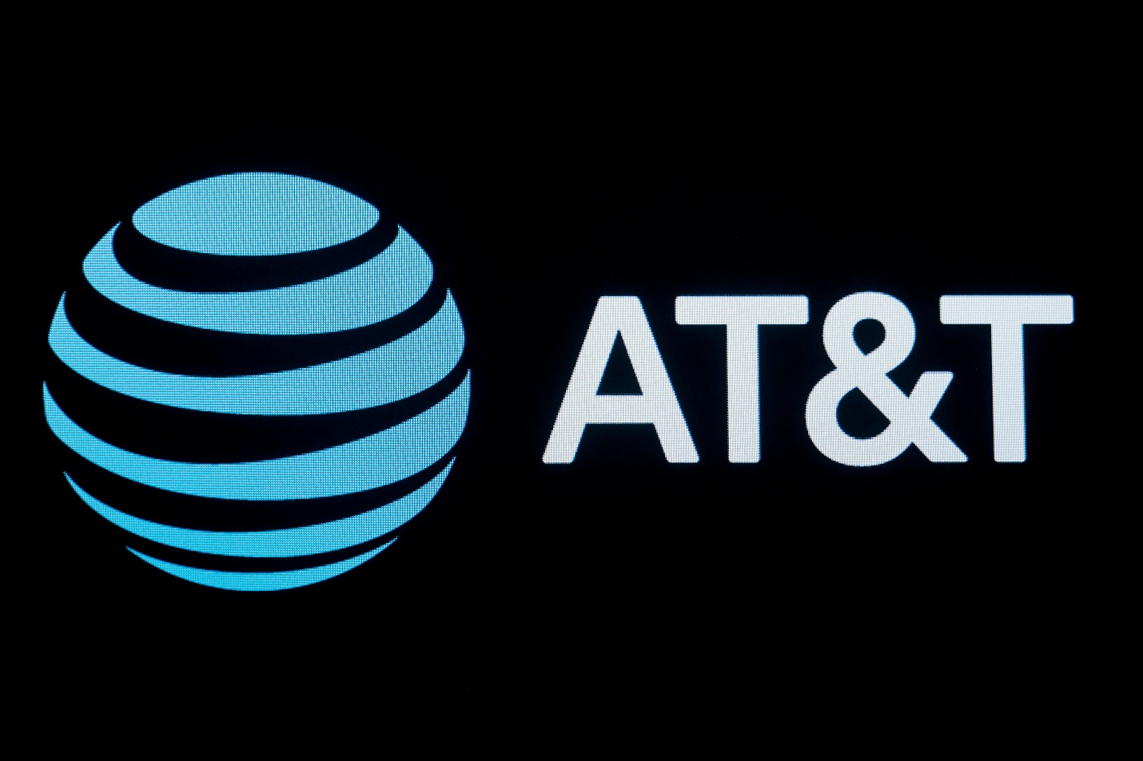

|  |
| --- |
| **AT&T(T) Stock Analysis**  **Financial Analytics**  **Group Members**  **Riya Bennychan - 0815633**  **Melvin Kozhikkadan Jolly - 0801117**  **Karthick Raja Dhanuskodi - 0811561** |

# Contents

Table of Contents

Contents 2

1. Company Overview 3

2. CAPM 4

3. Financial Ratios 5

4. Bollinger Bands 7

5. Monte Carlo Simulation 8

6. Facebook Prophet Simulation 9

7. Stock Signals 10

8. Recommendations 11

9. References 12

# Company Overview

AT&T, founded by Alexander Graham Bell in 1877, has grown into one of the telecommunications industry's largest global players. With a market capitalization of $116.66 billion and an enterprise value of $264.84 billion, AT&T holds a significant position in the market. Over the last year, the company reported revenue of $122.43 billion, generating profits of $14.19 billion and earnings per share of $1.97. Providing a diverse array of services including wireless communication, broadband internet, television, and digital entertainment, AT&T remains adaptable to changing consumer demands and technological advancements. Recent strategic initiatives include expanding its 5G network infrastructure, bolstering its fiber-optic broadband footprint, and investing in streaming services such as HBO Max. Despite its market leadership, AT&T faces robust competition from industry rivals like Verizon Communications, T-Mobile US, and Comcast Corporation.

In terms of market share, both AT&T and Verizon Communications maintain dominant positions as the two largest wireless carriers in the United States, each holding approximately 30% of the market share. However, the landscape shifted following T-Mobile US's merger with Sprint, propelling it to a strong contender position with around 20% market share. This evolution underscores the dynamic nature of the telecommunications industry and underscores the fierce competition among key players. To sustain their competitive advantages and adapt to changing market conditions, companies like AT&T must remain agile, innovative, and responsive to evolving consumer preferences and technological advancements.

# CAPM

Our analysis of AT&T stock using the Capital Asset Pricing Model (CAPM) reveals valuable insights into its expected return and risk profile. The CAPM model, which estimates the expected return on an investment based on its risk relative to the market's expected return, produced a Multiple R score of 0.4523, indicating a moderate correlation between predicted and observed values. However, the model's explanatory power appears limited, with an R Square value of 0.2045 suggesting that only approximately 20.45% of the variance in AT&T stock returns can be explained by market risk. Moreover, the Adjusted R Square value of 0.1907 indicates a slight reduction in explanatory power when accounting for the number of predictors in the model. Despite these limitations, the CAPM model offers valuable guidance for investors, with the calculated Standard Error of 0.0596 highlighting the average deviation between actual and predicted returns.

In addition to the CAPM analysis, the calculated beta of 0.563 for AT&T stock indicates that it is less volatile than the overall market, suggesting it may be considered a more stable investment option. A beta of less than 1, such as AT&T's 0.563, indicates that the stock is less risky and less volatile than the market. This insight provides investors with valuable information regarding the relative risk associated with investing in AT&T stock compared to the broader market. Additionally, the calculated RA value of 8.71% represents the expected return of AT&T stock according to the CAPM, offering further guidance for investment decisions based on risk assessment and market expectations. By considering both the CAPM-derived expected return, beta, and RA value, investors can make more informed decisions regarding portfolio allocation and risk management strategies, optimizing returns while managing risk effectively in the dynamic financial markets.

# Financial Ratios

|  |  |  |
| --- | --- | --- |
| Financial Ratio | Company Ratio | Description |
| Gross Profit Margin | 59.06% | A value of 59.06% Gross profit margin indicates company’s strong operational efficiency and profitability |
| Operation Profit Margin | 20.14% | Value of 20.14% operating profit margin suggests that the company is generating a significant amount of profit |
| Return On Assets | 3.54% | Value of 3.54% indicates higher ROA indicates that the company is more efficient in generating profits with its assets. |
| Return On Equity | 13.94% | Return on Equity of 13.94% indicates that the company is generating a moderate level of profit relative to shareholders' equity. |
| Return On Sales | 20.14% | Return on Sales of 20.14% indicates that the company is efficiently converting its sales revenue into profits. |
| Return On Investments | 0 | Return On Investments = 0 |
| Liquidity Ratio |  |  |
| Current Ratio | 0.71 | Value of 0.74 indicates company doesn’t have enough liquid assets to cover short-term Liabilities. |
| Quick Ratio | 0.67 | Value of 0.67 indicates ratio of less than 2 company doesn’t have twice as many assets than current liabilities. |
| Cash Ratio | 0.26 | A cash ratio of 0.26 suggests that for every dollar of current liabilities, the company has $0.26 in cash or cash equivalents available to cover those liabilities. |
| Debt To Equity Ratio | 1.5 | Value of 1.50 Indicates a balanced mix of debt and equity financing. It suggests a moderate level of financial risk. |
| Price To Earnings Ratio | 8.28 | A P/E ratio of 8.28 suggests that investors are willing to pay $8.28 for every dollar of earnings per share generated by the company. |
| Dividend Payout Ratio | 0.57 | A Dividend Payout Ratio of 0.57 means that for every dollar of net income the company generates, it distributes $0.57 as dividends to its shareholders. |

# Bollinger Bands

The chart of AT&T's stock prices along with its Bollinger Bands from January 2023 to January 2024 provides valuable insights into market volatility and potential trading opportunities. The Bollinger Bands, represented by two red dashed lines, delineate a range within which the stock price is expected to fluctuate, with the width of the bands serving as a measure of market volatility. AT&T's stock prices, depicted by the blue line, exhibit fluctuations over time, while the dashed green line represents the moving average, smoothing out short-term fluctuations to highlight longer-term trends or cycles. Points where AT&T's stock touches the upper band, denoted by green circles, signify potential overbought conditions and may signal a need to sell, while touches on the lower band, indicated by red circles, suggest potential oversold conditions and could be an indication to buy.

The analysis of Bollinger Bands provides valuable insights into stock volatility and potential trading opportunities. High touches on the lower band indicate potential downtrends, suggesting opportunities for strategic entry points for buyers. Conversely, high touches on the upper band suggest potential uptrends, indicating a need for caution and potential selling opportunities for investors. By closely monitoring the interactions between AT&T's stock prices and its Bollinger Bands, investors can make more informed decisions regarding entry and exit points, enhancing their ability to capitalize on market movements and optimize their trading strategies.

# Monte Carlo Simulation

Monte Carlo simulation, a computational technique employed to estimate the probability of various outcomes through multiple random trials, was utilized to model the behavior of AT&T stock. Initially, the simulation illustrates downtrends, with the stock reaching its lowest point around the 175th iteration, between the 150th and 200th trials. However, as the simulation progresses, the stock demonstrates a gradual increase with minor fluctuations, ultimately peaking just below the simulated price of 17 units. Analyzing the results further, the average return of 0.9903 suggests a positive expected return over the simulated period, while the standard deviation of return, calculated at 0.3254, indicates the level of volatility associated with these returns. This analysis offers valuable insights into the potential trajectory of AT&T stock prices based on the Monte Carlo simulation, aiding investors in making informed decisions regarding their investment strategies and risk management approaches.

# Facebook Prophet Simulation

In addition to the observed trends, applying the Facebook Prophet model to the simulation of AT&T stock profits can offer further insights into future price movements. By leveraging historical data and incorporating seasonality and trend components, the Facebook Prophet model can provide valuable forecasts, aiding investors in making informed decisions and adjusting their strategies accordingly.

The simulation of AT&T stock profits, depicted in the plot, reveals a fluctuating trend throughout the first and second quarters of 2024. Notably, the stock price reaches its highest peak, approximately 17.54 units, around April, suggesting a period of strong performance. However, following this peak, a discernible decreasing trend emerges, with the lowest stock price recorded at about 12.18 units in September. This decline indicates a potential period of volatility or market correction, potentially influenced by external factors such as economic conditions or industry dynamics. Despite the downturn, the plot indicates an upward trend towards the end of the year, suggesting potential recovery or stabilization in AT&T stock prices. Overall, this analysis offers valuable insights into the simulated profitability of AT&T stock, highlighting key trends and potential areas of concern or opportunity for investors to consider in their decision-making processes.

# Stock Signals

The analysis of stock signals based on the Simple Moving Averages (SMA) of 30 and 90 days reveals distinct patterns that can guide trading decisions. These SMA signals serve as important indicators of market trends and potential buying or selling opportunities. According to the graph analysis, mid-February and October emerge as opportune times to buy, as indicated by the observed SMA trend. Conversely, mid-March is highlighted as a favorable time to sell, reflecting potential shifts in market dynamics or investor sentiment. By leveraging these stock signals alongside other technical and fundamental analysis tools, investors can make informed decisions to enhance their trading strategies and maximize returns in the dynamic stock market environment.

# Recommendations

Short-term Investment: Investors seeking short-term gains may find opportunities to capitalize on the identified buy signals in mid-February and October. However, it's essential to note that while these periods offer potential for high average returns, the moderate standard deviation suggests significant short-term fluctuations. Therefore, investors with a lower risk tolerance may need to exercise caution, as the increased volatility could pose challenges for short-term investments.

Long-term Investment: For investors with a long-term investment horizon, the historically high average returns observed during opportune buying periods in mid-February and October offer substantial growth potential over time. These periods may represent attractive entry points for those seeking to capitalize on long-term growth opportunities in the stock market. However, it's crucial to consider individual risk tolerance levels, as the inherent volatility associated with stock market investments could impact portfolio performance over the long term.

In summary, while the identified stock signals present opportunities for both short-term and long-term investors, it's essential to align investment decisions with individual risk preferences and investment objectives. Short-term investors should be mindful of the increased volatility and potential for short-term fluctuations, while long-term investors may benefit from leveraging these signals to capitalize on growth opportunities over an extended investment horizon. Additionally, diversification and thorough research are key factors in mitigating risk and maximizing returns in the stock market.

# References

Stock Data: <https://ca.finance.yahoo.com/?guccounter=1&guce_referrer=aHR0cHM6Ly93d3cuZ29vZ2xlLmNvbS8&guce_referrer_sig=AQAAAEOlji-CUrxAkUEdw3hASShdG_mpyL1oGGU5XcQH_WEAG0-8xVcejX9H2N4i227cgmj5bRoTQ-u5DCstjcCi9EMG9-m3MK6nn1g8BwkZAmMWL9qHcK4CIbu6EzUXSPnND7-wO4raCMfbJikW81jIk8pJh68L_5h39u-KaQE3RtXf>

Cover image:

<https://www.reuters.com/business/media-telecom/att-one-america-news-keep-ad-deal-even-after-directv-drops-network-2022-03-14/>