Software Requirements Specification

for

Email Detection Spam API(Spam or no Spam)
Prepared by <author>

Table of Contents
Table of Contents ii
Revision History ii
1. Introduction 1
1.1 System Purpose 1
1.2 Scope 1
1.3 Definition, Acronyms and Abbreviations 1
1.4 Document Overview 1
2. System Context and Scope 2
2.1 System Purpose Statement 2
2.2 External Entities 2
2.3 Context Diagram (Level-0 DFD) 2
2.4 System Architecture Overview 2
2.5 In Scope 2
2.6 Out of Scope 2
3. Stakeholder Analysis 3
4. Functional Requirements 4
4.1 Functional Requirements Table 4
4.2 Use-Case Diagram 4
4.3 Expanded Use-Case Diagram: UC-01 – Submit Spam Detection Prediction 4
5. Non-functional Requirements 4
6. Data Requirements 5
6.1 Data Dictionary 4
6.2 API Endpoint Specification 5
6.3 Level-1 Data Flow Diagram 5
7. Constraints, Assumptions and Validation Strategy 4
7.1 Design and Implementation Constraints 5
7.2 Assumptions and Dependencies 5
7.3 Requirements Validation Plan 5

Appendix A: Glossary 5
5

Introduction

System Purpose
Spam or No Spam is a RESTful API using a fine-tuned ML system designed to integrate with independent users and professional enterprise users’ emails. Its primary purpose is to review incoming emails and detect and filter out the spam email away from the users’ primary inbox to ensure better organization with users inbox and avoid any phasing and malicious emails that could potentially harm the user’s inbox

Scope
This document will go over the full functional and non-functional requirements for the “Spam or not Spam” API. The API will first ask for authentication from the users in order to ensure proper security and permission procedures. From there it will access the email data; in JSON format; by accessing specific endpoints and returning a spam detection probability result (Span/ No Spam), explanation for the result and move the email the designated email folder based on the result; either manually or automatically via user’s preferences

Definition, Acronyms and Abbreviations
Term/Acronym | Defintion
API | Application programming Interface: A digital tool that allows communication between different software and systems
SRS | Software Requirements Specification: (This current document). A document that gives clarity and a in-depth look of project’s objective, purposes, requirements and constraints
ML | Machine Learning: A subset of artificial intelligence that focus on a machine’s ability to improve from past experiences
REST | Representative State Transfer: a specific architectural style that gives rules and constraints for designing networked application
JSON | JavaScript Object Notation: A popular semi-structured data type that allow users better ability to read and write and machine better ability to parse and generate data
FR | Functional Requirement: The core functionality of this project/product that are needed for it to be useable
NFR | Non-Functional Requirement: The aspect of the product not ties to the system’s main functionality. This includes categories such as Performance, Reliability, Availability Security, Scalability, etc.
JWT | JSON Web Token: A standard uses to securely transfer and communicate information from and to different systems
GDPR | General Data Protection Regulation: An EU regulation that focuses on information privacy
DFD | Data Flow Diagram: a tool that is able to visually represent data that moves through a system

Document Overview
This document has 9 sections. Section 1 is focused on introductions and establishing the system purpose and definitions that will be used in the document. Section 2 focuses on the system context and demonstrating the scope of the system. Section 3 is meant to give an overview of all relevant stakeholders in this project. Section 4 will focus on the functional requirements of the system while Section 5 will focus on the non-functional requirements. Section 6 will focus on the data requirements needed for this system while Section 7 will focus on the limitations and assumptions of the system. Section 8 will have the references that were used in the document. Section 9 will have the relevant appendices.

System Context and Scope

System Purpose Statement
SpamReportCo is an startup that has a fine-tuned and trained ML model that is meant to parse and detect incoming emails like spam or not. The organization wants to make the model accessible to a pubic user based via a public RESTful API so that users can integrate the service to their email to have better. The organization of the inbox and to avoid any potential phishing and malicious attacks. As (a) System Analyst(s), it is required to document the needed requirements before technical development begins.

SpamReportCo is a startup that has a fine-tuned ML model that is meant to parse and detect incoming spam emails. The organization wants to make the model accessible to public users via a public RESTful API so that users can integrate the service into their email to have a more organized inbox and to avoid any potential phishing and malicious attacks. Spam or not API will benefit both public users and enterprise users of SpamReportCo products as the API will provide a service that can prevent malicious attacks and provide a cleaner inbox. The SpamReportCo monitoring system will monitor the performance of the API with a dedicated ML development team ensuring continued improvement and updates to the API in order to deliver a quality product.

External Entities
External Entity | Entity Type | Interaction With System
Consumer | Human Actor | Interacting with the API to authenticate usage and allowance to access inbox for spam detection and receives spam detection results from API
Authentication API | External System Actor | An external system to ensure account security protection, where the API sends an authentication request to the Authentication API, which, once validated, allows access to the API
Email Client API | External System Actor | API receives a specific email client key to access the specific email provider by the user
Admin | Human Actor | Handles the performance and management of API. Provide necessary permissions, and new updates and setting configuration to the API
Data Log Database | System Actor | A container holding a collection of logs of the API security, performance, and error results

Context Diagram (Level-0 DFD)
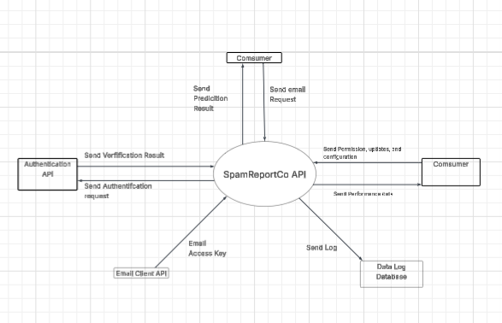

System Architecture Overview
The user sends an email as a request to the API Gateway ( or if the system is automated by user choice, the email is sent automatically). Before processing the user request, the API’s Business Logic Layer sends a request to the authentication API to verify the identity verification credentials from the user (either credentials provided manually or automatically). Once verified, the authentication API sends those results back to the API to start processing the user's request. Once validated, the API’s Feature Extraction Layer converts the email into a form readable to the ML and routes the request via API’s Business Logic Layer and sends to the ML model. The Model Inference Engine processes the request and makes a prediction, which is logged to the Logging Service, and it is sent and stored in the Data Log Database via the Business Logic Layer. The API gateway returns the prediction to the user

In Scope
In-Scope: The current release of the API can parse through email, send and receive authentication verification, and convert semi-structured data to mathematical form for the model and vice versa. It can run a prediction engine to generate results. It can create logs and send them to a database, and return results to the user

Out of Scope
Out-of-Scope: The model will not store any logs internally nor have any ability to manage, store, alter, or access inbox contents, only read them.

Stakeholder Analysis

Stakeholder | Role | Primary Interest | Priority | Key Concern
Public User | Independent users | Use the API product to avoid spam emails | High | f the email can detect the correct emails as spam
Enterprise Users | Organizational users | Use the API product to avoid spam and potential malicious email infecting the organizational system | High | If the email can correctly identify malicious emails to prevent attacks and avoid breaches of security and priority data
Admin staff | System management | Handling and monitoring the performance of the ML model and API | Medium | If the infrastructure of the API (and external components) is still running smoothly
Engineering Team | ML development team | Development, Training, Testing, and Updating the ML Model | High | adequate resources such as technical tools, real-life data and funding to work on building better and more accurate models in order to avoid model degradation
Office of the Privacy Commissioner of Canada (OPC) | Regulatory body | Ensuring API following regulatory framework and laws | High | If the API is following the regulatory laws
Board of Directors | Strategic decision makers | The financial growth of the organization | Medium | If the product is a viable product that can grow the company instead of hindering it

Functional Requirements

Functional Requirements Table

ID | Category | Requirement Statement | Priority | Stakeholder Rationale
FR-01 | User Input | The system shall receive an email manually or automatically from the user | Must Have | The users (both public and enterprise) need to be able to send their email to the API
FR-02 | Verification | The system shall send and receive authentication verification when user send their request | Must Have | OPC and admin staff require security measures for identity and privacy protection
FR-03 | System and predictor engine | The system shall parse emails once identity is verified | Must Have | The users need the system to be able to read the emails so that they can get them converted
FR-04 | System and predictor engine | The system shall convert semi-structured data to mathematical form and vice versa once the email is parsed | Must Have | The Engineering team need this functionality so that the ML model can read the emails
FR-05 | System and predictor engine | The system shall load the ML Model once all emails are converted | Must Have | The users need this functionality so the ML model has data to work on, making a new prediction
FR-06 | System and predictor engine | The system shall run a prediction engine to generate results about detecting spam and malicious email, and notify the users once the ML model is loaded | Must Have | The Engineering team, shareholders, public and enterprise users need this functionality for the system to work, the shareholders
FR-07 | Log keeping | The system shall make logs and send them to a database once the results are generated | Should Have | Admin staff need to know the condition of the system, and it is important for OPC compliance for the record keeping
FR-08 | System and predictor engine | The system shall receive updates from the admin staff once the admin staff receives updated model from the development | Should Have | The admin staff need this to update the system
FR-09 | Maintenance and Error system | The system shall display an error message to the database and the admin team once the API is unable to produce results from any stage | Must have | OPC, users, and the admin staff need this to handle errors

Use-Case Diagram
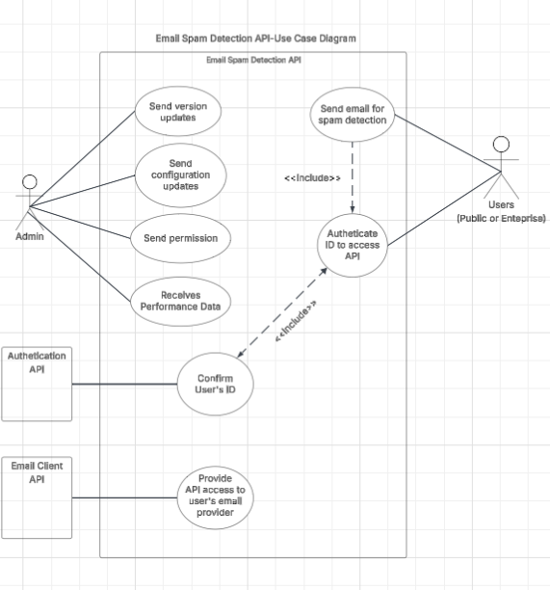

Expanded Use-Case Diagram: UC-01 – Submit Spam Detection Prediction
Actor:
- Public User
- Enterprise User
- Authenticate API
- Email Client API
Precondition:
Users must have registered their email to the API. Users must also have set up and establish their authentication ID prior using the API. Emails must be able to be convertible to JSON format.

Main success Scenario:

- Step 1- Once authenticated, User sends the email to the API
- Step 2- The API will parse through the emails sent by the user
- Step 3 -The API will convert semi-structured data to mathematical form and vice versa once the email is parsed
- Step 4 -Once all emails are converted, the data will be converted and delivered to the ML Model
- Step 5 The prediction engine will process the data and generate results about detecting spam and malicious email, and notify the users
- Step 6- Users look at the results of the prediction

Alternative Flows:

AF-01: If user fails initial verification, they have 4 more chances to verify and if they fail, admin will be informed to handle any problems with the users.
AF-02: If the email’s format is invalid, then the model/ API will return an error to the user citing to “send an email in the right format”
AF-03: If ML model takes too long or doesn’t generate a result, this notice will be sent to the administrator, and a notification will be sent to the user saying “failure to load prediction”

Post-conditions:

Successful post conditions:

- The users will get their email checked as spam or not
- The API will log predictions process and results to the data log database
- The users will be notified of the email prediction

Unsuccessful post conditions:
- If User has exceeded 5 sign-in attempts to the API, they will be temporarily locked out from the API and will require assistance from the admin to regain access.
- API will continue to return “send an email in the right format” if users send the wrong format
- If API continues to fail generating result, then the error will be logged and sent to admin, and the user will be informed the API is down for maintenance

Non-functional Requirements

ID | Category | Requirement Statement | Measurement/ Verification Method
NFR-01 | Performance | the system shall have a prediction response time of an average 200-500ms, from email input to spam probability result | Performance Test tool, the tool shall run a test based on an amount of request and result under a specific time interval
NFR-02 | Maintainability | the system shall give information of prediction model version and API model version to the users and admin staff in a JSON document format accessible in the API | API testing Tool to test the viability of the JSON document
NFR-03 | Maintainability | The system shall have logs that will be retained in the main Data Log databases for 30 days, in which backups will be made for them and deleted from the main database. Standards must be followed by standard of the OPC | API audit verification tool to verify the backups
NFR-04 | Maintainability/ Reliability and Availability | the system shall give alert to the admin team 200ms after an error occur in the API | API performance tool to measure the alerts response’s time
NFR-05 | Reliability and Availability, | The system shall have for the initial version of the API, an ideal of 99.9% for all users’ uptime per day | API Uptime tool, to test the uptime of the API
NFR-06 | Security, | the system shall give an alert to admin 200ms after 5 failed attempts to authenticate with the user and the API blocks the user | API authentication verification Tool, to test the verification process
NFR-07 | Regulatory/Compliance | the system shall have API audits log for compliance bodies such as OPC to access them at their discretion. | API audit verification tool, to test the audit log
NFR-08 | Scalability, | the system shall be able to handle about 100 requests per minute as total system capacity | Load testing tool to test the high traffic and volume of the system

Data Requirements

Data Dictionary
Field Name | Data Type | Format/ Constraints | Descrption | Source/Destination
email_id | String | UUID v4 format, required | Unique identifier assigned to each email submitted for analysis | User / API Request
email_subject | String | Max 998 chars, optional | The subject line of the email being submitted for spam detection | User / API Request
email_body | String | UTF-8, max 100KB, required | Full plain-text or HTML body content of the submitted email | User / API Request
sender_address | String | Valid RFC 5321 email format, required | The email address of the original sender of the submitted email | User / API Request
auth_token | String | JWT Bearer token, required | Authentication token used to verify the identity of the requesting user | Authentication API
spam_label | String | Enum: “SPAM” / “NOT_SPAM”, required | The classification result produced by the ML model | ML Model / API Response
confidence_score | Float | Range [0.0, 1.0], 4 decimal places, required | Probability score indicating the model’s certainty in the classification result | ML Model / API Response
model_version | String | Semantic versioning (e.g., v1.2.0), required | The version identifier of the ML model that processed the request | ML Model Repository
request_timestamp | DateTime | ISO 8601 format (YYYY-MM-DDTHH:MM:SSZ), required | UTC timestamp recorded when the API received the prediction request | API System
error_code | Integer | HTTP status codes (e.g., 400, 401, 500), optional | Numeric error code returned when the API is unable to complete the request | API System / Data Log DB

API Endpoint Specification
Property | Detail
Endpoint 1 | POST /api/v1/predict
HTTP Method | POST
URL Path | /api/v1/predict
Description | Submits an email for spam classification. Accepts email content and metadata, runs the ML model, and returns a spam/not-spam prediction with a confidence score.
Request Parameters | Header: Authorization: Bearer {JWT token} (String, required). Body: email_id (String, required), sender_address (String, required), email_subject (String, optional), email_body (String, required).
Example Request Body | { "email_id": "e9a3f1c2-...", "sender_address": "sender@example.com", "email_subject": "You won a prize!", "email_body": "Click here to claim your reward..." }
Success Response (200) | { "email_id": "e9a3f1c2-...", "spam_label": "SPAM", "confidence_score": 0.9731, "model_version": "v1.2.0", "request_timestamp": "2026-03-17T10:22:00Z" }
Error Response | 400: { "error_code": 400, "message": "Invalid email format" } | 401: { "error_code": 401, "message": "Unauthorized: invalid or missing token" } | 500: { "error_code": 500, "message": "Internal server error" }
HTTP Status Codes | 200 OK, 400 Bad Request, 401 Unauthorized, 422 Unprocessable Entity, 500 Internal Server Error
Authentication | JWT Bearer Token (Authorization header)
Endpoint 2 | GET /api/v1/status
HTTP Method | GET
URL Path | /api/v1/status
Description | Returns the current health status of the API, including the active ML model version, uptime, and system availability. Intended for both admin monitoring and user-facing health checks.
Request Parameters | Header: Authorization: Bearer {JWT token} (String, required). No request body required.
Success Response (200) | { "status": "healthy", "model_version": "v1.2.0", "uptime_seconds": 87523, "timestamp": "2026-03-17T10:00:00Z" }
HTTP Status Codes | 200 OK, 401 Unauthorized, 503 Service Unavailable
Authentication | JWT Bearer Token (Authorization header)
Endpoint 3 | PUT /api/v1/admin/model
HTTP Method | PUT
URL Path | /api/v1/admin/model
Description | Allows an authenticated admin to update the active ML model by uploading a new model version. The updated model will replace the current one used for predictions. This endpoint is restricted to admin staff only.
Request Parameters | Header: Authorization: Bearer {Admin JWT token} (String, required). Body: new_model_version (String, required), model_file_path (String, required), change_log (String, optional).
Example Request Body | { "new_model_version": "v1.3.0", "model_file_path": "/models/spam_v1.3.0.pkl", "change_log": "Retrained on Q1 2026 dataset; improved precision on phishing emails" }
Success Response (200) | { "message": "Model updated successfully", "active_model_version": "v1.3.0", "updated_at": "2026-03-17T12:00:00Z" }
Error Response | 401: { "error_code": 401, "message": "Unauthorized: admin access required" } | 404: { "error_code": 404, "message": "Model file not found at specified path" }
HTTP Status Codes | 200 OK, 401 Unauthorized, 403 Forbidden, 404 Not Found, 500 Internal Server Error
Authentication | JWT Bearer Token with Admin role claim (Authorization header)

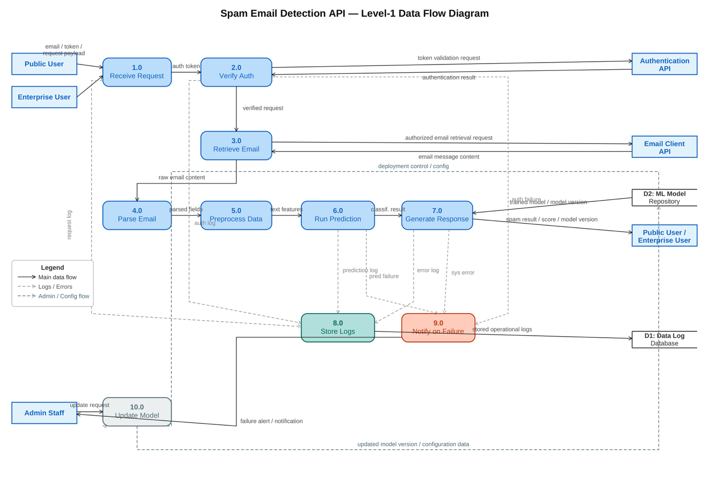
Level-1 Data Flow Diagram
Figure 3: Level-1 Data Flow Diagram — Spam Email Detection API

Constraints, Assumptions and Validation Strategy

Design and Implementation Constraints

ID | Constraint Type | Constraint Statement | Justitifcation
C-01 | Financial | Constraint Statement  Limited budget restricts physical server capacities and also a limited selection of available tools to be used to build and maintain the system | Because the organization is a startup, it has an initial, limited amount of funds available. This matters for the system as this can hinder the potential growth of the API's ability and potential
C-02 | Technical | Dependent of third-parties services to such as the authentication API and email client API to run the verification system and to access the necessary user information in their email | Due to not having certain tools in-house, as well as needing data from other applications, the use of third parties is necessary. Since the system needs access to emails and ways to authenticate, constraints affect the core design and purpose of the API
C-03 | Infrastructure | Constraint Statement: Limited physical hardware restricts the efficiency of the model as ML model training, and more data logs may hit the upper limits of the hardware, reducing potential performance | Reaching the upper limitations of the current hardware due to log saving and model training can potentially cause data saving issues and the hinderance in building better ML due to lack of space
C-04 | Regulatory | Canadian Anti-spam legislation requirement for direct user permission from user, forces the authentication API as a primary priority of the design of the API. | Regulatory laws exist in Canada to ensure best practice between product and user; thus, in order to comply with Canada's laws and avoid any potential fees, fines or major consequences, the API must follow a design philosophy with regulatory practices in mind

Assumptions and Dependencies
ID | Assumption | Dependency | Risk if Assumption is Flase
A-01 | That the API is compatible with different email providers' clients and API keys. | The API | Failure for the API to be used with email clients that are tied to user's providers which can cause user to stop using API for failing to provide them a service
A-02 | That the initial ML Model is trained with a quality set of data that can be able to predict with a degree of accuracy of spam or not. | the core aspect of the API. | Initial release of the product could be delayed, leading to poor user trust and potential reputation harm to the business
A-03 | hat the current infrastructure (hardware, servers and software storage) is capable of handling users' capacities. | the servers that are accessible by the API. | This could cause hardware limitations that can affect services such as data logging and ML models, and even the current functionality of the API and ML model can be affected as well

Requirements Validation Plan

Prototyping
A usable API prototype will be made available, following the design philosophy laid out in section 6 and a preliminary run through with the prototype will be conducted, with a selected test group of consumers encompassing both enterprise and public users for direct evaluation and feedback. Feedback will be discussed with the development team stakeholders to discuss potential revision of the SRS and API. The goal is to test the current version of the API is working as intended with expectations and the requirements that were set.

Formal Review
A session where all the major stakeholders of the products will come together and discuss the SRS after the full draft is submitted. This will allow all aspects and components of the SRS to be tested and reviewed by all active players involved and get the needed feedback to ensure the SRS is in alignment with stakeholders’ needs and project objectives. Formal review will be conducted after the prototyping phase to get hands-on feedback from the users. This is validated that the API is not only working within the needs of each stakeholder and making sure that the blueprint for establishing the full version is viable

Acceptance Testing
Each functional requirement will have an acceptable test case that will need the approval by Product Owner before the sprint is started. Each test case will have an input, an output and a criterion with a success/fail model. This validates that each step follows the standards set in the functional requirements to make each component of the project feasible

References
- The Artificial Intelligence and Data Act (AIDA) – Companion Document, ised-isde.canada.ca/site/innovation-better-canada/en/artificial-intelligence-and-data-act-aida-companion-document. Accessed 17 Mar. 2026.
- Bass, Len, et al. “Software Architecture in Practice, 4th Edition.” O’Reilly Online Learning, Addison-Wesley Professional, 3 Aug. 2021, www.oreilly.com/library/view/software-architecture-in/9780136885979/.
- Bwren. “Azure Monitor Documentation - Azure Monitor.” Azure Monitor | Microsoft Learn, learn.microsoft.com/en-us/azure/azure-monitor/. Accessed 17 Mar. 2026.
- Canada’s Anti-Spam Legislation, ised-isde.canada.ca/site/canada-anti-spam-legislation/en. Accessed 17 Mar. 2026.
- “Chapter 1: The Legislation: Freedom of Information and Protection of Privacy Manual.” Ontario.Ca, 9 Mar. 2023, www.ontario.ca/document/freedom-information-and-protection-privacy-manual/chapter-1-legislation.
- Getting Started with Amazon Cloudwatch - Amazon Web Services, aws.amazon.com/cloudwatch/getting-started/. Accessed 17 Mar. 2026.
- Hidden Technical Debt in Machine Learning Systems, proceedings.neurips.cc/paper_files/paper/2015/file/86df7dcfd896fcaf2674f757a2463eba-Paper.pdf. Accessed 17 Mar. 2026.
- IBM Cloud Api Docs, cloud.ibm.com/docs?tab=api-docs. Accessed 17 Mar. 2026.
- “IEEE SA - IEEE Recommended Practice for Software Requirements Specifications.” IEEE Standards Association, standards.ieee.org/ieee/830/1222/. Accessed 17 Mar. 2026.
- MLflow, mlflow.org/docs/latest/. Accessed 17 Mar. 2026.
- “MuleSoft API Documentation.” Mulesoft Documentation, docs.mulesoft.com/general/. Accessed 17 Mar. 2026.
- Office of the Privacy Commissioner of Canada. “PIPEDA Requirements in Brief.” Office of the Privacy Commissioner of Canada, 1 May 2024, www.priv.gc.ca/en/privacy-topics/privacy-laws-in-canada/the-personal-information-protection-and-electronic-documents-act-pipeda/pipeda_brief/.
- “OpenAPI Specification.” Swagger, swagger.io/specification/. Accessed 17 Mar. 2026.
- “Practitioners Guide to MLOps: A Framework for Continuous.” Practitioners Guide to MLOps: A Framework for Continuous, services.google.com/fh/files/misc/practitioners_guide_to_mlops_whitepaper.pdf. Accessed 17 Mar. 2026.
- Singhal, Anoop, et al. “Guide to Secure Web Services.” CSRC, 29 Aug. 2007, csrc.nist.gov/pubs/sp/800/95/final.
- Stakeholder Analysis, www.pmi.org/learning/library/stakeholder-analysis-pivotal-practice-projects-8905. Accessed 17 Mar. 2026.
- “The TFX User Guide : Tensorflow.” TensorFlow, www.tensorflow.org/tfx/guide. Accessed 17 Mar. 2026.
- “Welcome to the Purdue Owl.” Welcome to the Purdue OWL - Purdue OWL® - Purdue University, owl.purdue.edu/owl/. Accessed 17 Mar. 2026.

Appendix
Claude (Anthropic) and Google Gemini were used in the development of the assignment as research aids in the documentation process of the assignment. They worked as gathering and summarizing sources as well as a learning tool to verify and clarify terminology against sources. When it comes to the results produced by AI, independent verification of the facts that were produced was needed in order to ensure no falsehoods were produced or potentially be used. When it comes to any guidance or suggestions made by AI, constant elaboration and pushbacks were needed output provided to ensure accurate information is being demonstrated and while suggestions were made, not all were used such as designing the use-case diagram, confirming load testing and entry classification related to the context diagram just to name a few instances of pushback. All in all, AI was used as a research guide and an education tool in order to understand the terminology and concepts related to the assignment.

