BRACT’s

Vishwakarma Institute of Technology, Pune

Practical Implementation Sheet

Department: CSE-AI Semester: 5 Academic Year: 2026-27

Division:C Batch: 3 Practical No: 1

Roll no: 69 PRN No: 12410482 Name of Student: Kunal Patil

Subject Name : Deep Learning

Problem Statement : Install and configure TensorFlow/Keras in Google Colab. Perform data preprocessing, normalization, train-test split, and visualization on a sample dataset.

Algorithm :
Based on your Fashion MNIST TensorFlow/Keras code, here is the algorithm you can write in your assignment.

Algorithm: Image Classification using TensorFlow/Keras (Fashion MNIST)

- Start the program.

- Import the required libraries:

  - TensorFlow/Keras
  - Matplotlib
  - Scikit-learn modules (if required)
- Load the Fashion MNIST dataset into training and testing sets.

- Normalize the pixel values by dividing each pixel by 255.0 to scale them between

0 and 1.

- Display the shape of the training and testing datasets.

- Visualize a sample image from the training dataset.

- Create a Sequential Neural Network model.
- Add a Flatten layer to convert the 28 × 28 image into a one-dimensional vector.

- Add a Dense hidden layer with 128 neurons and ReLU activation.

- Add an output layer with 10 neurons and Softmax activation for classifying the 10 fashion categories.
- Compile the model using:
  - Optimizer: Adam
  - Loss Function: Sparse Categorical Crossentropy
  - Metric: Accuracy
- Train the model using the training dataset for 7 epochs.

- Evaluate the trained model using the testing dataset.

- Display the test accuracy.
- Save the trained model in .keras format.

- Stop the program.

Code :
#Importing libraries import tensorflow as tf
from tensorflow import keras import matplotlib.pyplot as plt
from sklearn.model_selection import train_test_split from sklearn.preprocessing import StandardScaler

#Loading and spliting dataset
(train_images, train_labels), (test_images, test_labels) = tf.keras.datasets.fashion_mnist.load_data()

#Scaling dataset
train_images = train_images /255.0 test_images = test_images / 255.0

#Visualizing data print(train_images.shape) print(test_images.shape) print(train_labels)

plt.imshow(train_images[1], cmap='gray') plt.show()

#Defining neural network models #Input layer
my_model = tf.keras.models.Sequential() #Hidden layer
my_model.add(tf.keras.layers.Flatten(input_shape=(28, 28))) my_model.add(tf.keras.layers.Dense(128, activation='relu')) my_model.add(tf.keras.layers.Dense(10, activation='softmax'))

#Compiling model
my_model.compile(optimizer='adam', loss='sparse_categorical_crossentropy', metrics=['accuracy'])

#Training Model
my_model.fit(train_images, train_labels, epochs=7)

#Testing Accuracy
val_loss, val_acc = my_model.evaluate(test_images, test_labels) print('Test accuracy: ', val_acc)

#Saving Model my_model.save('my_fashion_mnist_model.keras')
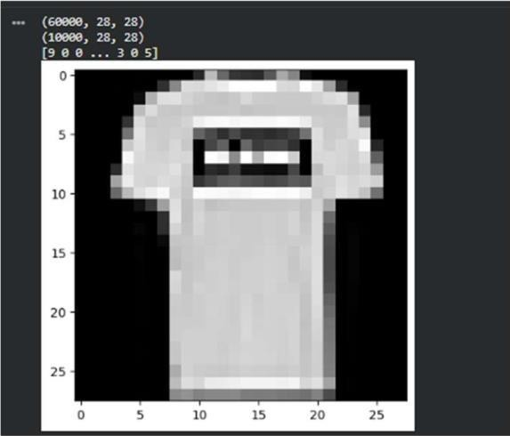
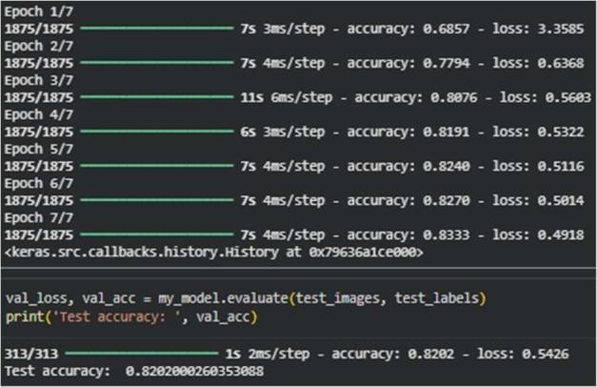
Output :

