Problem: NodeMCU gpio pin flickering/state during boot time (500 milliseconds)
Solution:
AI Prompt: 500 milliseconds on time delay of 2N2222 at Ib 3mA using NE555 for power on 5v 4 Channel 5V Relay Board Module
Do Not Power On any subsystem (5V Relay Module, etc.) during the first 500ms (NodeMCU boot time), i.e., guard the power rail of the subsystem/peripherals by an on-time delay.

To achieve a precise 500ms (0.5s) power-on delay using an NE555 Timer to drive a 2N2222 transistor at a 3mA base current, you should configure the NE555 in Monostable Mode. This ensures the relay coils (JD-VCC) remain unpowered until your Wemos D1 Mini has finished its boot-up sequence.

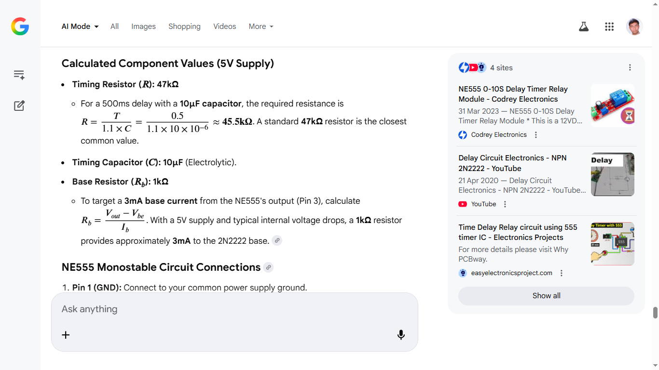

NE555 Monostable Circuit Connections
- Pin 1 (GND): Connect to your common power supply ground.
- Pin 2 (Trigger): Tie to Ground via a 0.1µF capacitor and to 5V via a 10kΩ resistor. This triggers the 500ms "High" pulse immediately upon power-up.
- Pin 3 (Output): Connect through the 1kΩ resistor to the Base of the 2N2222.
- Pin 4 (Reset): Connect directly to +5V.
- Pin 6 & 7 (Threshold/Discharge): Connect both to the junction of your 47kΩ resistor and 10µF capacitor.
- Pin 8 (VCC): Connect to +5V.
Codrey Electronics +1
Relay Module Integration
- Transistor Switching(GND Switch): Connect the 2N2222 Collector to the relay module's GND pin and the Emitter to your power supply ground.
- Isolation Jumper: Remove the jumper from the relay board and connect the JD-VCC pin directly to your external +5V supply.
- Logic Power: Connect the relay module's VCC pin to the Wemos D1 Mini 5V pin to power the optocouplers.
YouTube +1
Summary Table
Component | Value | Role
Timer IC | NE555P | Precision delay generator.
Timing Resistor | 47kΩ | Sets the 500ms window.
Timing Capacitor | 10µF | Energy storage for timing.
Base Resistor | 1kΩ | Ensures 3mA flow to 2N2222.
Transistor | 2N2222 | High-speed switch for relay coils.

