Lilypond, 2022.g. 25.novembris, JVLMA
http://www.dudajevagatve.lv/songs/jurjans/jurjans-vol1-part1.pdf (ērtāk izmantot folkloras vienības no LU LFMI resursa); "Latvju tautas muzikas materiali. Pirma gramata. Ligotnes, Jaņa jeb Ligo meldijas. Jurjanu Andreja izpetitas. Rigā, 1894."
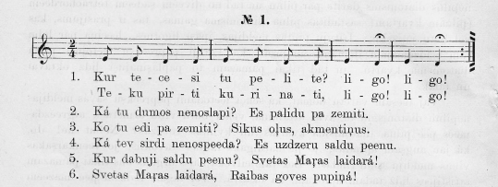
14.lpp.

\version "2.13.18"
#(ly:set-option 'crop #t)

\paper {
line-width = 14\cm
left-margin = 0.4\cm
between-system-padding = 0.1\cm
between-system-space = 0.1\cm
}
\layout {
indent = #0
ragged-last = ##f
}

voiceA = \relative c' {
\clef "treble"
\key c \major
\time 2/4
\repeat volta 2 { e8 e d d | e e d d | e4 d\fermata | e4 d\fermata | }
}

lyricAA = \lyricmode {
Kur te -- ce -- si tu pe -- li -- te? li -- go! li -- go!
}

lyricAB = \lyricmode {
Te -- ku pir -- ti ku -- ri -- na -- ti, li -- go! li -- go!
}

fullScore = <<
\new Staff {
<<
\new Voice = "voiceA" { \oneVoice \autoBeamOff \voiceA }
\new Lyrics \lyricsto "voiceA" \lyricAA
\new Lyrics \lyricsto "voiceA" \lyricAB
>>
}
>>

\score {
\fullScore
\header { piece = "__" opus = "__" }
}
Var arī voiceA = \transpose e a { \relative c' { ... } }
16.lpp.
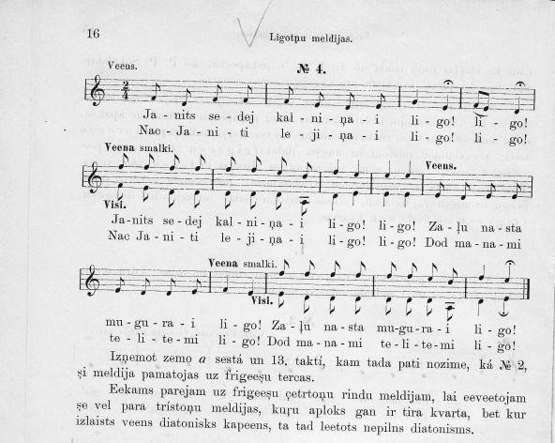
voiceA = \relative c' {
\clef "treble"
\key c \major
\time 2/4
f8^"Veens." d f f | f e d e | g4 e\fermata | f8[( e]) d4\fermata | \break
f'8^"Veena smalki."_"Visi." f f f | f f e d | f4 e | e e | \oneVoice e,8 d e e | \break
e d d e | f4 e | \voiceOne f'8 f f f | f f e d | f4 e\fermata
\bar "|."
}

voiceB = \relative c' {
\clef "treble"
\key c \major
\time 2/4
s2 | s2 | s2 | s2 |
f8 e d d | d d d a | d4 e | e e | s2 |
s2 | s2 | e8 d d d | d d d a | d4 e\fermata
}

...

fullScore = <<
\new Staff {
<<
\new Voice = "voiceA" { \voiceOne \autoBeamOff \voiceA }
\new Voice = "voiceB" { \voiceTwo \autoBeamOff \voiceB }
\new Lyrics \lyricsto "voiceA" \lyricAA
\new Lyrics \lyricsto "voiceA" \lyricAB
>>
}
>>
17.lpp.
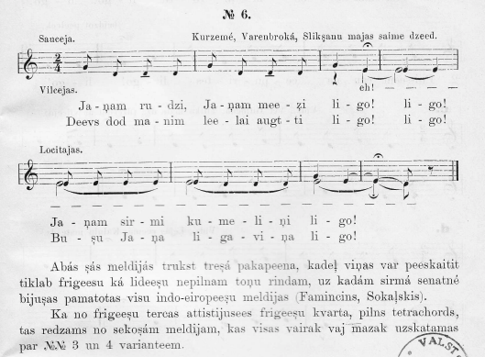
voiceA = \relative c' {
\clef "treble"
\key c \major
\time 2/4
g'8^"Sauceja."_"Vilcejas." d d\tenuto d | g d d\tenuto d | g4 e4\fermata | e4 e |
e8^"Locitajas." e e e | e d d d | g4 e( | e\fermata)( d8) r8
\bar "|."
}

lyricAA = \lyricmode {
Ja -- ņam ru -- dzi, Ja -- ņam mee -- z̧i li -- go! li -- go!
Ja -- ņam sir -- mi ku -- me -- li -- ņi li -- go!
}

lyricAB = \lyricmode {
Deevs dod ma -- nim lee -- lai augt -- ti li -- go! li -- go!
Bu -- şu Ja -- ņa li -- ga -- vi -- ņa li -- go!
}

voiceB = \relative c' {
\clef "treble"
\key c \major
\time 2/4
s2 | s2 | r4 e4( | e2)( <>) | e2( <>) | e2( <>) | e2( | e4)( d8) r8
}

lyricB = \lyricmode { eh! __ }

fullScore = <<
\new Staff {
<<
\new Voice = "voiceA" { \voiceOne \autoBeamOff \voiceA }
\new Voice = "voiceB" { \voiceTwo \autoBeamOff \voiceB }
\new Lyrics \lyricsto "voiceB" \lyricB
\new Lyrics \lyricsto "voiceA" \lyricAA
\new Lyrics \lyricsto "voiceA" \lyricAB
>>
}
>>
% ...

