# Configuration Management and C++ Environment Issues

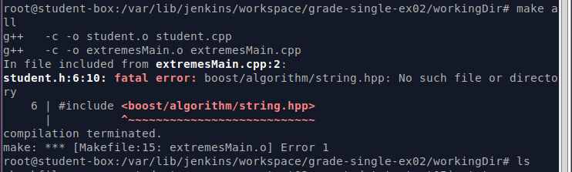

sudo apt-get install libboost-all-dev