Final Exam

RBS, Discrete Structures

2020-04-23

## Problem 1

By $U$ we denote the set of all positive integers between $1$ and $120$. This is our *universe* in which we define several subsets:

$$\left\{\begin{matrix}A=\{x∈U ∣ 2∣​x\}, \\ B=\{x∈U ∣ 3∣​x\}, \\ C=\{x∈U ∣ 5∣​x\}, \\ X=\{x∈U ∣ 2∣​x ∨ 3∣​x\}, \\ Y=\{x∈U ∣ (3∣​x ∧ 5∣​x) ∨¬(2∣​x)\}.\end{matrix}\right.$$

**(A)** Express $X$ using the sets $A,B,C$ (using set union $V∪W$, set intersection $V∩W$, set complement $\overline{V}$ operations).  
**(B)** Express $Y$ using the sets $A,B,C$ in a similar way.  
**(C)** Find $|X|$- the size of the set $X$.  
**(D)** Find $|Y|$- the size of the set $Y$.

## Problem 2

Let $A$ and $B$ be sets with sizes $|A|=8$ and $|B|=5$ and $|A∩B|=3$.

Calculate the largest and the smallest possible values for each of the following set sizes:

**(A) $|A∪B|$** .  
**(B) $|A×(B×B)|$** .  
**(C) $\left|P(P(A∩B))\right|$** - the powerset of a powerset of $A∩B$.  
**(D) $|A⊕B|$** - the symmetric difference of the sets $A$ and $B$.

## Problem 3

Consider the following recurrent sequence:

$$\left\{\begin{matrix}a_{0}=3 \\ a_{1}=4 \\ a_{n+2}=5a_{n+1}-6a_{n}, \text{if} n≥0\end{matrix}\right.$$

Assume that $b_{n}$ is another sequence satisfying the recurrence rule

$$b_{n+2}=5b_{n+1}-6b_{n}, \text{if} n≥0$$

(The first two members $b_{0},b_{1}$ are not known.)

**(A)** Write the first $6$ members of this sequence ($a_{1},…,a_{6}$).  
**(B)** Write the characteristic equation for this sequence.  
**(C)** Write the general expression for an arbirary sequence $b_{n}$ satisfying the recurrent expression as a sum of two geometric progressions (you can leave unknown coefficients in your answer; just explain which ones they are).  
**(D)** Write the formula to compute $a_{n}$ (that would satisfy the initial conditions $a_{1}=3$ and $a_{2}=4$).

## Problem 4

Consider this code snippet in Python:

n = 1000  
sum = 0  
for i in range(1, n*n+1):  
 for j in range(1,i+1):  
 sum += i % j

And a similar one in R:

n <- 1000  
sum <- 0  
for (i in 1:(n*n)) {  
 for (j in 1:i) {  
 sum <- sum + i %% j  
 }  
}

**(A)** Explain in human language what this algorithm does.  
**(B)** Denote by $f(n)$ the number of times the variable sum is incremented. Write the Big-O-Notation for $f(n)$. Find a function $g(n)$ such that $f(n)$ is in $O(g(n))$. (If there are multiple functions, pick the one with the slowest growth.)  
**(C)** Express the function $f(n)$ precisely - how many times sum is incremented in terms of variable $n$.

## Problem 5

Let $A$ be the set of all positive divisors of the number $120$ (including $1$ and $120$ itself).  
**(A)** What is the multiplication of all numbers in the set $A$?  
**(B)** Express this number as the product of prime powers.

## Problem 6

Define the following binary relationship on the set of integer numbers $Z$:  
We say that $aRb$ (numbers $a,b∈Z$ are in the relation $R$) iff

$$\left\{\begin{matrix}a-b≡0 (\text{mod} 11) \\ a-b≡0 (\text{mod} 12) \\ a-b≡0 (\text{mod} 13)\end{matrix}\right.$$

|  |  |  |
| --- | --- | --- |
| Item | Statement | True or False? |
| **(A)** | $R$ is reflexive |  |
| **(B)** | $R$ is symmetric |  |
| **(C)** | $R$ is antisymmetric |  |
| **(D)** | $R$ is transitive |  |
| **(E)** | $aRb$ iff $a=b$ |  |

For all items where you answered FALSE, specify a counterexample (values for some numbers that would make the condition true, but the conclusion false). If the statement was true, write “none”.

**(A)** counterexample ___

**(B)** counterexample ___

**(C)** counterexample ___

**(D)** counterexample ___

**(E)** counterexample ___

## Problem 7

Four people $A,B,C,D$ each has his own hat. After the meeting they leave their building in a hurry, everyone grabs some hat at random so that all $4!$ permutations of the hats have equal probabilities.

Let the random variable $X$ denote the number of hats that were picked up correctly. (For example, if the hat assignment is this: $(A→A,B→B,C→D,D→C)$, then $X=2$, because two people got their own hats.)

**(A)** Find $E(X)$- the expected value of $X$.  
**(B)** Find $V(X)$- the variance of $X$.

## Problem 8

There was a crooked man who had a crooked 1 euro coin. On lucky days it would flip the *heads* with probability $p=\frac{2}{3}$, and the *tails* with probability $p=\frac{1}{3}$, but on unlucky days it was the opposite ($p(heads)=\frac{1}{3}$, but $p(tails)=\frac{2}{3}$). There were equal probabilities of $\frac{1}{2}$ for lucky and unlucky days.

One morning he flipped the coin $5$ times and altogether got three *heads* and two *tails*.

Let us introduce the following events:

* $E$ (evidence): Five coin tosses result in three *heads* and two *tails*.
* $H$ (hypothesis): The current day is lucky.

**(A)** Find $P(E|H)$- the conditional probability of $E$ given that the day is lucky.  
**(B)** Find $P(E|H)⋅P(H)$- the probability that the day is lucky and $E$ happens.  
**(C)** Find $P(E|\overline{H})$- the conditional probability of $E$ given that the day is not lucky.  
**(D)** Find $P(E|\overline{H})⋅P(\overline{H})$- the probability that the day is unlucky and $E$ happens.  
**(E)** Find $P(E)$- as the sum of two probabilities ( $E$ happened on a lucky day and also $E$ happened on unlucky day).  
**(F)** Find the conditional probability $P(H|E)$- the likelyhood that the croocked man has a lucky day, given that the event $E$ has happened.

## Problem 9

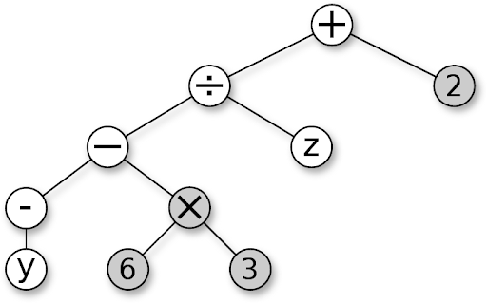  
*Figure: A syntax tree for an expression*

The syntax tree describes an algebraic expression (please note the difference between the unary minus that flips the value of the variable $y$ and the binary minus that subtracts the two subexpressions: $-y$ and $6×3$).

**(A)** Write the preorder DFS traversal of this tree.  
**(B)** Write the inorder DFS traversal of this tree.  
**(C)** Write the postorder DFS traversal of this tree.

*Note.* In all $3$ answers denote the unary minus with the tilde sign $∼$, but the regular/binary minus with $-$.

## Problem 10

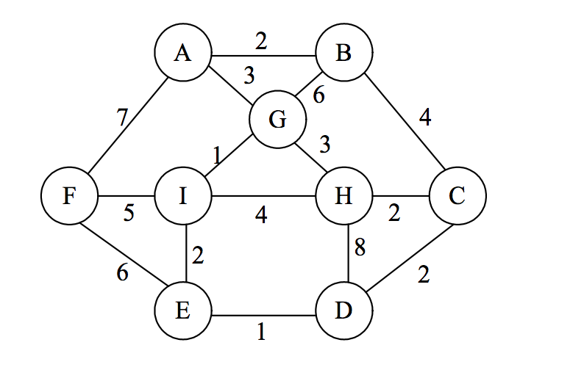  
*Figure: Graph with 9 vertices*

Run the Prim’s algorithm on the following weighted graph, start growing the tree from the vertex $I$.

|  |  |
| --- | --- |
| Step | Newly Added Edge |
| **Step 1** |  |
| **Step 2** |  |
| **Step 3** |  |
| **Step 4** |  |
| **Step 5** |  |
| **Step 6** |  |
| **Step 7** |  |
| **Step 8** |  |

What is the total weight of the obtained Minimum Spanning Tree? ______