## 1985.10

How many of the first $1000$ positive integers can be expressed in the form

$\lfloor 2x \rfloor + \lfloor 4x \rfloor + \lfloor 6x \rfloor + \lfloor 8x \rfloor$,

where $x$ is a real number, and $\lfloor z \rfloor$ denotes the greatest integer less than or equal to $z$?

## 1986.2

Evaluate the product

$(\sqrt 5+\sqrt6+\sqrt7)(-\sqrt 5+\sqrt6+\sqrt7)(\sqrt 5-\sqrt6+\sqrt7)(\sqrt 5+\sqrt6-\sqrt7)$.

## 1991.6

Suppose $r^{}_{}$ is a real number for which



Find $\lfloor 100r \rfloor$. (For real $x^{}_{}$, $\lfloor x \rfloor$ is the greatest integer less than or equal to $x^{}_{}$.)

## 1991.7

Find $A^2_{}$, where $A^{}_{}$ is the sum of the absolute values of all roots of the following equation:

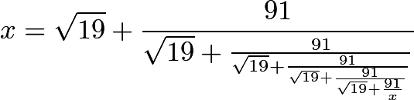

## 1994.4

Find the positive integer $n\,$ for which

$\lfloor \log_2{1}\rfloor+\lfloor\log_2{2}\rfloor+\lfloor\log_2{3}\rfloor+\cdots+\lfloor\log_2{n}\rfloor=1994$.

(For real $x\,$, $\lfloor x\rfloor\,$ is the greatest integer $\le x.\,$)

## 1994.7

For certain ordered pairs $(a,b)\,$ of real numbers, the system of equations

$ax+by=1\,$

$x^2+y^2=50\,$

has at least one solution, and each solution is an ordered pair $(x,y)\,$ of integers. How many such ordered pairs $(a,b)\,$ are there?

## 1995.7

Given that $(1+\sin t)(1+\cos t)=5/4$ and

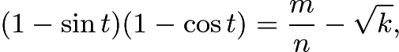

where $k, m,$ and $n_{}$ are positive integers with $m_{}$ and $n_{}$ relatively prime, find $k+m+n.$

## 1997.9

Given a nonnegative real number $x$, let $\langle x\rangle$ denote the fractional part of $x$; that is, $\langle x\rangle=x-\lfloor x\rfloor$, where $\lfloor x\rfloor$ denotes the greatest integer less than or equal to $x$. Suppose that $a$ is positive, $\langle a^{-1}\rangle=\langle a^2\rangle$, and $2<a^2<3$. Find the value of $a^{12}-144a^{-1}$.

## 1998.8

Except for the first two terms, each term of the sequence $1000, x, 1000 - x,\ldots$ is obtained by subtracting the preceding term from the one before that. The last term of the sequence is the first [negative](https://artofproblemsolving.com/wiki/index.php/Negative) term encountered. What positive integer $x$ produces a sequence of maximum length?

## 2017.2.6

Find the sum of all positive integers $n$ such that $\sqrt{n^2+85n+2017}$ is an integer.

## 2019.2.10

There is a unique angle $\theta$ between $0^\circ$ and $90^\circ$ such that for nonnegative integers $n,$ the value of $\tan(2^n\theta)$ is positive when $n$ is a multiple of $3$, and negative otherwise. The degree measure of $\theta$ is $\tfrac{p}{q}$, where $p$ and $q$ are relatively prime positive integers. Find $p+q$.