# How to create and Publish a Git Repository

## Create a GitHub account

(If you already have a GitHub account, skip this part.)

1. Visit <https://github.com/>
2. Click Sign up for GitHub.
3. Username: Enter a short username - better all lowercase (can include your firstname, lastname or nick, but this will be public - if you do not want anyone to recognize you, your nick has to be strange.)
4. Email address: Enter your email address
5. Select a password.
6. In the section where they verify, if you are a human, click Verify. Rotate the picture.
7. Create an account

**Validate your email address**

1. Check your email for an invitation from GitHub.
2. Click on the link there
3. Log into GitHub.

GitHub may also want to send a device verification code. In this case you enter the code in GitHub.

## Create and Publish a New Git Repository

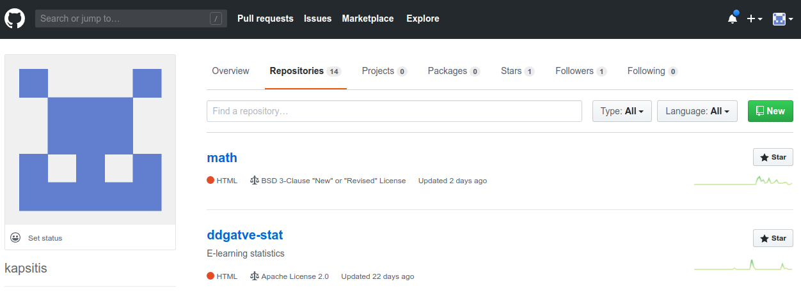

1. Select tab **Repositories**.
2. Click the green button **New** at the top.
3. Optionally - you can get some D3 sample files from my GitHub account - click **Import a repository.**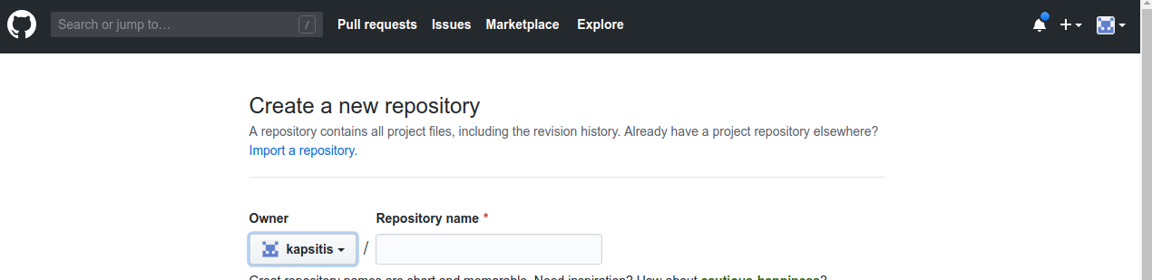
4. In the import screen pick the old repository address: <https://github.com/kapsitis/workshop> . Also pick a name for your new repository (where to copy 2 files from the project “workshop”). Click green button **Begin Import**. Wait until import finishes.
5. Enable GitHub Pages - click the link to go to your new repository. In that repository, select tab **Settings**. Scroll down until you see GitHub Pages.
6. Instead of **None** select **master branch**.

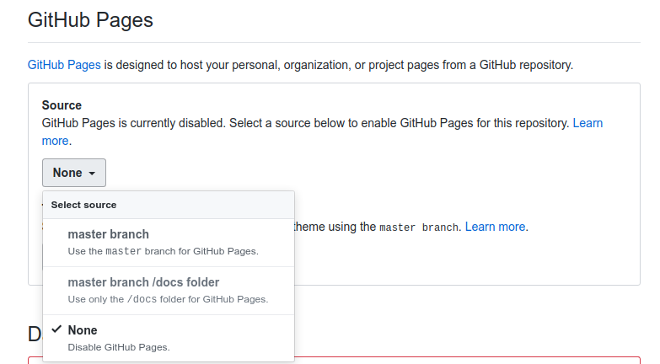

1. At this point the browser screen will reload. Scroll down there again.

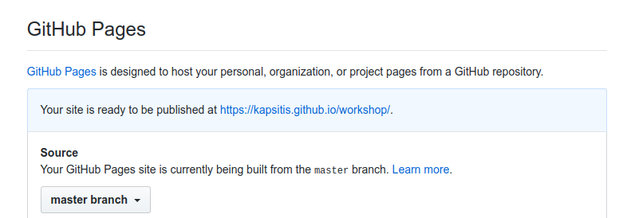

1. Click on the link (your link will be different than on the picture). You should see a simple barchart (I copied it from <http://bl.ocks.org/d3noob/8952219> - the first Google result for “D3 barcharts”). Repository contains **index.html** (in larger project you want to separate HTML, CSS and JavaScript in 3 separate files); it also contains the data file **bar-data.csv**.

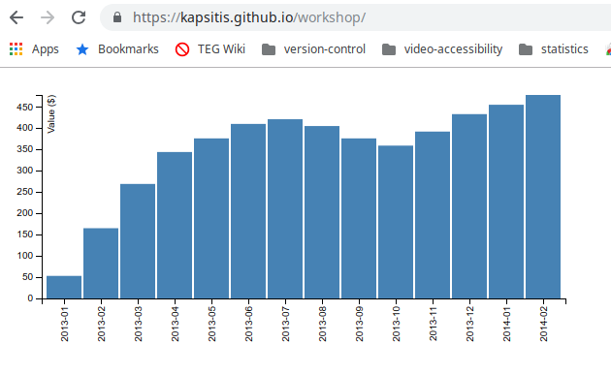

After this you may want to check out the code and write more D3 examples. Also link them to the **index.html** page so that they are easy to test.