A Baltic polyiamond is an -gon with side lengths 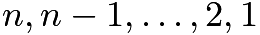 in exactly this order, and all internal angles or . Prove that for every Baltic polyiamond, is divisible by .

