Atrisini vienādojumu!
1. | $$\sin{3x}=1$$  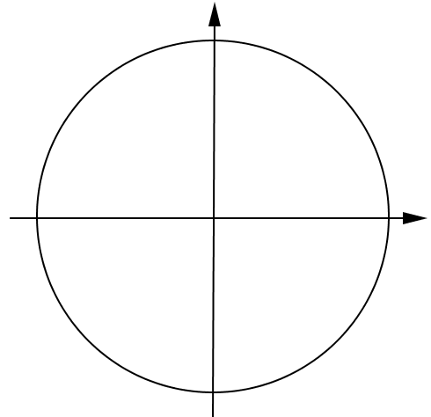 | 1. | $$\sin{4x}=-1$$  
2. | $$\sin{4x}=0$$   | 2. | $$\sin{6x}=0$$  
3. | $$\sin{\frac{x}{2}}=-1$$   | 3. | $$\sin{\frac{x}{3}}=1$$  
4. | $$\sin{2x}=\frac{1}{2}$$   | 4. | $$\sin{3x}=\frac{\sqrt{3}}{2}$$  
5. | $$\sin\left(9-5x\right)=\frac{\sqrt{2}}{2}$$   | 5. | $$\sin\left(-2x\right)=\frac{\sqrt{2}}{2}$$  
6. | $$\sin\left(x+\frac{π}{6}\right)=-\frac{1}{2}$$   | 6. | $$\sin\left(x-\frac{π}{3}\right)=-\frac{\sqrt{3}}{2}$$  
7. | $$\sin\left(x-\frac{π}{4}\right)=\frac{\sqrt{2}}{2}$$   | 7. | $$\sin\left(x+\frac{π}{4}\right)=-\frac{\sqrt{2}}{2}$$  

