Atrisini vienādojumu!
1. | $$\cos{x=1}$$  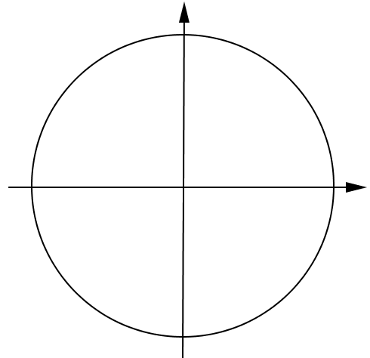 | 1. | $$\cos{x}=-1$$  
2. | $$\cos{3x=0}$$   | 2. | $$\cos{2x}=0$$  
3. | $$\cos{4x}=\frac{1}{2}$$   | 3. | $$\cos{5x}=\frac{\sqrt{2}}{2}$$  
4. | $$\cos{\frac{x}{3}}=\frac{\sqrt{3}}{2}$$   | 4. | $$\cos{\frac{x}{4}}=\frac{1}{2}$$  
5. | $$\cos\left(-2x\right)=\frac{\sqrt{2}}{2}$$   | 5. | $$\cos\left(-3x\right)=\frac{\sqrt{2}}{2}$$  
6. | $$\cos\left(x+\frac{π}{4}\right)=-\frac{\sqrt{2}}{2}$$   | 6. | $$\cos\left(x+\frac{π}{6}\right)=-\frac{\sqrt{3}}{2}$$  
7. | $$\cos\left(x-\frac{π}{3}\right)=-\frac{1}{2}$$   | 7. | $$\cos\left(x-\frac{π}{4}\right)=-\frac{\sqrt{2}}{2}$$  

