Atrisini vienādojumu!
1. | $$\operatorname{tg}{x}=1$$  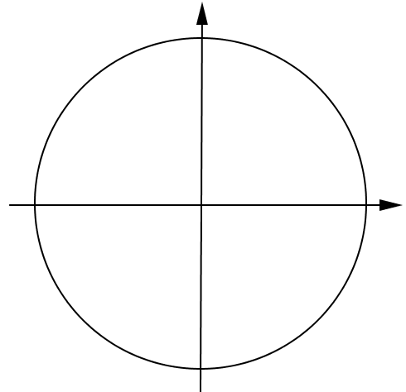 | 1. | $$\operatorname{tg}{x}=-1$$  
2. | $$\operatorname{tg}{x}=\sqrt{3}$$   | 2. | $$\operatorname{tg}{x}=\frac{\sqrt{3}}{3}$$  
3. | $$\operatorname{tg}{2x}=\frac{\sqrt{3}}{3}$$   | 3. | $$\operatorname{tg}{4x}=\sqrt{3}$$  
4. | $$\operatorname{tg}{\frac{x}{3}}=-\sqrt{3}$$   | 4. | $$\operatorname{tg}{\frac{x}{2}}=-\frac{\sqrt{3}}{3}$$  
5. | $$\operatorname{tg}\left(x+\frac{π}{4}\right)=-1$$   | 5. | $$\operatorname{tg}\left(x+\frac{π}{4}\right)=1$$  
6. | $$\operatorname{tg}\left(x-\frac{π}{6}\right)=\frac{\sqrt{3}}{3}$$   | 6. | $$\operatorname{tg}\left(x+\frac{π}{6}\right)=\sqrt{3}$$  
7. | $$\operatorname{tg}\left(x+\frac{π}{3}\right)=-\sqrt{3}$$   | 7. | $$\operatorname{tg}\left(x-\frac{π}{3}\right)=-\frac{\sqrt{3}}{3}$$  

