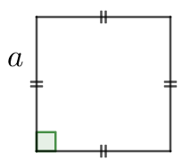  $$S=$$  $$P=$$ | 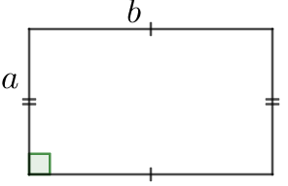  $$S=$$  $$P=$$ | 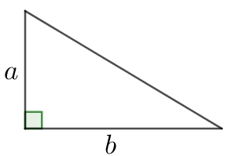  $$S=$$
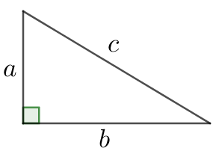 | 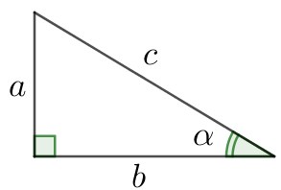  $$\sin{α}=$$  $$\cos{α}=$$  $$tgα=$$

