Uzzīmē funkciju grafikus, lietojot funkcijas grafika transformācijas!
1. | 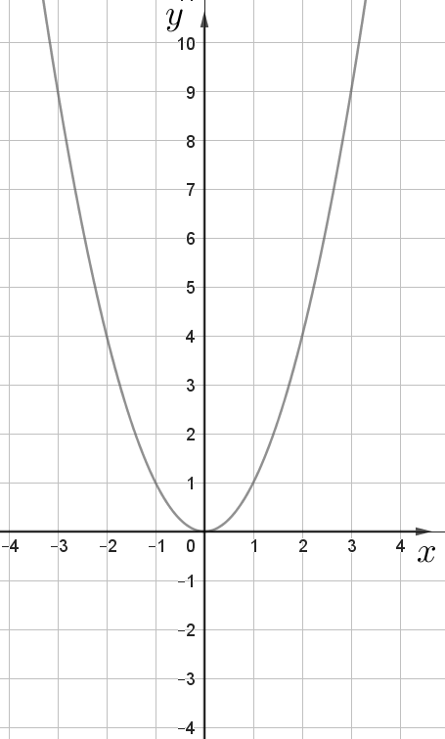 | $$y=x^{2}+3$$  $$y=x^{2}-2$$
2. | 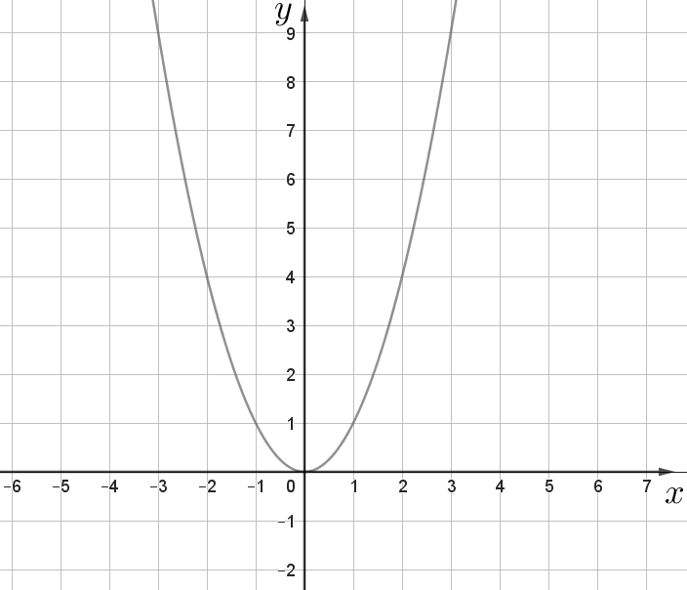 | $$y={\left(x+3\right)}^{2}$$  $$y={\left(x-2\right)}^{2}$$
3. | 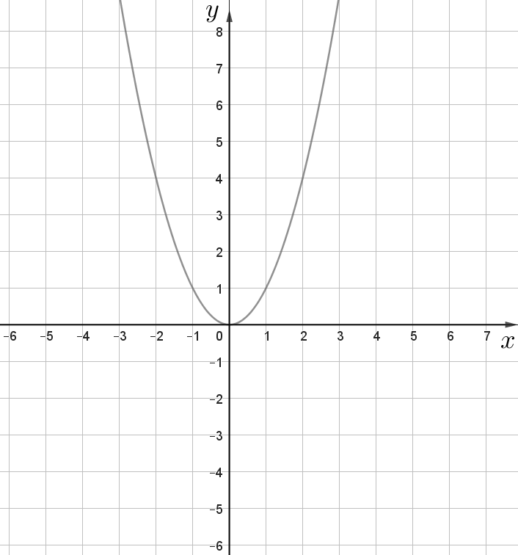 | $$y={\left(x-4\right)}^{2}+2$$  $$y={\left(x+5\right)}^{2}$$  $$y={\left(x+3\right)}^{2}-5$$  $$y={\left(x-2\right)}^{2}-3$$
4. | 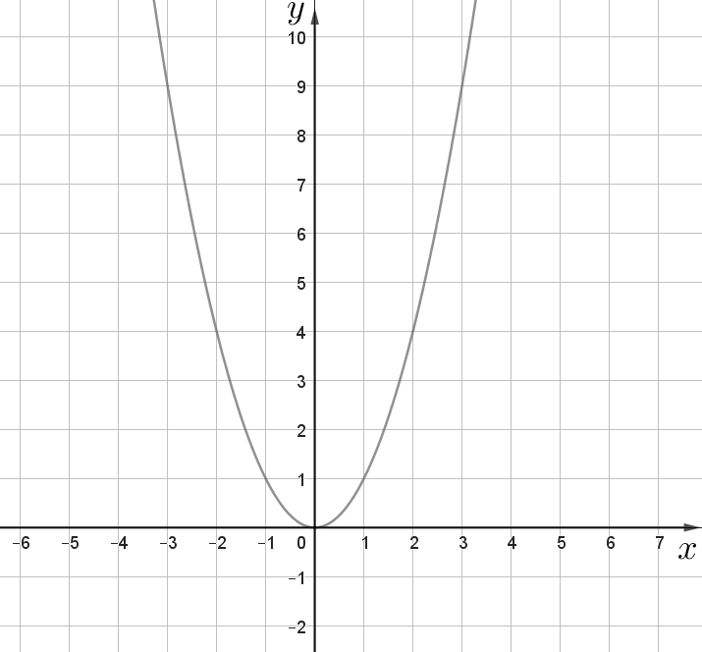 | $$y=2x^{2}$$  $$y=4x^{2}$$  $$y=\frac{1}{2}x^{2}$$  $$y=\frac{1}{4}x^{2}$$
5. | 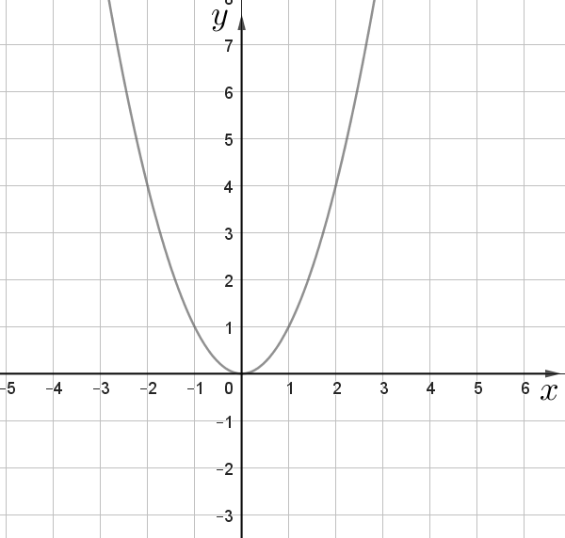 | $$y=x^{2}-2x$$
6. | 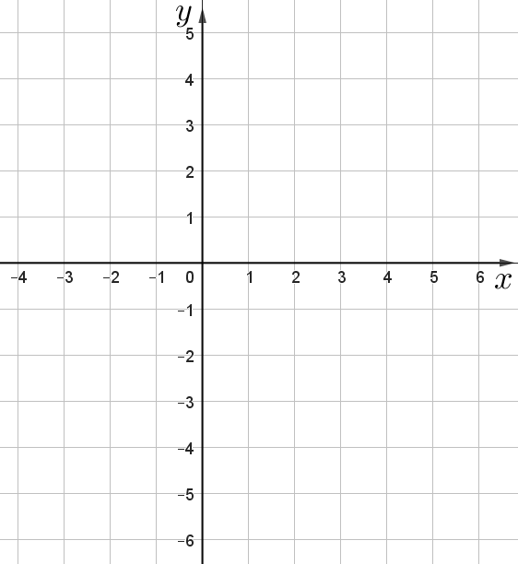 | $$y=-(x^{2}-2x)$$
7. | 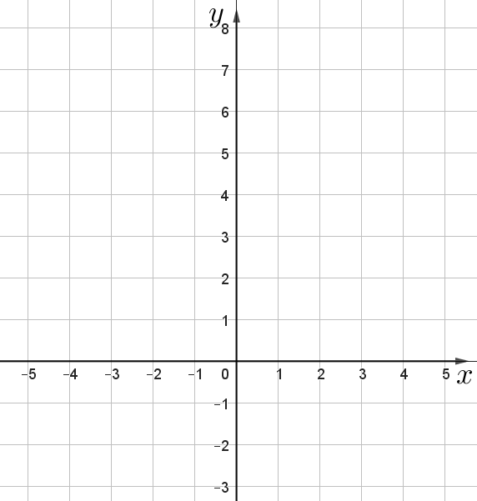 | $$y=x^{2}+4x+2$$

