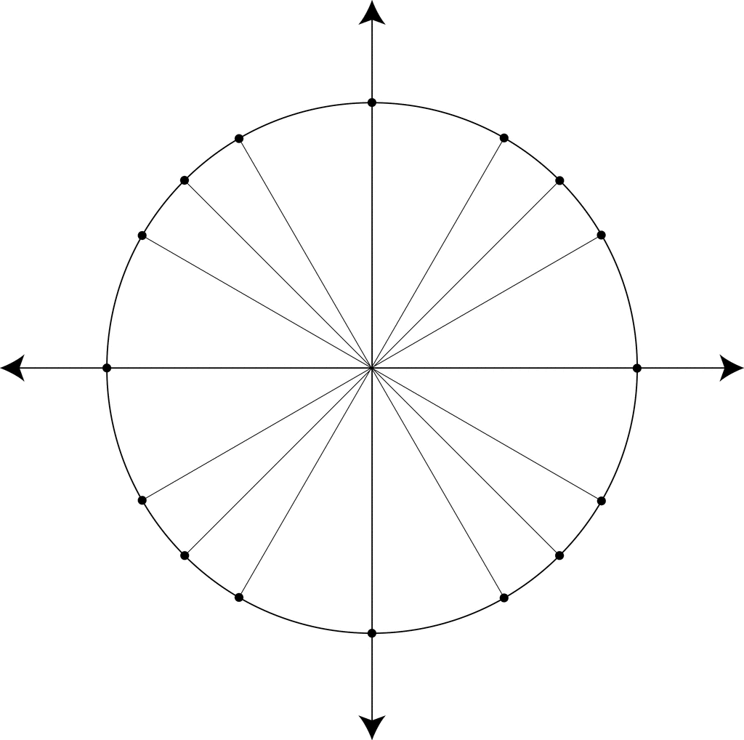
1. Uzraksti vienības riņķī biežāk lietotos leņķus grādos vai radiānos un to attiecīgās sinusa, kosinusa un tangensa vērtības!

2. Aprēķini, lietojot trigonometrisko vienības riņķi!
1. | $$\sin{\frac{π}{6}}=$$ | 1. | $$\sin{\frac{π}{4}=}$$
2. | $$\cos{\frac{π}{3}}=$$ | 2. | $$\cos{\frac{π}{4}}=$$
3. | $$\sin{\frac{5π}{6}}=$$ | 3. | $$\sin\left(-\frac{4π}{3}\right)=$$
4. | $$\cos\left(-\frac{2π}{3}\right)=$$ | 4. | $$\cos{\frac{7π}{6}}=$$
5. | $$\operatorname{tg}{\frac{π}{4}}=$$ | 5. | $$\operatorname{tg}{\frac{11π}{6}=}$$
6. | $$\operatorname{tg}{\frac{7π}{6}}=$$ | 6. | $$\operatorname{tg}{\frac{5π}{3}}=$$
7. | $$sin(-{π)=}$$ | 7. | $$\cos{π}=$$
8. | $$\cos{\frac{π}{2}=}$$ | 8. | $$\sin{\frac{π}{2}=}$$
9. | $$\sin{\frac{3π}{2}}=$$ | 9. | $$cos\left(-\frac{3π}{2}\right)=$$
10. | $$\sin{2π=}$$ | 10. | $$\cos{2π=}$$
11. | $$\operatorname{tg}{0}=$$ | 11. | $$\sin{4π}=$$
12. | $$\operatorname{tg}\left(-\frac{π}{2}\right)=$$ | 12. | $$\operatorname{tg}{\frac{3π}{2}}=$$
13. | $$\sin{\frac{27π}{6}}=$$ | 13. | $$\cos\left(-\frac{20π}{6}\right)=$$
14. | $$\cos{\frac{19π}{3}}=$$ | 14. | $$\cos{\frac{16π}{3}}=$$
15. | $$\operatorname{tg}{\frac{35π}{4}}=$$ | 15. | $$\operatorname{tg}{\frac{29π}{4}}=$$

3. Konstruē pēc moduļa divus mazākos pagrieziena leņķus $α$, ja zināma tā trigonometriskās funkcijas vērtība!
1. | $$\sin{α=}\frac{1}{2}$$  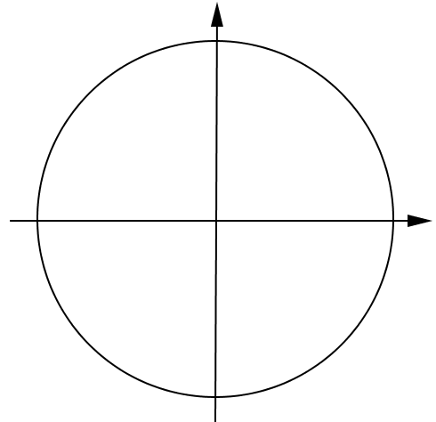 | 1. | $$\sin{α=}\frac{\sqrt{3}}{2}$$  
2. | $$\cos{α=}-\frac{\sqrt{2}}{2}$$   | 2. | $$\cos{α=}-\frac{1}{2}$$  
3. | $$\operatorname{tg}{α=}-1$$  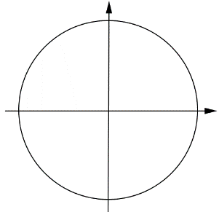 | 3. | $$\operatorname{tg}{α=}\sqrt{3}$$  
4. | $$\operatorname{tg}{α=}3$$   | 4. | $$\operatorname{tg}{α=}-2$$  
5. | $$\cos{α=}-\frac{4}{5}$$   | 5. | $$\sin{α=}0,6$$  

4. Salīdzini!
1. | $$\sin{15°} \cos{15°}$$ | 1. | $$\sin{\frac{π}{10}} \cos{\frac{π}{10}}$$
2. | $$\sin{\frac{π}{5}} \cos{\frac{4π}{5}}$$ | 2. | $$\cos{133°} \sin{23°}$$
3. | $$\operatorname{tg}{16°} \operatorname{tg}{88°}$$ | 3. | $$\operatorname{tg}{-17°} \operatorname{tg}{-60°}$$
4. | $$\cos{240°} \cos{\frac{2π}{3}}⁡$$ | 4. | $$\sin{225°} \sin{\frac{7π}{4}}⁡$$
5. | $$\sin{\frac{7π}{4}} \sin{\frac{π}{2}}⁡$$ | 5. | $$\cos{\frac{13π}{7}} \cos{\frac{7π}{8}}⁡$$
6. | $$\sin{-35°} \operatorname{tg}{-100°}$$ | 6. | $$\operatorname{tg}{\frac{13π}{15}} \cos{\frac{23π}{13}}$$
7. | $$\operatorname{tg}{\frac{5π}{4}} \cos{0°}$$ | 7. | $$\sin{\frac{π}{2}} \operatorname{tg}{\frac{13π}{4}}$$
8. | $$\cos{248°} \cos{112°}⁡$$ | 8. | $$\sin{217°} \sin{323°}⁡$$
9. | $$\sin{3} \cos{3}⁡$$ | 9. | $$\sin{5} \cos{5}⁡$$
10. | $$\operatorname{tg}{2} \cos{1}$$ | 10. | $$\operatorname{tg}{4} \operatorname{tg}{6}$$

5. Aprēķini!
1. | $$\sin{30°+\cos{60°=}}$$ | 1. | $$\operatorname{tg}{45°}-\sin{90°}=$$
2. | $$\sin^{2}{\frac{π}{6}}+\cos^{2}{\frac{π}{6}}=$$ | 2. | $$\operatorname{tg}{\frac{π}{4}}∙\cos{\frac{π}{3}=}$$
3. | $$\frac{\sin{45°∙\cos{45°}}}{\operatorname{tg}{45°}}=$$ | 3. | $$\sin{60°∙\cos{30°}-\operatorname{tg}{45°}}=$$
4. | $$\sin{\frac{π}{2}}+\cos{0}-\operatorname{tg}{\frac{π}{4}=}⁡$$ | 4. | $$\cos{\frac{π}{3}∙}\sin{\frac{π}{6}+\operatorname{tg}{0=}}⁡$$
5. | $$\sin^{2}{\frac{2π}{3}}-\cos^{2}{\frac{7π}{6}=}⁡$$ | 5. | $${tg}^{2}{\frac{3π}{4}+}\sin^{2}{\frac{3π}{2}=}⁡$$
6. | $$\frac{\sin{150°+\cos{120°}}}{\sin{225°}}=$$ | 6. | $$2sin{135°}-\cos{60°=}$$
7. | $$\frac{1}{2}sin{\frac{π}{3}}+\frac{1}{3}\cos{30°=}$$ | 7. | $$\frac{2}{3}sin{45°+}\frac{3}{4}\cos{\frac{π}{4}=}$$
8. | $$\sin{30°\cos{60°}+}\sin{60°}\cos{30°=}⁡$$ | 8. | $$\sin{45°\cos{45°}+}\sin{30°}\cos{60°=}⁡⁡$$
9. | $$\frac{3\sin{\frac{π}{6}+4\cos{\frac{π}{3}}}}{-2\operatorname{tg}{\frac{7π}{4}}}=$$ | 9. | $$\frac{5\sin{\frac{π}{4}-2\cos{\frac{π}{4}}}}{-3\operatorname{tg}\left(-\frac{π}{4}\right)}=$$
10. | $$\frac{4\sin^{2}{30°+2\cos^{2}{60°}}}{3\operatorname{tg}{45°-1}}=$$ | 10. | $$\frac{6\sin^{2}{45°-3\cos^{2}{45°}}}{2\operatorname{tg}{45°+1}}=$$

6. Aprēķini ar precizitāti līdz simtdaļām!
1. | $$\sin{17°}≈$$ | 1. | $$\sin{21°}≈$$
2. | $$\cos{\frac{23π}{5}}≈$$ | 2. | $$\cos{\frac{12π}{7} }≈$$
3. | $$\operatorname{tg}\left(-118°\right)≈$$ | 3. | $$\operatorname{tg}\left(-40°\right)≈$$
4. | $$\cos\left(-12\right)≈⁡$$ | 4. | $$sin(-{6)}≈⁡$$
5. | $$\operatorname{tg}{3,4}≈⁡$$ | 5. | $$\operatorname{tg}{7,1}≈⁡$$

7. Aprēķini leņķi $α$ ar precizitāti līdz veselam grādam!

1. | $$\sin{α}=0,3$$  $$α≈$$ | 1. | $$\sin{α}=0,9$$  $$α≈$$
2. | $$\operatorname{tg}{α}=4$$  $$α≈$$ | 2. | $$\operatorname{tg}{α }=3$$  $$α≈$$
3. | $$\cos{α}=-\frac{4}{5}$$  $$α≈$$ | 3. | $$\cos{α}=-\frac{1}{25}$$  $$α≈$$
4. | $$\cos{α}=0,2⁡$$  $$α≈$$ | 4. | $$\sin{α}=-0,1⁡$$  $$α≈$$
5. | $$\operatorname{tg}{2α}=15⁡$$  $$α≈$$ | 5. | $$\operatorname{tg}{4α}=12⁡$$  $$α≈$$

