Effectiveness of Pre-Trained CNN Networks for Detecting Abnormal Activities in Online Exams

Since Covid19 world has entered into virtual online reality where all manual meetings are converted to online meeting and one such example is Online Exam. Online exam provides advantages to both teachers and students to attend exam from home and this advantage may suffer from cheating and to prevent cheating from online exam author is evaluating performance of various deep learning algorithms such as InceptionV3, DenseNet121, Yolov5 and many more. Among all algorithms Yolov5 is giving best accuracy.

To train above algorithms author has developed his own dataset and said he will provide data upon request but there is no response on Email for dataset request. Author created dataset with 4 classes such as Multiple Persons, Head Movement, using Gadgets and talking others and such dataset is not available on internet. So we downloaded available dataset from ROBOFLOW website which contains two classes called ‘No Head Movement (no cheating) and Head Movement cheating).

By using above two classes dataset we have train and test all algorithm performance.

Extension Concept

In propose paper author has used old Yolov5 algorithm but there is another advance version called YoloV8 is available so as extension we have experimented with YOLOV8 which is giving high MAP (average precision) compare to YoloV5 algorithm

Here we train all algorithms and then using webcam just checking algorithm performance of cheating and no-cheating.

SCREEN SHOTS

We have coded this project using JUPYTER notebook and below are the code and output screens with blue colour comments

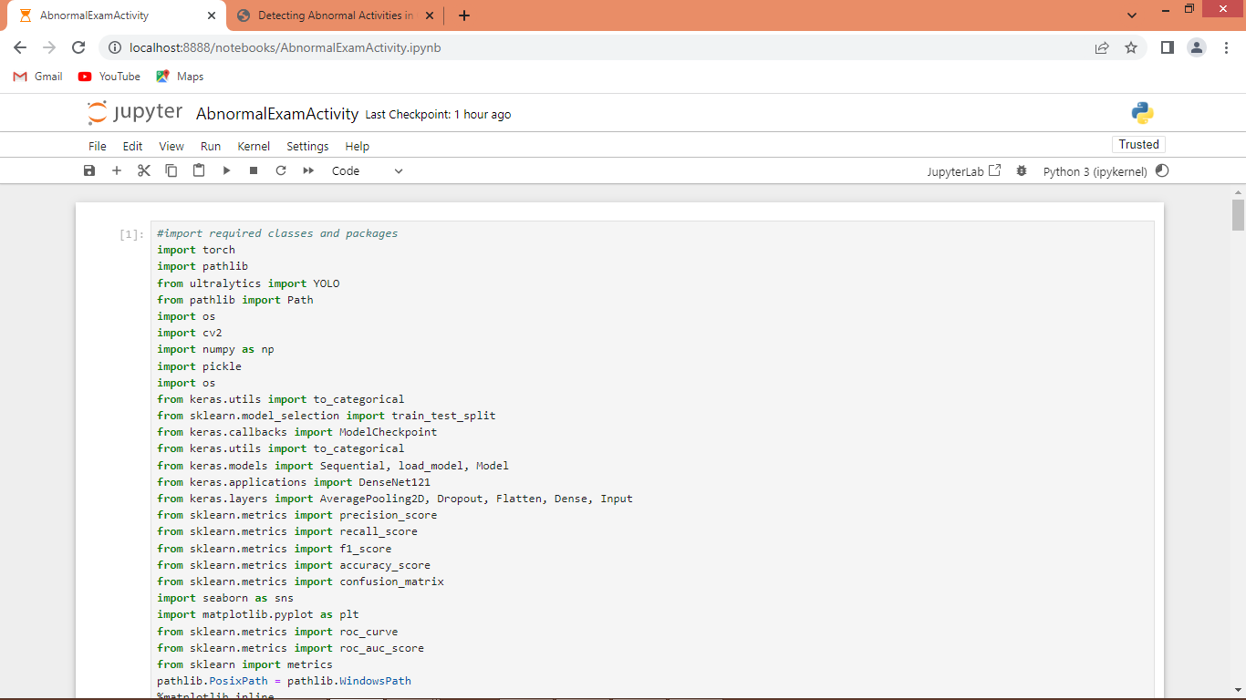

In above screen importing required python classes and packages

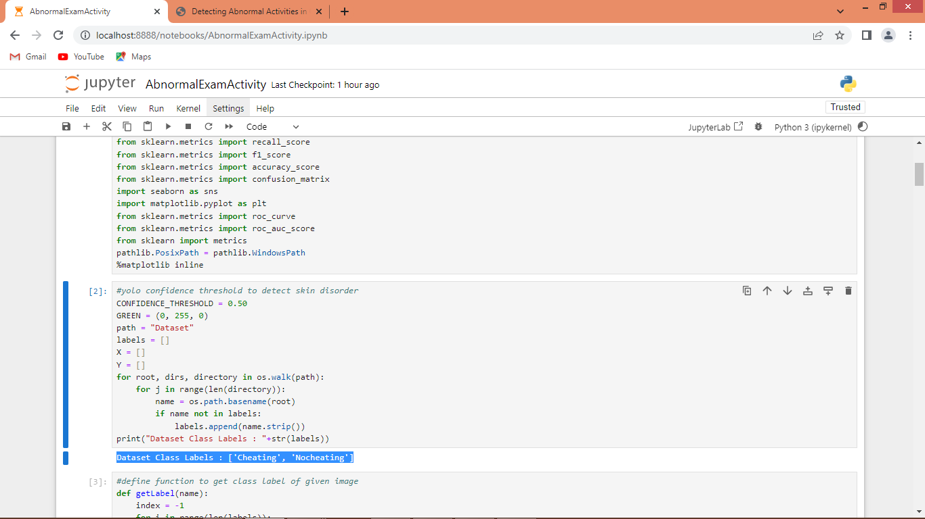

In above screen defining global variables and then scanning dataset to print available classes

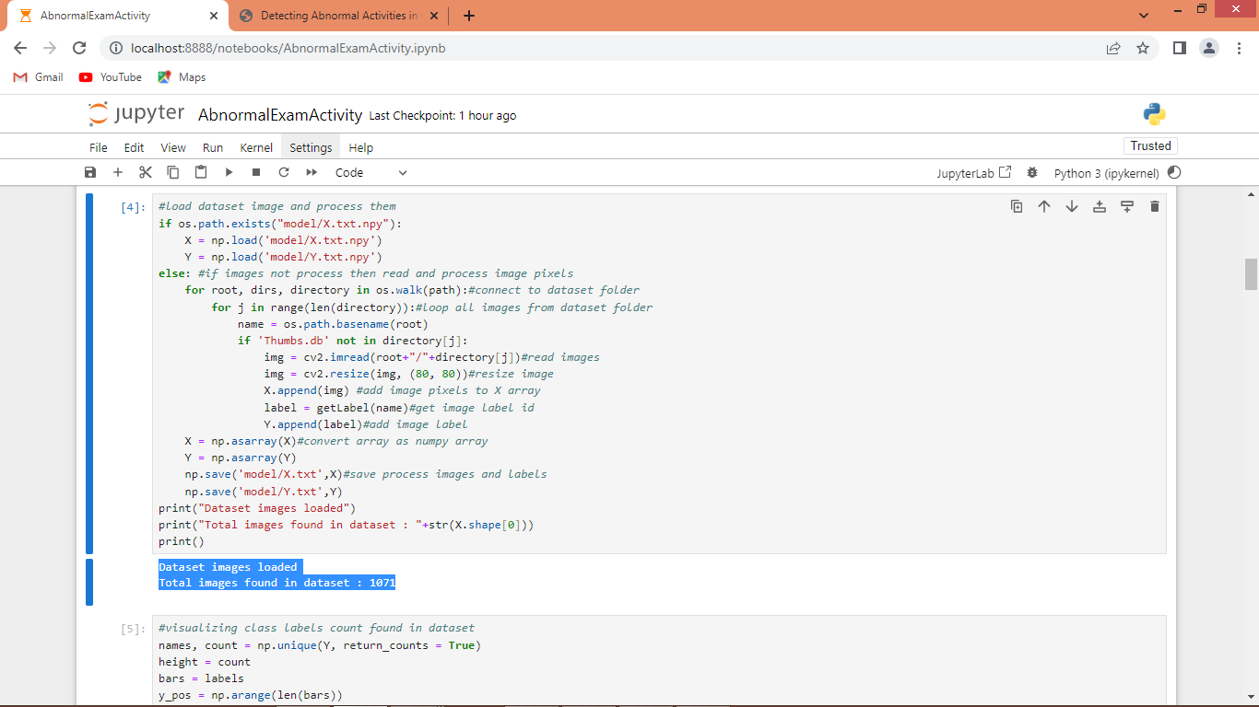

In above screen looping and processing all images from dataset and then printing total images loaded from dataset

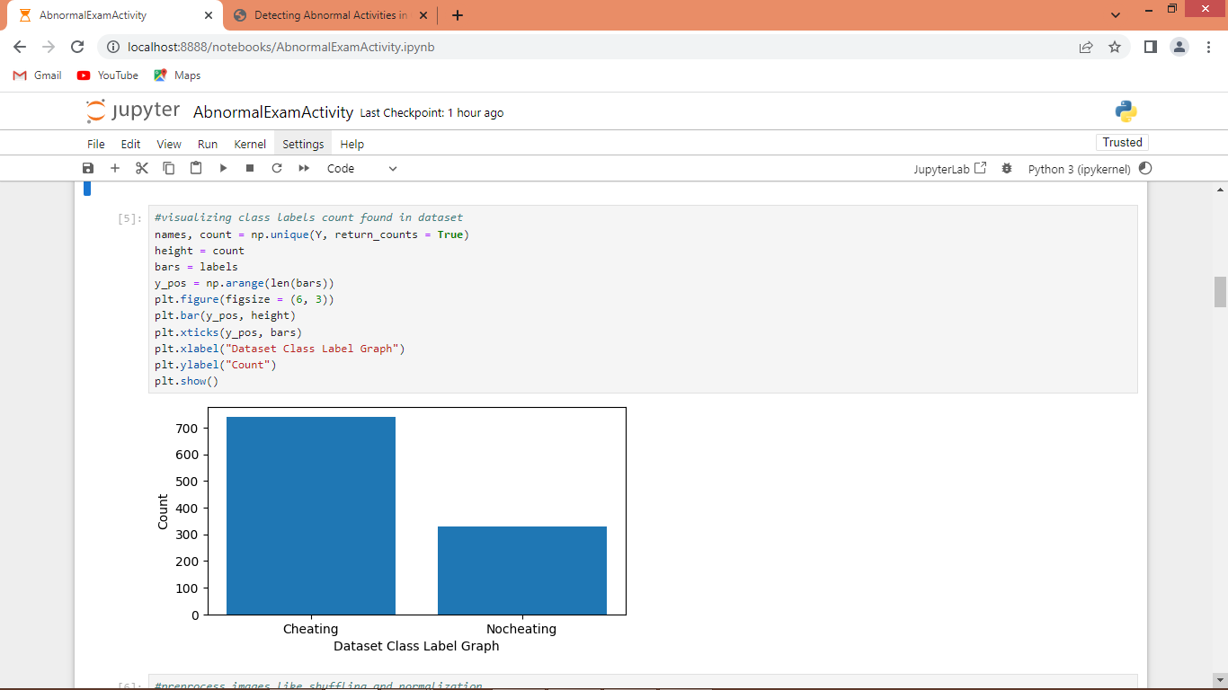

In above graph x-axis represents class labels and y-axis represents number of images exists in that class labels

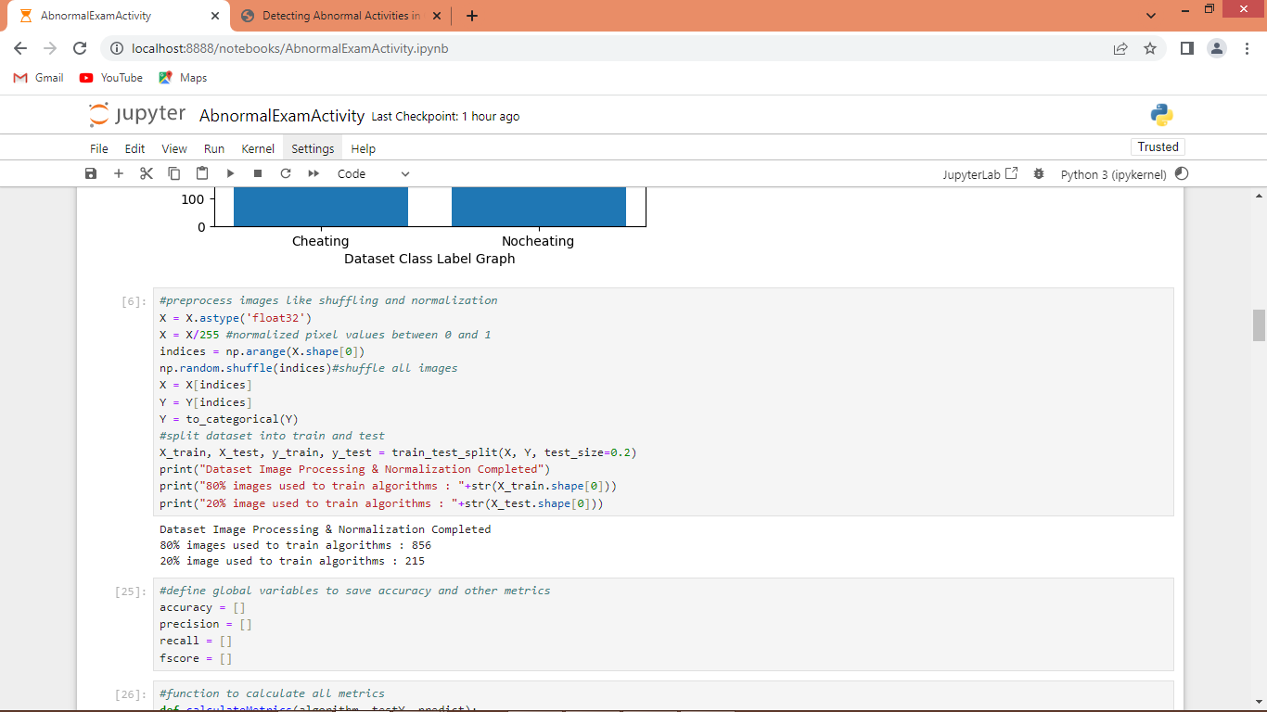

In above screen applying image processing techniques such as shuffling, normalization and splitting to train and test

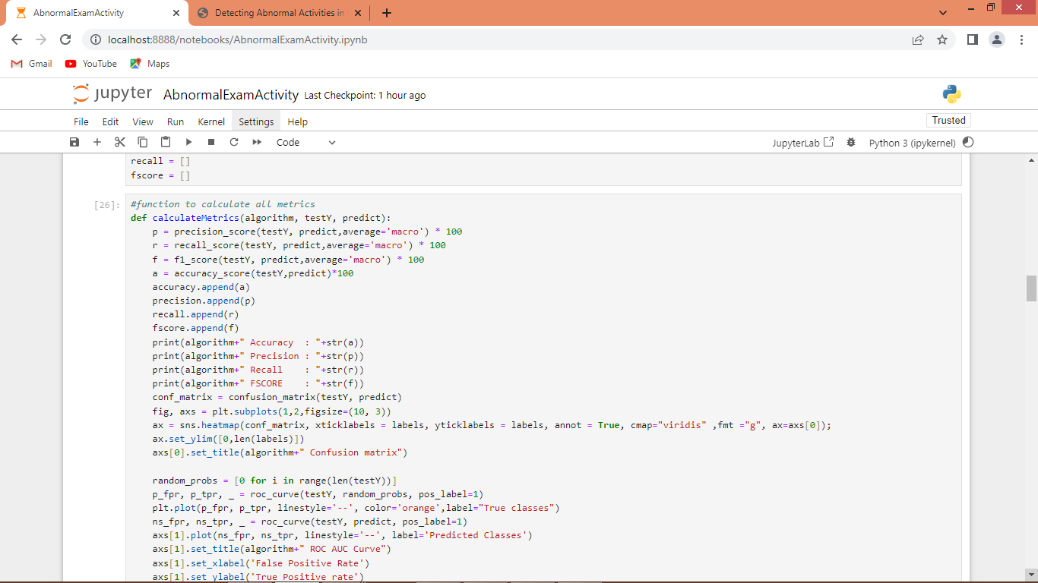

In above screen defining function to calculate accuracy and other metrics

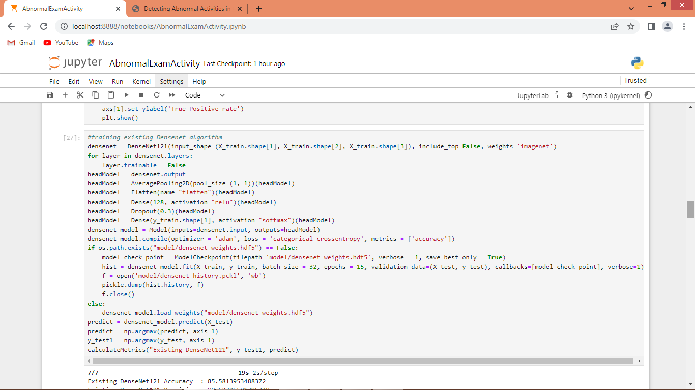

In above screen training existing DenseNet121 algorithm and after executing this block will get below output

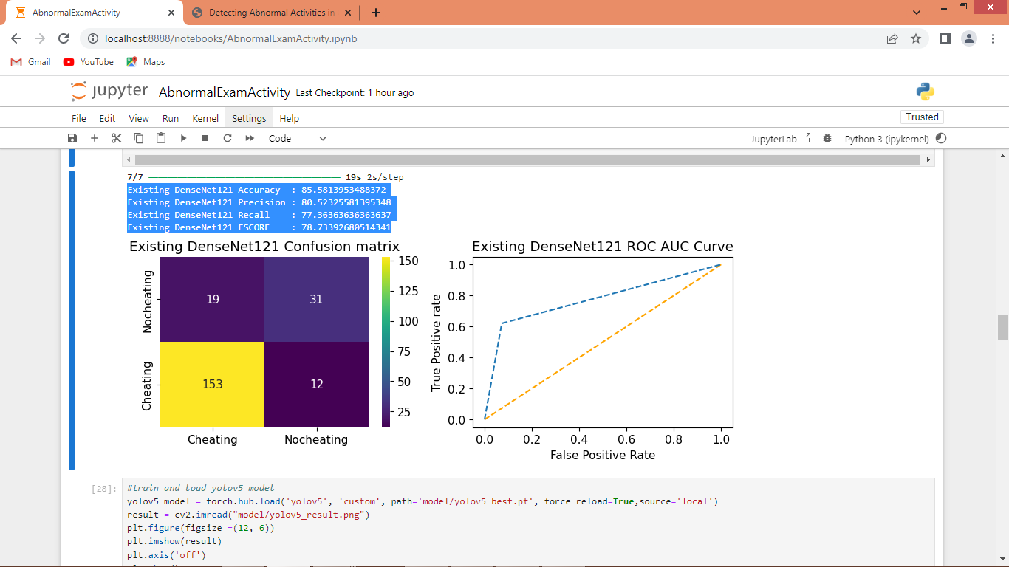

In above screen DenseNet121 got accuracy as 85% and can see other metrics like precision, recall and FSCORE. In confusion matrix graph x-axis represents Predicted Labels and y-axis represents True Label and then yellow and light blue box in diagonal represents correct prediction count and dark blue boxes represents incorrect prediction count. In ROC graph x-axis represents False Positive Rate and y-axis represents True Positive Rate and if blue line comes on top of orange line then predictions are correct and if goes below orange line then predictions are incorrect.

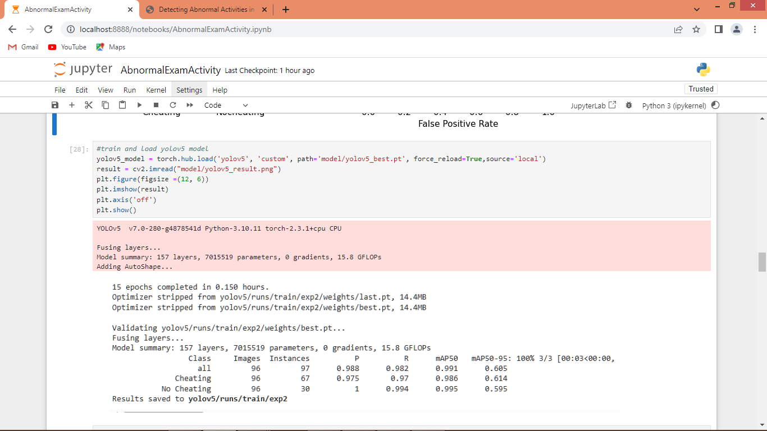

In above screen training and loading YoloV5 and then in output can see all classes precision, recall and MAP values are more than 97%

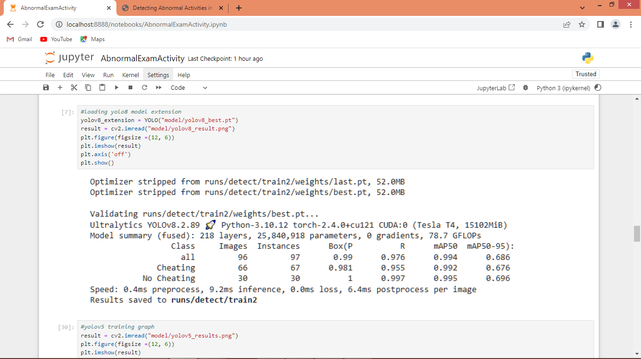

In above screen training and loading Yolov8 algorithm performance and then in output can see maximum classes got more than 99% precision, recall and MAP.

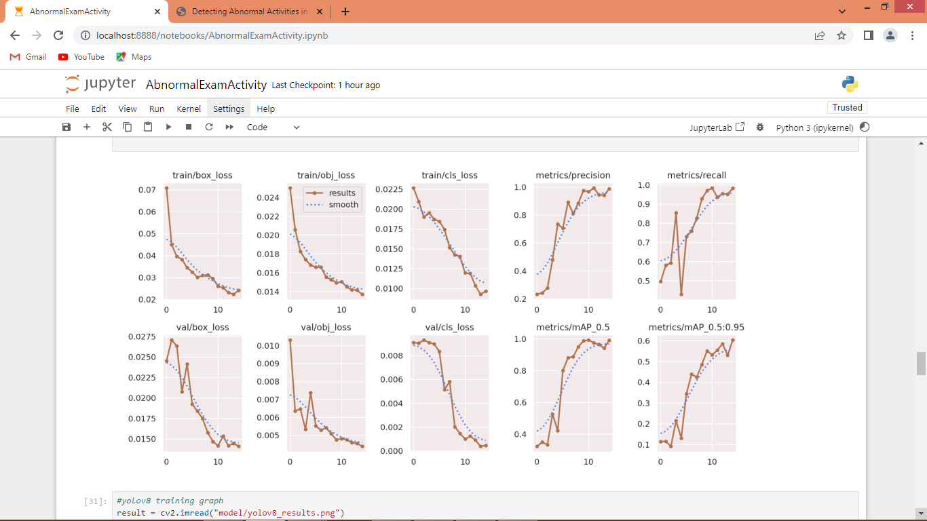

In above screen can see YoloV5 training performance graph where loss values decrease in each epoch and reached closer to 0 and then all precision, recall and MAP values goes closer to 1.

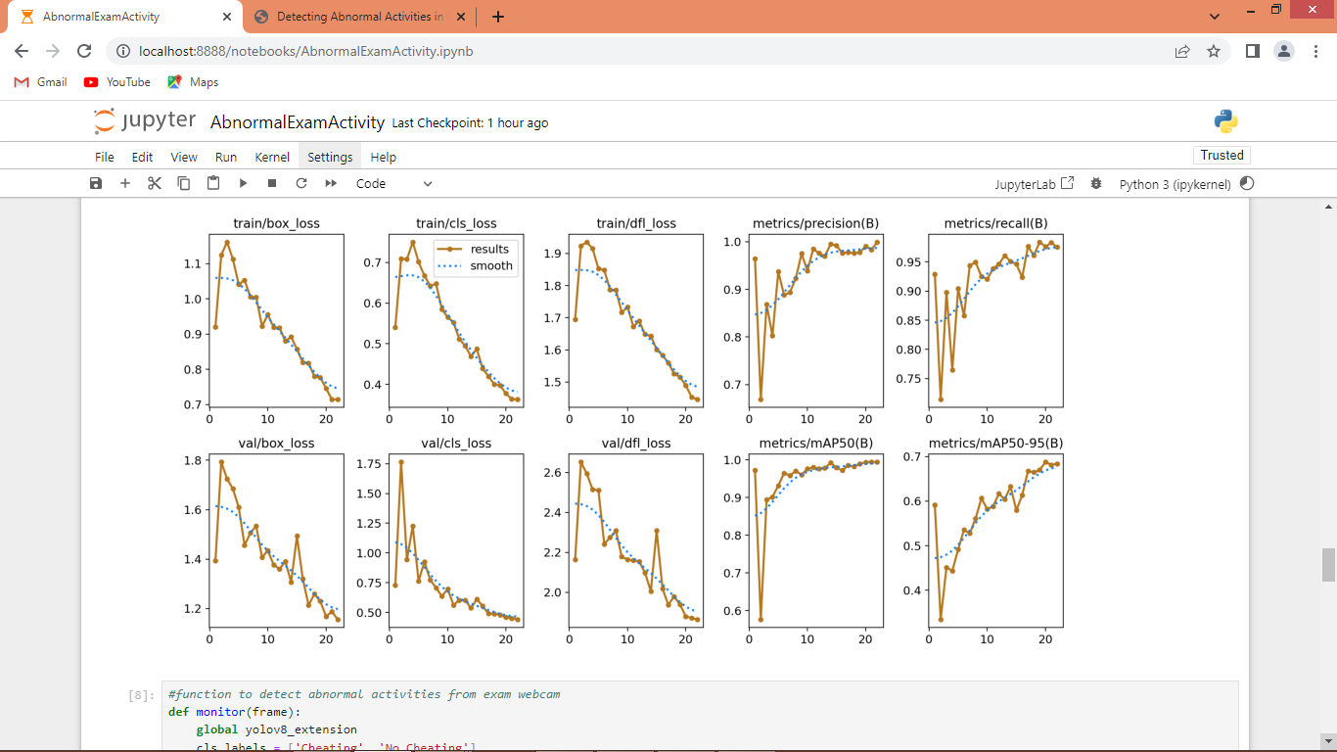

In above screen can see Yolov8 training performance graph

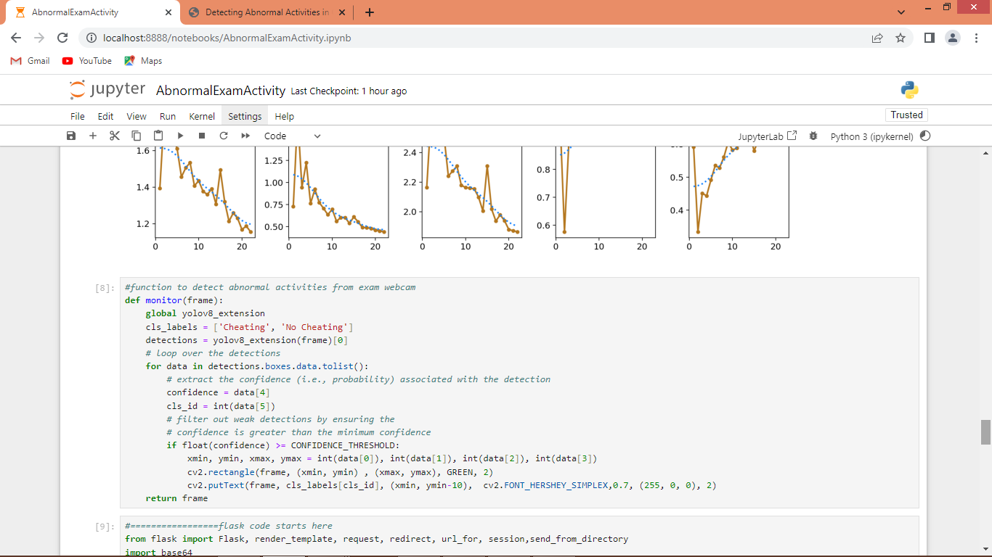

In above screen from webcam reading each frame and then applying Yolov8 extension model to detect abnormal activity

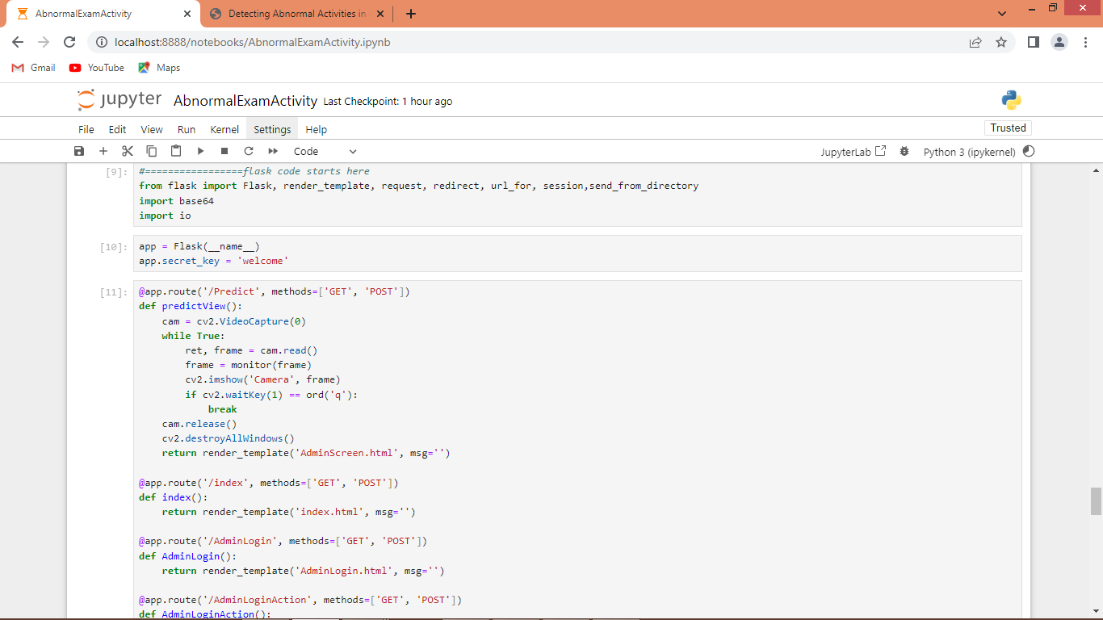

In above screen defining flask code and after running all blocks then flask server will be started and now open browser and enter URL as <http://127.0.0.1:5000/index> and press enter key to get below page

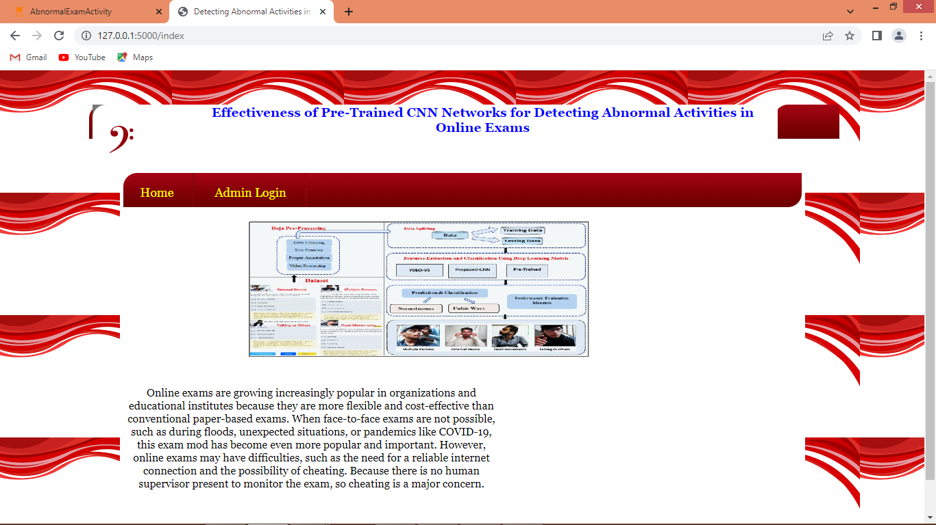

In above screen click on ‘Admin Login’ link to get below page

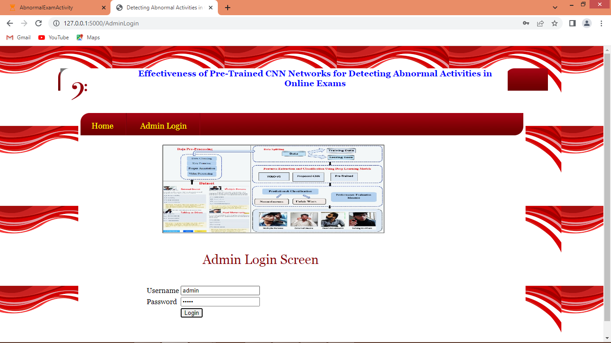

In above screen admin is login and after login will get below page

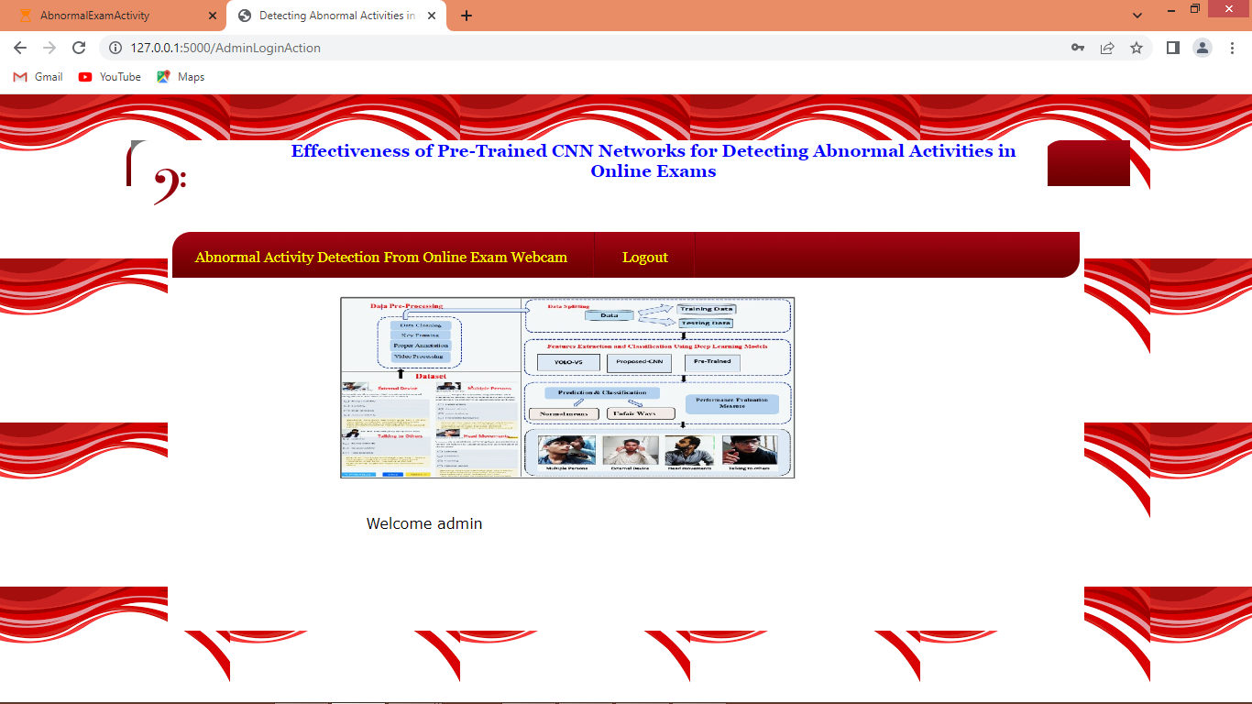

In above screen click on ‘Abnormal Activity Detection’ link to start webcam and monitor activities from person behaviour

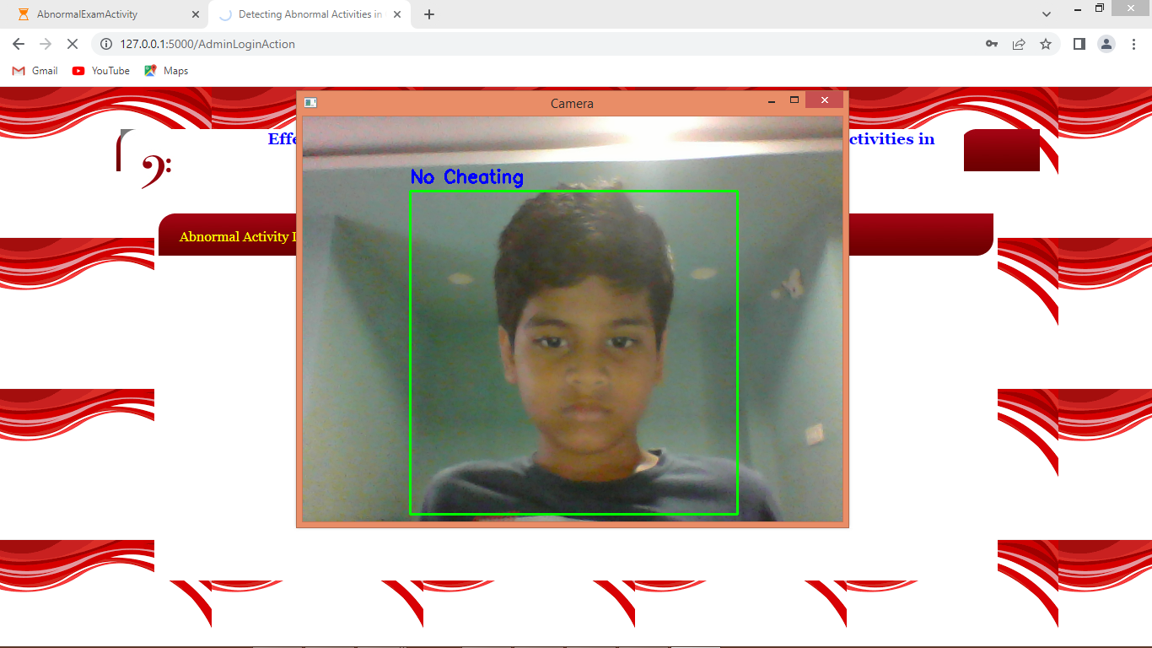

In above screen if student saw in front direction of webcam and complete exam then it will be consider as ‘No Cheating’

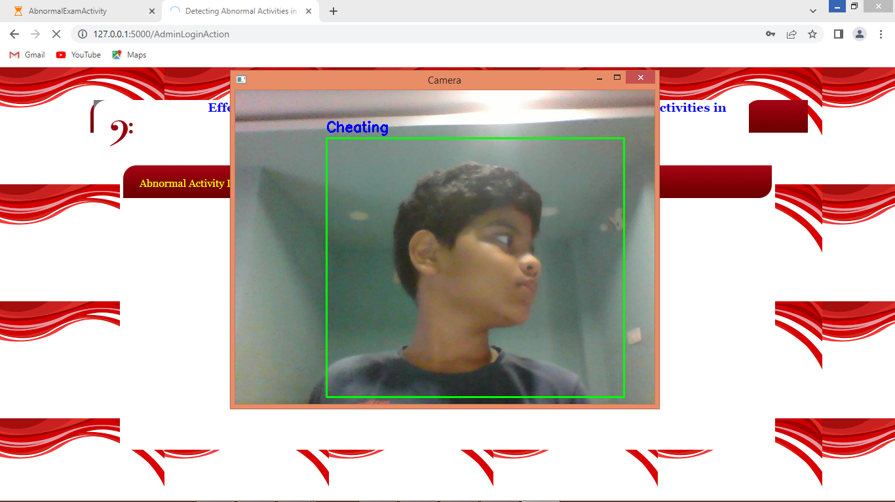

Is student saw here and there like left or right then Yolov8 will detect as ‘Cheating’.

Similarly by following above screens you can run code.

Note: we don’t have exact dataset and whatever dataset available on net is applied to build project