**Parth Kapur**

**HW2, 3 questions, 100 points**

Note: b denotes bits and B denotes Bytes (1 Byte = 8 bits).

**Question 1**: **32 points: (16)+(16)**

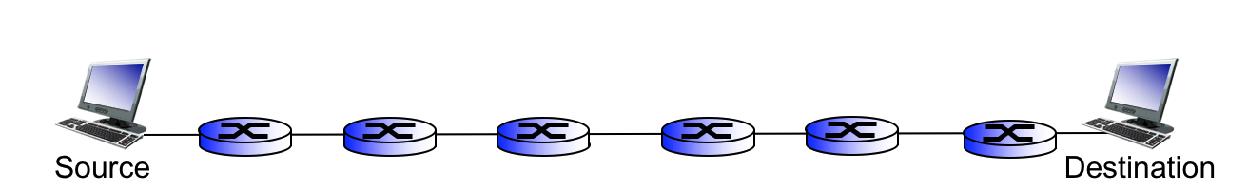

Consider a packet of length L, which begins at source and travels over seven links to a destination. These links are connected through six routers. Let di, si, and Ri denote the length, propagation speed, and the transmission rate of link i, for i = 1 to 7. The processing delay at each router is d-proc. The queuing delay at each router is d-que. What is the total end-to-end delay for the packet in terms of di, si, Ri (i = 1 to 7), and L?

**ANSWER:**

Dend-to-end = ∑i=1-7(L/Ri) + ∑i=1-7(di/si) + 6 (dproc) + 6(dqueue)

Now suppose, the packet is 2,500 Bytes, the propagation speed on all links is 2.5x108 m/s, the transmission rates of all links are 1.6 Mbps. The length of first and second links are 5,000 Km, the length of third, fourth, fifth and sixth links are 4,000 Km, and the length of seventh links is 1,000 Km. Processing delay in each router is 2 msec (mili-second) and queuing delay in each router is 7 msec. For these values, what is the end-to-end delay? Write down your calculations.

**ANSWER:**

Dtrans = 2500 bytes / 1.6 Mpbs = 20000 bits / 1.6 mpbs = 20 x 103 / 1.6 x 106 = 12.5 ms. Multiply 12.5 x 7 = **87.5 ms**

Link 1-2 Dprop = 2 x (50000 x 102 / 2.5 x 108 m/s) = 2 x 20000 microseconds = 40000 microseconds = **40 ms**

Link 3,4,5,6 Dprop = 4(40000 x 102 / 2.5 x 108) = 4 x 16000 microseconds = 64000 microseconds = **64 ms**

Link 7 Dprop = 1(10000 x 102/ 2.5 x 108) = 4000 microseconds = **4 ms**

Dproc = 2 ms x 6 links = **12 ms**

Dqueue = 7 ms x 6 links = **42 ms**

Dend-to-end = 87.5ms + (40ms + 64ms + 4 ms) + 12ms + 42ms = **249.5 ms**

**Question2:** **32 points: 2x(4+4+4+4)**

**Part1:**

For each of the following cases, calculate the latency (from first bit sent to the last bit received). Assume the bandwidth of each link is 2 Gbps, and the size of each packet is 120 Kb. Assume the length of each link is 40 meters, and propagation speed is 2*106 meters per second. There is no queuing or processing delay.

*a. If the source sends a message containing 1 packet and there are 2 routers on the path.*

*b. If the source sends a message containing 1 packet and there are 4 routers on the path.*

*c. If the source sends a message containing 10 packets and there are 2 routers on the path.*

*d. If the source sends a message containing 10 packets and there are 4 routers on the path.*

**Dtrans** = Packet Size / Bandwidth = 120 Kpbs / 2 Gpbs = **60 microseconds**

**Dprop** = Link Length / Prop Speed = (40 meters / 2 x 106 m/s) = **20 microseconds**

**Part 1a ANSWER:**

(60 microseconds + 20 microseconds) x 3 = **240 microseconds**

**Part 1b ANSWER:**

(60 microseconds + 20 microseconds) x 5 = **400 microseconds**

**Part 1c ANSWER:**

(# of packets – 1) x (dtrans) + (1 pkt)

= (10-1) x (60 microseconds) + 240 microseconds = **780 microseconds**

**Part 1d ANSWER:**

(# of packets – 1) x (dtrans) + (1 pkt)

= (10-1) x (60 microseconds) + 400 microseconds = **940 microseconds**

**Part2:**

Now keep all assumptions from part1 except processing delay. Assume each router begins retransmitting a packet after it has finished receiving the packet and processed it for 4 microseconds (d-proc = 4 μs). Processing delay is zero at source. Solve the problem for each of the 4 above-mentioned cases with this assumption.

**Part 2a ANSWER:**

(60 microseconds + 20 microseconds) + (60 microseconds + 20 microseconds + 4 microseconds) + (60 microseconds + 20 microseconds + 4 microseconds) = **248 microseconds**

**Part 2b ANSWER:**

(60 microseconds + 20 microseconds) + (60 microseconds + 20 microseconds + 4 microseconds) + (60 microseconds + 20 microseconds + 4 microseconds) + (60 microseconds + 20 microseconds + 4 microseconds) + (60 microseconds + 20 microseconds + 4 microseconds) = **416 microseconds**

**Part 2c ANSWER:**

(# of packets -1) x (dtrans) + (1 pkt + proc delay)

= (10-1) x (60 microseconds) + (248 microseconds) = **788 microseconds**

**Parth 2d ANSWER:**

= 9 x 60 microseconds + 416 microseconds = 540 + 416 = **956 microseconds**

**Notes:**

1. Refer to lecture3, slides 9 and 15, end-to-end delay for a message containing several packets.
2. When a node transmits a packet, it doesn’t need to wait for the last packet to be propagated along the link. As soon as one packet is transmitted into the link, the node can start transmitting the next packet.

**Question3:** **36 points: (6+6+6) + (6+6+6)**

For this question, use the following topology. All links are 300 meters long. Propagation speed is 2x108 m/s. Transmission rates of links R3-R4, R4-R5 and R5-R6 are 8 Gbps. Transmission rates of all other links are 0.5 Gbps. There are 3 sources of traffic in this network Src1, Src2, Src3: 1) Src1 generates packets of size 3 Kb and transmits them to Dst1, 2) Src2 generates packets of size 6 Kb and transmits them to Dst2, 3) Src3 generates packets of size 3 Kb and transmits them to Dst3. Assume only these three traffics are available in the network. Each of the shared links R3-R4, R4-R5 and R5-R6 divides its bandwidth between three traffics based on the amount of traffic generated at each source. For instance, Src1 uses 2 Gbps of the bandwidth on each of these shared links. It is calculated as follows:

$\frac{3Kb}{\left(3+6+3\right)Kb}$* 8 Gbps = 2Gbps

Therefore, the network is like three separate flows of traffics where each traffic uses a fixed portion of the shared links bandwidths all the time. Assume there is no processing or queuing delay. Calculate the end-to-end **delay** for each of three traffics in the following cases.

*a. Each of the 3 sources of traffic generates a message containing 1 packet.*

*b. Each of the 3 sources of traffic generates a message containing 200 packets.*

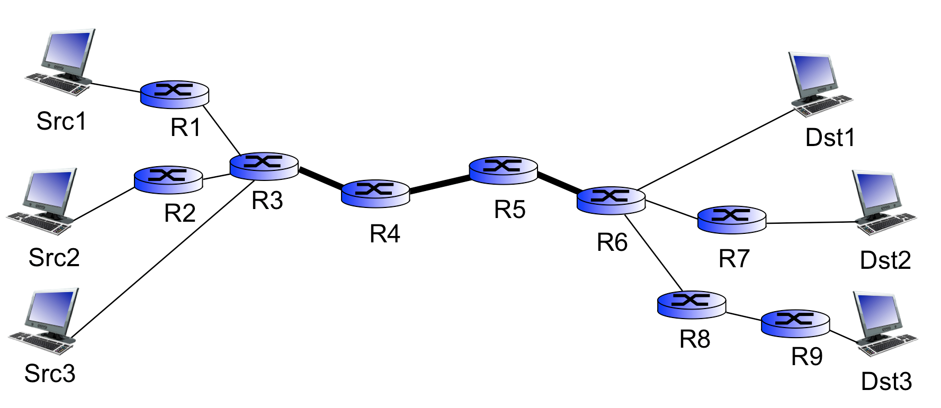

**Notes:**

1. Refer to lecture3, slides 9 and 15, end-to-end delay for a message containing several packets.
2. When a node transmits a packet, it doesn’t need to wait for the last packet to be propagated along the link. As soon as one packet is transmitted into the link, the node can start transmitting the next packet.

**Question 3 Part A Answer:**

**Dprop =**  (300m/2 x 108 m/s) = **1.5 microseconds**

Src1 Bandwidth on R3-R4 & R4-R5 = (3/(3+6+3)) x 8 Gbps = **2 Gbps**

Src2 Bandwidth on R3-R4 & R4-R5 = (6/(3+6+3) x 8 Gbps = **4 Gpbs**

Src3 Bandwidth on R3-R4 & R4-R5 = (3/(3+6+3) x 8 Gbps = **2 Gbps**

**Src1 Total Delay**:

(3Kb/0.5 Gbps + 1.5 microseconds) x 3 + (3Kb/2Gbps + 1.5 microseconds) x 3 = **31.5 microseconds**

**Src2 Total Delay:**

(6 Kb / 0.5 Gpbs + 1.5 microseconds) x 4 + (6 Kb/4 Gbps + 1.5 microseconds) x 3 = **63 microseconds**

**Src3 Total Delay:**

(3 Kb/0.5 Gpbs + 1.5 microseconds) x 4 + (3KB/2 Gbps + 1.5 microseconds) x 3 = **39 microseconds**

**Question 3 Part B Answer:**

**Src1 Total Delay:**

199 x (3 Kb/0.5 Gbps) + 31.5 microseconds = **1225.5 microseconds**

**Src2 Total Delay:**

199 x (6 Kb/0.5 Gbps) + 63 microseconds = **2451 microseconds**

**Src3 Total Delay:**

199 x (3 Kb/0.5 Gbps) + 39 microseconds = **1233 microseconds**