Parth Kapur

CS441

5/1/2019

**Assignment 5 Report**

**URL to group repository:** <https://github.com/kapur002/rideshare>

1. Create a GitHub repository for your CS 441 class project, and add all the team members as collaborators. Note: only one member of each group needs to perform this step.

**Status: Completed. Added repository called rideshare**.

2. Go to your email box linked to your GitHub account, and accept the collaboration request.

**Status: Accepted**.

3. Open GitHub Desktop, login to your account, and clone the repository from the shared project repository. Include a screenshot of your local (private) repository.

**Status: Completed. Cloned Repository – see attached picture.**

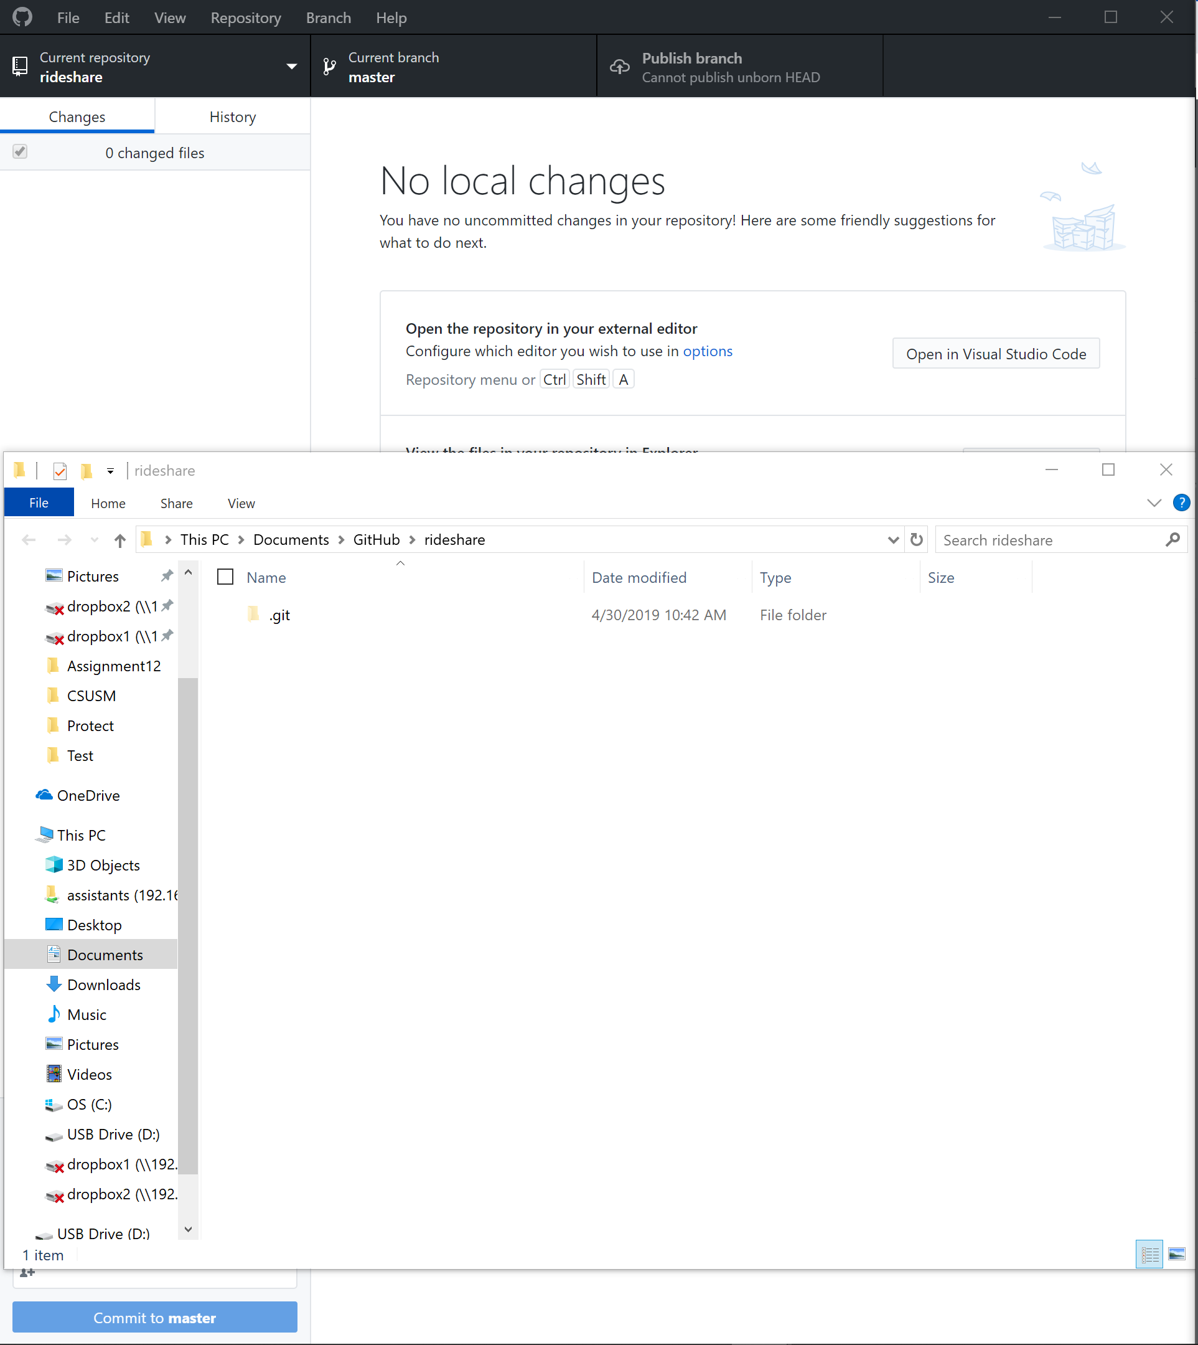

4. Create a new local branch and use your first name as the Branch name. Push this branch to the shared project repository. Include a screenshot of the shared project that lists the branches of all the team members.

**Status: Completed**. **Branches: Parth, Seren, Thomas** **created**.

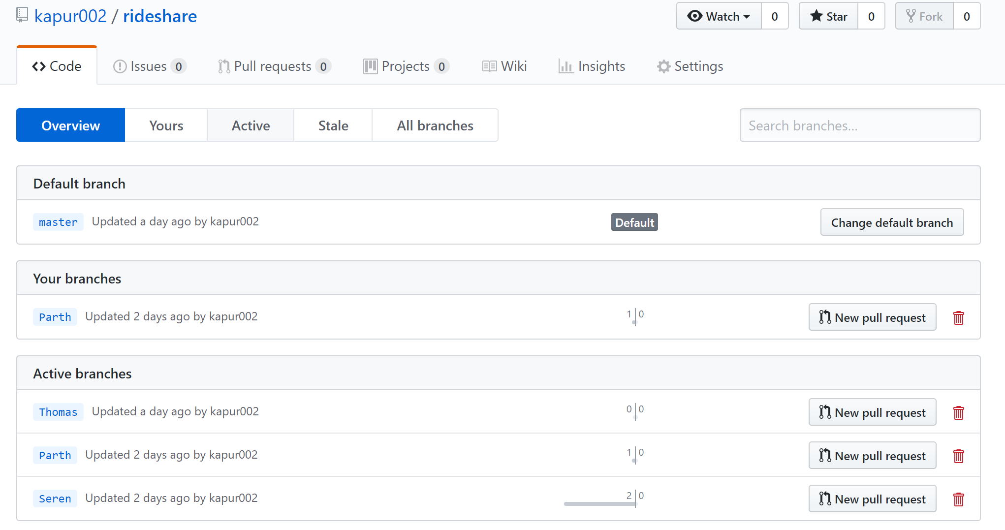

5. Merge your new branch into your Master branch. Create a situation where there is a conflict between your Master branch and the new branch you just created. Resolve the conflict and finish the merging process. Include a screenshot that shows the conflict occurs and another screenshot that shows the conflict has been resolved.

**Status: Showing Conflict – Made Edits to Line 1 in Master Branch as well as Line 1 in Parth Branch.**

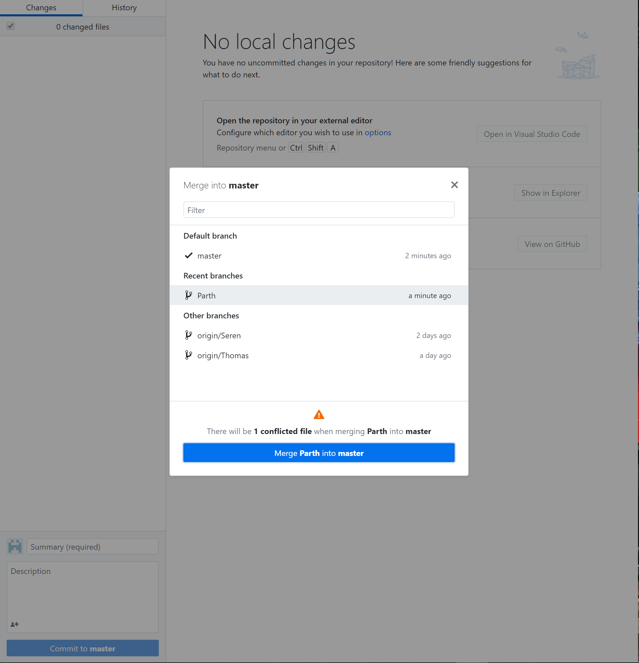

**Status: Resolving Conflict – Choosing which edit remains & which edit will not remain. I chose to accept incoming change to resolve the conflict. This means that the Parth branch edit will replace Master branch edit on the same line #. I then committed the merge and pushed the merge to remote repository.**

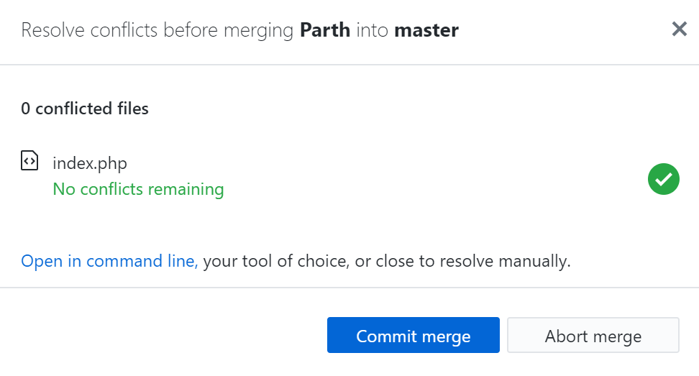

6. Push your Master branch to the shared project branch. Collaborate with your teammates so that a conflict occurs when you push. Resolve your conflicts and push again. Include a screenshot that shows a conflict occurs and another screenshot that shows the conflict has been resolved.

**Status**: **Showing Conflict – Made Edits to the Last Line. Thomas made edits to Last Line of file as well.**

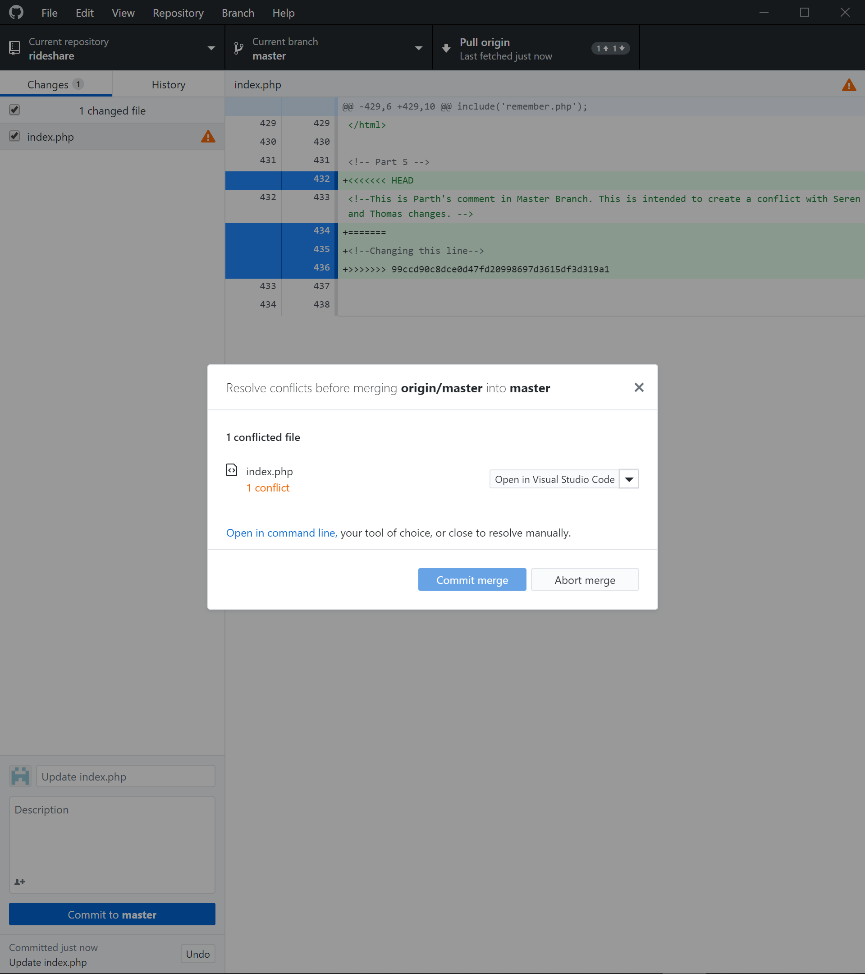

**Status: Resolving Conflicts – Accept incoming change to resolve conflict. Merge succeeded & pushed.**

