Assignment 2

CS443 hadaegh

Parth Kapur

Spring 2018

### CS443 Assignment 2

# Question 1

You are given a task to create a Database for Holiday Inn. Here is some of the information you have.

HOTEL

**hNum:** It is a unique id assigned to each hotel

**hNoOfRooms:** Number of rooms in a hotel

**hPhone:** It is the hotel phone number

**hAdd:** It is the hotel address

ROOM

**rNum:** It is the room number in a hotel

**rRate:** It is the rate of a room in a hotel per night

**rSize:** It is an integer to indicate the size of the room (ex: 2 means two bedroom)

**rOccupied:** It has a value of True or False to indicate if the room is occupied in a hotel

**rLoc:** It refers to the location of a room in a hotel (ex: 2 means second-floor)

MANAGER

**mId:** It is the emp id of the hotel manager

**mName:** It refers to the name of the manager who manages the hotel

**mAdd:** It refers to the address of the manager

**mPhone:** It is the personal cell phone number of the manager (not the hotel phone Num)

**mEmail:** It is the email of the manager

**mSal:** It is the salary of the manager

CARETAKER

**ctId:** It is the emp id of the hotel care taker

**ctName:** It is the name of the caretaker who takes care of the maintenance of a hotel

**ctAdd:** It refers to address of the caretaker

**ctPhone:** It is the personal cell phone number of the caretaker

**ctEmail:** It refers to email of the caretaker

**ctSal:** It is the salary of the caretaker

CUSTOMER

**cNum:** It is the customer number of a customer who is staying in a hotel

**cSSN:** It is the SSN of the customer

**cName:** It is the name of the customer

**cCreditCart:** It is the credit cart number of the customer

**cAdd:** It is the personal address of the customer

**cStartDate:** It indicates the date when the customer has checked in

**cEndDate:** It indicates the date the customer checks out.

**cAmtOwing:** It is the amount the customer owes to the hotel

**Assumptions:**

* Since you are creating this database for the Holiday Inn Hotel, you do not have to give any name to a specific hotel. They are all called Holiday Inn. Holiday Inn has several branches in North America. Each branch is uniquely identified by its “hNum”. In fact “hNum” attribute refers to the branch number of the hotel
* Each manager may manage more than one branch of the Holiday Inn, but each hotel is managed by only 1 manager
* Each customer can stay in one hotel and can only be given one room in that hotel
* Each caretaker works for only one hotel but a hotel can have many caretakers.
* Rooms in a particular hotel are unique but may not be unique across all branches. For example, branch 10 has only one room with room number 100 but branch 20 may also have a room number 100. These rooms may be completely different in terms of size, rate, etc.

1. Draw your ERD based on the above assumptions and data

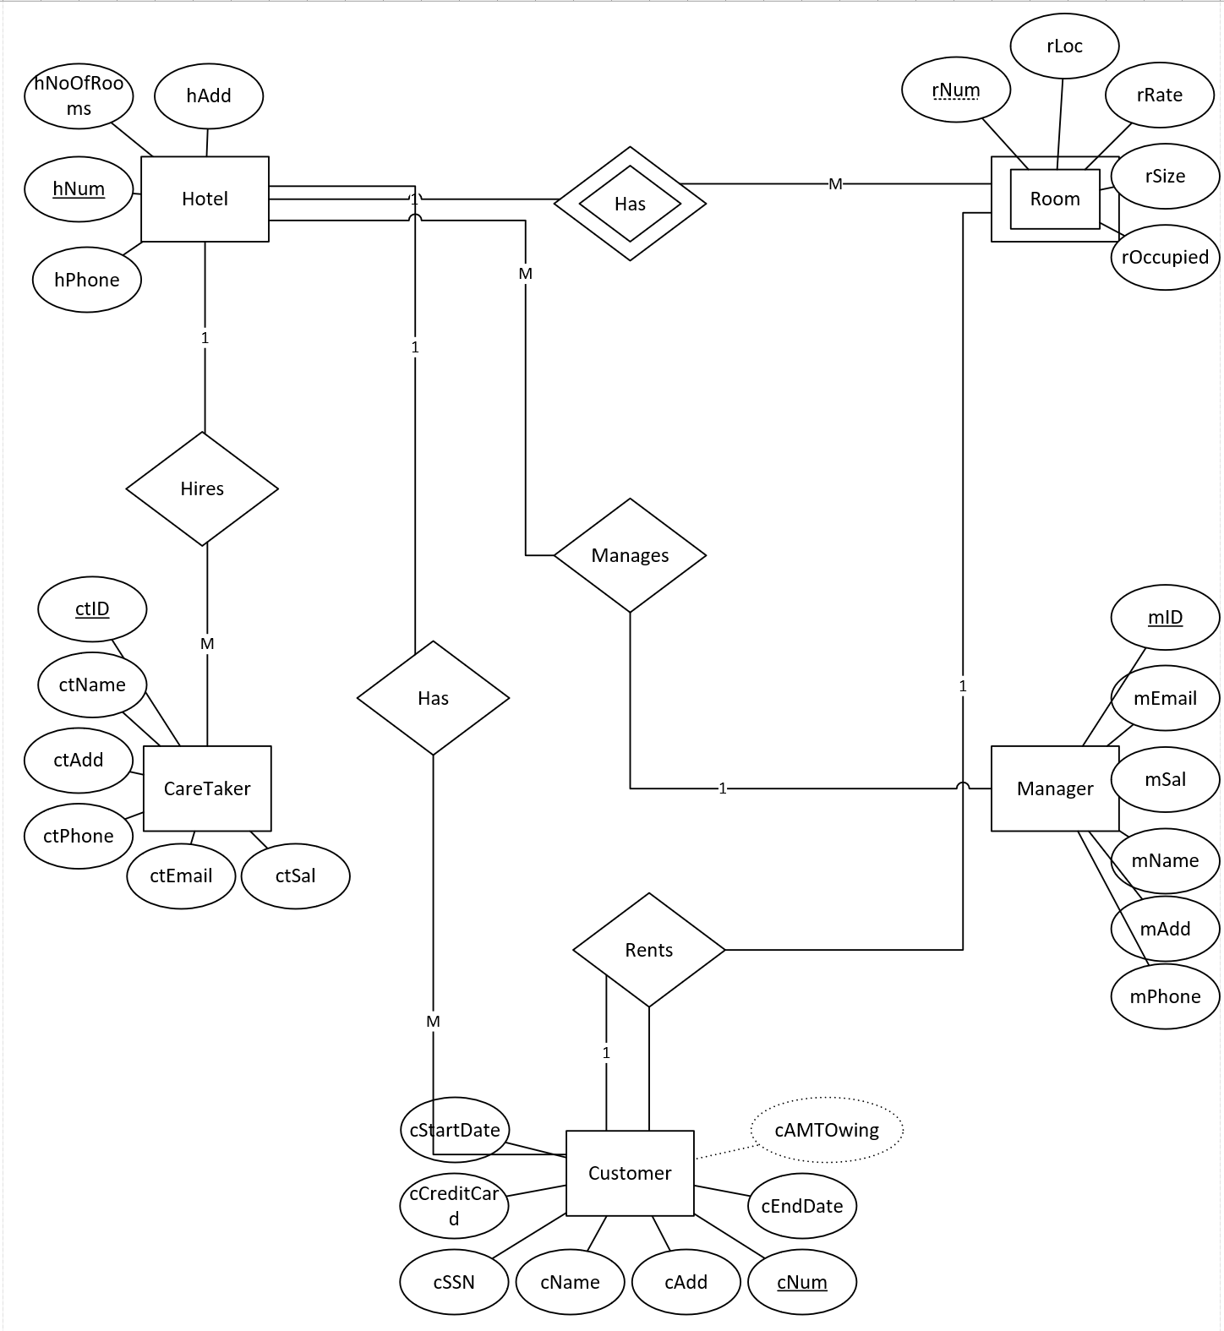

1. Draw tables from the initial ERD and normalize them. Place all tables in 3rd normal form (if necessary)

**Hotel(hNum, hAdd, hPhone, hNoOfRooms, mID)**

**Room(rNum, hNum, rLoc, rRate, rOccupied, rSize)**

**Manager(mID, mAdd, mEmail, mPhone, mSal, mName)**

**CareTaker(ctID, ctEmail, ctSal, ctPhone, ctName, ctAdd, hNum)**

**Customer(cNum, cAdd, cName, cEndDate, cSSN,cCreditCard, cStartDate, hNum, rNum)**

1. Revise your ERD (if necessary)

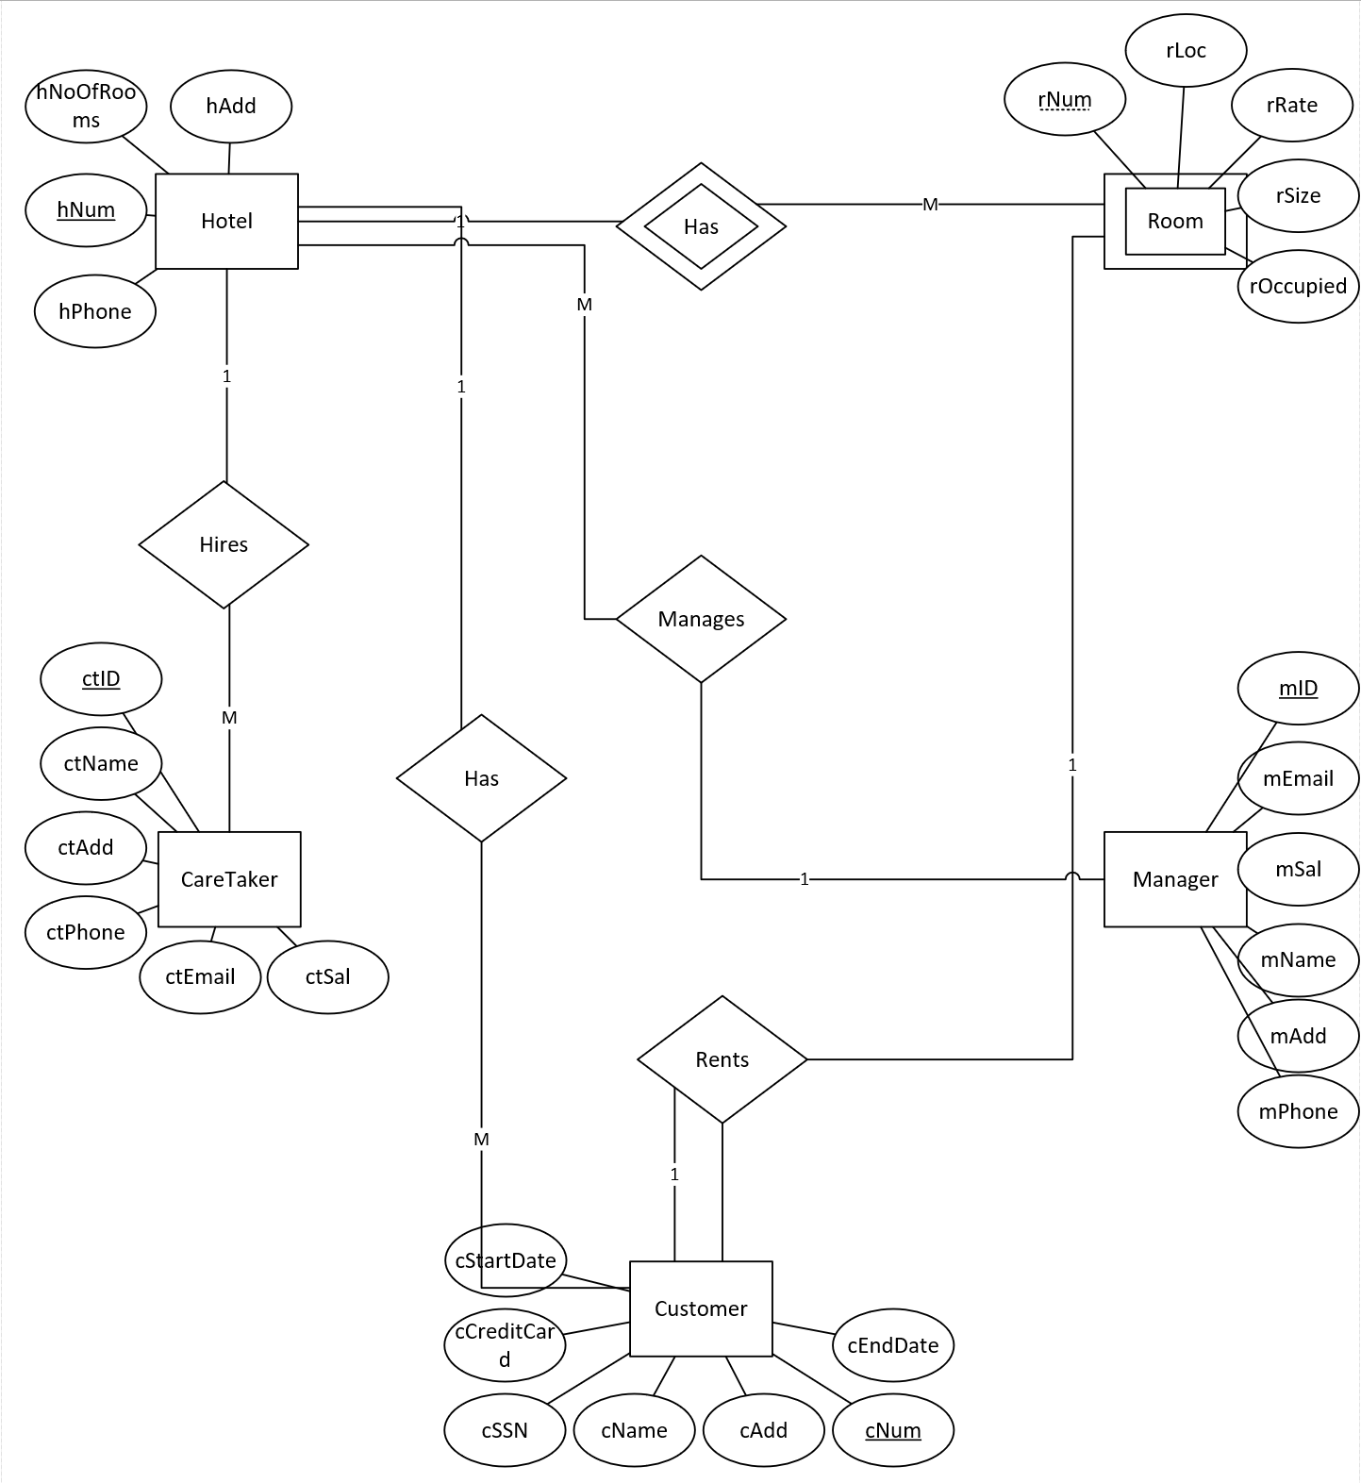

1. Create your tables based on the given types and restrictions using the following rules:
   1. Create all table primary key constraints on the Create Table statement. Add all Foreign Key constraints after all tables have been created using the ‘Alter Table’ statement.
   2. Beside the constraint you use for the primary and foreign keys, add the following constraints (on the Create Table statement):

**hNoOfRooms:** > 0 and <= 200

**Phone: unique and should be >= ‘2202222’ and <= ‘9909999’**

**rNum:** > 0 and <= 200

**rRate:** >= 50

**rSize:** >= 2 and <= 4

**rOccupied:** = ‘false’ or = ‘true’

**rLoc:** > 0 and <= 100

**mId:** >= 111111 <= 999999

**mPhone:** >= ‘2222222’ and <= ‘9999999’

**ctId:** >= 111111 <= 999999

**ctPhone**: >= ‘2222222’ and <= ‘9999999’

**ctSal:** > 20000 and < 40000

**cSSN:** unique and > ‘660000000’ and <= ‘609999999’

|  |  |  |
| --- | --- | --- |
| Data Item (Column Name) | Type | Size |
| hNum | Integer |  |
| hNoOfRooms | Integer |  |
| hPhone | Fixed Character | 7 |
| hAdd | Character | Up to 50 |
| rNum | Integer |  |
| rRate | Decimal | 5 with 2 decimals |
| rSize | Integer |  |
| rOccupied | Fixed Character | 5 |
| rLoc | Integer |  |
| mId | Integer |  |
| mName | Character | Up to 50 |
| mAdd | Character | Up to 50 |
| mPhone | Fixed Character | 7 |
| New: mEmail | Character | Up to 100 |
| mSal | Decimal | 7 with 2 decimals |
| ctId | Integer |  |
| ctName | Character | Up to 50 |
| ctAdd | Character | Up to 50 |
| ctPhone | Fixed Character | 7 |
| ctEmail | Character | Up to 200 |
| ctSal | Decimal | 7 with 2 decimals |
| cNum | Integer |  |
| cSSN | Fixed Character | 9 |
| cName | Character | Up to 50 |
| cCreditCart | Character | Up to 25 |
| cAdd | Character | Up to 50 |
| cStartDate | DATE |  |
| cEndDate | DATE |  |
| New: cAmtOwing | Decimal | 7 with 1 decimals |

**ANS:**

**CREATE TABLE HOTEL**

**(**

**hNum NUMBER,**

**hNoOfRooms NUMBER,**

**hPhone CHAR(7),**

**hAdd VARCHAR2(50),**

**mID NUMBER,**

**CONSTRAINT hNum_PK PRIMARY KEY(hNum),**

**CONSTRAINT hNoOfRooms_CK CHECK (hNoOfRooms > 0 AND hNoOfRooms <= 200),**

**CONSTRAINT hPhone_unique UNIQUE(hPhone),**

**CONSTRAINT hPhone_CK CHECK (hPhone >= '2202222' AND hPhone <= '9909999')**

**);**

**CREATE TABLE ROOM**

**(**

**rNum NUMBER,**

**rRate NUMBER(5,2),**

**rSize NUMBER,**

**rOccupied CHAR(5),**

**rLoc NUMBER,**

**hNum NUMBER,**

**CONSTRAINT rNum_PK PRIMARY KEY(rNum, hNum),**

**CONSTRAINT rNum_CK CHECK (rNum < 0 AND rNum <= 200),**

**CONSTRAINT rRate_CK CHECK (rRate >= 50),**

**CONSTRAINT rSize_CK CHECK (rSize >= 2 AND rSize <=4),**

**CONSTRAINT rOccupied_CK CHECK (rOccupied = 'false' OR rOccupied = 'true'),**

**CONSTRAINT rLoc_CK CHECK (rLoc > 0 AND rLoc <= 100)**

**);**

**CREATE TABLE MANAGER**

**(**

**mId NUMBER,**

**mName VARCHAR2(50),**

**mAdd VARCHAR2(50),**

**mPhone CHAR(7),**

**mEmail VARCHAR2(100),**

**mSal NUMBER(7,2),**

**CONSTRAINT mId_PK PRIMARY KEY (mID),**

**CONSTRAINT mID_CK CHECK (mID >= 111111 AND mID <= 9999999),**

**CONSTRAINT mPhone_CK CHECK (mPhone >= 2222222 AND mPhone <= 9999999)**

**);**

**CREATE TABLE CARETAKER**

**(**

**ctId NUMBER,**

**ctName VARCHAR2(50),**

**ctAdd VARCHAR2(50),**

**ctPhone CHAR(7),**

**ctEmail VARCHAR2(200),**

**ctSal NUMBER(7,2),**

**hNum NUMBER,**

**CONSTRAINT ctID_PK PRIMARY KEY (ctID),**

**CONSTRAINT ctId_CK CHECK (ctId >= 111111 AND ctId <= 999999),**

**CONSTRAINT ctPhone_CK CHECK (ctPhone >= 2222222 AND ctPhone <= 9999999),**

**CONSTRAINT ctSal_CK CHECK (ctSal > 20000 AND ctSal < 40000)**

**);**

**CREATE TABLE CUSTOMER**

**(**

**cNum NUMBER,**

**cSSN CHAR(9),**

**cName VARCHAR2(50),**

**cCreditCart VARCHAR2(25),**

**cAdd VARCHAR2(50),**

**cStartDate DATE,**

**cEndDate DATE,**

**hNum NUMBER,**

**rNum NUMBER,**

**CONSTRAINT cNum_PK PRIMARY KEY (cNum),**

**CONSTRAINT cSSN_Unique UNIQUE (cSSN),**

**CONSTRAINT cSSN_CK CHECK (cSSN >= '660000000' AND cSSN <= '609999999')**

**);**

**ALTER TABLE HOTEL ADD CONSTRAINT mID_H_FK FOREIGN KEY (mID) REFERENCES MANAGER(mID);**

**ALTER TABLE ROOM ADD CONSTRAINT hNum_R_FK FOREIGN KEY (hNUM) REFERENCES HOTEL(hNum);**

**ALTER TABLE CARETAKER ADD CONSTRAINT hNum_CT_FK FOREIGN KEY (hNum) REFERENCES HOTEL(hNum);**

**ALTER TABLE CUSTOMER ADD CONSTRAINT hNum_CUST_FK FOREIGN KEY (rNum, hNum) REFERENCES ROOM(rNum, hNum);**

**ALTER TABLE CUSTOMER ADD CONSTRAINT hNum_CUST_FKTWO FOREIGN KEY (hNUM) REFERENCES Hotel(hNum);**

**Question 2:**

Do the following SQL questions. The resulting columns must all have descriptive names

1. Write a select statement to list all the columns from the Offices table. 'Select *' is not allowed. Return the list in Office order.

**SELECT OFFICE, CITY, REGION, MGR, TARGET, SALES**

**FROM OFFICES**

**ORDER BY OFFICE;**

OFFICE CITY REGION MGR TARGET SALES

---------- --------------- ---------- ---------- ---------- ----------

11 New York Eastern 106 575000 692637

12 Chicago Eastern 104 800000 735042

13 Atlanta Eastern 105 350000 367911

21 Los Angeles Western 108 725000 835915

22 Denver Western 108 300000 186042

SE

1. List the Product Name (its description), and dollar value of quantity on hand (price * quantity) . Return the list in descending order by value.

**SELECT DESCRIPTION, PRICE*QTY_ON_HAND "DLR VALUE OF QTY ON HND"**

**FROM PRODUCTS**

**ORDER BY "DLR VALUE OF QTY ON HND" DESC;**

**DESCRIPTION DLR VALUE OF QTY ON HND**

**-------------------- ---------------------------------------**

**WIDGET INSTALLER 70000**

**WIDGET REMOVER 68750**

**RIGHT HINGE 54000**

**LEFT HINGE 54000**

**300-LB BRACE 27300**

**REDUCER 27202**

**SIZE 3 WIDGET 22149**

**RETAINER 17550**

**HOUSING 17020**

**900-LB BRACE 16875**

**RATCHET LINK 16590**

**DESCRIPTION DLR VALUE OF QTY ON HND**

**-------------------- ---------------------------------------**

**SIZE 4 WIDGET 16263**

**SIZE 1 WIDGET 15235**

**BRACE RETAINER 15200**

**REDUCER 13490**

**SIZE 2 WIDGET 12692**

**BRACE HOLDER 12042**

**500-LB BRACE 7125**

**REDUCER 6549**

**BRACE PIN 6000**

**HINGE PIN 4900**

**MOTOR MOUNT 3645**

**DESCRIPTION DLR VALUE OF QTY ON HND**

**-------------------- ---------------------------------------**

**HANDLE 1956**

**WIDGET ADJUSTER 925**

**PLATE 0**

**25 rows selected**

1. List the Order Number, Order Date, Customer Number and Sales Rep Number for orders for part 'XK47' or '775C'. (Use a compound search condition - OR.)

**SELECT ORDER_NUM, ORDER_DATE, CUST, REP**

**FROM ORDERS**

**WHERE PRODUCT = 'XK47' OR PRODUCT = '775C';**

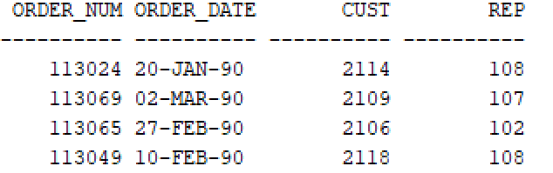SELE

1. List the Name and Age for all Sales Reps in the following offices: 12; 21; 13. (Use the set membership test - IN.)

**SELECT name, age**

**FROM salesreps**

**WHERE rep_office IN (12, 21, 13);**

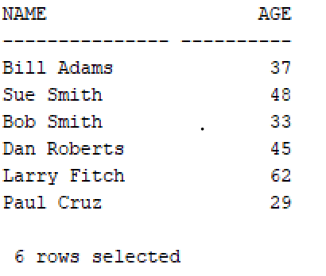

1. List the names of all Sales Reps who have the letter 'o' (this is lower case o) as the third character of their name.

**SELECT NAME**

**FROM SALESREPS**

**WHERE NAME LIKE '__o%';**



1. Return the Sales Rep ID and Name of any Sales Rep not assigned to an office yet.

**SELECT EMPL_NUM, NAME**

**FROM SALESREPS**

**WHERE REP_OFFICE IS NULL;**

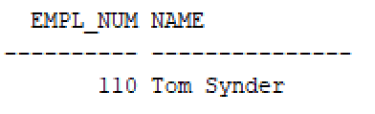

1. Show all the sales rep names with last name “Smith”.

**SELECT name**

**FROM salesreps**

**WHERE name LIKE '% Smith';**

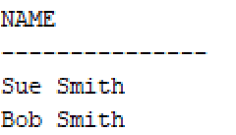

1. List different titles in the sales reps table. Only list each title once and unknown titles should be ignored.

**SELECT DISTINCT title**

**FROM salesreps**

**WHERE title IS NOT NULL;**

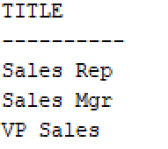

1. List the description of the products which are at least 6 character and less than or equal to 10 characters long. No duplicate row is allowed. You can use the build in function length() to do this. For example, length(name) return the number of characters for attribute called “name”.

**SELECT DISTINCT(description)**

**FROM products**

**WHERE length(description) >= 6 AND length(description) <= 10;**

**DESCRIPTION**

**--------------------**

**REDUCER**

**LEFT HINGE**

**HANDLE**

**HOUSING**

**HINGE PIN**

**BRACE PIN**

**RETAINER**

**7 rows selected**

1. List the the order nums with the name of the rep who placed the order and the name of the customer who made the order and the name of the rep for that customer

**SELECT ORDERS.ORDER_NUM, REPS.NAME, CUSTOMERS.COMPANY, CUSTREPS.NAME**

**FROM ORDERS, SALESREPS REPS, CUSTOMERS, SALESREPS CUSTREPS**

**WHERE**

**ORDERS.REP = REPS.EMPL_NUM**

**AND ORDERS.CUST = CUSTOMERS.CUST_NUM**

**AND CUSTREPS.EMPL_NUM = REPS.EMPL_NUM;**

**Result:**

ORDER_NUM NAME COMPANY NAME

---------- --------------- -------------------- ---------------

113057 Paul Cruz JCP Inc. Paul Cruz

112975 Paul Cruz JCP Inc. Paul Cruz

113012 Bill Adams JCP Inc. Bill Adams

112968 Dan Roberts First Corp. Dan Roberts

112983 Bill Adams Acme Mfg. Bill Adams

112963 Bill Adams Acme Mfg. Bill Adams

112987 Bill Adams Acme Mfg. Bill Adams

113027 Bill Adams Acme Mfg. Bill Adams

113034 Tom Synder Ace International Tom Synder

113036 Tom Synder Ace International Tom Synder

112989 Sam Clark Jones Mfg. Sam Clark

ORDER_NUM NAME COMPANY NAME

---------- --------------- -------------------- ---------------

113007 Larry Fitch Zetacorp Larry Fitch

113045 Larry Fitch Zetacorp Larry Fitch

112979 Sue Smith Orion Corp. Sue Smith

113024 Larry Fitch Orion Corp. Larry Fitch

112997 Nacy Angelli Peter Brothers Nacy Angelli

113062 Nacy Angelli Peter Brothers Nacy Angelli

113055 Dan Roberts Holm and Landis Dan Roberts

113058 Mary Jones Holm and Landis Mary Jones

113003 Mary Jones Holm and Landis Mary Jones

112961 Sam Clark J.P. Sinclair Sam Clark

113048 Sue Smith Rico Enterprises Sue Smith

ORDER_NUM NAME COMPANY NAME

---------- --------------- -------------------- ---------------

113065 Sue Smith Fred Lewis Corp. Sue Smith

112993 Sue Smith Fred Lewis Corp. Sue Smith

113051 Larry Fitch Midwest Systems Larry Fitch

112992 Larry Fitch Midwest Systems Larry Fitch

113013 Larry Fitch Midwest Systems Larry Fitch

113049 Larry Fitch Midwest Systems Larry Fitch

113042 Dan Roberts Ian and Schmidt Dan Roberts

113069 Nacy Angelli Chen Associates Nacy Angelli

30 rows selected

**Question 3:**

1. List the Mfr Id, the Product Id, Company and PRICE of all products brought by customers where customer number is one of (2112,2105,2119) and where the amount of the order < $5500.00. Order the results by ascending Company.

**QUERY:**

**SELECT MFR_ID, PRODUCT_ID, COMPANY, PRICE**

**FROM PRODUCTS, CUSTOMERS, ORDERS**

**WHERE CUST_NUM IN (2112, 2105, 2119)**

**AND ORDERS.AMOUNT < 5500**

**AND ORDERS.CUST = CUSTOMERS.CUST_NUM**

**AND ORDERS.PRODUCT = PRODUCTS.PRODUCT_ID**

**AND ORDERS.MFR = PRODUCTS.MFR_ID**

**ORDER BY COMPANY ASC;**

**RESULT:**

MFR PRODU COMPANY PRICE

--- ----- -------------------- ----------

IMM 773C Zetacorp 975

1. List all salesreps (id and names) and all orders (orderNumber) in which the salesrep is the company’s (i.e. the customer) rep (Cust Rep), but didn’t take the order. Order the result based on name in ascending order.

**Query:**

SELECT DISTINCT salesreps.empl_num, salesreps.name, orders.order_num

FROM salesreps, orders, customers

WHERE salesreps.empl_num = customers.cust_rep AND orders.rep != salesreps.empl_num

AND orders.cust = customers.cust_num

ORDER BY salesreps.name ASC;

**Result:**

**MFR PRODU COMPANY PRICE**

**--- ----- -------------------- ----------**

**IMM 773C Zetacorp 975**

**EMPL_NUM NAME ORDER_NUM**

**---------- --------------- ----------**

**104 Bob Smith 113042**

**109 Mary Jones 113055**

**103 Paul Cruz 113012**

**103 Paul Cruz 113069**

**102 Sue Smith 113024**

1. List all customers (Customer number, Company, and Credit Limit) and orders (Order Number, Amount) where the order is within $1000.00 of the Credit Limit (less than or equal to $1000). Sort the result by Customer number in descending order.

**SELECT DISTINCT customers.CUST_NUM, customers.COMPANY, customers.CREDIT_LIMIT, orders.ORDER_NUM, orders.AMOUNT**

**FROM orders, customers**

**WHERE ((orders.AMOUNT <= customers.CREDIT_LIMIT - 1000)) AND orders.cust = customers.cust_num**

**ORDER BY customers.CUST_NUM DESC;**

**RESULT:**

**CUST_NUM COMPANY CREDIT_LIMIT ORDER_NUM AMOUNT**

**---------- -------------------- ------------ ---------- ----------**

**2124 Peter Brothers 40000 112997 652**

**2124 Peter Brothers 40000 113062 2430**

**2120 Rico Enterprises 50000 113048 3750**

**2118 Midwest Systems 60000 112992 760**

**2118 Midwest Systems 60000 113051 1420**

**2118 Midwest Systems 60000 113049 776**

**2118 Midwest Systems 60000 113013 652**

**2117 J.P. Sinclair 35000 112961 31500**

**2114 Orion Corp. 20000 112979 15000**

**2114 Orion Corp. 20000 113024 7100**

**2112 Zetacorp 50000 113007 2925**

**CUST_NUM COMPANY CREDIT_LIMIT ORDER_NUM AMOUNT**

**---------- -------------------- ------------ ---------- ----------**

**2112 Zetacorp 50000 113045 45000**

**2111 JCP Inc. 50000 113012 3745**

**2111 JCP Inc. 50000 112975 2100**

**2111 JCP Inc. 50000 113057 600**

**2108 Holm and Landis 55000 113055 150**

**2108 Holm and Landis 55000 113058 1480**

**2108 Holm and Landis 55000 113003 5625**

**2107 Ace International 35000 113036 22500**

**2107 Ace International 35000 113034 632**

**2106 Fred Lewis Corp. 65000 112993 1896**

**2106 Fred Lewis Corp. 65000 113065 2130**

**CUST_NUM COMPANY CREDIT_LIMIT ORDER_NUM AMOUNT**

**---------- -------------------- ------------ ---------- ----------**

**2103 Acme Mfg. 50000 113027 4104**

**2103 Acme Mfg. 50000 112983 702**

**2103 Acme Mfg. 50000 112987 27500**

**2103 Acme Mfg. 50000 112963 3276**

**2102 First Corp. 65000 112968 3978**

**2101 Jones Mfg. 65000 112989 1458**

**28 rows selected**

1. List all salesreps names and their managers’ names where the salesrep is at least as old as the manager.

**SELECT EMPLOYEES.NAME, MANAGERS.NAME**

**FROM SALESREPS EMPLOYEES, SALESREPS MANAGERS**

**WHERE EMPLOYEES.AGE >= MANAGERS.AGE**

**AND EMPLOYEES.MANAGER = MANAGERS.EMPL_NUM;**

**RESULT:**

**NAME NAME**

**--------------- ---------------**

**Bill Adams Bob Smith**

**Dan Roberts Bob Smith**

**Larry Fitch Sam Clark**

1. List all salesreps (Name) and the City they work in where the sales of the salesrep < Quota and the sales for the office is < Target.

**SELECT salesreps.name, offices.city**

**FROM offices, salesreps**

**WHERE salesreps.rep_office = offices.office AND salesreps.SALES < salesreps.quota AND offices.sales < offices.target;**

**RESULT:**

**NAME CITY**

**--------------- ---------------**

**Bob Smith Chicago**

**Nacy Angelli Denver**

1. List the name, id, and hire date of the salesreps where at least one of the two conditions hold:

* The salesrep sales should be greater than the quota
* The salesrep has taken an order from Customer number 2117, 2111, or 2101.

Sort the result by the salesrep’s id.

**SELECT DISTINCT salesreps.NAME, salesreps.EMPL_NUM, salesreps.HIRE_DATE**

**FROM salesreps, orders**

**WHERE salesreps.SALES > salesreps.QUOTA OR salesreps.EMPL_NUM=orders.REP AND orders.CUST IN (2117, 2111, 2101)**

**ORDER BY salesreps.EMPL_NUM;**

**RESULT:**

**NAME EMPL_NUM HIRE_DATE**

**--------------- ---------- ----------**

**Dan Roberts 101 20-OCT-86**

**Sue Smith 102 10-DEC-86**

**Paul Cruz 103 01-MAR-87**

**Bill Adams 105 12-FEB-88**

**Sam Clark 106 14-JUN-88**

**Larry Fitch 108 12-OCT-89**

**Mary Jones 109 12-OCT-89**

**7 rows selected**

1. List all orders (Order Number) over $25500 showing the company placing the order, the Customer Rep assign to the company, the Office id and the city where the Customer Rep works in, such that the Customer Rep’s manager is not the person who actually took the order.

**SELECT DISTINCT order_num, company, cust_rep, rep_office, city**

**FROM orders, salesreps, customers, offices**

**WHERE orders.cust = customers.cust_num**

**AND salesreps.empl_num = customers.cust_rep**

**AND salesreps.rep_office = offices.office**

**AND salesreps.manager != orders.rep**

**AND (orders.AMOUNT > 25500);**

**RESULT:**

**ORDER_NUM COMPANY CUST_REP REP_OFFICE CITY**

**---------- -------------------- ---------- ---------- ---------------**

**112987 Acme Mfg. 105 13 Atlanta**

**113069 Chen Associates 103 12 Chicago**

**113045 Zetacorp 108 21 Los Angeles**

1. List all customer reps (their name and their id) and their managers name in which the manager has taken an order for the customer Rep’s company or the manager is based in New York or Denver. Use appropriate column header

**SELECT DISTINCT EMPLOYEES.NAME, EMPLOYEES.EMPL_NUM, MANAGERS.NAME**

**FROM SALESREPS EMPLOYEES, SALESREPS MANAGERS, ORDERS, OFFICES, CUSTOMERS**

**WHERE EMPLOYEES.EMPL_NUM = CUSTOMERS.CUST_REP**

**AND ORDERS.REP = EMPLOYEES.MANAGER**

**AND ORDERS.CUST = CUSTOMERS.CUST_NUM**

**AND EMPLOYEES.MANAGER = EMPLOYEES.EMPL_NUM**

**OR (OFFICES.MGR = EMPLOYEES.EMPL_NUM**

**AND (OFFICES.CITY = 'New York' OR offices.city = 'Denver'));**

**Result:**

**NAME EMPL_NUM NAME**

**--------------- ---------- ---------------**

**Larry Fitch 108 Mary Jones**

**Larry Fitch 108 Bob Smith**

**Sam Clark 106 Bob Smith**

**Sam Clark 106 Bill Adams**

**Sam Clark 106 Sue Smith**

**Sam Clark 106 Nacy Angelli**

**Larry Fitch 108 Sam Clark**

**Larry Fitch 108 Larry Fitch**

**Sam Clark 106 Mary Jones**

**Sam Clark 106 Dan Roberts**

**Larry Fitch 108 Paul Cruz**

**NAME EMPL_NUM NAME**

**--------------- ---------- ---------------**

**Larry Fitch 108 Bill Adams**

**Larry Fitch 108 Dan Roberts**

**Sam Clark 106 Sam Clark**

**Sam Clark 106 Tom Synder**

**Sam Clark 106 Paul Cruz**

**Larry Fitch 108 Sue Smith**

**Larry Fitch 108 Tom Synder**

**Larry Fitch 108 Nacy Angelli**

**Sam Clark 106 Larry Fitch**

**20 rows selected**

1. List all products (ProductId, and Description), customers (CustNum, Company) who have bought that product, and orders (Order Number, and Order Date) where the order < $1500. Sort the rows by the OrderDate.

**SELECT PRODUCT_ID, DESCRIPTION, CUST_NUM, COMPANY, ORDER_NUM, ORDER_DATE**

**FROM PRODUCTS, CUSTOMERS, ORDERS**

**WHERE MFR_ID = MFR**

**AND PRODUCT_ID = PRODUCT**

**AND CUST_NUM = CUST**

**AND AMOUNT < 1500**

**ORDER BY ORDER_DATE;**

**Result:**

**PRODU DESCRIPTION CUST_NUM COMPANY ORDER_NUM ORDER_DATE**

**----- -------------------- ---------- -------------------- ---------- ----------**

**41002 SIZE 2 WIDGET 2118 Midwest Systems 112992 04-NOV-89**

**41004 SIZE 4 WIDGET 2103 Acme Mfg. 112983 27-DEC-89**

**114 MOTOR MOUNT 2101 Jones Mfg. 112989 03-JAN-90**

**41003 HANDLE 2124 Peter Brothers 112997 08-JAN-90**

**41003 HANDLE 2118 Midwest Systems 113013 14-JAN-90**

**2A45C RATCHET LINK 2107 Ace International 113034 29-JAN-90**

**XK47 REDUCER 2118 Midwest Systems 113049 10-FEB-90**

**4100X WIDGET ADJUSTER 2108 Holm and Landis 113055 15-FEB-90**

**4100X WIDGET ADJUSTER 2111 JCP Inc. 113057 18-FEB-90**

**112 HOUSING 2108 Holm and Landis 113058 23-FEB-90**

**10 rows selected**

1. List the name of the salesreps and the name of their managers only if the manager has taken care of some orders.

**SELECT DISTINCT EMPLOYEES.NAME, MANAGERS.NAME**

**FROM SALESREPS EMPLOYEES, SALESREPS MANAGERS, ORDERS**

**WHERE EMPLOYEES.MANAGER = MANAGERS.EMPL_NUM**

**AND ORDERS.REP = MANAGERS.EMPL_NUM;**

**RESULT:**

**NAME NAME**

**--------------- ---------------**

**Tom Synder Dan Roberts**

**Sue Smith Larry Fitch**

**Nacy Angelli Larry Fitch**

**Larry Fitch Sam Clark**

**Mary Jones Sam Clark**

**Bob Smith Sam Clark**

**6 rows selected**