**CS443 – Lab 2**

**Question 1:**

Consider the following information:

Supplier: SupplierId, SupplierName, SupplierAddress (The address consists of StreetName, AptNo, PostalCode)

Shipment: ShipmentId, ShipmentDate, ShipmentTime

Item: ItemNo, ItemDescription, QuantityOnHand

One supplier can send many shipments; however, a particular shipment is only sent by one supplier. One item can be in many shipments and a shipment can include many items. A supplier can supply many items and a particular item can also be supplied by many suppliers.

1. **Create your ERD.**
2. **Create associated tables**

**Question 2:**

Provide the tables for the following ERD

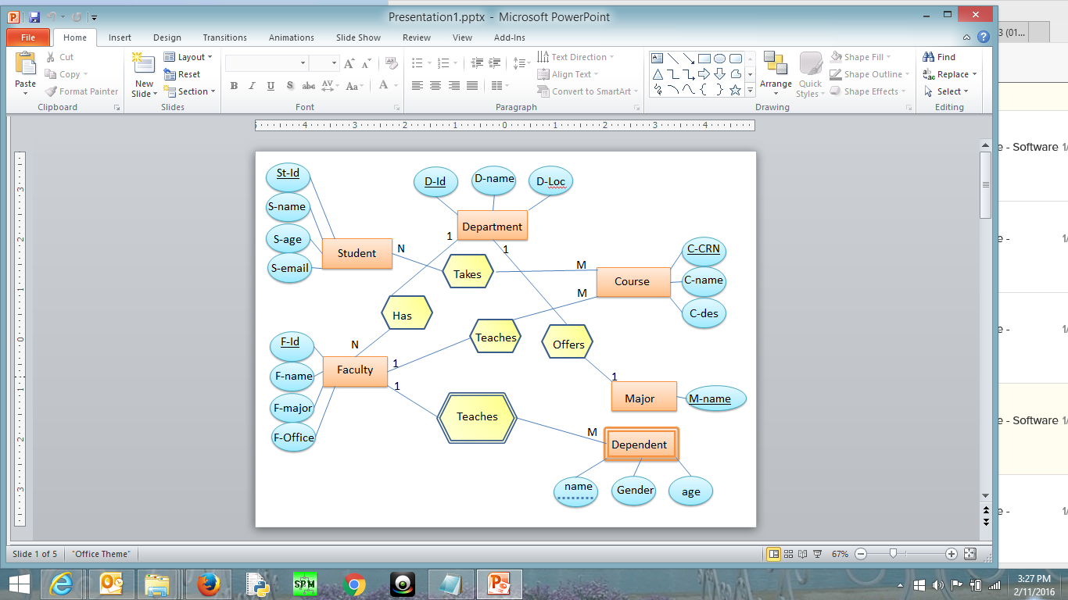

**Parth Kapur**

**1a)**

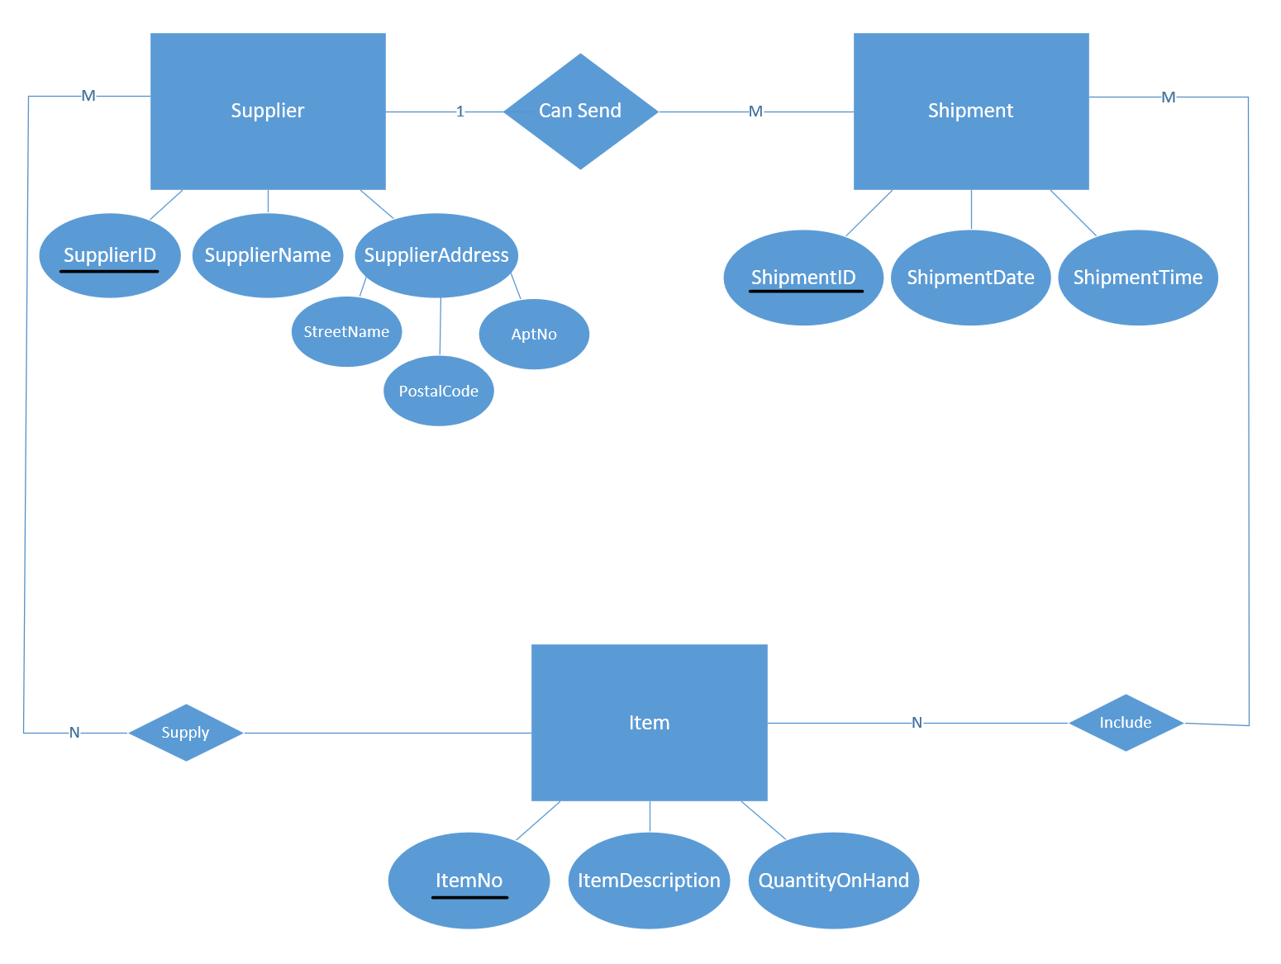

**1b)**

**\*refers to Foreign Key. Underlined will refer to a primary key.**

Supplier **(**SupplierID**,** SupplierName, StreetName, AptNo, PostalCode)

Shipment (ShipmentID, ShipmentDate, ShipmentTime, SupplierID*)

Item (ItemNo, ItemDescription, QuantityOnHand)

Supply (SupplierID, ItemNo) This is a composite primary key.

Include (ShipmentID, ItemNo) This is a composite primary key.

**2a)**

**\*refers to Foreign Key. Underlined will refer to a primary key.**

The tables for the following ERD are:

Department(D-Id, D-name, D-Loc)

Student(St-Id, S-name, S-age, S-email)

Faculty(F-Id, D-Id*, F-name, F-major, F-Office)

Dependent(name, F-Id, Gender, age) Note: F-Id is a foreign key, but name and F-D is the composite primary key of dependent table.

Major(M-name, D-Id*)

Course(C-CRN, F-Id*, C-name, C-des,)

Takes(St-Id, C-CRN) NOTE: For the Takes relationship, St-Id and C-CRN are primary keys of the Student entity and Course entity, respectively. When creating the takes table, they are foreign keys. HOWEVER, the combination of the two results in the Takes table’s composite primary key. Hence, why they are underlined as a composite primary key.