**Configuring PPTP VPN on Softlayer with Python**

This document provides the steps to create a PPTP VPN on Softlayer and a client on Windows. The PPTP VPN allows simultaneous connections from as many uses as there are portable private IPs

1. **Configuring Vyatta PPTP VPN in Softlayer with Python**

The steps included below describe the procedure to be followed to configure a PPTP VPN on Softlayer. Unzip pptp-vpn. Into a folder

1. **Setup Python**
2. Download and install Python version 2.7.9 - https://www.python.org/downloads/
3. Download and install easy_install- setuptoolshttps://pypi.python.org/pypi/setuptools
4. **Install necessary modules**
5. Go to <path>/Python27/Scripts. You should see easy_install.exe

Enter

1. >easy_install SoftLayer
2. >easy_install paramiko

SoftLayer has all SL APIs. The module paramiko is a python implementation of OpenSSH. A ssh connection to the VM is created and Vyatta configured through this

1. **Create VM**

The details of the values in each of the files is listed in info.txt

1. Edit account.txt. Replace username/authentication key with your values
2. Edit vm.text and enter the details as mentioned in info.txt
3. From this directory run

>python createvm.py

This will create a public CCI on Softlayer

1. **Configure PPTP VPN**

To configure Vyatta the python module ‘paramiko’ is used to create a ssh session with the VM. vyatta-cfg-command-wrapper is used to perform the actual configuration of Vyatta

1. Go to Softlayer portal and get the public IP of the VM and the password for the user vyatta
2. Edit vm-details and enter the details for the VM
3. Run

>python replace_all

This script will replace the public IP and password in another Python script which is used as a template (pptp_vpn_create_py) and substitute the values in appropriate places and create a new scrip pptp_vpn_create-sl.pl

1. Run

* python pptp_cpn_create_sl.py

If all goes well the PPTP VPN on Softlayer should be configured and the configuration should be displayed on the screen.

This can be checked at Softlayer portal by using putty to create a SSH window for the public IP of the CCI. This will bring up a window – username: vyatta – password – the password from SL portal

Once inside vyatta, do the following

$configure

# show vpn pptp remote-access

This should display the configuration

# exit

Note: The current setup uses 8 portable private IPs (5 usable) ordered from Softlayer. Depending on the number of simultaneous connections 16, 32, 64 portable private IPs need to be ordered. The following lines will with the start and stop of the private IP range in the script pptp-vpn-create.py will need to be changed.

/opt/vyatta/sbin/vyatta-cfg-cmd-wrapper set vpn pptp remote-access client-ip-pool start 10.66.14.146

/opt/vyatta/sbin/vyatta-cfg-cmd-wrapper set vpn pptp remote-access client-ip-pool stop 10.66.14.150

1. **Configure the Windows client**
2. Choose 'Setup up a new connection to the network'

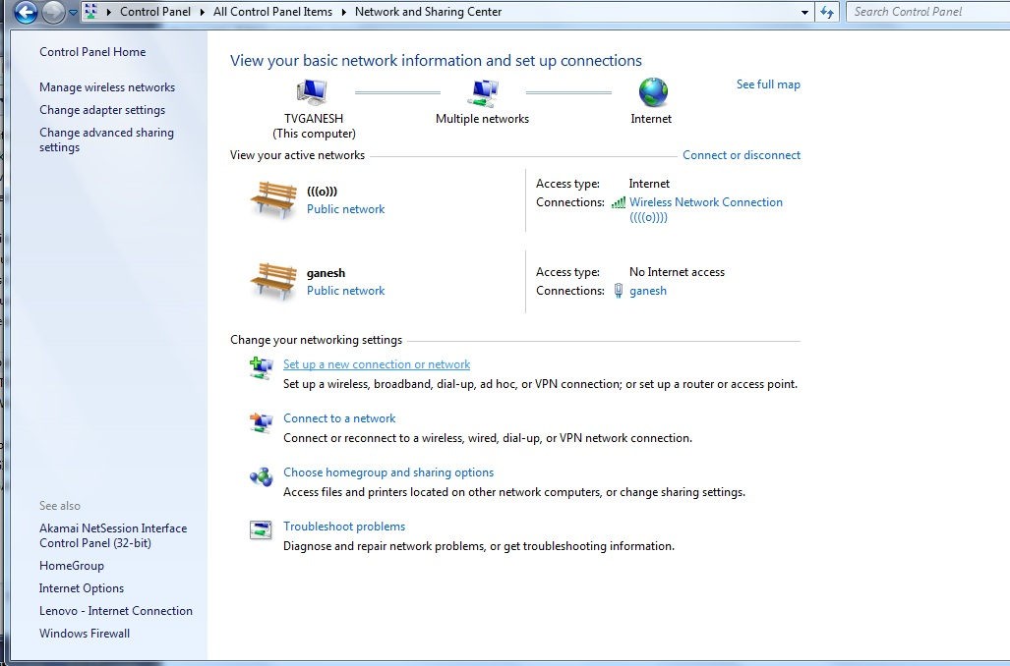

1. Choose 'Connect to a workplace' and click Next

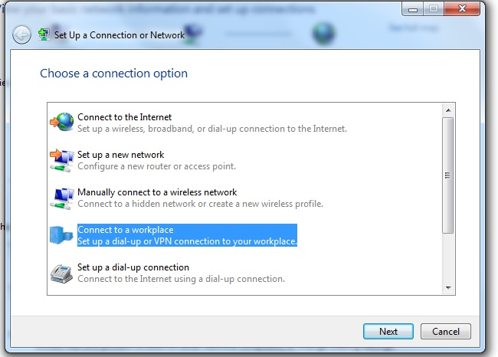

1. In the next screen "Do you want to use a connection you already have?", choose 'No create a new connection' and click Next

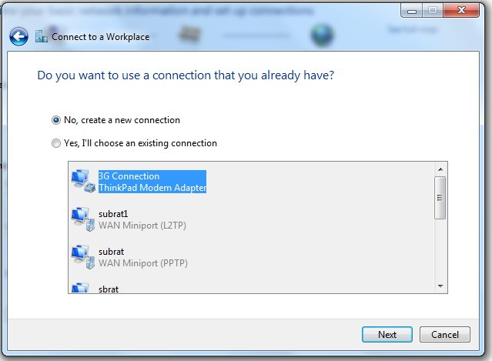

1. In the next screen 'How do you want to connect?" choose 'Use my internet connection (VPN)'

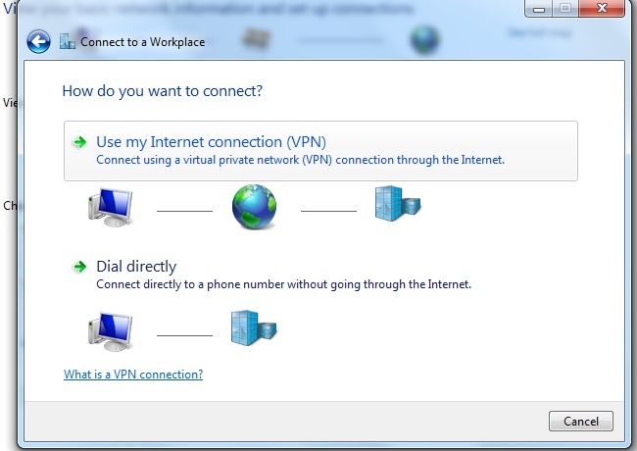

1. In the next screen enter the values as follows

Internet address : <IP addres of CCI>

Destination name: PPTP-VPN

Also select 'Don't connect now, just set up so I can connect later' as shown

and click Next

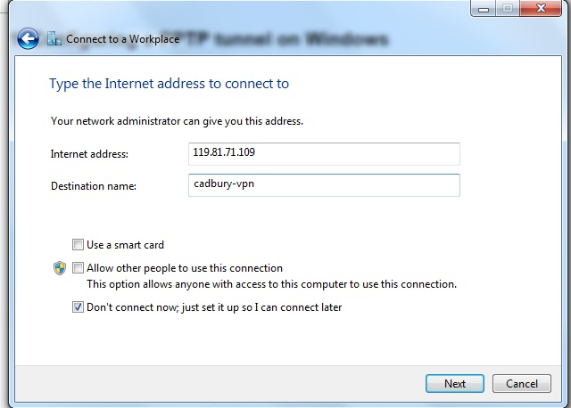

1. Enter the following

Username: poctest

Password: poctest

Also select 'Show characters' & 'Remember this password' and

click Create

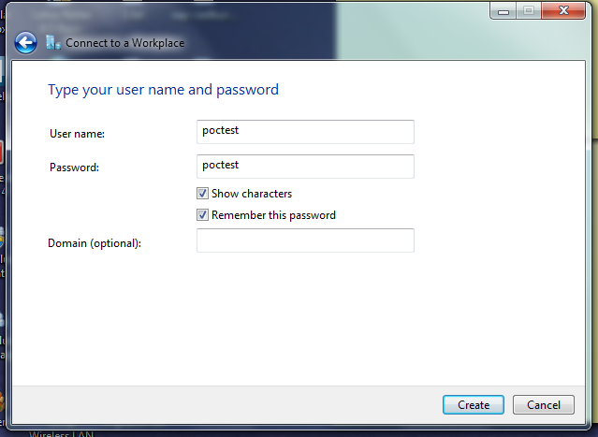

1. Click 'Create' in the next screen
2. In the next screen click 'Close'
3. Click Start->Control Panel->Network and Sharing Center, click 'Connect to network'. You should see PPTP-VPN on the right hand corner of the screen
4. Right click PPTP-VPN and select "Properties'

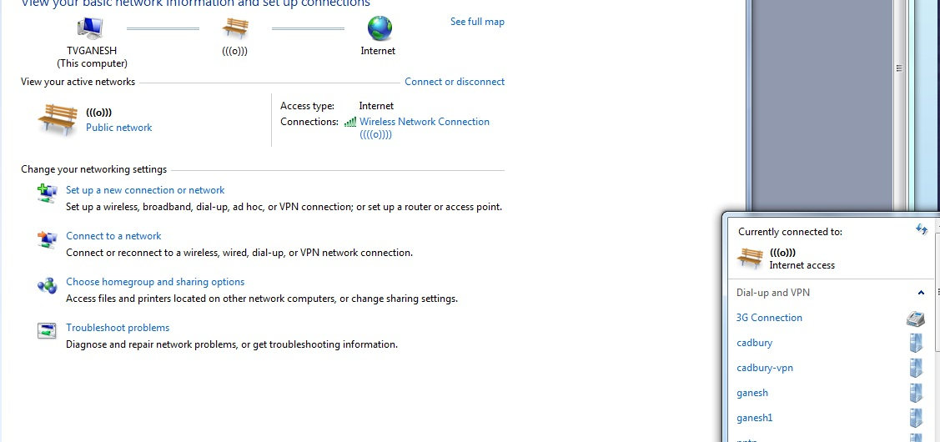

1. Go to Security tab and set the following

Type of VPN : Point to Point Tunneling protocol

Data encryption: Require encryption (disconnect if server declines)

Let the Challenge handshake Authentication protocol and Microsoft CHAP version 2 be selected as shown

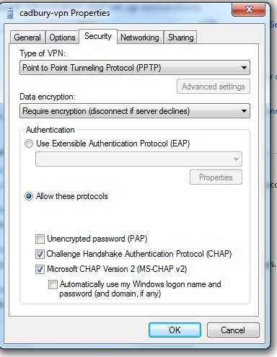

1. Click the 'Networking tab' select Internet Protocol Version 4 (TCP/IPv4) and click the Properties button. This will open another window. Click the 'Advanced button' and 'Unselect' Use default gateway on remote network. Click Ok, Ok and Ok.

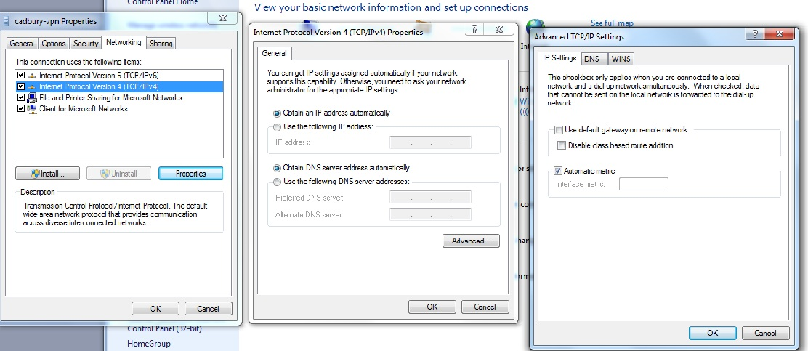

1. Click Start->Control Panel->Network and Sharing Center, click 'Connect to network'. (The Username & password are already populated)

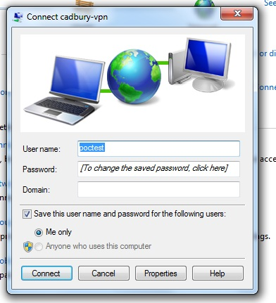

1. Click cadbury-vpn and choose 'Connect'. You will get messages 'Verifying Username & password' followed by 'Registering computer on the network'. Now if you click Start->Control Panel->Network and Sharing Center should show this new connection 'cadbury-vpn'

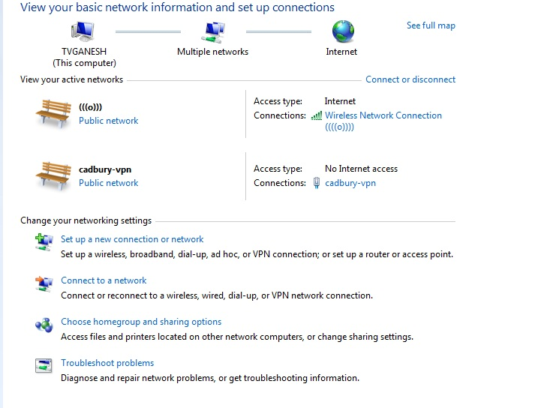

1. Now a PPTP tunnel exists between the local computer and a Vyatta gateway at Softlayer.

**Checking PPTP**

Login into Vyatta using putty and type

$ show vpn remote-access

This should show the connection from your laptop