Semaphore Wrapper Testing
Test 1:
Create two tasks. Both trying to print to serial monitor. Both task is running at 1s task rate.
Serial monitor printing is made as critical section with semaphore lock.
Counting semaphore is initialized with maxCount 2 and InitialCount 2.

Expected result:
Each task prints to serial monitor only when semaphore is available ie count>0.
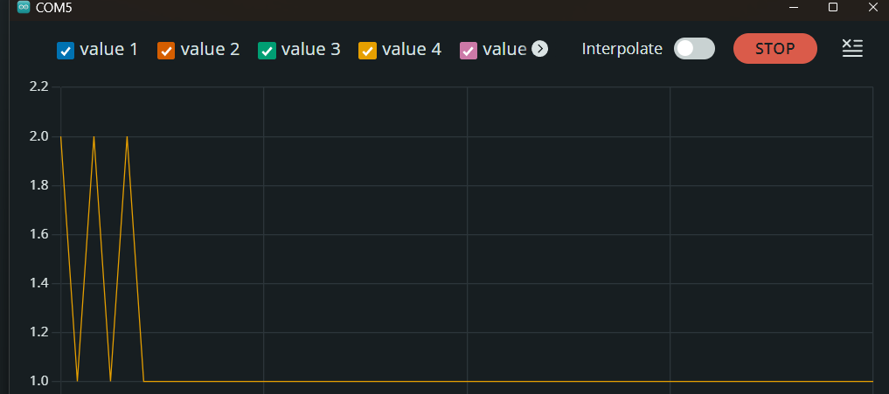

Test 2:
In this test, task 1 will take the semaphore and does not release it. Task 2 will wait infinitely for semaphore ie, count>0.
