AKS DEPLOYMENT USING AZURE CLI

ABSTRACT:

We need to set up AKS worker node in our local machine and AKS master node (AKS Cluster) in azure portal using azure cli.

PROCESS:

1. INSTALLATION OF AZURE CLI

Install azure cli in your linux machine using below commands,

1. Run the following command to update package list:

sudo apt-get update

2. Run the following command to install the CLI dependencies:

sudo apt-get install ca-certificates curl apt-transport-https lsb-release gnupg

3. Import the Microsoft GPG key using the following command:

curl -sL https://packages.microsoft.com/keys/microsoft.asc | \
gpg --dearmor | \
sudo tee /etc/apt/trusted.gpg.d/microsoft.gpg > /dev/null

4. Add the Azure Cli repository to the list of sources with the following command:

AZ_REPO=$(lsb_release -cs)
echo "deb [arch=amd64] https://packages.microsoft.com/repos/azure-cli/ $AZ_REPO main" | \
sudo tee /etc/apt/sources.list.d/azure-cli.list

5. Run the following command to update the package lists again:

sudo apt-get update

6. Finally, install the Azure CLI using the following command:

sudo apt-get install azure-cli

7. Verfiy the Azure CLI version post installation using below command:

az –version

2. INSTALLATION OF AKS MASTER NODE (AKS CLUSTER) IN AZURE PORTAL AND AKS WORKER NODE IN LOCAL MACHINE USING AZURE CLI COMMANDS

1. Run the following command to login to azure portal using azure cli:

az login

Once you are the above command, it will redirect to browser to enter your respective azure poral login credentials and screenshot for reference,

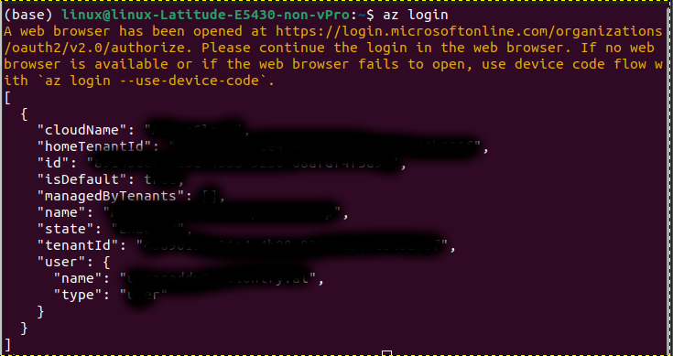

2. Run the following command to choose a specific subscription:

az account set -subscription name or id_of_subscription

3. Run the following command to get version of kubernetes API version:

az aks get versions –location region_name

Output screenshot for reference
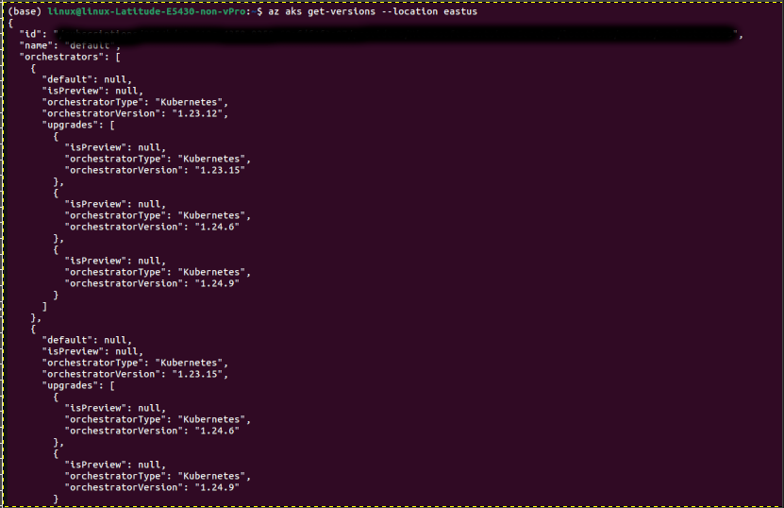

4. Run the following command to deploy AKS

az aks create --resource-group name_of_resource_group --name name_of_aks_cluster --node-count 1 --kubernetes-version 1.17.0 --generate-ssh-keys

name_of_resource_group = Enter name of RG where you wish to deploy AKS

name_of_aks_cluster = Enter name of aks cluster as per your requirement

node-count = Enter number worker nodes as per the requirement

kuberneters-version = Enter the kubernetes API version as per the requirement

5. Run the following command to confirm AKS Cluster deployment

az aks show --name name_of_aks_cluster --resource-group name_of_resource_group

name_of_aks_cluster = Enter the name of created AKS cluster

name_of_resource_group = Enter the name of resource group mentioned while creating aks cluster

6. Run below commands to install kubectl in your local machine

az aks install-cli

kubectl version

7. Run the command to get node details in AKS cluster

kubectl get nodes

3. INSTALLATION OF VISIONIFY DOCKER IMAGES

A. VISIONAI-API IMAGE

1. Run the following command to create visionaiapi.yaml with vi editor

vi visionaiapi.yaml

Once vi editor do enter below yaml file,

apiVersion: v1
kind: Pod
metadata:
name: visionai-api-pod
spec:
containers:
- name: api
image: visionify/visionai-api:latest

After saving visionaiapi.yaml, enter below command to confirm visionaiapi.yaml,

cat visionaiapi.yaml

2. Run the following command to create a namespace for your pod for easy identification

kubectl create namespace <xxxx>

3. Run the following command to check created namespace

kubectl get ns

4. Run the following command to create a pod with above namespace using visionifyai-api image

kubectl create -f visionaiapi.yaml -n <xxxx>

5. Run the following command to check created pod with specific namespace

kubectl get pods -n <xxxx>

B. VISIONAIWEB IMAGE

1. Run the following command to create visionaiapi.yaml with vi editor

vi visionaiweb.yaml

Once vi editor do enter below yaml file,

apiVersion: v1
kind: Pod
metadata:
name: visionaiweb-pod
spec:
containers:
- name: web
image: visionify/visionaiweb:latest

After saving visionaiweb.yaml, enter below command to confirm visionaiweb.yaml,

cat visionaiweb.yaml

2. Run the following command to create a namespace for your pod for easy identification

kubectl create namespace <xxxx>

3. Run the following command to check created namespace

kubectl get ns

4. Run the following command to create a pod with above namespace using visionifyaiweb image

kubectl create -f visionaiweb.yaml -n <xxxx>

5. Run the following command to check created pod with specific namespace

kubectl get pods -n <xxxx>

