**Summary of Papers**

Type of calorimeter (3 types),

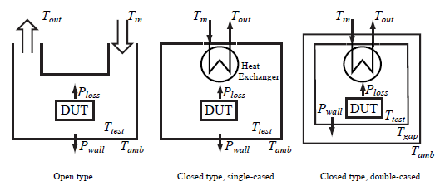

Figure 1: Type of Calorimeters

1. **Open Type**
   * Disadvantages
     + Heat capacity changes with changing in temperature, humidity, volume flow.
     + Time is generally longer.
   * Typical Usage
     + Measuring several kilowatts.
2. **Closed Type Singe-Cased**
   * Disadvantages
     + Same as Open Type but more accurate.
3. **Closed Type Double-Cased**

The double-cased closed type calorimeter allows an active control of the air temperature in the gap (Tgap) between the cases and therefore to control the heat leakage across the walls.

**Additional Notes:**

A major error source of all calorimeter types is heat leakage through the walls of the calorimeter.

Volume and response time are inversely proportional.

In higher volume air diffuse heterogeneously.

Heating foils are being used for to diffuse the air in the gap between inner and outer cases.