Client Design

  - Klerksdorp Golf & Country Club
Project ID | CMPG325-2026-116
Student | Raolane, Karabo (42733308)
Industry | Sports
Assigned addressing block | 10.44.0.0/16
Design constraint | Building is heritage-listed, no new cabling through external walls
Change request | CR6: A small branch office (6–10 users) must be connected to the main network
Assigned networking challenge | Basic OSPF (single-area dynamic routing) — implemented and demonstrated at Milestone 2
Submission date | August 2026

Introduction
This document is the Client Design Review. It presents the analysis of the assigned client's requirements, the proposed physical and logical network topology, the IP addressing plan derived from the assigned 10.44.0.0/16 block, and the structure of the initial GitHub portfolio of evidence. It is submitted alongside the initial GitHub repository.
The client is Klerksdorp Golf & Country Club, a member-based sports and hospitality organisation. The network must support day-to-day club operations, protect member and payment data, respect a heritage-listed building constraint, and accommodate a new small branch office as described in change request CR6.

Client Requirements Analysis

Understanding The Client's Business
Klerksdorp Golf & Country Club operates a golf course, driving range, clubhouse restaurant and bar, pro shop, and membership administration from a single heritage-listed main building. The club is adding a small branch office (6–10 staff) to support the change in operations described in CR6. Reliable connectivity underpins day-to-day operations: member and visitor bookings, point-of-sale (POS) transactions in the pro shop and restaurant/bar, administrative and financial systems, and guest/member Wi-Fi as an amenity.

Departments, Users and Applications
- Administration & Management (±20 users) — membership database, booking system, financial/admin applications; highest sensitivity, restricted access.
- Reception & Pro Shop (±12 users/devices) — booking terminals and POS for merchandise/green fees.
- Restaurant & Bar (±12 users/devices) — POS terminals for food and beverage sales.
- Member/Guest Wi-Fi (±50 concurrent devices) — internet access only, isolated from internal systems.
- Staff Wi-Fi (±25 devices) — mobile/handheld access for staff (greenkeeping, floor staff) to internal applications.
- Servers (DHCP, DNS, file/print) — centralised in a server room.
- Branch Office (6–10 users, CR6) — general administrative/operational staff at a second, smaller site.

Security Considerations
Point-of-sale traffic (pro shop and restaurant/bar) and administrative data must be logically separated from member/guest and staff wireless traffic through VLAN segmentation, limiting the impact of a compromised guest device on financial or membership systems. A dedicated network-management VLAN keeps switch and AP management traffic off user VLANs. Full inter-VLAN access-control (ACLs) is scoped for a later phase of the project; Milestone 1 establishes the segmentation these controls will apply to.

Design Constraint
Because the main clubhouse is heritage-listed, no new cabling may be run through external walls. The design therefore reuses existing internal cabling pathways/conduits for wired access switches and extends coverage to areas where new fixed cabling is impractical (e.g., outdoor/veranda seating, driving range) using wireless access points fed from the existing internal cable plant. Connectivity to the new branch office (which is a separate site) is provided over a WAN link — a leased line or site-to-site VPN riding the club's existing telecommunications entry point — rather than any new cable run through the heritage structure.

Client Change Request
CR6 requires a small branch office of 6–10 users to be connected to the main network. This is addressed with a dedicated branch router and access switch, its own VLANs (users and management), and a routed WAN link back to the main site. Basic OSPF (single area, Area 0) runs between the Main and Branch routers so that both sites dynamically learn each other's networks, satisfying the assigned networking challenge and giving CR6 a resilient, standards-based routing design rather than static routes.

Budget and future growth
The design favours reuse of existing internal cabling and wireless coverage over new civil/cabling work, keeping cost down while respecting the heritage constraint. The 10.44.0.0/16 allocation is used conservatively at this stage, small, right-sized VLSM subnets per department/VLAN. The large majority of the block (10.44.2.0/24 through 10.44.255.0/24, plus spare space within the Main and Branch /24s) remains reserved for future departments, additional branch offices, or expanded Wi-Fi capacity without renumbering the existing network.

Design Approach Summary
- Hierarchical design at the Main Site: edge router → Layer-3 core switch → access switches per department, plus wireless APs for guest/staff coverage.
- VLAN segmentation separates Admin, Reception/Pro Shop, Restaurant & Bar, Member/Guest Wi-Fi, Staff Wi-Fi, Servers, and Network Management.
- A routed WAN link connects the Main Site to the new Branch Site (CR6), avoiding any new external cabling at the heritage building.
- Basic OSPF (single area, Area 0) provides dynamic routing between the Main and Branch routers and will be verified and demonstrated as the assigned networking challenge.
- IP addressing uses VLSM within the assigned 10.44.0.0/16 block, sized to each VLAN's real host count with room reserved for growth.

Physical Topology
The physical topology shows real devices, their physical locations (main clubhouse vs. branch office) and how they are cabled or wirelessly linked.
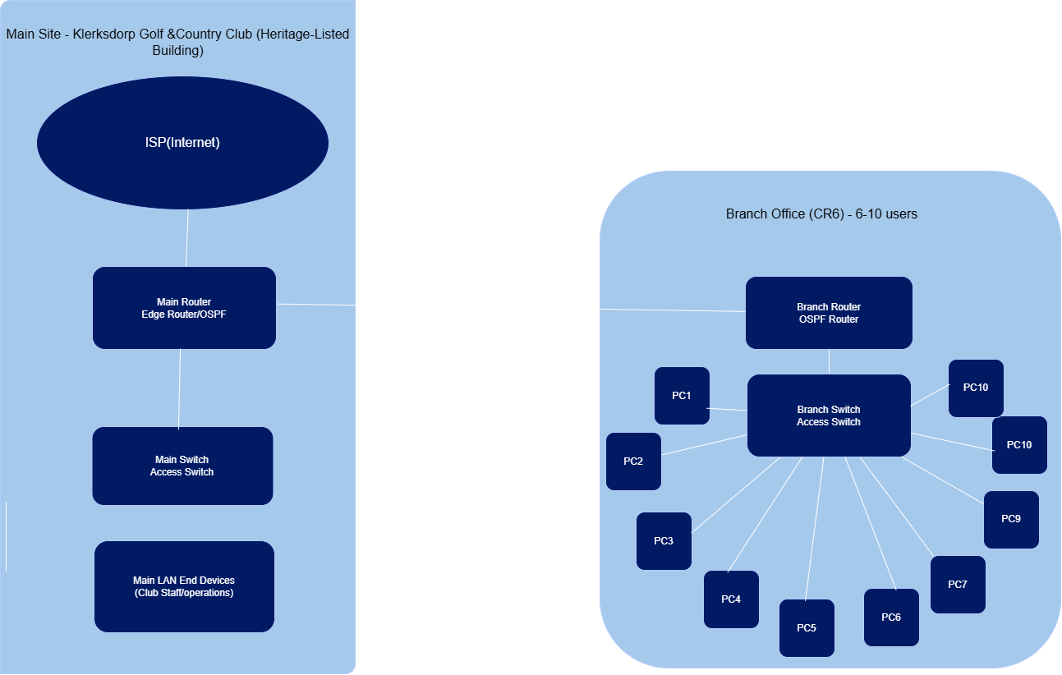

Device Summary
DEVICE | ROLE
Main Router | Edge router for the main site; connects to the ISP and to the branch office; OSPF-facing
Main Switch | Access switch connecting the main LAN's end devices to the Main Router.
Main LAN End Devices | Club staff/operations devices on the main LAN
Branch Router | Branch-office router; terminates the wireless WAN bridge to the Main Router; OSPF-facing
Branch Switch | Branch-office access switch for the 6–10 staff PCs
Branch LAN End Devices | Branch office staff PCs (CR6), per Section 1.2

Logical Topology
The logical topology abstracts away physical cabling and shows IP networks, VLANs, gateways and the planned OSPF Area 0 adjacency between the two sites.

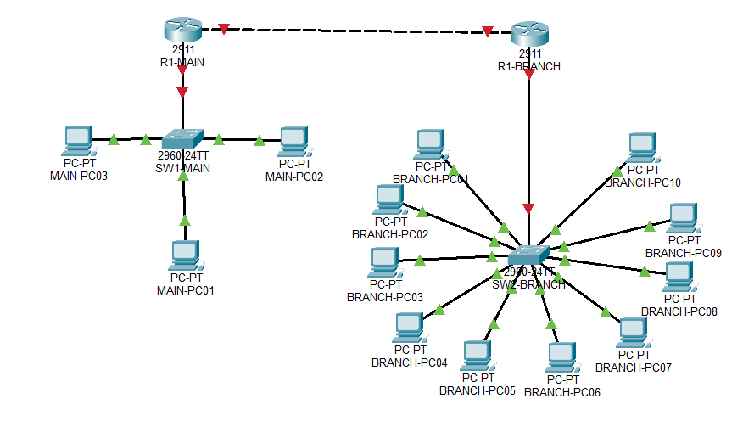

IP Addressing Plan

Addressing Scheme
The client's assigned block, 10.44.0.0/16, is subnetted using VLSM: the main LAN receives a /24 (simple, ample headroom); the small branch office (CR6) receives a right-sized /27 for its 6–10 users; the main and branch WAN link uses a /30 point-to-point subnet; and two /32 loopbacks provide stable OSPF router IDs. This keeps addressing efficient, no oversized allocations on the point-to-point and loopback links, while remaining simple, since only two sites are defined in the brief.

Addressing Table
Segment | Network | Mask | Usable Range | Gateway | Broadcast | Approx. Hosts | Purpose
Main LAN | 10.44.0.0/24 | 255.255.255.0 | .1 – .254 | 10.44.0.1 | 10.44.0.255 | ≤ 254 | Main site clubhouse staff/operations devices
Branch LAN (CR6) | 10.44.1.0/27 | 255.255.255.224 | .1 – .30 | 10.44.1.1 | 10.44.1.31 | 6-10 (30 max) | Branch office staff LAN
WAN - Main & Branch link | 10.44.254.0/30 | 255.255.255.252 | .1 – .2 | n/a (P2P) | 10.44.254.3 | 2 | Point-to-point wireless bridge
Loopback the Main Router | 10.44.255.1/32 | 255.255.255.255 | n/a | n/a | n/a | 1 | OSPF Router ID
Loopback the Branch Router | 10.44.255.2/32 | 255.255.255.255 | n/a | n/a | n/a | 1 | OSPF Router ID

Routing Plan
- The Main Router routes between the main LAN, the WAN link to the branch, and the ISP facing default route.
- The Main Router and the Branch Router will run Basic OSPF in a single area (Area 0), advertising the main LAN, the branch LAN, the WAN /30, and both loopbacks, this is the assigned networking challenge, to be configured and verified at Milestone 2.
- The Main Router provides the default route out to the ISP for internet bound traffic from both sites.

Milestone 1 Deliverables Checklist
Milestone 1 item | Status | Reference
Client requirements | Complete | Section 1
Physical topology | Complete | Section 3
Logical topology | Complete | Section 4
IP addressing plan | Complete | Section 5
GitHub repository | Complete | https://github.com/karabo2303/Networking_Project_KlerksdorpGCC

