*The IIE’s Varsity College Pretoria*

ASSESSMENT COVER PAGE

KARABO NICHOLAS BALOYI

ST10033503

ADDB6311

GROUP 1

Practical Assignment 2

DUE: 27 MAY 2024

**QUESTION 1**

CREATE TABLE CUSTOMER (

CUSTOMER_ID NUMBER PRIMARY KEY,

FIRST_NAME VARCHAR2(30),

SURNAME VARCHAR2(30),

ADDRESS VARCHAR2(100),

CONTACT_NUMBER VARCHAR2(20),

EMAIL VARCHAR2(100)

);

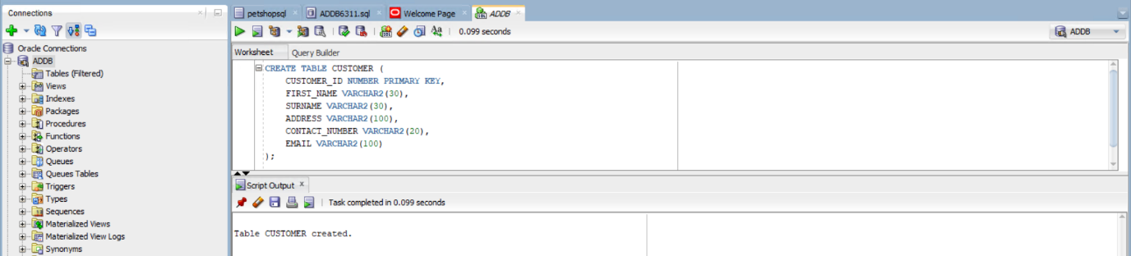

CREATE TABLE EMPLOYEE (

EMPLOYEE_ID NUMBER PRIMARY KEY,

FIRST_NAME VARCHAR2(30),

SURNAME VARCHAR2(30),

CONTACT_NUMBER VARCHAR2(20),

ADDRESS VARCHAR2(100),

EMAIL VARCHAR2(100)

);

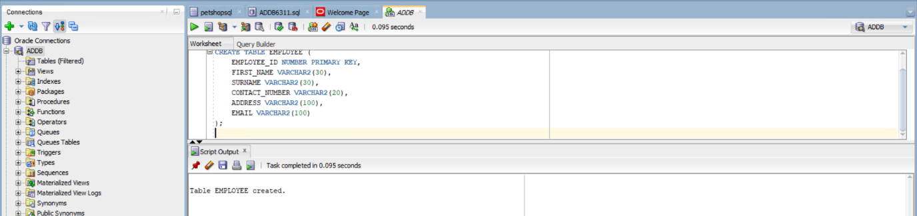

CREATE TABLE DONATOR (

FIRST_NAME VARCHAR2(30),

SURNAME VARCHAR2(30),

CONTACT_NUMBER VARCHAR2(20),

EMAIL VARCHAR2(100)

);

CREATE TABLE DONATION (

DONATION_ID NUMBER PRIMARY KEY,

DONATION VARCHAR2(100),

PRICE NUMBER(10, 2),

DONATION_DATE DATE

);

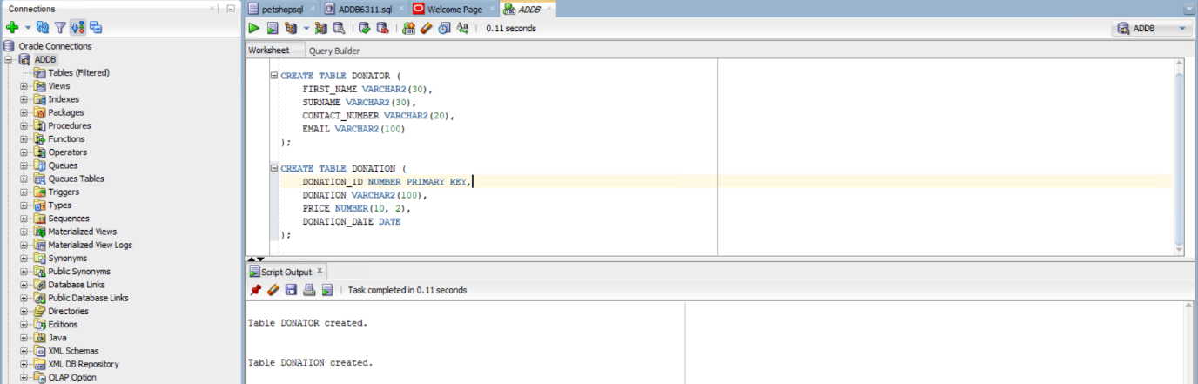

CREATE TABLE DELIVERY (

DELIVERY_ID NUMBER PRIMARY KEY,

DELIVERY_NOTES VARCHAR2(250),

DISPATCH_DATE DATE,

DELIVERY_DATE DATE

); 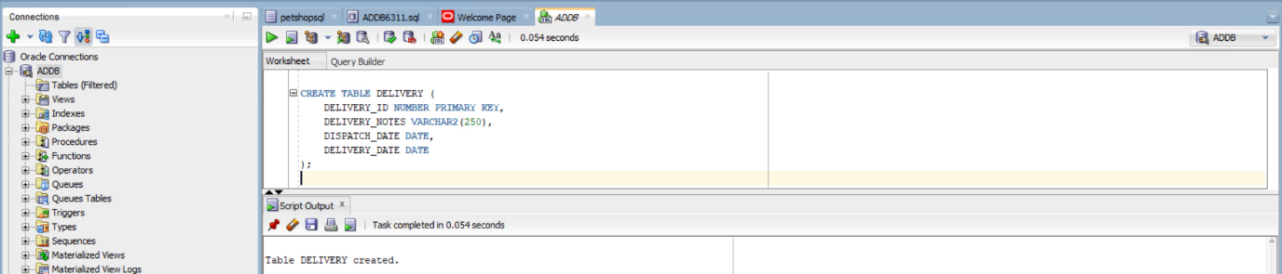

CREATE TABLE RETURNS (

RETURN_DATE DATE,

REASON VARCHAR2(250),

CUSTOMER_ID NUMBER,

DONATION_ID NUMBER,

EMPLOYEE_ID NUMBER,

FOREIGN KEY (CUSTOMER_ID) REFERENCES CUSTOMER(CUSTOMER_ID),

FOREIGN KEY (DONATION_ID) REFERENCES DONATION(DONATION_ID),

FOREIGN KEY (EMPLOYEE_ID) REFERENCES EMPLOYEE(EMPLOYEE_ID)

);

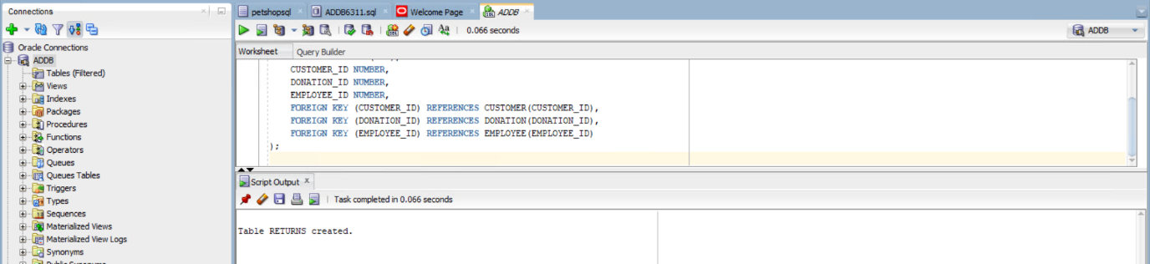

CREATE TABLE INVOICE (

INVOICE_NUM NUMBER PRIMARY KEY,

CUSTOMER_ID NUMBER,

INVOICE_DATE DATE,

EMPLOYEE_ID NUMBER,

DONATION_ID NUMBER,

DELIVERY_ID NUMBER,

FOREIGN KEY (CUSTOMER_ID) REFERENCES CUSTOMER(CUSTOMER_ID),

FOREIGN KEY (EMPLOYEE_ID) REFERENCES EMPLOYEE(EMPLOYEE_ID),

FOREIGN KEY (DONATION_ID) REFERENCES DONATION(DONATION_ID),

FOREIGN KEY (DELIVERY_ID) REFERENCES DELIVERY(DELIVERY_ID)

);

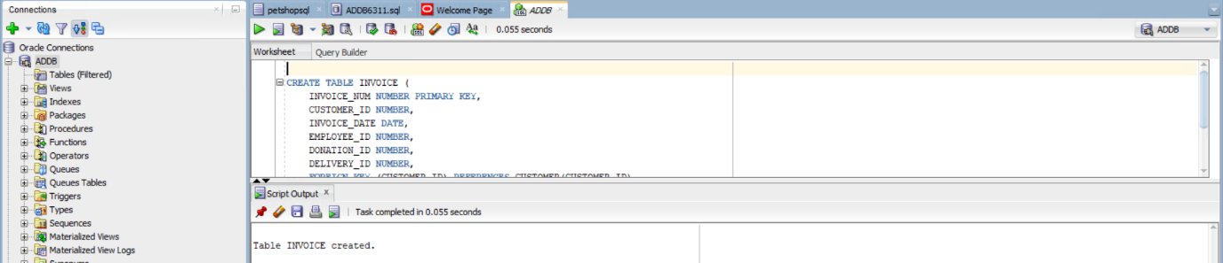

Populating Tables

INSERT INTO CUSTOMER (CUSTOMER_ID, FIRST_NAME, SURNAME, ADDRESS, CONTACT_NUMBER, EMAIL)

VALUES

('11011', 'Jack', 'Smith', '18 Water Rd', '0877277521', 'jsmith@isat.com'),

('11012', 'Pat', 'Hendricks', '22 Water Rd', '0863257857', 'ph@mcom.co.za'),

('11013', 'Andre', 'Clark', '101 Summer Lane', '0834567891', 'aclark@mcom.co.za'),

('11014', 'Kevin', 'Jones', '55 Mountain way', '0612547895', 'kj@isat.co.za'),

('11015', 'Lucy', 'Williams', '5 Main rd', '0827238521', 'lw@mcal.co.za');

INSERT INTO EMPLOYEE (EMPLOYEE_ID, FIRST_NAME, SURNAME, CONTACT_NUMBER, ADDRESS, EMAIL)

VALUES

('emp101', 'Jeff', 'Davis', '0877277521', '10 main road', 'jand@isat.com'),

('emp102', 'Kevin', 'Marks', '0837377522', '18 water road', 'km@isat.com'),

('emp103', 'Adanya', 'Andrews', '0817117523', '21 circle lane', 'aa@isat.com'),

('emp104', 'Adebayo', 'Dryer', '0797215244', '1 sea road', 'aryer@isat.com'),

('emp105', 'Xolani', 'Samson', '0827122255', '12 main road', 'xosam@isat.com');

INSERT INTO DONATOR (FIRST_NAME, SURNAME, CONTACT_NUMBER, EMAIL)

VALUES

('Jeff', 'Watson', '0827172250', 'jwatson@ymail.com'),

('Stephen', 'Jones', '0837865670', 'joness@ymail.com'),

('James', 'Joe', '0878978650', 'jj@isat.com'),

('Kelly', 'Ross', '0826575650', 'kross@gsat.com'),

('Abraham', 'Clark', '0797656430', 'aclark@ymail.com');

INSERT INTO DONATION (DONATION_ID, DONATION, PRICE, DONATION_DATE)

VALUES

(7111, 'KIC Fridge', 599.00, '2024-05-01'),

(7112, 'Samsung 42inch LCD', 1299.00, '2024-05-03'),

(7113, 'Sharp Microwave', 1599.00, '2024-05-03'),

(7114, '6 Seat Dining room table', 799.00, '2024-05-05'),

(7115, 'Lazyboy Sofa', 1199.00, '2024-05-07'),

(7116, 'JVC Surround Sound System', 179.00, '2024-05-09');

INSERT INTO DELIVERY (DELIVERY_ID, DELIVERY_NOTES, DISPATCH_DATE, DELIVERY_DATE)

VALUES

(511, 'Double packaging requested', '2024-05-10', '2024-05-15'),

(512, 'Delivery to work address', '2024-05-12', '2024-05-15'),

(513, 'Signature required', '2024-05-12', '2024-05-17'),

(514, 'No notes', '2024-05-12', '2024-05-15'),

(515, 'Birthday present wrapping required', '2024-05-18', '2024-05-19'),

(516, 'Delivery to work address', '2024-05-20', '2024-05-25');

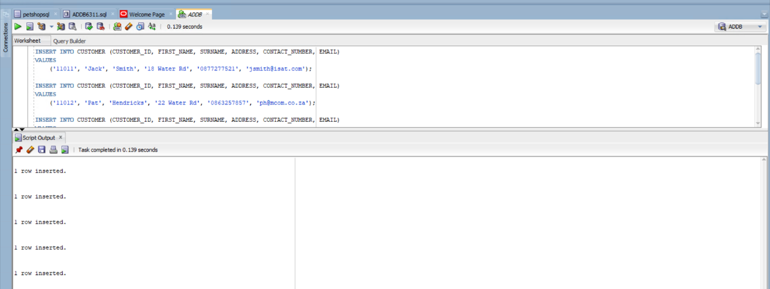

**QUESTION 2**

SELECT

CUSTOMER.FIRST_NAME || ' ' || CUSTOMER.SURNAME AS CUSTOMER_NAME,

INVOICE.EMPLOYEE_ID,

DELIVERY.DELIVERY_NOTES,

DONATION.DONATION AS DONATION_PURCHASED,

INVOICE.INVOICE_NUM

FROM

INVOICE

JOIN

CUSTOMER ON INVOICE.CUSTOMER_ID = CUSTOMER.CUSTOMER_ID

JOIN

EMPLOYEE ON INVOICE.EMPLOYEE_ID = EMPLOYEE.EMPLOYEE_ID

JOIN

DELIVERY ON INVOICE.DELIVERY_ID = DELIVERY.DELIVERY_ID

JOIN

DONATION ON INVOICE.DONATION_ID = DONATION.DONATION_ID

WHERE

INVOICE.INVOICE_DATE < '2024-05-18';

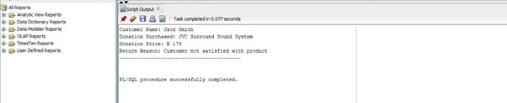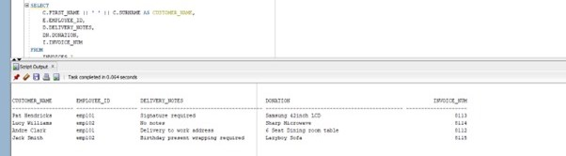

**QUESTION 3**

CREATE SEQUENCE ‘FUNDING_SEQ’

START WITH 1

INCREMENT BY 1;

CREATE TABLE FUNDING (

FUNDING_ID NUMBER PRIMARY KEY,

FUNDER VARCHAR (100),

FUNDING_AMOUNT NUMBER

);

Oracle (2024).

**QUESTION 4**

SELECT

c.FIRST_NAME || ' '|| C.SURNAME AS CUSTOMER,

d.DONATION AS DONATION_PURCHASED,

d.PRICE,

r.REASON AS RETURN_REASON

FROM

RETURNS r

JOIN

CUSTOMER c ON R.CUSTOMER_ID = c.CUSTOMER_ID

JOIN

DONATION d ON r.DONATION_ID = d.DONATION_ID;

**QUESTION 5**

SET SERVEROUTPUT ON;

DECLARE

v_customer_name VARCHAR (30);

v_employee_name VARCHAR (30);

v_donation VARCHAR2(100);

v_dispatch_date DATE;

v_delivery_date DATE;

v_days_to_deliver NUMBER;

BEGIN

SELECT

c.FIRST_NAME || '.' || c.SURNAME AS CUSTOMER_NAME,

e.FIRST_NAME || '.' || e.SURNAME AS EMPLOYEE_NAME,

d.DONATION,

del.DISPATCH_DATE,

del.DELIVERY_DATE,

(del.DELIVERY_DATE - del.DISPATCH_DATE) AS DAYS_TO_DELIVER

INTO

v_customer_name,

v_employee_name,

v_donation,

v_dispatch_date,

v_delivery_date,

v_days_to_deliver

FROM

INVOICE i

JOIN

CUSTOMER c ON I.CUSTOMER_ID = c.CUSTOMER_ID

JOIN

EMPLOYEE e ON I.EMPLOYEE_ID = e.EMPLOYEE_ID

JOIN

DONATION d ON i.DONATION_ID = d.DONATION_ID

JOIN

DELIVERY del ON i.DELIVERY_ID = del.DELIVERY_ID

WHERE

c.CUSTOMER_ID = '11013';

DBMS_OUTPUT.PUT_LINE ('CUSTOMER: ' || v_customer_name);

DBMS_OUTPUT.PUT_LINE ('EMPLOYEE: ' || v_employee_name);

DBMS_OUTPUT.PUT_LINE ('DONATION: ' || v_donation);

DBMS_OUTPUT.PUT_LINE ('DISPATCH DATE: ' || TO_CHAR (v_dispatch_date, 'DD/MON/YY'));

DBMS_OUTPUT.PUT_LINE ('DELIVERY DATE: ' || TO_CHAR (v_delivery_date, 'DD/MON/YY'));

DBMS_OUTPUT.PUT_LINE ('DAYS TO DELIVER: ' || v_days_to_deliver);

END;

Database Tutorial (2018).

**QUESTION 6**

SELECT

c.FIRST_NAME || ': ' AS "FIRST NAME:",

c.SURNAME || ': ' AS "SURNAME:", 'R ' ||

SUM (d.DONATION_AMOUNT) ||

CASE

WHEN

SUM (d.DONATION_AMOUNT) > = 1500 THEN ' (*) '

ELSE

END AS "AMOUNT:"

FROM

CUSTOMER c

JOIN

INVOICE i ON c.CUSTOMER_ID = i.CUSTOMER_ID

JOIN

DONATION d ON i.DONATION_ID = d.DONATION_ID

GROUP BY

c.FIRST_NAME, c.SURNAME

ORDER BY

c.FIRST_NAME, c.SURNAME;

**QUESTION 7**

7.1

DECLARE

-- declare a variable with the same datatype as a column in the ORDERS table

_customer_name ORDERS.CUSTOMER_NAME%TYPE;

BEGIN

--assign value to the variable

_customer_name := 'Jack';

-- display value of the variable

DBMS_OUTPUT.PUT_LINE('Customer Name: ' || _customer_name);

END;

7.2

DECLARE

-- declare a variable with the same datatype as a column in the ORDERS table

_customer_name ORDERS.CUSTOMER_NAME%TYPE;

BEGIN

--assign value to the variable

_customer_name := 'Jack';

-- display value of the variable

DBMS_OUTPUT.PUT_LINE('Customer Name: ' || _customer_name);

END;

Oracle (2024).

7.3

DECLARE

_customer_id CUSTOMERS.CUSTOMER_ID%TYPE;

BEGIN

-- assign value to the variable

_customer_id := 11016;

BEGIN

SELECT CUSTOMER_ID INTO _customer_id

FROM CUSTOMERS

WHERE CUSTOMER_ID = _customer_id;

-- if SELECT statement returns a row, output that the customer is found

DBMS_OUTPUT.PUT_LINE('Customer Found.');

EXCEPTION

-- handle NO_DATA_FOUND exception

WHEN NO_DATA_FOUND THEN

DBMS_OUTPUT.PUT_LINE('Customer not found.');

END;

END;

Tutorialspoint (2024).

SQL language reference (2024) Oracle Help Center. Available at: https://docs.oracle.com/en/database/oracle/oracle-database/19/sqlrf/CREATE-SEQUENCE.html (Accessed: 27 May 2024).

How to enable DBMS_OUTPUT in SQL developer: Oracle SQL Developer Tips and tricks (2018) YouTube. Available at: https://youtu.be/uZhOkp3CIzw?si=_0HDmhsiyJKwfRqQ (Accessed: 26 May 2024).

%ROWTYPE attribute. Available at: https://docs.oracle.com/cd/B13789_01/appdev.101/b10807/13_elems042.htm (Accessed: 27 May 2024).

PL/SQL - exceptions (no date) Tutorialspoint. Available at: https://www.tutorialspoint.com/plsql/plsql_exceptions.htm (Accessed: 27 May 2024).