

# CSE2062

# Object Oriented Programming

# Instructure : Şakir Bingöl

|  |  |  |
| --- | --- | --- |
|  | Student ID Number | Name & Surname |
| 1 | 150717052 | Tahir Temizkan |
| 2 | 150718003 | Mehmet Temmuz Boyraz |
| 3 | 150718021 | Uygar Gündüz |
| 4 | 150718039 | Şerife Küçükköşker |
| 5 | 150718050 | Mehmet Karaca |
| 6 | 150720842 | Talha Yavçın |

Pizza Shop:

*Pizza Shop Order System*

This project’s aim in general is allowing customers to order pizza and their drinks easily. Best way to do this is creating a Java based GUI program. To achieve this we implemented 6 different classes. These classes are:

*Selection Class*

In this class we take care customers selections as we process the informations we got from the user and use them as we needed. This class is the superclass of the pizza classes and the Drink class.

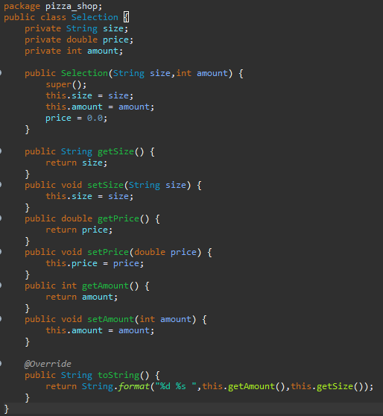

*Pizza Classes(Pepperoni,Funghi,Margarita)*

These classes are subclasses of the class “Selection”. In these classes we determine the price of the order and we ask if the user wants more cheese or not.

metin içeren bir resim

Açıklama otomatik olarak oluşturuldu

metin içeren bir resim

Açıklama otomatik olarak oluşturuldu

metin içeren bir resim

Açıklama otomatik olarak oluşturuldu

*Drink Class*

This class is a subclass of the class “Selection”. In thes class we determine the price of the order and we ask the user what type of drink they want.

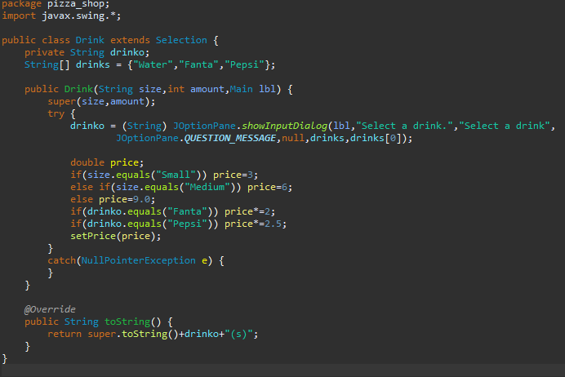

*Main Class*

In the main class we have four methods which are “Main” , “init” , “actionPerformed” and “main”. In the “Main” and “init” methods we simply create the GUI objects. In the “actionPerformed” method we analyze the entries of the user and response as necessary. And in “main” method we just run the “Main” method. We explained how to run the code in our video.

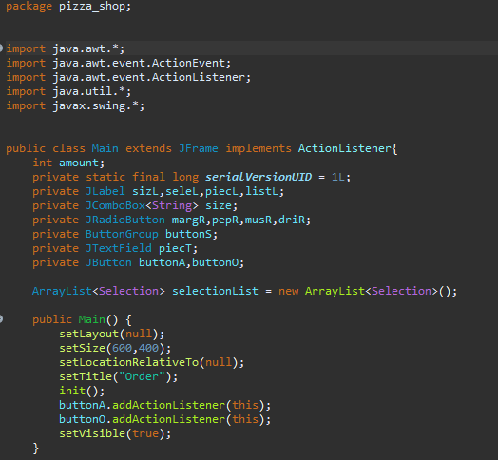

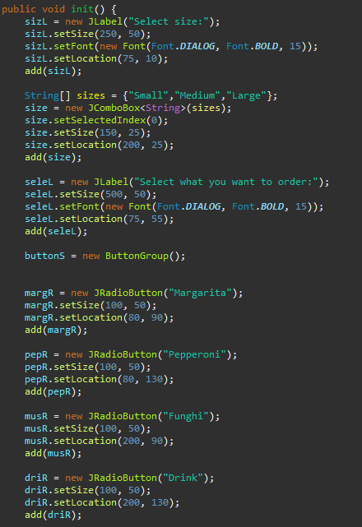

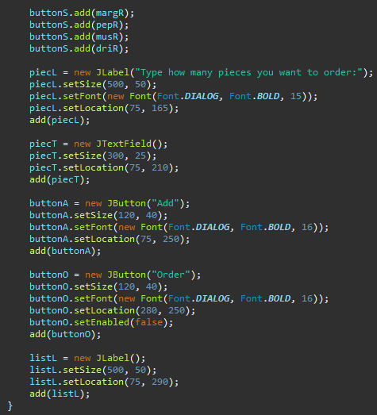

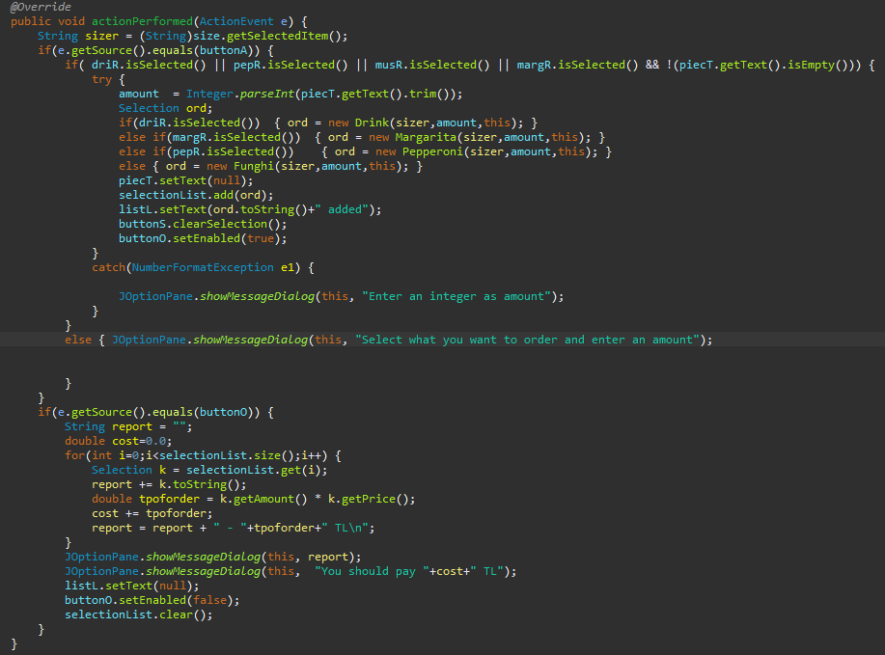

metin içeren bir resim

Açıklama otomatik olarak oluşturuldu

*UML Diagram of Our Project*

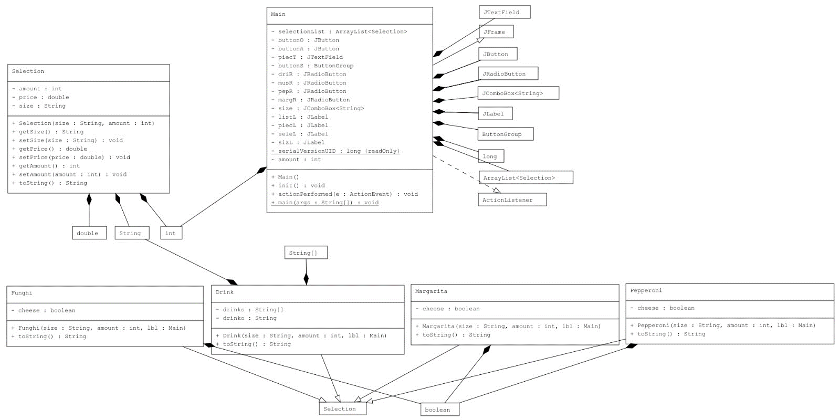

*Outputs and Screens/Windows of Our Project*

*Main Screen*

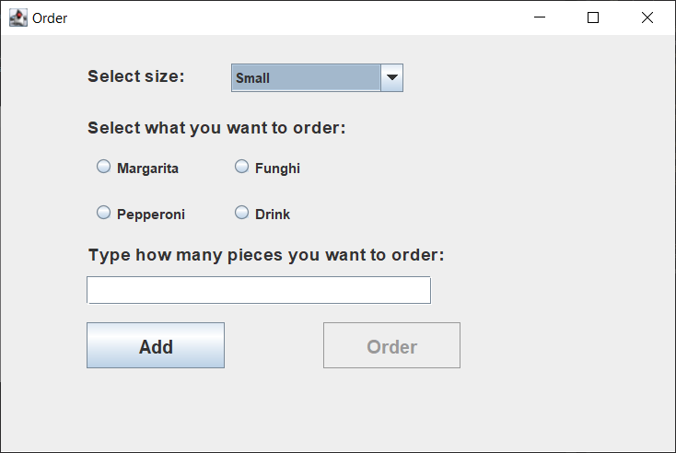

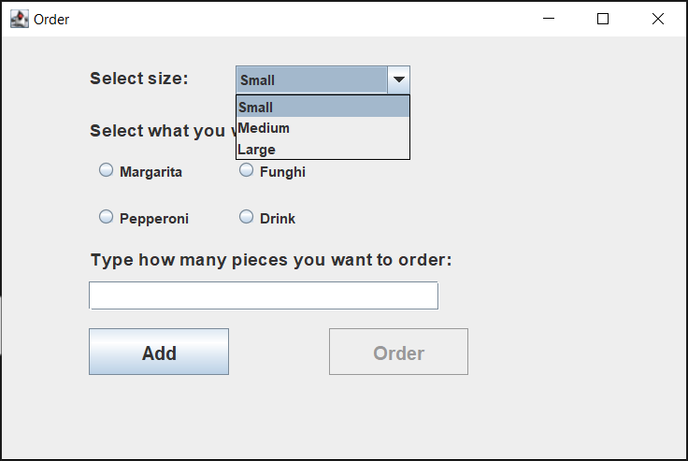*Size Selection Box*

*Cheese Addition Screens*

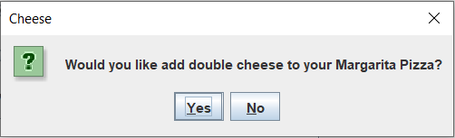

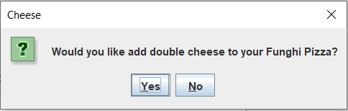

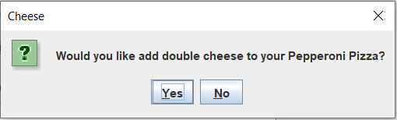

*Drink Selection Screen*

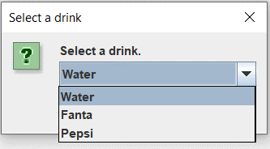

*Error Message Screens*

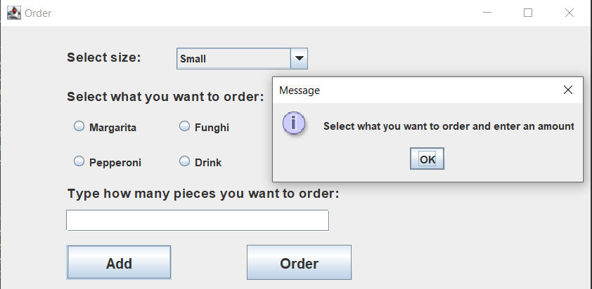

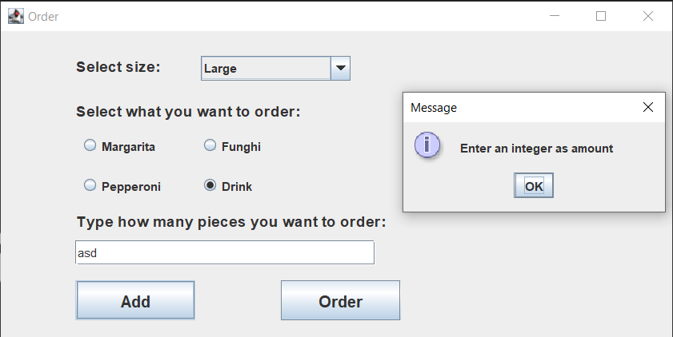

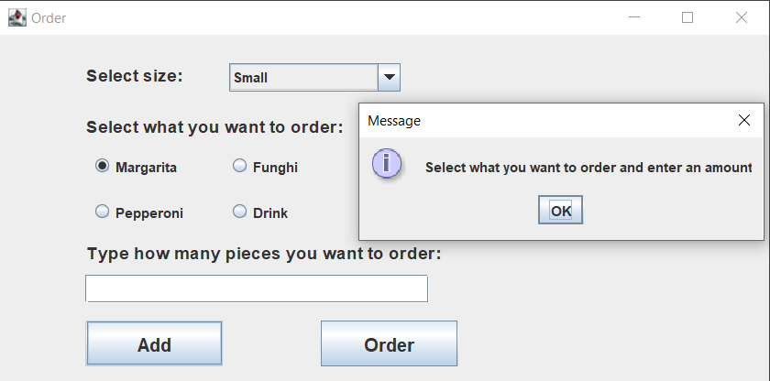

*Selection Complete Screen*

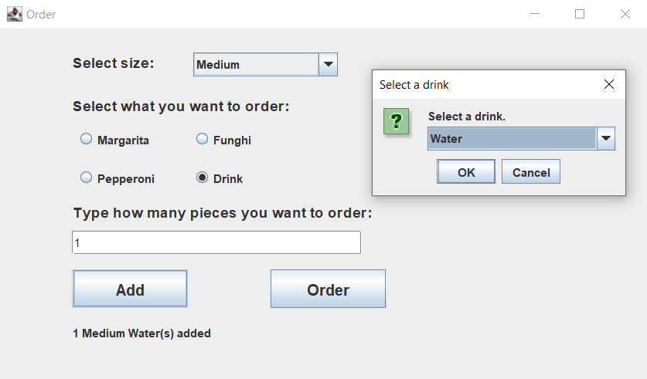

*Order Summary Screen*

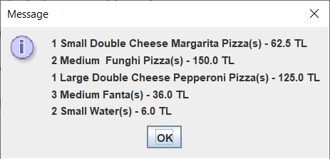

*Total Price Screen*

metin içeren bir resim

Açıklama otomatik olarak oluşturuldu