YUNUS EMRE KARADAĞ  Computer Engineering Graduate  Data Science & Machine Learning  Alanya / Antalya, Türkiye | +90 539 786 4106 |  karadagynsemr@gmail.com  LinkedIn | GitHub | Portfolio | 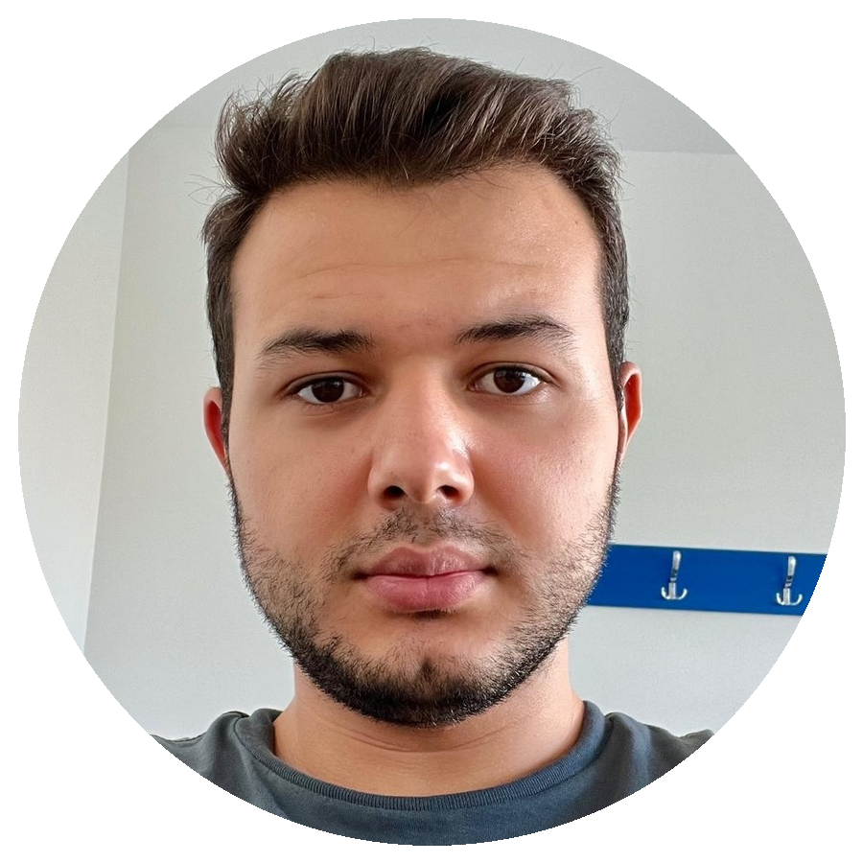

PROFESSIONAL SUMMARY
Computer Engineering graduate with hands-on experience in data science, machine learning, data analytics, and database-driven applications. Skilled in Python, SQL, C#, PostgreSQL, scikit-learn, Streamlit, Flask, and Tableau. Experienced in building machine learning workflows, database systems, dashboards, and user-oriented software solutions.

TECHNICAL SKILLS
Programming: Python, SQL, C#, Java, C | Web & Apps: Flask, Streamlit, HTML/CSS
Databases: PostgreSQL, Database Design, ER Modeling | Data Science & ML: Pandas, NumPy, scikit-learn, SHAP, Matplotlib, Seaborn
Software Practices: Git, GitHub, Data Preprocessing, Model Evaluation | Visualization & Tools: Tableau, Jupyter Notebook
EXPERIENCE
Intern | Telcorex Communication and Digital Transformation Services | Istanbul, Türkiye | Aug 2025
- Supported data preparation, exploratory data analysis, and machine learning model training using Python.
- Applied Pandas, NumPy, and scikit-learn in practical data preprocessing and model evaluation workflows.

EDUCATION
B.Sc. in Computer Engineering | Alanya Alaaddin Keykubat University | 2022 - 2026
Relevant focus: data science, machine learning, database systems, software development, and data visualization.

SELECTED PROJECTS
Explainova - No-Code Machine Learning Platform | Python, Streamlit, scikit-learn, SHAP
- Built an end-to-end platform that enables non-technical users to analyze tabular datasets and compare ML models.
- Added preprocessing, automatic classification/regression flow, SHAP explainability, PDP/ICE outputs, and Word report generation.
Mobile App Store Database Design & Visualization | SQL, ER Model, Tableau
- Designed ER diagram, relational schema, normalization structure, SQL queries, and Tableau dashboards for app store data.
Student Attendance Tracking System | Python, Flask, PostgreSQL, ZeroMQ
- Developed a web-based attendance system connecting Flask UI, PostgreSQL data layer, and ZeroMQ messaging structure.
Restaurant Management System | PostgreSQL, Database Design
- Designed relational tables and basic SQL queries for reservation, order, menu, and restaurant operations.

CERTIFICATIONS & LANGUAGES
Certifications: Huawei AI Bootcamp; Git & GitHub - BTK Akademi; Data Science & Data Visualization - Turkcell; Machine Learning - Udemy; UX-UI 101: User Experience and User Interface Design, Pupilica.

Language: English B2.

