Customers Led-Network Revolution – data workflow

The Customer-Led Network Revolution project is the largest smart grid demonstration project ever undertaken in the UK. 13,000 GB of electricity data from customers were collected all over UK providing important information and learning from trials with real customers on real networks. Data has been provided by the Northern Power grid.

The datasets are anonymous and comes from domestic and SME customers. The data comprises electricity consumption and PV (Photo Voltaic) generation for individual customers, and related information about the customer, the tariff and the technology being used. Customers have been indicated as “**Location ID**”.

Data has been provided in csv format for each of the “Test Cells” reported below. Data file for each Test Cell was named **“TrialMonitoiringData.csv”**. Test cell represent the type of customer who was targeted for data collection. Test cells are referred to different type of customers who have different equipment for energy consumption such as, electric vehicles, solar PV and heat pumps.

**Table 1:** Description of the main fields contained in the file **“TrialMonitorignData.csv”**. The additional data field comes from the files **“LowCarbonTechnologyMeteringAttributes.csv”**, **“TemperatureData.csv”** and **“SubGroups.csv”**.

|  |  |  |  |  |  |  |
| --- | --- | --- | --- | --- | --- | --- |
| **Test Cell** | **Description** | **Customer Type** | **Number of customers (Location ID)** | **Measurement description** | **Parameter Type and Units** | **Additional**  **data** |
| TC1a | Basic profiling of domestic smart meter customers | Domestic | 8798 | Electricity supply meter | Consumption in period [kWh] | - |
| TC1b | Basic profiling of small and medium sized enterprise (SME) customers | SME | 1783 | Electricity supply meter | Consumption in period [kWh] | SubGroups data |
| TC2a | Enhanced profiling of domestic smart meter customers | Domestic | 199 | Utilities consumption | Consumption in period [kW] | - |
| TC3  Heat Pump | Enhanced profiling of domestic customers with air source heat pumps | Domestic | 89 | Whole home power import  Heat pump power consumption | Average power [kW] | Temperature data [degrees Celsius] |
| TC5  PV | Enhanced profiling of domestic customers with solar photovoltaics (PV) | Domestic | 155 | Whole home import  Solar power | Average power [kW] | Low Carbon Technology data. Peak Power [kW] |
| TC6  Electric Vehicles | Enhanced profiling of domestic customers with Electric Vehicles (EVs) | Domestic | 144 | Charge point  House data | Consumption in period [kWh] | - |
| TC9a  Time of use tariff | Domestic smart meter customers on time of use tariffs | Domestic | 665 | Electricity supply meter | Consumption in period [kWh] | - |
| TC20 Auto  PV | Domestic solar PV customers with automatic in-premises balancing for hot water charging | Domestic | 98 | Maximum current exported | Highest 1 minute average during period [A] | - |
| Supply voltage | Average in period [V] |
| Demand current | Average consumption in period [A] |
| Photovoltaic meter | Generation in period [kWh] |
| TC20 IHD  PV | Domestic solar PV customers using in-home displays for manual in-premises balancing | Domestic | 147 | Whole home import  Solar power | Average power [kW] | Low Carbon Technology data. Peak Power [kW |

The customer test cell definition table is the defining table for trial participants and was available for all test cells except test cell 6: enhanced profiling of domestic customers with Electric Vehicles (EVs).

Customer test cell data has been joined with each test cell by Test Cell ID.

**Table 2:** Description of the main fields contained in the file **“CustomerTestCellDefinition.csv”**

|  |  |  |  |
| --- | --- | --- | --- |
| **Field Name (spread sheet column)** | **Type** | **Values** | **Comments & Restrictions** |
| Location ID | Numeric string | Any | Uniquely identifies the location. |
| Customer Type | string | “RES”  “SME” | The test cell ID may not unambiguously indicate which test cells are residential or SME so the customer type field will indicate this. |
| Test Cell ID | string | Alphanumeric descriptor | This identifies the test cell of which the location is a member. A location can be a member of more than one test cell. |
| In/Out Region | unit | 0 = not defined  1 = in-region  2 = out | This indicates whether a customer is in or out of Northern Powergrid’s region. For some test cells this is not important and the value may be left as zero (undefined). |
| Data Valid Start Date | Date | Any between 2011 and 2014 | This is date of the first day’s data that can be used for analysis.  This allows for the fact that customer joining and leaving dates may not coincide directly with the trial monitoring data. |
| Data Valid End Date | Date | Any between 2011 and 2014; and >= value in field 7 | This is date of the last day’s data that can be used for analysis. (See ‘Data valid start date’). |
| Tariff Type | string | Describes tariff type of the customer | Tariff type for each customer. |
| Mosaic Class | text | Any valid Mosaic class | Any non-valid type will be an error |

Provided data for each test cell were too large to be opened in MS-Excel. Unless they are interrogated through a database, the data cannot be wholly explored as they are. Therefore, data has been processed following a particular procedure. Basically, data has been grouped and summarized by customer ID and by hour. Therefore, the resulting size of the processed dataset was easily readable by the end-user who would like to explore the data, perform statistical analysis and data visualization.

Zipped data from provided by Northern Powergrid are located in the **gisdev** server of Ricardo Energy & Environment in the directory**: /SAN/data/NetworkRevolution/TC1a** **(/TC1b; TC2a; TC3; TC5; TC6; TC9a; TC20_Auto; TC20IHD**)

* **basic dom sm profile - TC1a.zip** (file used: TrialMonitoringDataHH.csv, CustomerTestCellDefinition.csv)
* **TC1b - Basic profiling of small and medium sized enterprise SME customers.zip** (file used: TrialMonitoringData.csv, CustomerTestCellDefinition.csv)
* **TC3 - Enhanced profiling of domestic customers with air source heat pumps.zip** (file used: TrialMonitoringData.csv; CustomerTestCellDefinition.csv; TemperatureData.csv)
* **TC5 - Enhanced profiling of domestic customers with solar photovoltaics.zip** (file used: TrialMonitoringData.csv; CustomerTestCellDefinition.csv; LowCarbonTechnologyMeteringAttributes.csv)
* **TC6 - Enhanced profiling of domestic customers with electric vehicles Evs.zip** (file used: TrialMonitoringDataHH.csv)
* **TC9a - Domestic smart meter customers on time of use tariffs.zip** (file used: TrialMonitoringData.csv; CustomerTestCellDefinition.csv)
* **TC20Auto - Domestic solar PV customers with automatic in-premises balancing for hot water charging.zip** (file used: TrialMonitoringData.csv; CustomerTestCellDefinition.csv)
* **TC20IHD - Domestic solar PV customers using in-home displays for manual in-premises balancing.zip** (file used: TrialMonitoringData.csv; CustomerTestCellDefinition.csv; LowCarbonTechnologyMeteringAttributes.csv)

Figure 1 show the workflow diagram for the processing of the data as received from the Customer led Network Revolution Project.

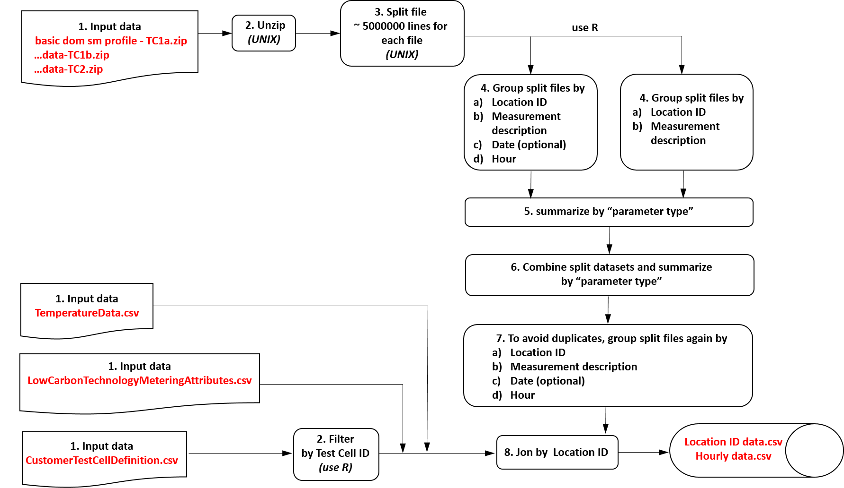

Output files with aggregated data have been located in the driver: **Q:\Delivery\Projects\ECC\ED59817 Future Cities - REHP Phase2\WP5 Modelling\Internal\Data\NetworkRevolution/Data_Crunching**

Each Test Cell has a folder containing the aggregated csv files:

* /TC1a contain **Electricity_data_TC1a.csv** (aggregated data by Location ID) and **Electricity_data_TC1a_hour.csv** (aggregated data by hour)
* /TC1b contain **Electricity_data_TC1b.csv** (aggregated data by Location ID) and **Electricity_data_TC1b_hour.csv** (aggregated data by hour)
* /TC2a contain **Electricity_data_TC2a.csv** (aggregated data by Location ID) and **Electricity_data_TC2a_hour.csv** (aggregated data by hour)
* /TC3 contain **Electricity_data_TC3.csv** and **Temperature_data_TC3.csv** (aggregated data by Location ID) and **Electricity_data_TC3_hour.csv** and **Temperature_data_TC3_hour.csv** (aggregated data by hour)
* /TC5 contain **Electricity_data_TC5.csv** and **Carbon_data_TC5.csv** (aggregated data by Location ID) and **Electricity_data_TC5_hour.csv** (aggregated data by hour)
* /TC6 contain **Electricity_data_TC6.csv** (aggregated data by Location ID) and **Electricity_data_TC6_hour.csv** (aggregated data by hour)
* /TC9a contain **Electricity_data_TC9a.csv** (aggregated data by Location ID) and **Electricity_data_TC9a_hour.csv** (aggregated data by hour)
* /TC20_Auto contain **Electricity_data_TC20_Auto.csv** (aggregated data by Location ID) and **Electricity_data_TC20_Auto_hour.csv** (aggregated data by hour)
* /TC20IHD contain **Electricity_data_TC20IHD.csv** and **Carbon_data_TC20IHD.csv** (aggregated data by Location ID) and **Electricity_data_TC20IHD_hour.csv** (aggregated data by hour)

Data visualization for the above results are available in the folder: **Q:\Delivery\Projects\ECC\ED59817 Future Cities - REHP Phase2\WP5 Modelling\Internal\Data\NetworkRevolution/Plots**