Methodology for the determination of the PM2.5 standard in the United Arab Emirates: estimated values, effects and proposed actions

**Dr. Federico Karagulian**

Table of contents

Summary 3

1. Introduction 5

1.1. Health Impact of PM2.5 5

1.2. Source contributions to PM2.5 in the UAE 6

2. Health Data 7

3. PM2.5 exposure data 8

4. Regression spline Model 9

4.1. Relative risk 10

5. Data processing 11

6. Results 13

**6.1.** **PM2.5 standard for long term exposure** 18

**6.2.** **PM2.5 standard for short term exposure** 18

7. Preliminary Conclusions and Outlook 20

7.1. Proposed PM2.5 standards 20

7.2. The role of dust/sand in the PM2.5 standard 20

7.3. Suggested implementation of measures to target lower PM2.5 standards 21

**Measures in the transport sector** 21

**Measures in the industry/energy sector** 22

**Measures in the residential/commercial sector** 23

# **Summary**

Objective of reporting period:

* Development of a methodology to estimate the Air Quality **Standard for Particulate Matter PM2.5** in the United Arab Emirates
* Analysis of health data and air quality data to determine a relationship between health outcome and human exposure to PM2.5 in the UAE
* Estimation of PM2.5 Interim Target Values for long-term (annual) and short-term (24-h) exposure in the UAE
* Proposition of a long-term and short-term PM2.5 standard value for the UAE
* Proposition of **measures to reach PM2.5 standard values**

Achievements:

* A methodology to estimate a **PM2.5 standard** for the UAE has been developed and tested following **peer-reviewed** scientific work and **suggestions from international recognised epidemiologist in USA and Europe**
* **PM2.5 standards** have been estimated for **long-term** (annual) and **short-term** (24-h) exposure using health data and air pollution data from the Emirate of Abu Dhabi and Dubai-Northern Emirates
* An indicative percentage risk and **number of possible hospital admissions** associated with **respiratory diseases** caused by PM2.5 exposure has been estimated
* Air Quality Guidelines from the World Health Organization (WHO) have been used to define **Interim Targets** as progressive step to follow to reach the Air Quality Standards (AQS)

Recommendations and next steps:

A list of different **measures to reduce emissions responsible for PM2.5** ambient concentrations has been suggested. These measures are in line with most of the common initiatives that are currently implemented in Europe.

Further actions should be taken to draft a **National Air Quality Plan** based on modelled emission scenarios o by simply gathering already available information from different Emirates.

The proposed PM2.5 standards have been estimated based on available data. As matter of safety, we strongly suggest adopting lower limit values for long- and short- term PM2.5 exposure. This means that the Ministry of the Environment and Climate Change can decide to slightly reduce the proposed PM2.5 standard value in order to add a “security range” which can only bring benefit to UAE’s residents. As further suggestion, the UAE should enforce the PM2.5 limit values based on a selection of effective measures that do not have negative social and economic impact across all the Country.

## Introduction

Environmental impacts of anthropogenic air pollutants are becoming a demanding problem for present and future generations. Recent release by the World Health Organization (WHO) confirmed that air pollution is the world's largest single environmental health risk (WHO, 2014). On March 2014, WHO reported that in 2012 around 7 million premature deaths could be attributed to in- and outdoor air pollution, that is one in eight of total global premature deaths. Therefore, understanding the sources of air pollution is crucial to identify cost-effective emission reduction measures. Particulate matter, in particular those ones with a diameter up to 2.5 microns (PM2.5), is of particular concern, because it penetrates deep into the respiratory system.

According to the WHO and to published studies (Burnett et al., 2014; Kiesewetter et al., 2015; Lelieveld et al., 2015; WHO, 2006; Wichmann and Heinrich, 1995) the **health impact** of **ambient** **pollution** can almost entirely be attributed to **fine airborne suspended particles (PM2.5)** that are composed of a mixture of organic and inorganic compounds, originating from anthropogenic sectors. Primary PM2.5 results from direct emissions of carbonaceous particles (elemental carbon, organic carbon) from **combustion processes**, but also from **re-suspension of road dust**, tire and brake wear, and **agricultural sources** (Karagulian et al., 2015). **Natural dust emissions** are an important component of PM2.5 concentrations above in the Middle East Region.

### Health Impact of PM2.5

Past and recent epidemiological studies have played an important role to establish guideline values for airborne suspended particulate matter. At the date, concerns about the health effects of airborne particles are mostly based on the results of recent epidemiological studies suggesting effects on mortality and morbidity at very low levels of exposure.

In the following, we are going through a brief review of epidemiological studies relating ambient particulate matter exposure to various health outcomes such as mortality and hospital admissions.

Time-series studies usually relate the time-trend of air pollution data and some health variables such as mortality and hospital admissions. While **air pollution data** are now routinely collected and used as **exposure variables**, **health data** are less frequent and not of easy access (WHO, 1987). Health variables usually have some **seasonal patterns** over time that needs to be accounted for before air pollution effects can be studied. Time-series have the advantage they can catch the variation of events occurring on a very short time range of days to weeks at most, where many personal characteristics such as age and anthropogenic habits do not change. In addition, short-term variation of air pollution concentrations is often much greater than the variation of long-term average pollution concentrations that is at the basis of studies of long-term effects of air pollution on health (Dockery and Brunekreef, 1996). This is extremely important to **allow sufficient variation in exposure during epidemiological study**.

Previous study of the potential impact of **long-term PM2.5 exposure** on **mortality** was estimated having a relative risk increase of ~ 1.3% per 10 g/m3 in six eastern U.S. cities for eight years, (Schwartz et al., 1996) whereas, Thurston et al. (2016) estimated ~ 1% increase in a long-term PM2.5 cardiovascular mortality study in 50 US states.

Similar studies have been carried out about the impact of long-term PM2.5 exposure linked to **hospital admissions** caused by respiratory diseases. Among these studies, we can report the relative risk increase of **~ 1.13%** in 213 Counties in the US (Bell et al., 2015), of **~ 4.2%** in the New England (USA) (Kloog et al., 2012), of ~ 4% in 50 US States (Pope et al., 2002), and, of ~ 15% in Brazil (Mantovani et al., 2016). The above numbers are only few of the many relative risk estimations carried out by several epidemiological studies in different Countries (WHO, 1987).

The effects of PM2.5 on health are several but the ones interesting the **respiratory and cardiovascular systems** are predominant. It has been established that the lower end at which no adverse effect is attributable to PM2.5 is when the background PM2.5concentrations is less than 3-5 g/m3. However, this is an estimate valid for United States and Western Europe (WHO, 2006). We do not have any evidence these value can be applied to other Countries.

Epidemiological studies also showed evidence of the adverse effect of PM2.5 on both short-term and long-term exposure. Despite many epidemiological studies on the topic, a thresholds level of PM2.5concentration was not identified since it depends from the variability of the exposure and in the response in a given exposure.

The **World Health Organization** suggested a guideline to perform a quantitative risk assessment to compare alternative control scenarios and to estimate the residual risk associated with a particular guideline value. As done by the United States Environmental Protection Agency and the European Commission, the United Arab Emirates are going to use this approach to set its quality standards for PM2.5 (WHO, 2006).

As explained below, we have used the WHO guideline to set a long-term (annual mean) and short-term (24-hours) values for PM2.5concentrations (AQG). The guideline is also used to set interim target (IT) values reflecting the PM2.5 concentrations at which increase of hospital admissions responses (from respiratory disease) due to PM2.5 is expected based on the health analysis presented in this work.

### Source contributions to PM2.5 in the UAE

A previous study about the chemical speciation of fine airborne particles in eight sites in the Emirate of Abu Dhabi estimated that about **44% of PM2.5** could be attributed to **mineral dust**, that is almost half of the PM2.5 mass (Hak et al., 2011). This estimation is close to the value of ~ 51% that the WHO estimated as fraction of natural sources (sand/dust and sea salt) attributed to PM2.5 concentrations in the Middle East (Karagulian et al., 2015). Both the above studies reported that, apart from the direct natural contribution to the particulate matter concentration, natural materials were used in anthropogenic activities such as construction or cement production, where natural materials are commonly used as primary raw materials.

Recent study published by NILU about source apportionment carried out over the site of Khalifa and Bida Zayed in Abu Dhabi from April to December 2012 showed that, natural sources contributed for only 25% to the PM2.5 concentrations. The major PM2.5 source contribution (~ 40%) was identified as secondary inorganic source mainly composed of sulphate (SO4) (NILU, 2012). That study indicated shipping and oil production activities as SO2 emission sources responsible for the formation of sulphate in the Region of the Arabian Sea. This is in contradiction with previous work reporting dust as dominant PM2.5 source in the Abu Dhabi (Hak et al., 2011) and in the Middle East region (Karagulian et al., 2015). The NILU study pointed out that long-range transport of these sources from the Arabian Sea was favorite by the synoptic conditions present in the Region. Additionally, the same study reported that, more than 61% and 88% of the daily PM2.5 concentration measured at the sites of Khalifa and Bida Zayed in Abu Dhabi was exceeding the EPA limit value of 35 g/m3. On the other hand, 63% and 24% of the daily PM10 concentration measured in those two sites was exceeding the EPA limit value of 150 g/m3. It is evident that these exceedances could not be attributed to sulphate only.

However, the high percentage of sulphate in the PM2.5 compositions as reported in the NILU study, was attributed both to anthropogenic and crustal sources. In addition, laboratory analysis showed large uncertainty in the sulphate content estimation. The above points are evidently a source of large uncertainty when performing source apportionment analysis that should be carried out according to well defined protocols (Belis et al., 2014). The anthropogenic fraction (in concentrations) of sulphate should be estimated separately from the mineral fraction to allow correct estimation of the effective sulphate mass to be used in source apportionment study. In addition, the source apportionment analysis in the NILU study has omitted to include Silica as key element to quantify the crustal/source factor.

We understand that the above issue is not an easy task to address. However, more extensive work on the estimation of anthropogenic sulphate content should be performed at National level and over a long time scale before coming to misleading conclusions.

## Health Data

Health data consisted of records of **hospital admission** associated with **respiratory diseases**. Data were selected from datasets obtained from two government Bodies in the UAE: the **Abu Dhabi Health Service Co. (SEHA)** and the **UAE Ministry of Health**. The first dataset was comprehensive of health records for the Emirate of **Abu Dhabi** only, whereas the second dataset was comprehensive of health records for the **Emirate of Dubai, Ajman, Sharjah, Ras Al Khaimah and, Umm Al Quwain**.

For both datasets, the health outcomes were selected according to the **international diagnosis code ICD-9CM** contained in the datasets (International Classification of Diseases, Ninth Revision, Clinical Modification (MEDICODE (FIRM), 1996)).

Health outcomes with the ICD-9CM codes 464 (Acute laryngitis and tracheitis), 465 (Acute upper respiratory infections), 466 (acute bronchitis and bronchiolitis), 480 (Pneumonia and Influenza), 482 (Other bacterial pneumonia), 483 (Pneumonia due to other specified organism), 484 (Pneumonia in infectious diseases classified elsewhere), 487 (Influenza), 491 (Chronic bronchitis), 492 (Emphysema), 493 (Asthma), 494 (Bronchiectasis) and 495 (Extrinsic allergic alveolitis), were selected from the health dataset and classified as **“respiratory” diseases**.

Respiratory health outcome for the **Dubai-Northern Emirate** dataset included: **acute upper respiratory infections 465 (73%), acute bronchitis and bronchiolitis 466 (15%), Asthma 493 (8.5%), other respiratory (3.5%)** from January 2013 to October 2015. On the other hand, respiratory outcomes from the **Emirate of Abu Dhabi** only consisted of **Asthma** records from June 2011 to May 2013.

Only unscheduled hospital admissions from encounter types classified as **clinic outpatients (60%), emergency (20%) and, outpatients (19%)** were considered. Outpatients (patients that visit hospitals without spending the night in) were used to estimate the sum (counts) of patient admitted to hospital on daily basis.

For the estimation of the relative risk associated to ambient PM2.5 exposure, the above datasets (Abu Dhabi and Dubai-Northern Emirates) have been treated separately. However, an estimation of the relative risk at National level has been done averaging the outcome from the analysis carried out for Abu Dhabi and Dubai-Northern Emirate.

## PM2.5 exposure data

Air quality data in the UAE have been recently organized in a unique database and assessed against UAE Air Quality regulations. The air quality data used for this work represent the first dataset comprehensive of measurements gathered from all seven Emirates in the UAE. The majority of the monitoring stations were located in areas where anthropogenic activities occur, including urban and suburban sites, traffic sites, rural backgrounds, residential and, industrial sites. We want to point out that more than 80-85% of the UAE territory is covered by the desert, with rapid urbanization mostly occurring on the coastal areas. **42 monitoring stations measuring PM2.5** concentrations were considered for this study with their location in the Emirate of Abu Dhabi (21 stations), in the Emirate of Dubai (13 stations) and in the northern Emirates (8 stations).

Daily concentrations of PM2.5 were obtained both from satellite data and from ground measurements. For the period from 2011 to 2013 (corresponding to the health data from the Emirate of Abu Dhabi) we did not have availability of ground measurements of PM2.5, therefore we used satellite data. Daily PM2.5 concentrations were estimated from Aerosol Optical Depths (AOD) obtained from the **satellites MODIS Terra and AQUA** (Remer et al., 2005). These data were transformed into PM2.5 concentrations through a linear conversion factor derived from the comparison of ground-measurements of PM2.5 data with AOD satellite data from 2014 to 2016. Prior the comparison, MODIS data have been interpolated at a spatial resolution of 1km over the UAE region. The spatial co-location of MODIS pixels with PM2.5 ground-based stations was carried out using the nearest neighbor method that calculates the distance between the pixel and PM2.5 station to finds the minimum radius with a tolerance of 1km. Ground based AOD data from the Aerosol Robotic Network (**AERONET**) located at **Masdar City** (Abu Dhabi), was used to validate the AOD satellite data from MODIS (Holben et al., 1998).

In order to be consistent with the representativeness of the monitoring stations, data from satellite-derived PM2.5 concentrations were only considered at the locations of the monitoring station in the UAE and matched the date of the health records from the Emirate of Abu Dhabi.

For the period from 2013 to 2015, that corresponded to the period of the health data for the Emirate of Dubai-Northern Emirates, we used **ground measurement of PM2.5** obtained from the **National Air Quality monitoring network**. The overall time-series of PM2.5 concentrations in the UAE from 2011 to 2016 is shown in Figure 1. The seasonal pattern has been highlighted as well the linear trend observed in the overall dataset.

## Regression spline Model

For the estimation of relative rates of **hospital admissions** due to **PM2.5 exposure**, a log-linear model was used to describe the statistical relationship between one or more predictors (PM2.5) and a continuous response dependent variable (sum of hospital admissions or counts) (Hastie and Tibshirani, 1990). The response and the predictors are not linearly related therefore, a link function provides transforming the dependent variable into a linearly related variable to the predictors. The linear function of the predictor variable performs the regression using an iterative routine based on least squares.

To predict the total count of hospital admissions due to exposure to PM2.5, we used a **Generalized Linear Model (GLM)** that is a regression that can be expressed as follow (Nelder and Wedderburn, 1972):

(1)

where  is the expected or predicted hospital admissions, is the linear predictor coefficient (******is the slope and the intercept) and it can be a linear combination of parameters; is the link function that is usually assumed following a normal distribution. is the mean of the distribution and usually depends on the independent variable PM2.5.

The response variable is assumed to be from a particular [distribution](https://en.wikipedia.org/wiki/Probability_distribution) in the [exponential family](https://en.wikipedia.org/wiki/Exponential_family). For the present analysis, we chose the [**Poisson**](https://en.wikipedia.org/wiki/Poisson_distribution)**distribution** and the GLM was carried out using the **R software (package “stats”)**. The Poisson distribution is commonly used as an effective technique to analyze data in time-series and case-crossover studies of the health effects of ambient pollutants (Thurston et al., 1992; Wordley et al., 1997; Zhang et al., 2016). In typical Poisson regression analyses, events (hospital admissions) are tabulated by categorizing predictor variables (PM2.5) that were originally measured on a continuous scale. We allowed for additional flexibility in the pollution-hospital admissions relationships by replacing the linear term in the regression model with S where S is a **natural cubic spline** with 3 degrees of freedom (Dominici et al., 2002).

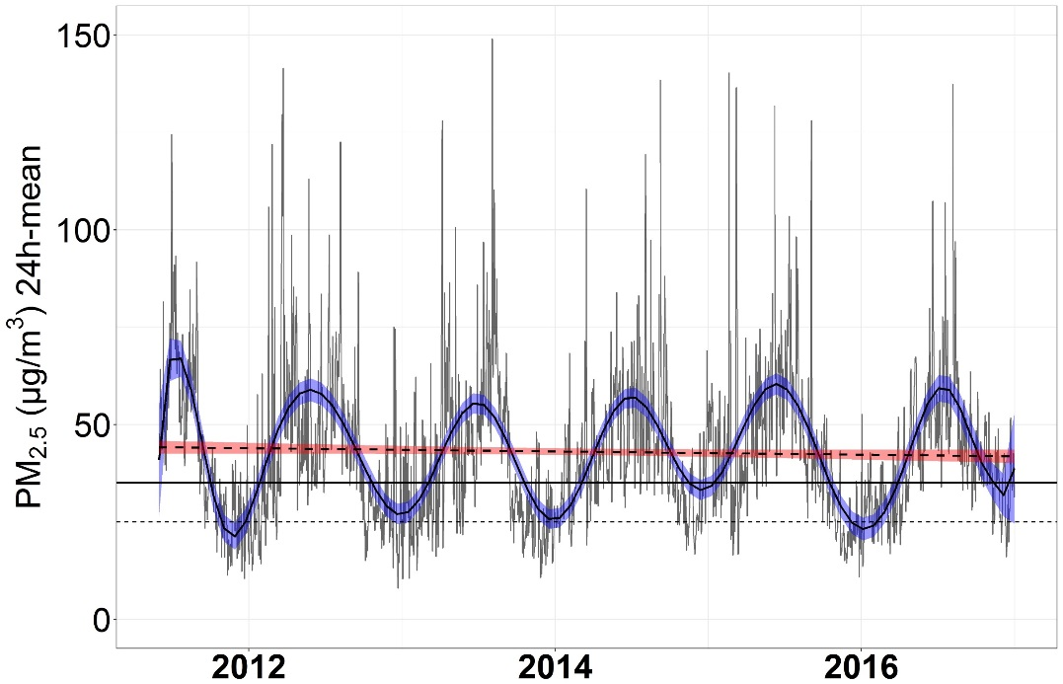

**Figure 1.** Time-series of PM2.5 concentrations data from 2011 to 2016 at locations of monitoring sites in the UAE. Data from 2011 to 2013 has been obtained from satellite observations whereas, data from 2014 to 2016, are ground measurements. Extreme outliers have been smoothed. Smooth blue line indicates the fit of the time series. Smooth red line indicate linear fit of the time-series. Dashed black line indicate the annual mean calculated over 6 years. Solid black line indicates the EPA PM2.5 limit value of 35 g/m3, whereas dashed line indicated the WHO PM2.5 limit value of 25 g/m3 for 24-h PM2.5 concentrations.

### Relative risk

The outcome of the **GLM model** generates coefficients **** **for each PM2.5 concentration giving the fitted count of daily hospital admissions. In health studies, the regression coefficients ** are also known as the **concentration-response coefficients** and are peculiar for each type of dataset used in the regression. In this study, **coefficients **** are peculiar for the UAE region. Previous studies on the burden of disease in the Emirate of Abu Dhabi and in the UAE have used coefficients ** from other epidemiological studies carried out in other Countries (Gibson et al., 2013; Li et al., 2010). However, only specific epidemiological studies in the UAE would indicate whether the UAE population response to pollutant is similar to that observed elsewhere in the world.

Coefficients ** were used to estimate of the **relative risk** (or risk ratio or relative rate) (***RR***) due to PM2.5 exposure. In epidemiology studies on health effect of ambient air pollution, *RR* is commonly estimated from the following equation (Aunan, 1996):

(2)

An alternative way to interpret the *RR* is to compute the percent relative effect (the percent change in an exposed group of people). In few words, when ***RR* > 1**, the % **increase in risk** = (*RR* - 1) x 100 that means an increase of the daily hospital admissions. On the other hand, when ***RR* < 1**, the % **decrease in risk** = (1 - *RR*) x 100 that means a decrease of the daily hospital admissions.

## Data processing

The purpose of the generalized linear regression model is to investigate if short-term variations in the health outcomes can be linked to changes in the PM2.5 exposure on daily basis. However, in the raw time-series data, **long-term patterns** such as **seasonality** might dominate (Figure 1). There are several methodological problems involved in the analysis of time-series studies. One is that the health variables usually exhibit some pattern over time which needs to be accounted for before air pollution effects can be studied. On the other hand, the great advantage of time-series studies is that they focus on variation with time over relatively short periods such as **daily variation** in the present study. Over such short periods, many personal characteristics such as age, smoking habits, do not change, so that they can be ignored as potential confounders. In addition, the variation in time of short-term average air pollution concentrations is often much greater than the variation in space of **the long-term average pollution concentrations** that form the basis of studies of **long-term effects of air pollution on health** (WHO, 1987). This is important because **sufficient variation in exposure** is a prerequisite in any analytical epidemiological study.

Therefore, in the present work, **seasonality has been removed** both from daily counts of hospital admissions and PM2.5 daily concentrations. For the elaboration of time series, we somewhat followed the methodology explained in the work of [Bhaskaran](https://www.ncbi.nlm.nih.gov/pubmed/?term=Bhaskaran%20K%5BAuthor%5D&cauthor=true&cauthor_uid=23760528) et al. (2013). Seasonality trends were calculated for the time series and subtracted to daily hospital admissions and PM2.5 concentrations to calculate the anomalies. Figure 2 and Figure 3 show the time-series and calculated anomalies of hospital admissions and PM2.5 concentrations used for the health analysis in the Emirates.

The removal of **outliers** from time-series of PM2.5 exposures is a matter of debate. Most frequently, relatively high PM2.5 concentrations levels in the UAE are strongly influenced by the presence of dust blowing from desert areas located outside urbanized areas. With the use of interactive time-series, it was possible to check and compare PM2.5 concentrations at different monitoring sites and to understand when an outlier could be considered an exceptional event in the whole set of data. After several trials and considerations, we decided to consider as **“potential outliers”** all the points of the time series that fall outside 4-times the Interquartile range (4-IQR) of the pollutant concentration over a quarter-time period. This procedure allowed **keeping the signature of dust events in the time series without then loosing potential and relevant exposure data for the health analysis.**

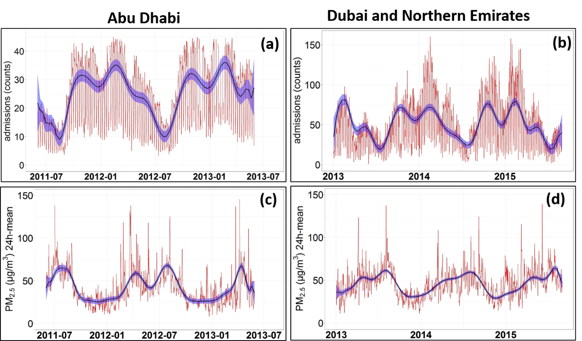

**Figure 2.** Time series of daily hospital admissions (a-b) and daily PM2.5 exposure (c-d) in selected clinics in Abu Dhabi, Dubai-Northern Emirates. Seasonal yearly cycle (blue line) is overlapped to raw data (red curve). PM2.5 outliers from dust events have not been completely removed.

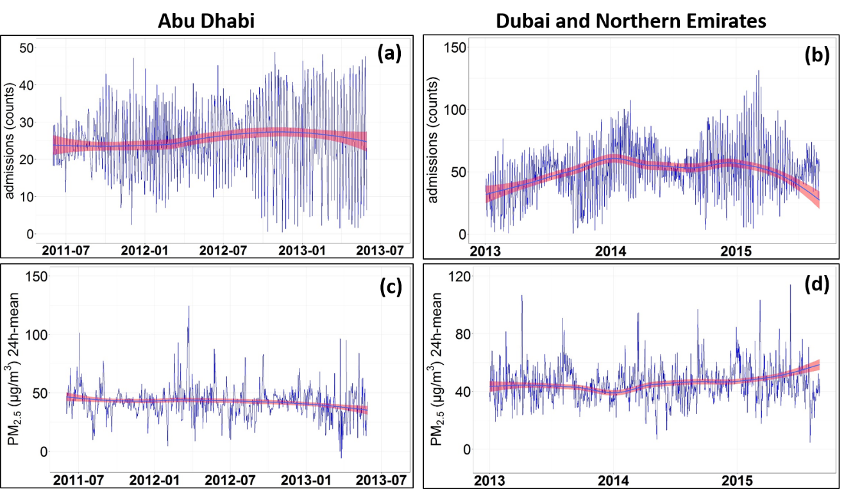

**Figure 3.** Filtered time series of daily hospital admissions (a-b) and daily PM2.5 exposure (c-d) in selected clinics in Abu Dhabi, Dubai-Northern Emirates. Same as Figure 1 but with the subtraction of seasonal yearly cycles.

In the investigation of the relationship between PM2.5 exposure and hospital admissions, we observed that **lag effects** influenced the performance and the significant coefficient in the regression used in for the health analysis. Therefore, we observed that PM2.5 exposure with a lag of 2 days and with a lag of 1 days were significantly associated with respiratory disease in health analysis in the Emirate of Abu Dhabi and Dubai-Northern Emirates, respectively.

## Results

In this work, we first verified if a relationship existed between the number of daily hospital admissions and the exposure to PM2.5. Figure 4, shows that in the Emirate of Abu Dhabi, an **increase of the rate of daily hospital admissions**, due to respiratory diseases, was observed at PM2.5 exposure levels higher than ~ 100 g/m3. On the other hand, for the Emirates of Dubai-Northern Emirate, the rate of daily hospital admissions showed a quasi-linear relationship with the PM2.5 exposure. Increasing PM2.5 concentrations corresponded to increasing rate of hospital admissions.

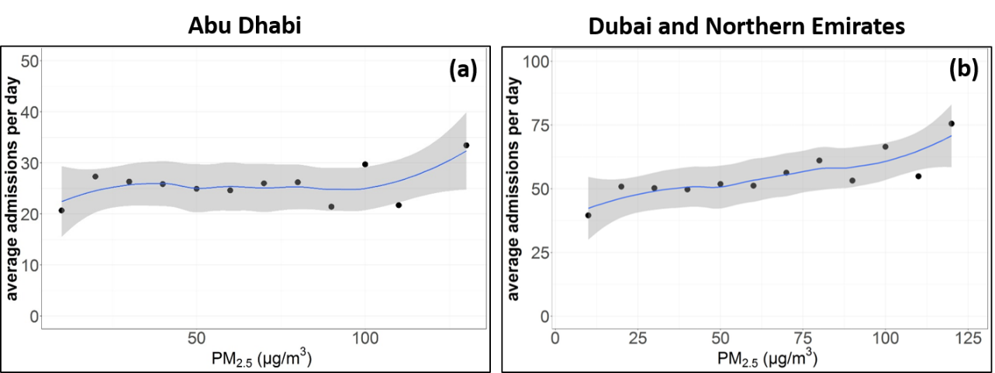

**Figure 4.** Average hospital admissions versus PM2.5 concentration in the emirate of Abu Dhabi, Dubai and Northern Emirates. Averages are at PM2.5 intervals of 10 g/m3,

The frequency of hospital admissions, due to respiratory diseases, was observed to be small at lower PM2.5 concentrations (Figure 5). This means that the potential **number of individuals reacting at very low concentrations was lower at lower concentrations**. The same trend was observed at higher concentrations. This behavior usually results in an exposure-effect relationship similar to an S-shape, with a slope approximately decreasing both to low and high PM2.5 concentrations (EU-Commission, 1997).

Estimates of the **relative rates (*RR*)** and 95% **Confidence Interval (CI)** of hospital admissions where obtained for each PM2.5 concentration when applying the generalized linear regression model (GLM) to the health datasets. Figure 6 shows the computed exposure curves expressed in relative risk (*RR*) for exposure to PM2.5 from the Emirate of Abu Dhabi and Dubai-Northern Emirates. For **small range of PM2.5 concentrations**, the **assumption of linearity** in the **exposure-effect relationship** was used an acceptable simplification in the study periods (EU-Commission, 1997). In fact, the number of individuals reacting at very low concentrations (and therefore the *RR*) is smaller with lower concentrations (Figure 5) (McClellan, 1989).

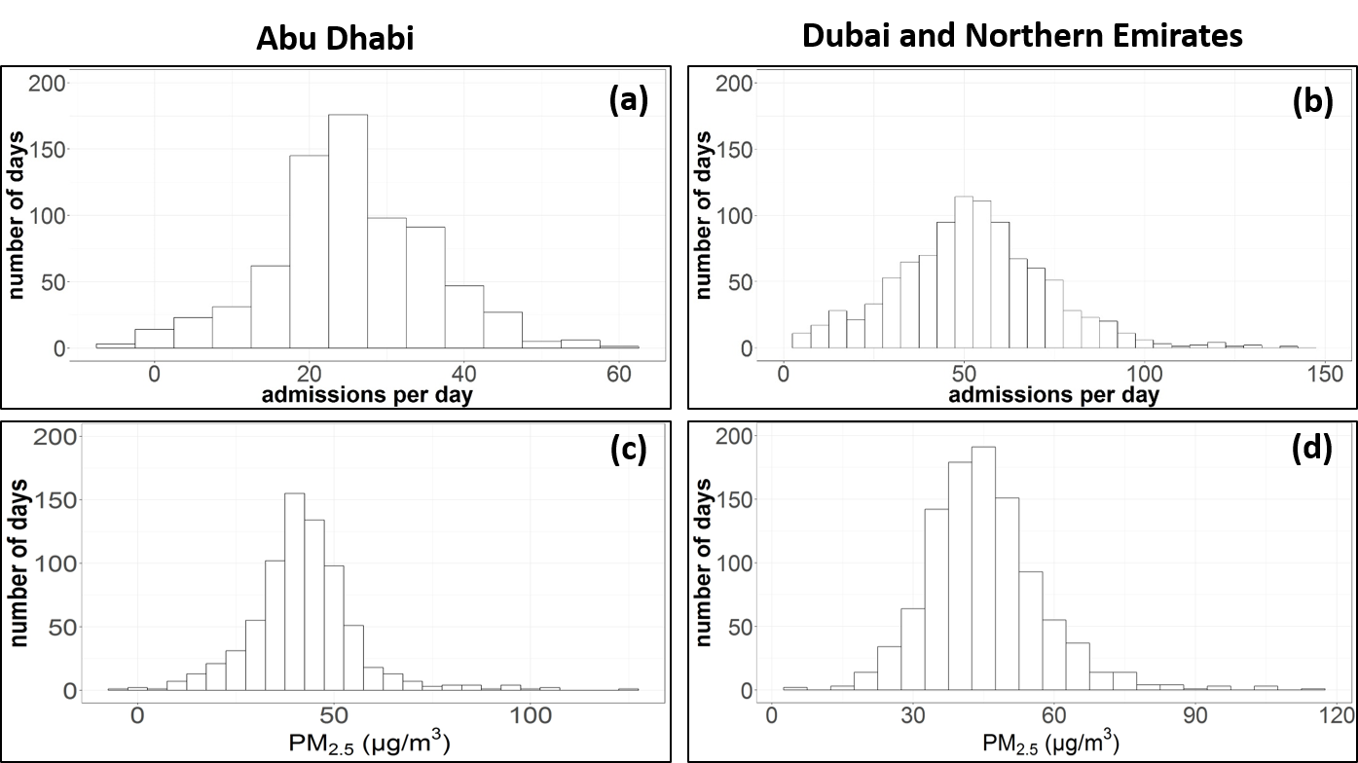

**Figure 5.** Distribution of the number of hospital admissions per day (a-b) and of the PM2.5 concentrations (c-d) in the Emirate of Abu Dhabi, Dubai and in the Northern Emirates. The intervals of the distributions are set to 5 admissions per day and to 5 g/m3for the admissions per day and for the PM2.5 concentration, respectively.

In the present analysis, a **linear-exposure curve** could be extrapolated from the tangent to the linear part of the exposure curve where the *RR* = 1. As shown in Figure 6, at zero exposure (PM2.5 = 0), the basal *RR* (i. e. that one associated with causes other than PM2.5 exposure) is higher than the one found using a linear-exposure curve. However, the **zero exposure basal value** corresponded to a non-zero exposure on the linear-exposure curve. This value was **~ 32 and ~ 31 g/m3**for the Emirate of Abu Dhabi and Dubai-Northern Emirates, respectively. Therefore, these values are representative for the entire UAE region and can be likely associated to the **background PM2.5 concentration in the UAE** with no risk on human health. However, we want to stress out that the background PM2.5 value is NOT the PM2.5 limit value to be statistically assumed as safe value for human health.

On the other hand, the **threshold PM2.5 concentrations** at which the relative risk associated to PM2.5 exposure starts increasing, were found at values of **~ 45 and ~ 48 g/m3 for the Emirate of Abu Dhabi and Dubai-Northern Emirates**, respectively.

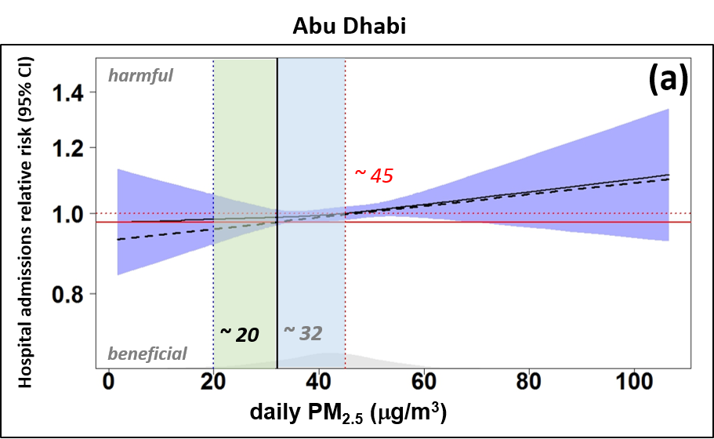

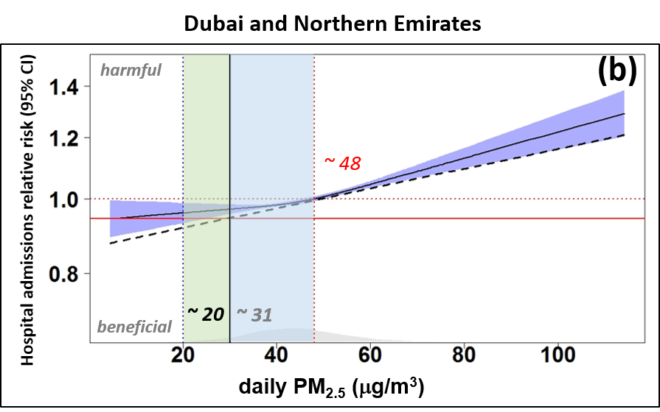

**Figure 6.** Concentration response curve (solid line) and 95% Confidence Interval (shaded area) for daily PM2.5 concentrations in the Emirate of Abu Dhabi (a), and Dubai-Northern Emirates (b). The regression was based on natural spline models with 3 degrees of freedom. Diagonal dashed line represents the exposure curve when assuming linearity.

The vertical scale can be interpreted as the relative rate (*RR*) of mortality as a function of PM2.5.The first vertical dashed line at ~ 20 g/m3 represents the lowest concentration at which relative risk increases more than 95% Confidence Interval, that is the PM2.5 values to be assumed as standard value. The second vertical dashed line at ~ 48 g/m3 represents the PM2.5 concentration when the Relative Risk (*RR)* is 1 (risk starts for human health). Middle vertical solid line indicate the *RR* at the lowest PM2.5 exposure likely considered as the PM2.5 background concentration in the UAE. Gray distribution along the abscissa indicate PM2.5 data density. Dashed line represents the exposure curve when assuming linearity.

|  |  |  |  |  |  |  |  |  |
| --- | --- | --- | --- | --- | --- | --- | --- | --- |
|  | **Health Outcome** | **Population**  (million) | **n**  (admissions) | **mean-daily admissions1** | **Relative Risk *(RR)***  (95% CI) | **% Increase risk in daily admissions**  (95% CI) | **Absolute increase in daily hospital admissions**  (95% CI) | **PM2.5 threshold1** (no risk)  (*RR* = 1) |
| **UAE** | Respiratory diseases | ~ 9.16 | ~ 70200 | 36 | 1.03 (1.01 – 1.04) | 3.0 (1.0 to 4.0) | 1.1 (0.36 to 1.44) | 46.5 |

1over 2 years

**Table 1.** Summary of outcomes for the increase in health effects for a 10 g/m3 change in PM2.5 for respiratory diseases in the United Arab Emirates (CI stands for Confidence Interval).

### 

### **Relative Risk from PM2.5 exposure in the UAE**

Table 1 reports the **average Relative Risk** *(RR)* derived from **PM2.5 exposure in the UAE**. A value of **~ 1.03 (1.01 – 1.04)** was obtained from averaging relative risks obtained from separate analysis for the Emirate of Abu Dhabi and the Emirate of Dubai-Northern Emirate. We want to stress out that these results are estimates based on samples of health data from some health facilities in the UAE. The outcome of the present analysis can be considered as starting point for future studies to characterize the health effect of PM2.5 on human health. Finally, in the UAE, we have estimated and increase in the **relative risk** of **hospital admissions of ~ 3% per day** and **per 10 g/m3 increase in PM2.5** exposure (Table 1). This means that an excursion of PM2.5 of 10 g/m3 would result in **1.1 extra hospital daily admissions** in the respective Emirates. These figures are related to the total UAE population.

### **PM2.5 standard for long term exposure (annual)**

According to the **guidelines** suggested by the **World Health Organization** (WHO, 2006), the exposure curves (Figure 6) and the outcome of the time-series analysis (Figure 1) were used to calculate estimates for PM2.5 at various **interim targets (IT)** for the UAE (Table 2). These targets can be thought as **intermediate steps** the UAE could use to reach the long-term exposure PM2.5 standard suggested below.

To estimate the **PM2.5 Air Quality Standard** **(AQS)** for **long-term exposure,** the annual mean PM2.5 concentration limit was chosen from the exposure-concentration curves (*RR*) when the uncertainty (Confidence Interval) was observed becoming significantly wider ( > 95%) (Dockery et al., 1993; Pope et al., 2002). This was done separately for the Emirate of Abu Dhabi and for the Emirate of Dubai-Northern Emirate using raw data from Figure 6. Then, the outcomes were averaged together to get one estimate for the UAE. Therefore, according to this criterion, a value of **~ 20 g/m3** was estimated for the Entire UAE (Table 2). This value could be tentatively assigned as the **PM2.5 Air Quality Standard** **(AQS)** for **long-term exposure (annual mean value)** we have estimated over a 2-year time-series in the UAE.

Starting for the above estimated PM2.5 Air Quality Standard, three other **interim targets (IT)** for **annual mean PM2.5** concentrations were estimated from different variations of the relative risk according to criteria suggested by the WHO (Table 2). Each interim target has been associated to number of potential increase/decrease in daily hospital admissions due to respiratory diseases.

### **PM2.5 standard for short term exposure (24-h)**

The guidelines for the 24-hours mean are designed to protect against peaks of pollution that can be observed on daily basis. As suggested by the WHO, the 24-hours average AQS was estimated from the relationship between the 24-hours and annual PM2.5 concentrations (WHO, 2006). For this purposes, we used a time time-series of 6 years PM2.5 concentrations (Figure 1). As shown in Figure 1, the average annual concentration estimated from 2011 to 2016, was ~ 43 g/m3.

The fit of the 6-years’ time trend, showed that the annual mean concentration was slightly decreasing from 2011 to 2016 with a lower limit value of ~ 39 g/m3. Additional analysis showed that annual PM2.5 mean for each year fell within the distribution of annual PM2.5 daily means. Therefore, the value of ~ **39 g/m3** could be tentatively designed as the **PM2.5 Air Quality Standard** for **short-term exposure (24-h or daily)** estimated over a 6-year time (Table 2).

Three other interim targets PM2.5 for 24-hours concentrations were estimated from different variations of the relative risk according to criteria suggested by the WHO (Table 2).

### **Final remarks and suggestions about the PM2.5 standards**

The above long-term and short-term PM2.5 limit values suggested for the UAE were compared with the ones in force in Europe, USA and adopted by the WHO (Table 4). The comparison showed that the suggested PM2.5 limit values for the UAE are in line with the one adopted in other Countries where effective and efficient measures have been take to mitigate air pollution.

It is extremely important to draw a delimitation line between the estimated PM2.5 standards values calculated according a statistical method (following the WHO guidelines), and **the real PM2.5 values** that can be practically reached in the UAE. Table 3 reports the PM2.5 annual concentrations estimated for the UAE from 2011 to 2016. As we can see, PM2.5 annual values are much higher than the proposed PM2.5 standard of ~ 20 g/m3. In addition, as mentioned above, it is likely that a recurrent background annual PM2.5 concentration of ~ 31 g/m3 is always present in the UAE. This most likely originates from natural sources (dust/sand). Therefore, a possible adoption of interim targets play a fundamental role in preparation to the reachability of the lowest PM2.5 limit value.

If structural actions are taken to mitigate natural source effects of PM2.5 as well anthropogenic source responsible for PM2.5, then the PM2.5 standards can be always revised in the future.

|  |  |  |  |
| --- | --- | --- | --- |
|  | **Long-term** (annual) | | |
| **PM2.5**  *(UAE)*  (g/m3) | **criteria for selected levels** | **Absolute increase/decrease in daily hospital admissions**  (95% CI) |
| **Interim Target-1 (IT-1)** | ~ 80 - 90 | 15% higher long-term risk relative to the AQS level | ~ 3.3 |
| **Interim Target-2 (IT-2)** | ~ 65 | lower the risk by 6% (2-11%)relative to IT-1 level | ~ 1.4 |
| **Interim Target (IT-3)** | ~ 35 | lower the risk by 6% (2-11%)relative to IT-2 level | ~ -0.5 |
| **Air Quality Standard (AQS)** | **~ 20** | lowest concentration at which relative risk increases more than 95% Confidence Interval (CI) | ~ -1.3 |
|  | **Short-term**(24-hours) | | |
| **PM2.5**  *(UAE)*  (g/m3) | **criteria for selected levels** | **Absolute increase/decrease in daily hospital admissions**  (95% CI) |
| **Interim Target-1 (IT-1)** | ~ 62 | 5% increase of short-term risk relative to the AQS level | ~ 1.18 |
| **Interim Target-2 (IT-2)** | ~ 51.5 | 2.5% increase of short-term risk relative to the AQS level | ~ 0.23 |
| **Interim Target (IT-3)** | ~ 45 | 1.2% increase of short-term risk relative to the AQS level | ~ -0.24 |
| **Air Quality Standard (AQS)** | **~ 39** | based on the relationship between 24-hours and annual PM2.5 levels1 | ~ -0.6 |

1 Extreme dust event outliers have been removed/reduced

**Table 2**. Target values proposed for PM2.5 limit value in the UAE as well for the Air Quality Standards. Estimation were carried out from the output of the regression analysis shown in Figure 6(a) and Figure 6(b). WHO guideline has been followed to set the AQS and the Interim Targets (WHO, 2006). CI stands for Confidence Interval.

|  |  |
| --- | --- |
| **year** | **PM2.5 daily mean in the UAE** |
| **2011** | 45.1 |
| **2012** | 42.6 |
| **2013** | 41.0 |
| **2014** | 43.4 |
| **2015** | 44.0 |
| **2016** | 42.0 |

**Table 3.** PM2.5 annual mean concentrations measured over all the monitoring stations in the UAE from 2011 to 2016. All values are given in g/m3. Data from 2011 to 2013 are from satellite estimations, while data from 2014 to 2016 are from monitoring stations.

|  |  |  |  |  |
| --- | --- | --- | --- | --- |
|  | **Europe** | **USA** | **UAE** | **WHO (AQG)** |
| **PM2.5, annual** | 25 | 15 | **20** | 10 |
| **PM2.5, 24-h** | 40 | 35 | **39** | 25 |

**Table 4.** Air quality standards (AQS) for PM2.5 in Europe, USA, and the World Health Organization (WHO), for 24-h averages and annual averages, respectively. All values are given in g/m3. Tentative PM2.5 Air Quality Standards for the UAE are reported.

## Preliminary Conclusions and Outlook

### Proposed PM2.5 standards

The present analysis is the first effort carried out in the UAE to estimate an exposure curve for PM2.5 concentration based on in-situ and satellite data. Health data of hospital admissions associated to respiratory diseases have been used together with PM2.5 exposure data recorded in the UAE in selected periods.

The exposures curve estimated from a well-known methodology has been used to evaluate the relative risk (*RR*) associated to increases in PM2.5 exposure. Although the present analysis has been carried out with a limited set of available health data, the results showed that the risk of **hospital admission** caused by **respiratory diseases** should increase by ~ **3% for each 10 g/m3 of PM2.5** exposure that correspond to ~ **1.1 extra hospital admission** when referred to the current population number in the UAE. As first guess, we can consider this result valid for the whole UAE. These estimates are indicative and based on the available data and assumption done for this work. A more comprehensive dataset of health record might be useful to achieve better estimates not only for hospital admission but also for mortality.

The WHO guidelines was used to estimate ad interim targets to gradually reach the proposed Air Quality Standards (AQS). The above figure has been used to estimate a lower limit for the **long-term PM2.5 exposure** of ~ **20 g/m3** (as PM2.5 AQS) that corresponded with the lowest relative risk measured within a significant statistically uncertainty. On the other hand, for **the short-term PM2.5 exposure**, a value of ~ **39 g/m3** (as PM2.5 AQS) was found from the relationship between multiple years’ time-series PM2.5 data and its annual means. Overall, PM2.5 standard limit values estimated and here proposed for the UAE are in line with the ones in force in Europe and in the USA.

### The role of dust/sand in the PM2.5 standard

At the date, there is not yet scientific evidence about the association of dust exposure and health disease. For PM10, recent studies conducted in Kuwait and Taipei (Taiwan), reported negative association between PM10 and all-cause of diseases, strengthening that **desert dust** is **less toxic** than **anthropogenic particles** (Al-Taiar and Thalib, 2014; Lee et al., 2014; Zhang et al., 2016). This consideration can be somewhat valid for PM2.5 because the present results showed that hospital admissions in the UAE slightly increase when PM2.5 concentration are above ~ 100 g/m3 that is when strong dust events probably start occurring. Ongoing work within this framework project is trying establishing the background concentration of PM2.5 that, on average, is always present across the UAE and that might likely associated to natural origins.

In the present analysis, the PM2.5 dust component could not be completely removed as it is always a component of PM2.5. However, after several trials, only extreme and rare outliers have been reduced in order to keep the signature of dust event in the whole PM2.5 dataset.

### Suggested implementation of measures to target lower PM2.5 standards

The UAE is encouraged to implement **plans and strategies** to reach short- and long-term PM2.5 standards in the near future. As general suggestion, the UAE should develop a **National Air Quality** plan foreseeing attainment of the PM2.5 limit value in the next 5 years period. The air quality plan should take into considerations some of the following critical issues such as:

* the **complexity** of the mechanism for the PM2.5 formation in the atmosphere
* the contribution of PM2.5 concentration from **global and regional sources**
* the contribution of PM2.5 from **natural sources**

The UAE has also critical issues related to **meteorological and morphological conditions**, which are often responsible for increase of PM2.5 concentrations across the whole County. These factors might have important impact on the **accumulation and the dispersion** of pollutants above all in urban areas.

At the date, in the UAE there is no available documentation about the contribution of different emission sources to PM2.5 at National level except for few works carried out in the Emirates of Abu Dhabi and Sharjah. However, according to the recent works on source apportionment carried out by NILU (2012), and Hamdan et al.(2016), in the absence of dust events, emissions from **industrial** activities, **energy** production and, **traffic** may be considered the major sources of PM2.5. This is in agreement with the review carried out in by the WHO about the major source apportionment of PM2.5 and PM10 a global level. The Middle East region showed PM2.5 concentrations dominated by a high dust component (52%) followed by industrial (27%) and traffic emissions (12%) and unspecified sources of human origin (12%) (Karagulian et al., 2015). Industry emissions include power generation (energy) using fossil fuels oil productions/refinery activities.

In the following, we are going to suggest some measure that Western Countries are currently adopting in order to reduce the ambient concentrations of PM2.5. These measures have been thought and designed according to scenarios where anthropogenic emissions were reduced by enforcing the **use of new technologies**, **renewables**, **regulations** and **educating people** to a **sustainable use of natural resources**.

For the purpose of this work, measures have been adapted to UAE needs and environmental conditions typical of the region.

As further suggestion, the UAE should enforce the PM2.5 limit values based on a selection of effective measures that **do not have negative social and economic impact across all the Country**.

### **Measures in the transport sector**

To reduce emissions in the transport sector at Country level, the following measures are suggested:

* Deployment of vehicles with **lower environmental impact** in the private and public sector
* Enhancement of public transportation with the purchase of low emission vehicles for the public sector
* Establishment of **Low Emission Zones** (LEZ) in urban areas (traffic restrictions in urban areas for most polluting vehicles, traffic restrictions in urban areas subjected to high traffic flows)
* Implementations of regulations on the distributions of goods in urban areas
* Programs of **sustainable mobility** (incentives for the purchasing of electric vehicles, recharging points for the electrical vehicles)
* Incentives promoting integrated transportation of goods on railways, roads and sea
* Differentiated **toll** to be paid by vehicles based on their **emissions**
* Implementation of additional controls and measures for **opacity level** on roads caused by **diesel vehicles** (mostly **heavy duty trucks**)
* Establishment of urban plans for **traffic management** (construction of additional roads to improve traffic management, construction of new public parking sites and new roundabouts to avoid traffic congestion)
* Implementation of sustainable mobility: metro-tram, introduction of carpooling schemes, implementation of energy efficiency with the use of **LEDs** in traffic lights.
* Restrictions on the use of cars in urban areas during days where emissions of PM2.5 exceed the limit values.
* More frequent **road cleaning** with water based products on the days where emissions of PM2.5 exceeds the limit values.
* Inspection of emissions from private boats and promotion of boats using Liquefied petroleum gas (LPG)

### **Measures in the industry/energy sector**

To reduce emissions in the industry/energy sector at Country level, the following measures are suggested:

* Definition of **emission limits** for some categories of industrial plants (in compliance with the International Panel on Climate Change, IPCC). Obligation for all industrial plants to comply with a National authorization for the emissions in the atmosphere
* Reduction of industrial emissions from specific plants located in urban areas
* Conversion of industrial machinery to allow operating with **cleaner fuels** (above all the ones burning oil and kerosene)
* Development of technologies for the production of energy from biomass (e.g. **biogas**)
* Improve energy **efficiency in industrial plants**. Promotion of the use of renewable energy in manufacturing plants
* Introduction of an **energy audit** in factories
* Realization of **smart grids** for energy distribution
* Promotion of **energy savings** in industrial and commercial activities
* Introduction of guidelines for the use of chemical products in the agriculture.

### **Measures in the residential/commercial sector**

To reduce emissions in the residential/commercial sector at Country level, the following measures are suggested:

* Introduction of guidelines for residential power plants, **energy performance certification** for buildings and implementation of thermoregulation systems
* Enhanced controls on the thermal efficiency of the existing residential power plants
* Intervention to regulate all domestic cooling plants to comply with the regulations
* Incentives of the installation of **photovoltaic systems** for the production of electric energy. Installation of photovoltaics on public buildings.
* Implementation of more stringent measures for the operation of power plants located in the urban area during the summer season
* Substitution of public and private lights (currently using mercury bulbs) with **LEDs bulbs**.
* Promotion for the use of **sustainable materials** and technologies for the construction of new buildings
* Incentives for the use of **energy saving technologies** in residential and public buildings
* Interventions on energetic re-qualification of public buildings.
* Realization of remote cooling systems through partnership between public and private bodies
* Domestic apparatus that allows the tenants and landlords to easily **verify energy consumptions**
* **Prohibition to burn biomass in open air**
* Implementation of additional **green areas** covered with vegetation in around urban agglomerates to reduce the emission of dust/sand from desert areas. Suitable **high trees** should be planted around urban areas to stop coarse and fine particles during windy days.

Finally, work on **source apportionment** is highly recommended at regional level. This will supplement the missing information about the specific contribution of emission sources to PM2.5 formation. A better knowledge of emission sources will allow targeted intervention at regional and/or Emirate level.

References

Al-Taiar, A., Thalib, L., 2014. Short-term effect of dust storms on the risk of mortality due to respiratory, cardiovascular and all-causes in Kuwait. Int. J. Biometeorol. 58, 69–77. doi:10.1007/s00484-012-0626-7

Aunan, K., 1996. Exposure-response functions for health effects of air pollutants based on epidemiological findings. Risk Anal. Off. Publ. Soc. Risk Anal. 16, 693–709.

Belis, C., Bo, L., Amato, F., Haddad, I., Favez, O., Harrison, R.M., Hopke, P., Nava, S., Paatero, P., Prevot, A.S., Quass, U., Vecchi, R., Viana, M., 2014. European Guide on Air Pollution Source Apportionment with Receptor Models. European Commission, Joint Research Centre, Institute for Environment and Sustainability, JRC-Reference Reports, Luxembourg.

Bell, M.L., Son, J.-Y., Peng, R.D., Wang, Y., Dominici, F., 2015. Ambient PM2.5 and Risk of Hospital Admissions: Do Risks Differ for Men and Women? Epidemiol. Camb. Mass 26, 575–579. doi:10.1097/EDE.0000000000000310

Bhaskaran, K., Gasparrini, A., Hajat, S., Smeeth, L., Armstrong, B., 2013. Time series regression studies in environmental epidemiology. Int. J. Epidemiol. 42, 1187–1195. doi:10.1093/ije/dyt092

Burnett, R.T., Pope, C.A., Ezzati, M., Olives, C., Lim, S.S., Mehta, S., Shin, H.H., Singh, G., Hubbell, B., Brauer, M., Anderson, H.R., Smith, K.R., Balmes, J.R., Bruce, N.G., Kan, H., Laden, F., Prüss-Ustün, A., Turner, M.C., Gapstur, S.M., Diver, W.R., Cohen, A., 2014. An integrated risk function for estimating the global burden of disease attributable to ambient fine particulate matter exposure. Environ. Health Perspect. 122, 397–403. doi:10.1289/ehp.1307049

Dockery, D.W., Brunekreef, B., 1996. Longitudinal Studies of Air Pollution Effects on Lung Function. Am. J. Respir. Crit. Care Med. 154, S250–S256. doi:10.1164/ajrccm/154.6_Pt_2.S250

Dockery, D.W., Pope, C.A., Xu, X., Spengler, J.D., Ware, J.H., Fay, M.E., Ferris, B.G., Speizer, F.E., 1993. An association between air pollution and mortality in six U.S. cities. N. Engl. J. Med. 329, 1753–1759. doi:10.1056/NEJM199312093292401

Dominici, F., Daniels, M., Zeger, S.L., Samet, J.M., 2002. Air Pollution and Mortality: Estimating Regional and National Dose-Response Relationships. J. Am. Stat. Assoc. 97, 100–111.

EU-Commission, 1997. Ambient Air Pollution by Particulate Matter, Position Paper. Eur. Comm.

Gibson, J.M., Thomsen, J., Launay, F., Harder, E., DeFelice, N., 2013. Deaths and Medical Visits Attributable to Environmental Pollution in the United Arab Emirates. PLOS ONE 8, e57536. doi:10.1371/journal.pone.0057536

Hak, C., López-Aparicio, S., Sivertsen, B., 2011. Chemical speciation of fine airborne particles in Abu Dhabi. Elements, inorganic ions and carbonaceous fractions at eight sites in Abu Dhabi. NILU OR 21/2011. Kjeller NILU.

Hamdan, N.M., Alawadhi, H., Jisrawi, N., 2016. Particulate Matter Pollution in the United Arab Emirates: Elemental Analysis and Phase Identification of Fine Particulate Pollutants. ICEPR 158 Proc. 2 Nd World Congr. New Technol. NewTech16. doi:10.11159/icepr16.158

Hastie, T.J., Tibshirani, R.J., 1990. Generalized Additive Models, New York: Chapman and Hall.

Holben, B.N., Eck, T.F., Slutsker, I., Tanré, D., Buis, J.P., Setzer, A., Vermote, E., Reagan, J.A., Kaufman, Y.J., Nakajima, T., Lavenu, F., Jankowiak, I., Smirnov, A., 1998. AERONET—A Federated Instrument Network and Data Archive for Aerosol Characterization. Remote Sens. Environ. 66, 1–16. doi:10.1016/S0034-4257(98)00031-5

Karagulian, F., Belis, C.A., Dora, C.F.C., Prüss-Ustün, A.M., Bonjour, S., Adair-Rohani, H., Amann, M., 2015. Contributions to cities’ ambient particulate matter (PM): A systematic review of local source contributions at global level. Atmos. Environ. 120, 475–483. doi:10.1016/j.atmosenv.2015.08.087

Kiesewetter, G., Schoepp, W., Heyes, C., Amann, M., 2015. Modelling PM2.5 impact indicators in Europe: Health effects and legal compliance. Environ. Model. Softw. 74, 201–211. doi:10.1016/j.envsoft.2015.02.022

Kloog, I., Coull, B.A., Zanobetti, A., Koutrakis, P., Schwartz, J.D., 2012. Acute and Chronic Effects of Particles on Hospital Admissions in New-England. PLOS ONE 7, e34664. doi:10.1371/journal.pone.0034664

Lee, H., Honda, Y., Lim, Y.-H., Guo, Y.L., Hashizume, M., Kim, H., 2014. Effect of Asian dust storms on mortality in three Asian cities. Atmos. Environ. 89, 309–317. doi:10.1016/j.atmosenv.2014.02.048

Lelieveld, J., Evans, J.S., Fnais, M., Giannadaki, D., Pozzer, A., 2015. The contribution of outdoor air pollution sources to premature mortality on a global scale. Nature 525, 367–371. doi:10.1038/nature15371

Li, Y., Gibson, J.M., Jat, P., Puggioni, G., Hasan, M., West, J.J., Vizuete, W., Sexton, K., Serre, M., 2010. Burden of disease attributed to anthropogenic air pollution in the United Arab Emirates: Estimates based on observed air quality data. Sci. Total Environ., Special Section: Integrating Water and Agricultural Management Under Climate Change 408, 5784–5793. doi:10.1016/j.scitotenv.2010.08.017

Mantovani, K.C.C., Nascimento, L.F.C., Moreira, D.S., Vieira, L.C.P.F. da S., Vargas, N.P., Mantovani, K.C.C., Nascimento, L.F.C., Moreira, D.S., Vieira, L.C.P.F. da S., Vargas, N.P., 2016. Air pollutants and hospital admissions due to cardiovascular diseases in São José do Rio Preto, Brazil. Ciênc. Amp Saúde Coletiva 21, 509–516. doi:10.1590/1413-81232015212.16102014

McClellan, R.O., 1989. Reflections on the Symposium: Susceptibility to Inhaled Pollutants. doi:10.1520/STP22842S

MEDICODE (FIRM), 1996. ICD-9-CM: International classification of diseases, 9th revision, clinical modification, Salt Lake City, Utah. MEDICODE FIRM.

Nelder, J.A., Wedderburn, R.W.M., 1972. Generalized Linear Models. J R Stat. Soc A Part 3, 370.

NILU, 2012. Chemical Speciation of Fine Airborne Particles in Abu Dhabi: Source Apportionment.

Pope, C.A., Burnett, R.T., Thun, M.J., Calle, E.E., Krewski, D., Ito, K., Thurston, G.D., 2002. Lung Cancer, Cardiopulmonary Mortality, and Long-term Exposure to Fine Particulate Air Pollution. JAMA J. Am. Med. Assoc. 287, 1132–1141.

Remer, L.A., Kaufman, Y.J., Tanré, D., Mattoo, S., Chu, D.A., Martins, J.V., Li, R.-R., Ichoku, C., Levy, R.C., Kleidman, R.G., Eck, T.F., Vermote, E., Holben, B.N., 2005. The MODIS Aerosol Algorithm, Products, and Validation. J. Atmospheric Sci. 62, 947–973. doi:10.1175/JAS3385.1

Schwartz, J., Dockery, D.W., Neas, L.M., 1996. Is daily mortality associated specifically with fine particles? J. Air Waste Manag. Assoc. 1995 46, 927–939.

Thurston, G.D., Burnett, R.T., Turner, M.C., Shi, Y., Krewski, D., Lall, R., Ito, K., Jerrett, M., Gapstur, S.M., Diver, W.R., Pope, C.A., 2016. Ischemic Heart Disease Mortality and Long-Term Exposure to Source-Related Components of U.S. Fine Particle Air Pollution. Environ. Health Perspect. 124, 785–794. doi:10.1289/ehp.1509777

Thurston, G.D., Ito, K., Kinney, P.L., Lippmann, M., 1992. A multi-year study of air pollution and respiratory hospital admissions in three New York State metropolitan areas: results for 1988 and 1989 summers. J. Expo. Anal. Environ. Epidemiol. 2, 429–450.

WHO, 2014. News release: 7 million premature deaths annually linked to air pollution. Media centre WHO Geneva, http://www.who.int/mediacentre/news/releases/2014/air-pollution/en/.

WHO, 2006. WHO Air quality guidelines for particulate matter, ozone, nitrogen dioxide and sulfur dioxide. Global update 2005. World Health Organ.

WHO, 1987. Air quality guidelines for Europe, Copenhagen, WHO Regional Office for Europe. WHO Reg. Publ. Eur. Ser. No 23.

Wichmann, H.E., Heinrich, J., 1995. Health effects of high level exposure to traditional pollutants in East Germany--review and ongoing research. Environ. Health Perspect. 103, 29–35.

Wordley, J., Walters, S., Ayres, J.G., 1997. Short term variations in hospital admissions and mortality and particulate air pollution. Occup. Environ. Med. 54, 108–116.

Zhang, X., Zhao, L., Tong, D., Wu, G., Dan, M., Teng, B., 2016. A Systematic Review of Global Desert Dust and Associated Human Health Effects. Atmosphere 7, 158. doi:10.3390/atmos7120158