*Type of the Paper (Review)*

**Review of performance of Low-cost Sensors for Air Quality Monitoring**

**Federico Karagulian1, Michel Gerboles1*, Maurizio Barbiere1, Friedrich Lagler1, Alex Kotsev2, Laurent Spinelle3,4 , Caroline Marchand3,4, Nathalie Redon5, Sabine Crunaire5, Benoît Herbin5 and Annette Borowiak1**

1 European Commission, Joint Research Centre (JRC), Directorate for Energy, Transport and Climate, Air and Climate Unit, Via Enrico Fermi 2749, 21027 Ispra VA, Italy, [federico.karagulian@ec.europa.eu](mailto:federico.karagulian@ec.europa.eu); [michel.gerboles@ec.europa.eu](mailto:michel.gerboles@ec.europa.eu); [maurizo.barbiere@ec.europa.eu](mailto:maurizo.barbiere@ec.europa.eu); f[riedrich.lagler@ec.europa](mailto:Friedrich.lagler@ec.europa.eu).eu;[annette.borowiak@ec.europa.eu](mailto:annette.borowiak@ec.europa.eu)

2 European Commission, Joint Research Centre (JRC) Digital Economy Unit, Growth and Innovation Directorate, Via Enrico Fermi 2749, 21027 Ispra VA, Italy), [alex.kotsev@ec.europa.eu](mailto:alec.kotsev@ec.europa.eu)

3 Institut national de l'Environnement Industriel et des Risques (INERIS), Parc technologique Alata, BP 2, F-60550 Verneuil-en-Halatte, France, [laurent.spinelle@ineris.fr](mailto:laurent.spinelle@ineris.fr); [caroline.marchand@ineris.fr](mailto:caroline.marchand@ineris.fr)

4 Laboratoire Central de Surveillance de la Qualité de l’Air (LCSQA), Parc technologique Alata, BP 2, F-60550 Verneuil-en-Halatte, France, [laurent.spinelle@ineris.fr](mailto:laurent.spinelle@ineris.fr)

5 IMT Lille-Douai, Univ. Lille, SAGE-Departement Sciences de l’Atmosphère et Génie de l’Environnement, F-59000 Lille, France, [nathalie.redon@imt-lille-douai.fr](mailto:nathalie.redon@imt-lille-douai.fr); [sabine.crunaire@imt-lille-douane.fr](mailto:sabine.crunaire@imt-lille-douane.fr); benoit.herbin@[imt-lille-douane.fr](mailto:sabine.crunaire@imt-lille-douane.fr)

**\*** Correspondence: michel.gerboles@ec.europa.eu; Tel.: +39-0332-78-5652

Received: date; Accepted: date; Published: date

**Abstract**

A growing number of companies started commercializing Sensor Systems that are said to be able to monitor air pollution in outdoor air. The benefit about the use of low-cost sensor is the increase spatial coverage when monitoring air quality in cities and remote locations. Today, there are more than 250 low-cost sensor systems commercially available on the market with a cost ranging from a few hundreds to a few thousand euro. At the same time, independent evaluation of the performance of sensor systems against reference measurements is only available in literature for about 70 sensor systems in literature. In fact, studies report that low-cost sensors are unstable and often affected by atmospheric condition, cross sensitivities with interfering compounds that may change of concentration levels form site to site location where the LCS are used. In this work, quantitative data about the performance of tested low-cost sensors against reference measurement were collected into a repository. This information was gathered from published reports and relevant testing laboratories. Other information was drawn from peer-reviewed journals that tested different types of sensors in research studies. Relevant metrics about the comparison of sensor systems against reference systems highlighted the most cost-effective sensor systems that could be used to monitor air quality pollutants with a good level of agreement represented by a coefficient of determination of R2 > 0.75 a *slope* of 1.0 ± 0.5 and a price < 3 k€. This review wanted to highlight the possibility to have versatile sensors able to operate with multiple pollutants and with transparent data treatment .

**Keywords:** electrochemical sensors, metal oxide sensors; optical particle counters; nephelometers, citizen science, performance evaluation, sensor validation.

# 1 Introduction

The widening of the commercial availability of micro-sensors technology is contributing to the rapid adoption of low-cost sensors (LCS) for air quality monitoring either for citizen science initiative either for public authorities [[1]](https://www.zotero.org/google-docs/?jVwAsd). In general, public authorities want to increase the density of monitoring measurements and often want to rely on LCS because they cannot afford any reference Air Quality Monitoring Station (AQMS) ([[2]](https://www.zotero.org/google-docs/?9h7fII)). Low-cost in this context is typically referring to the cost of the hardware components needed to make a measurement compared to the purchasing and maintenance cost of AQMS. LCS can provide real time measurements at lower cost allowing higher spatial coverage than the current reference methods of measurements of air pollutants. Additionally, the monitoring of air pollution with reference measurements methods requires skilled operators for the maintenance and calibration of measuring devices that are described in detailed Standard Operational Procedures [[3–7]](https://www.zotero.org/google-docs/?1eUOhZ). Conversely, it is expected that LCS can be operated without human intervention making it possible for unskilled users to be able to monitor air pollution without the need of important technical understanding

Plenty of institutes in charge of air quality monitoring for regulatory purposes or other local authorities are considering to include LCS within their method of measurements. However, the lack of exhaustive and accessible information in order to compare the performance of LCS and the wide offer within the market of LCS make it difficult to select the most appropriate LCS for monitoring purposes. We have carried out an extensive literature review of sensors produced by Original Equipment Manufacturer (hereafter such sensors are called OEM) and sensor systems (SS), which include such OEM and protective box, internal hardware and software for data acquisition, data treatment and data transfer [[8]](https://www.zotero.org/google-docs/?PAR9Ow) . Hereafter, OEM and SS are referred as Sensors. The results of this review was used to estimate concentration of air pollutants against a reference systems during field and laboratory tests. The aim of this work is to provide all stakeholders with exhaustive information that is not available elsewhere. The purpose was to gather quantitative information about the performance of sensors according to the following criteria:

1. Agreement between sensor and reference measurements
2. Availability of raw data, transparency of data treatment making a-posteriori calibration possible
3. Capability to measure multiple pollutants
4. Affordability of sensor systems taking into consideration the number of provided sensors

Although a number of reviews of the suitability of sensors for ambient air quality have been published [[1,9–15]](https://www.zotero.org/google-docs/?Djgr6d), quantitative data for comparing and evaluating the agreement between sensors and reference data are mostly missing in the existing reviews. Additionally, there is no commonly accepted protocol for the test of LCS, the metrics reported are generally diverse making it difficult to compare the performance of sensor between evaluation studies. Nearly all published studies report the coefficient of determination (R²) between reference and sensor data. R² measures the strength of the association between two variables but it is insensitive to any type of bias between sensor and reference data. Fortunately, the majority of these studies also reports the slope and intercept of the regression line between sensor and reference measurements that describe the possible bias of sensor data. A few studies also report the Root Mean Square of Error, RMSE [[16–29]](https://www.zotero.org/google-docs/?SJNHta) which clearly indicates the magnitude of the error in sensor unit and that is sensitive to extreme values and outliers. Only a few studies report the measurement uncertainty [[24,25,30–35]](https://www.zotero.org/google-docs/?lLWb0P), which in Europe is the main legislative indicator used in European Air Quality Directive [[36]](https://www.zotero.org/google-docs/?zIxHVB). Here after, the results of an exhaustive review of the existing literature on LCS evaluation are presented.

Among the available LCS, there are clear indications that the accuracy of sensor measurements can be questionable [[16,37]](https://www.zotero.org/google-docs/?vxrPAa) when comparing LSC values and reference measurement. LCS can be of variable quality making, therefore it is fundamental to evaluate LCS before choosing any LCS for routine measurements and case studies [[38]](https://www.zotero.org/google-docs/?sAAi7N). As reported above, only a few independent tests are reported in academic publications.

The main aim of this work is to provide an up to date quantitative evaluation and comparison of sensor performances that cannot be found in other publications. This information is going to be beneficial for all sensor users when selecting the most appropriate LCS for their monitoring purposes.

Add main conclusion on which sensors? are best for ?

The interest in low sensors showed an increase of the number of publication starting in 2014.

The majority of calibration of sensors is carried out using field tests.

The main metrics used for evaluating the goodness of fit of sensor data versus reference measurements consist of the coefficient of determination, R² and the slope of their regression line.

Majority of calibration method use linear calibration while a few laboratory studies under controlled conditions showed that sensors are affected by non-linear cross-sensitivities and meteorological parameters. Wrong the majority is MLR, then LR and then quadratic

# 2 Sources of available information, method of classification and evaluation

## 2.1 Origin of data

The research was focused on sensors for Particulate Matter (PM), Ozone (O3), Nitric Dioxide (NO2) and Carbon Monoxide (CO), the pollutants that are included into the European Air Quality Directive [[2]](https://www.zotero.org/google-docs/?9h7fII). References were also included for nitrogen monoxide sensors.

About 1401 independent laboratory or field tests of sensor versus reference measurements (called Records in the rest of the manuscript) were gathered from peer-reviewed studies of sensors for air quality and air pollution reported in the Scopus database, the World Wide Web, the AirMontech website (<http://db-airmontech.jrc.ec.europa.eu/search.aspx>), ResearchGate, Google search and reports from research laboratories. Overall, 62 independent studies were found from different sources from reports, peer-reviewed papers and sensors manufacturers.

Additionally, a significant number of test results comes from reports published by research institutes. In fact, the rapid technological progress on LCS, the difficulty to publish sensor data that do not agree with reference measurements and the time needed to publish studies in academic journals makes publication of articles not the preferred route. Consequently, a great part of the available information is found in grey literature, mainly of report types. A substantial quantity of presented results comes from research institutes having a sensor testing program in place [e.g., Air Quality Sensor Performance Evaluation Center (AQ-SPEC), EU JRC, US EPA, etc.].

A part of the data comes from the first French field intercomparison exercise (Crunaire[[39]](https://www.zotero.org/google-docs/?iGcfsq)) for gas and particle sensors carried out in January/February 2018. This exercise was carried out by two members of the French Reference Laboratory for Air Quality Monitoring (LCSQA). The objective of the study was to test sensors under field conditions at a fixed stations of urban type of the ITM Lille Douai sited at its research facilities of Dorignies. A large number of different sensors systems were installed in order to evaluate their ability to monitor the main pollutants of interest in ambient air: nitrogen dioxide (NO2), ozone (O3) and particles (PM2.5 and PM10). This exercise involved nearly 25 French laboratories in charge of air pollution monitoring, 23 sensor systems of different design and origin (France, Netherlands, United Kingdom, Spain, Italy, Poland, United States), for a total of more than sixty devices, when taking into account replicates.

A publicly available database of laboratory and field test results and its associated scripts for summary statistics were created using the collected information. It will be possible to update with future results of sensor tests. The purpose was to setup a structured repository to be used for intercomparison analysis between sensors.

Each database Record describing the laboratory or field sensor test results was included into the database only if comparison against a reference measurement ([hereinafter](https://context.reverso.net/traduzione/inglese-italiano/hereinafter) defined as “comparison”) was provided. The comparison data allowed evaluating the correlation between sensor data with reference measurements. Most of the reviewed studies reported only regression parameters obtained from the comparison between sensors and reference measurements, generally without more sophisticated metrics like RMSE and measurement uncertainty (see section 3).

## 2.2 Classification of sensors

For each model of sensor system we identified the manufacturer of OEM sensor and the manufacturer of the sensor system itself. Overall, we found 112 models of sensors including both OEMs (33) and sensor systems (81) manufactured by 80 manufacturers (17 OEM and 63 SS). In addition, we identified 19 projects about the evaluation of OEMs/sensor systems under different operational conditions (Air Quality Egg, Air Quality Station, AirCasting [[22,40–42]](https://www.zotero.org/google-docs/?ioPEJr), Carnegie Mellon [[22,43]](https://www.zotero.org/google-docs/?aum9Xp), CitiSense [[30]](https://www.zotero.org/google-docs/?4NNnf5) Cairsense [[44]](https://www.zotero.org/google-docs/?LaIKI1), Developer Kit [[40]](https://www.zotero.org/google-docs/?uDQIvd), HKEPD/14-02771 [[45]](https://www.zotero.org/google-docs/?013YV3), making-sense.eu [[29]](https://www.zotero.org/google-docs/?3asMF0), communitysensing.org [[46]](https://www.zotero.org/google-docs/?J3UMOo), MacPoll.eu [[16]](https://www.zotero.org/google-docs/?bMENBV), OpenSense II [[27,28]](https://www.zotero.org/google-docs/?xVU0OK), Proof of Concept AirSensEUR [[25]](https://www.zotero.org/google-docs/?qx9iLA), SNAQ Heathrow [[47,48]](https://www.zotero.org/google-docs/?ZY5glu)). Out of 1401 Records collected from literature, we identified 1262 Records (288 OEM and 974 SS) from 92 alive sensors (28 OEM and 64 SS) and 139 Records (28 OEM and 111 SS ) from 20 “non active” (or discontinued) sensors (5 OEM and 15 SS).

Commonly speaking, “low-cost” refers to the cost of a sensor system compared to the cost of a reference instrument measuring the air pollutant [[8]](https://www.zotero.org/google-docs/?GchP9K). More recently, ultra-affordable OEMs are starting to appear on the market for PM monitoring. Many of them are designed to be integrated in the Internet of things (IoT) network of devices. Currently, for PM detection it is possible to purchase optical sensor at prices of a few hundred euros to few tens of euros from devices manufactured in emerging economies such as the Republic of China and the Republic of Korea [[49]](https://www.zotero.org/google-docs/?5uJTGd). For the PM monitoring, some of these sensors are starting achieving performances comparable to low-cost OEMs manufactured in the Western world [[18,22,35,40–42,44,50–56]](https://www.zotero.org/google-docs/?eN7gV6).

The data treatment of sensor data can be classified in two distinct categories:

1. Data processing of sensor data performed by an “open source” software tuned according to several calibration parameters and environmental conditions. All data treatments from data acquisition until the conversion to pollutant concentration levels is known to the user. We identified 401 Records made of 280 OEMs and 121 sensor systems using an open source software for data management. These 401 Records came from 37 unique Sensors. Usually, outputs from these sensors are already in the same measurement units as the reference measurements. In this category, sensor devices are generally connected to a custom-made data acquisition system to acquire sensor raw data. Generally, users are expected to set a calibration function in order to convert sensor raw data to validate against reference measurements.
2. Sensor systems with calibration algorithms whose data treatment is unknown and without the possibility to change any parameter have been identified as “black box”. This is because of the impossibility for the user to accurately know the whole chain of data treatment and to tune the sensor itself. We identified 1000 Records made up of 36 OEMs and 964 sensor systems not using an open source software for data treatment. These 1000 Records came from 82 unique Sensors. In most cases, these sensor systems are previously calibrated against a reference system or, the calibration parameters can be remotely adjusted by the manufacturer.

Clear definitions and examples of the principle of operations used by the different types of sensor (electrochemical, metal oxides, optical particulate counter, optical sensors) are reported in a recent work by WMO [[8]](https://www.zotero.org/google-docs/?e8nlhf). This work also describes several limitations of each type of sensor such as, interference by meteorological parameters, cross-sensitivities to other pollutants, drifts and aging effect. At the date, there is a larger number of active and commercially available sensors (Figure 2). However, while most of the OEM sensors are open sources, allowing end-users to integrate them into sensors systems, most of the sensor systems themselves were found to be “black-box” devices. This represents a limitation when the sensor system might need further re-calibration other then the one provided by the manufacturer.

Sensor are also classified according to their commercial availability. Sensors were assigned to the “Commercial” category if they could be purchased and operated by any user. Sensors fell under category non-commercial when it was non possible to find any supplier for purchasing. Typically this type of sensors are used for research and publication while it is difficult for any user to repeat the same sensor setup.

Figure 1. shows the number of Sensors, either OEM or SS, that were found still active or discontinued, with open or “black box” type of data treatment and that are commercially available.

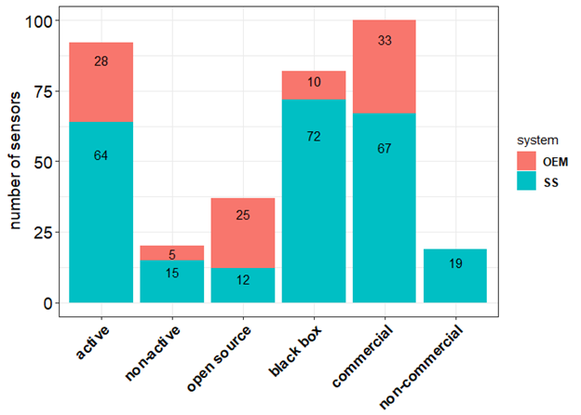

**Figure 1.** Number of sensor models gathered from the literature review highlighting their transparent data treatment (open source vs black box) and commercial availability.

## 2.3 Recent tests per pollutants and per sensor types

Table 1 reports the number of Records, by pollutant and sensor technology, gathered in literature about validation and testing of OEMs/sensor systems against a reference system. Records were collected from laboratory (138) and field tests (1263). The majority of records refers to commercially available OEMs and sensor systems, even though a few references about non-commercial sensors were also picked up.

**Table 1**. Number of analyzed Records for OEMs/Sensor Systems by pollutant and by type of technology.

|  |  |  |  |  |
| --- | --- | --- | --- | --- |
| **pollutant** | **type** | **n. Records Field** | **n. Records Laboratory** | **references** |
| CO | electrochemical | 50 | 9 | AQ-SPEC[[40]](https://www.zotero.org/google-docs/?PgYGJl), Jiao[[44]](https://www.zotero.org/google-docs/?yUSMpn), Sun[[45]](https://www.zotero.org/google-docs/?3DYsnk), Marjovi[[57]](https://www.zotero.org/google-docs/?AOD2RN), Gerboles[[25]](https://www.zotero.org/google-docs/?zUVcYQ), Mead[[47]](https://www.zotero.org/google-docs/?TslZuA), Popoola[[48]](https://www.zotero.org/google-docs/?FjOmVb), Borrego[[50]](https://www.zotero.org/google-docs/?rwnkig), Castell[[24]](https://www.zotero.org/google-docs/?fC3n4p), Cross[[23]](https://www.zotero.org/google-docs/?i1y1tK), Gerboles[[58]](https://www.zotero.org/google-docs/?EQDMzq), Wei[[31]](https://www.zotero.org/google-docs/?AYxSeK), Gillooly[[21]](https://www.zotero.org/google-docs/?DviNtY), Zimmerman[[32]](https://www.zotero.org/google-docs/?qfflHi), Spinelle[[37]](https://www.zotero.org/google-docs/?NfjENc) |
| CO | MOs | 26 | 2 | AQ-SPEC[[40]](https://www.zotero.org/google-docs/?nj1FwW), Piedrahita[[20]](https://www.zotero.org/google-docs/?OXGBni), Spinelle[[37]](https://www.zotero.org/google-docs/?s6UIWo) |
| NO | electrochemical | 42 | 6 | Jiao[[44]](https://www.zotero.org/google-docs/?FofBNw), Bigi[[59]](https://www.zotero.org/google-docs/?GrXqY5), Gerboles[[25]](https://www.zotero.org/google-docs/?V4DeMJ), Mead[[47]](https://www.zotero.org/google-docs/?8PgfO7), Popoola[[48]](https://www.zotero.org/google-docs/?oyVqAt), AQ-SPEC[[40]](https://www.zotero.org/google-docs/?uM8eYR), Castell[[24]](https://www.zotero.org/google-docs/?hGp0aT), Borrego[[50]](https://www.zotero.org/google-docs/?TZQ01h), Cross[[23]](https://www.zotero.org/google-docs/?D3rk28), Gillooly[[21]](https://www.zotero.org/google-docs/?X92g1v), Spinelle[[33]](https://www.zotero.org/google-docs/?pEGvn0), Gerboles[[58]](https://www.zotero.org/google-docs/?c13n8g), Wei[[31]](https://www.zotero.org/google-docs/?mnuCqt), Crunaire[[39]](https://www.zotero.org/google-docs/?CTK1YP) |
| NO | MOs | 1 | - | Crunaire[[39]](https://www.zotero.org/google-docs/?G4CnS9) |
| NO2 | electrochemical | 130 | 21 | AQ-SPEC[[40]](https://www.zotero.org/google-docs/?7i8RC8), Jiao[[44]](https://www.zotero.org/google-docs/?qglO69), Williams[[30]](https://www.zotero.org/google-docs/?ts6GYo), Sun[[45]](https://www.zotero.org/google-docs/?UOHsDs), Mijling[[29]](https://www.zotero.org/google-docs/?GXryBY), Vaughn[[46]](https://www.zotero.org/google-docs/?dRbwW4), Spinelle[[16]](https://www.zotero.org/google-docs/?E7xIFX), Mueller[[28]](https://www.zotero.org/google-docs/?iUX1kh), Bigi[[59]](https://www.zotero.org/google-docs/?hFyLVY), Marjovi[[57]](https://www.zotero.org/google-docs/?9BCbO9), Cordero[[26]](https://www.zotero.org/google-docs/?o3fg6b), Gerboles[[25]](https://www.zotero.org/google-docs/?kg6Qq1), Mead[[47]](https://www.zotero.org/google-docs/?7Rwk61), Popoola[[48]](https://www.zotero.org/google-docs/?ZKuXBx), Borrego[[50]](https://www.zotero.org/google-docs/?d5UFMg), Castell[[24]](https://www.zotero.org/google-docs/?C7dURO), Cross[[23]](https://www.zotero.org/google-docs/?Ymfv1e), Spinelle[[60]](https://www.zotero.org/google-docs/?mELvt9), Duvall[[61]](https://www.zotero.org/google-docs/?kmdSAb), Gillooly[[21]](https://www.zotero.org/google-docs/?m1Dg7d), Gerboles[[58]](https://www.zotero.org/google-docs/?QBV9LJ), Wei[[31]](https://www.zotero.org/google-docs/?bwjFjt), Sun[[62]](https://www.zotero.org/google-docs/?VNu02a), Zimmerman[[32]](https://www.zotero.org/google-docs/?WSkaEQ), Lin[[63]](https://www.zotero.org/google-docs/?XIOiT1), Crunaire[[39]](https://www.zotero.org/google-docs/?cb6P0a) |
| NO2 | MOs | 28 | 10 | AQ-SPEC[[40]](https://www.zotero.org/google-docs/?T9eHpH), Vaugh[[64]](https://www.zotero.org/google-docs/?fVYcca), Williams[[30]](https://www.zotero.org/google-docs/?Ix2rJl), US-EPA[[65]](https://www.zotero.org/google-docs/?LayIZ3), Borrego[[50]](https://www.zotero.org/google-docs/?PkxvME), Piedrahita[[20]](https://www.zotero.org/google-docs/?d6DYzg), Spinelle[[16]](https://www.zotero.org/google-docs/?OGXOuk), Crunaire[[39]](https://www.zotero.org/google-docs/?YSt9Hb) |
| O3 | electrochemical | 63 | 10 | AQ-SPEC[[40]](https://www.zotero.org/google-docs/?j47XGR), Jiao[[44]](https://www.zotero.org/google-docs/?3pFDk0), Spinelle[[60]](https://www.zotero.org/google-docs/?3QkBPs), Spinelle[[16]](https://www.zotero.org/google-docs/?Jb4UGA), Mueller[[28]](https://www.zotero.org/google-docs/?TxbVLA), Marjovi[[57]](https://www.zotero.org/google-docs/?bZa9T8), Gerboles[[25]](https://www.zotero.org/google-docs/?2KGpGT), Borrego[[50]](https://www.zotero.org/google-docs/?VtBoo6), Castell[[24]](https://www.zotero.org/google-docs/?Jp8Mwo), Cross[[23]](https://www.zotero.org/google-docs/?chs8Yo), Duvall[[61]](https://www.zotero.org/google-docs/?VqDHIE), Feinberg[[22]](https://www.zotero.org/google-docs/?VlqDla), Gerboles[[58]](https://www.zotero.org/google-docs/?GPxHBp), Wei[[31]](https://www.zotero.org/google-docs/?4tDbnT), Crunaire[[39]](https://www.zotero.org/google-docs/?2Lay7t) |
| O3 | MOs | 54 | 3 | AQ-SPEC[[40]](https://www.zotero.org/google-docs/?WNjEor),Jiao[[44]](https://www.zotero.org/google-docs/?fxc2Mh), Spinelle[[66]](https://www.zotero.org/google-docs/?ZWQuKG), Borrego[[50]](https://www.zotero.org/google-docs/?KNMPBj), Feinberg[[22]](https://www.zotero.org/google-docs/?gySBUu) |
| O3 | UV | 9 | 1 | Sun[[45]](https://www.zotero.org/google-docs/?s1iFIi), AQ-SPEC[[40]](https://www.zotero.org/google-docs/?Ma5416) |
| PM2.5 | Electrical | 6 | - | AQ-SPEC[[40]](https://www.zotero.org/google-docs/?D2eK5s) |
| PM2.5 | nephelometer | 192 | 27 | AQ-SPEC[[40]](https://www.zotero.org/google-docs/?X1v1wl), Borghi[[41]](https://www.zotero.org/google-docs/?ezeOrB), Jiao[[44]](https://www.zotero.org/google-docs/?WqFb7f), Feinberg[[22]](https://www.zotero.org/google-docs/?l6zAQv), US-EPA[[65]](https://www.zotero.org/google-docs/?TOXobW), Williams[[51]](https://www.zotero.org/google-docs/?98p0LW), Manikonda[[52]](https://www.zotero.org/google-docs/?ZSyOeD), Zikova[[53]](https://www.zotero.org/google-docs/?5otX2X), Wang[[67]](https://www.zotero.org/google-docs/?h6XuY0), Alvarado[[68]](https://www.zotero.org/google-docs/?u57ZS6), Chakrabarti[[69]](https://www.zotero.org/google-docs/?57jPew), Sousan[[54]](https://www.zotero.org/google-docs/?glBpyN),Borrego[[50]](https://www.zotero.org/google-docs/?BjPOk6), Olivares[[70]](https://www.zotero.org/google-docs/?67xWqb),Sun[[45]](https://www.zotero.org/google-docs/?Vv6Pxn), Pillarisetti[[71]](https://www.zotero.org/google-docs/?J4Dpjb), Holstius[[18]](https://www.zotero.org/google-docs/?uMuEdZ), Austin[[72]](https://www.zotero.org/google-docs/?NqxKsx), Gao[[73]](https://www.zotero.org/google-docs/?mwwt0y), Kelly[[74]](https://www.zotero.org/google-docs/?1Sv4io), Karagulian[[75]](https://www.zotero.org/google-docs/?U8rqBP), Badura[[76]](https://www.zotero.org/google-docs/?m1qvnz), Crunaire[[39]](https://www.zotero.org/google-docs/?lX24l2) |
| PM2.5 | OPC | 358 | 27 | AQ-SPEC[[40]](https://www.zotero.org/google-docs/?uZFUAv), Mukherjee[[77]](https://www.zotero.org/google-docs/?NWHkJd), Feinberg[[22]](https://www.zotero.org/google-docs/?mtHk0S), Jiao[[44]](https://www.zotero.org/google-docs/?UCA6x8), Cavaliere[[78]](https://www.zotero.org/google-docs/?HOW83S), Borrego[[50]](https://www.zotero.org/google-docs/?7D7kZ3), Viana[[79]](https://www.zotero.org/google-docs/?IO9NiH), Williams[[51]](https://www.zotero.org/google-docs/?N8pt8w), Manikonda[[52]](https://www.zotero.org/google-docs/?uX66KE), Northcross[51], Holstius[[18]](https://www.zotero.org/google-docs/?z67so8), Steinle[[80]](https://www.zotero.org/google-docs/?OGvglV), Han[[81]](https://www.zotero.org/google-docs/?K86w81), Jovasevic[[82]](https://www.zotero.org/google-docs/?RptEc4), Dacunto[[55]](https://www.zotero.org/google-docs/?15KqUF), Gillooly[[21]](https://www.zotero.org/google-docs/?NanquK), Sousan[[83]](https://www.zotero.org/google-docs/?5qJ5Kj), Crilley[[84]](https://www.zotero.org/google-docs/?qFHmLn), Badura[[76]](https://www.zotero.org/google-docs/?SfHgm6), Kelly[[74]](https://www.zotero.org/google-docs/?uUvqqe), Zheng[[17]](https://www.zotero.org/google-docs/?XEujPb), Laquai[[34]](https://www.zotero.org/google-docs/?VQ26iN), Budde[[10]](https://www.zotero.org/google-docs/?xJ97ro), Liu[[19]](https://www.zotero.org/google-docs/?WHnaDW), Crunaire[[39]](https://www.zotero.org/google-docs/?XTHWQF) |
| PM1 | Electrical | 6 | - | AQ-SPEC[[40]](https://www.zotero.org/google-docs/?gsvdml) |
| PM1 | nephelometer | 1 | - | Crunaire[[39]](https://www.zotero.org/google-docs/?B8MIGH) |
| PM1 | OPC | 99 | 8 | AQ-SPEC[[40]](https://www.zotero.org/google-docs/?R6tBm5), Williams[[51]](https://www.zotero.org/google-docs/?3vdvdm), Sousan[[83]](https://www.zotero.org/google-docs/?t13y5X), Crilley[[84]](https://www.zotero.org/google-docs/?i5Arli), Crunaire[[39]](https://www.zotero.org/google-docs/?9g3Lzd) |
| PM10 | nephelometer | 32 | 1 | AQ-SPEC[[40]](https://www.zotero.org/google-docs/?O5T2Na), Borrego[[50]](https://www.zotero.org/google-docs/?qUDPTk), Alvarado[[68]](https://www.zotero.org/google-docs/?rfllOU), Crunaire[[39]](https://www.zotero.org/google-docs/?TSetf8) |
| PM10 | OPC | 166 | 13 | AQ-SPEC[[40]](https://www.zotero.org/google-docs/?IlRcwV), Cavaliere[[78]](https://www.zotero.org/google-docs/?ApJbIt), Borrego[[50]](https://www.zotero.org/google-docs/?nBfdD5), Feinberg[[22]](https://www.zotero.org/google-docs/?elTCoR), Manikonda[[52]](https://www.zotero.org/google-docs/?MkD7tC), Sousan[[54]](https://www.zotero.org/google-docs/?nXujPc), Han[[81]](https://www.zotero.org/google-docs/?1y11Wn), Jovasevic[[82]](https://www.zotero.org/google-docs/?0zVE5C), Williams[[51]](https://www.zotero.org/google-docs/?QHCweQ), Sousan[[83]](https://www.zotero.org/google-docs/?pZCLaI), Crilley[[84]](https://www.zotero.org/google-docs/?Ppzm4g), Budde[[10]](https://www.zotero.org/google-docs/?ScsRDr), Crunaire[[39]](https://www.zotero.org/google-docs/?UGLNyc) |

For the detection of Particulate Matter, the largest number of sensor tests were carried out for Optical Particle Counters (OPC) with 671 Records followed by Nephelometers with 253 Records (see Table 1). Both systems detect particulate matter by measuring the light scattered by particles, with the OPC being able to directly count particles according to their size. On the other hand, nephelometers estimate particle density that is subsequently converted into particle mass. For the detection of gaseous pollutants such as CO, NO, NO2 and O3, the largest number of tests were performed using electrochemical sensors with 331 Records, followed by metal oxides sensors (MOs) with 124 Records (see Table 1). Electrochemical sensors are based on a chemical reaction between gases in the air and the working electrode of an electrochemical cell that is dipped into an electrolyte. In a metal oxide sensor, also named resistive sensor, semiconductor, gases in the air react on the surface of a semiconductor and exchange electrons modifying its conductance.

Table A3 reports the models of OEM sensors currently used to monitor particulate matter and gaseous pollutants (NO2, O3, NO and CO) according to their type of technology. On the other hand, models of sensor systems measuring concentration of particulate matter and gaseous pollutants are reported in Table A4. We want to point out that several sensor systems can use the same OEM. In very few cases, the same model of sensor system was tested using different types of OEM sensors when performing validation tests.

Comparing table A3 and table A4, one may observe that there are less living OEMs (24) rather than living Sensor System (65) (often based on the same OEM). Living sensors are devices currently available for commercial or research purposes. Additionally, there is a lack of laboratory tests for the OEMs compared to sensor systems. Among the reviewed Records only ~ 11% were attributed to laboratory tests. Therefore, most sensors ( ~ 90%) were tested in the field where it is not possible to isolate the effect of single pollutants which might often interfere with each other during the measurements. Possible correlation between pollutants and meteorological parameters can also

Some pollutants are often correlated with meteorological parameters that have no effect on the sensors introducing therefore important bias during the correction/calibration of the sensor itself.

The research covered the period between 2010 and 2019 (year of publication). As reported in Figure 2, only a few preliminary works were published from 2010 to 2014. In 2015, we recorded the highest number of references with 16 different works publishing results about performances of sensors for air quality monitoring. Since 2015, the number of references publishing works on sensors with about 10 - 16 publications per year.

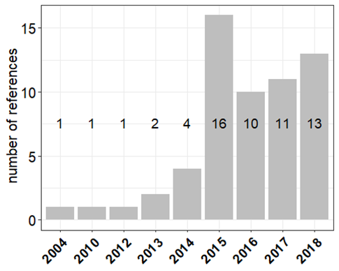

**Figure 2**. Number of references per year of publication.

Overall, we found 32 references reporting field tests with sensors co-located at urban sites, 8 references for rural sites, and 8 references for traffic sites. Most of the laboratory and field tests reported hourly averages with about 594 Records obtained for over 85 models of OEMs and sensor systems. On the other hand, we found about 248 Records from tests performed over an averaging time of 24 hours and 5 minutes with about 42 models of sensors (Table A1). Therefore, 1 hour averaged measurements were considered statistically more signifative to represent most of the scrutinized 112 models of OEMs and sensor systems.

**Table 2**. Number of Records gathered by metric used in this work.

|  |  |  |
| --- | --- | --- |
| **metrics** | **n. Field Tests** | **n. Laboratory Tests** |
|  | 1263 | 138 |
| R² from calibrations | 213 | 65 |
| R² from comparisons | 1141 | 72 |
| slope of reg. line | 1041 | 55 |
| intercept | 1023 | 54 |
| RMSE | 270 | 5 |
| Measurement uncertainty (U) | 153 | 29 |

For the evaluation of sensors against reference systems we considered the metrics that were more frequently reported in the reviewed works about the evaluation of the sensor performance both in field and/or laboratory tests. The coefficient of determination R2 is usually used as indication of “usefulness” or “goodness” of fit obtained from regression models comparing sensor measurements with reference measurements Table A2. However, R2 is a partial measures of how sensors data agree with reference measurements according to a regression model [[85]](https://www.zotero.org/google-docs/?8kpzee). A larger R2 reflects an increase in the predictive precision of the regression model but it ignores the loss in information due to possible loss in degrees of freedom. A significance test is therefore suggested in this case. Alternatively, R2 can be viewed as a measure of goodness of fit (how close evaluation data is to the reference measurements) and the slope of the regression as level of accuracy. However, if the goodness of fit about the regression is fixed, then the slope will increase and consequently also the R2. Therefore, when it happens to calibrate different datasets, calibration using *slope* and R2 values close to 1.0 might be less precise than calibration using smaller values of *slope* and R2. As shown in Table 2, most of the works reported coefficients of determination R2 as well as the of regression line mainly from field tests. Root mean square error (RMSE) and the uncertainty (U), were mostly calculated as value of standard deviation and only reported in few works (25). Therefore, for the purpose of this work, we only focused on the analysis of the comparison of and of laboratory and field tests of sensors.

The major sources of information of LCS evaluation consist of reports published by AQ-SPEC [[40]](https://www.zotero.org/google-docs/?3tYDON), the US-EPA and by the Joint Research Centre [[66]](https://www.zotero.org/google-docs/?3msqYZ).

# 3 Method of evaluation

Critise R²

The purpose of this review is to identify LCSs whose comparison with reference measurements shows the highest correlation and accuracy. For this purpose, we performed a comprehensive review about the performance of commercial LCSs. We have aggregated summary statistics about the agreement between sensors and reference instruments. Although in Europe, the main metrics to evaluate the performance of measuring methods consists of the measurement uncertainty, this metric could not be used in our study since the majority of studies do not report it (*274* Records out of *1401* total number of Records reporting RMSE and other metrics for uncertainty ) give the number of studies with this parameter. Conversely, we had to rely on most common metrics, i. e., the coefficient of determination R2, the slope and intercept of linear regression line between sensor and reference measurement and, in few cases, the Root Mean Square of Error that were scrutinized and analyzed to identify sensors that could potentially be complementary to the reference methods of air quality monitoring.

The market of LCSs for ambient air monitoring only consists of a small number of sensor model types that are manufactured by a few companies (see Table A3). On the other hand a Sensor System (SS) is an integrated set of hardware that uses one or more sensors to detect and/or measure a chemical concentration or quantity that is able to supply real time measurements. A sensor systems contain a number of common components in addition to the basic sensing/analytical element that is used for detection. Common core components and functions may include:

* Sensing element or detector (actually the sensor)
* Sampling capability (active or passive sampling)
* Power systems, including batteries
* Analogue to digital conversation
* Signal processing
* Local data storage
* Data transmission
* Remote calibration
* Housing/casing

OEMs use chemical and physical techniques phenomena to sense pollutant in ambient air. However, in order to simplify measurement operations, calibration and data transfer into a convenient sensor object, OEMs need be integrated into a sensor system (SS), consisting of electronic boards, software and protective box gathering the hardware, software and OEM sensors.

The use of low-cost sensors is extensively interesting for citizen-science initiatives. Therefore, Small Medium Enterprises were able to sell sensor-systems which could be deployed by citizens who wanted to monitor air quality in a chosen environment. Up to date, there are several sensor systems using sensors from the same OEM. However, outputs from these sensors system often differ from each other. The ideal candidate sensor system would show good agreement with reference measurements and, at the same time, provide sensor raw data allowing to be calibrated using open source correction algorithms. The number of air pollutants being measured was also a parameter taken into consideration. Finally, the price of a low cost-sensor was also taken into account.

# 4 Results

## 4.1 Calibration of sensors

Calibration of the sensor is somewhat considered a sensitive information from most of sensor manufacturers. Several studies performed calibration of sensors during laboratory or field tests. The calibration consisted in the application of a regression model in order to adjust the response of the sensor to a reference system. We found calibration Records for both OEMs and sensor systems. Overall, we gathered over 324 Records about calibration of sensors using different types of mathematical models (Table 3) and at different time resolutions. The linear model and the multi linear regression model (MLR) were largely used to calibrate the sensor response against a reference measurement. Other calibration approaches used the exponential, logarithmic, quadratic, Random Forest and, few types of neural network models. We could observe that most of MLR models, covariates such as meteorological parameters Temperature and Relative Humidity, and gaseous pollutant such as, Nitric Dioxide (NO2), Nitric Monoxide (NO) and Ozone (O3), were used to optimize the calibration. Some types of model also took into consideration the *time-drift* of the sensor as covariate. The calibration of OEMs was performed using the raw signal of the sensor that most of the time was expressed as a voltage or as a current. On the other hand, for sensor systems, the calibration was carried out using the units of the reference system.

**Table 3.** Types of calibration models used for the calibration of sensors at different time resolutions (ANN: artificial neural network, exp: exponential; log: logarithmic; MLR: multilinear regression; quad: quadratic; RF: random forest; SVM: support vector machine; SVR: support vector regression).

**calibration model**

|  |  |  |
| --- | --- | --- |
| **calibration model** | **n. Records** | **references** |
| ANN | 8 | Cordero[[26]](https://www.zotero.org/google-docs/?bi0BZw), Gerboles[[58](https://www.zotero.org/google-docs/?C7xt8O) |
| exp | 9 | Dacunto[[55]](https://www.zotero.org/google-docs/?ictnyx), AQ-SPEC[[40]](https://www.zotero.org/google-docs/?SMZLQ8), Kelly[[74]](https://www.zotero.org/google-docs/?F3reRR), Austin[[72]](https://www.zotero.org/google-docs/?NrOpzF) |
| linear | 99 | Mukherjee[[77]](https://www.zotero.org/google-docs/?hetZXw), Sun[[45]](https://www.zotero.org/google-docs/?aK8CMF), Spinelle[[16]](https://www.zotero.org/google-docs/?dvgI9L), Wang[[67]](https://www.zotero.org/google-docs/?wTIGo9), Alvarado[[68]](https://www.zotero.org/google-docs/?RB1hnE), Cavaliere[[78]](https://www.zotero.org/google-docs/?Y5wsVv), Castell[[24]](https://www.zotero.org/google-docs/?amm70d), Cross[[23]](https://www.zotero.org/google-docs/?O5Aoys), Gerboles[[58]](https://www.zotero.org/google-docs/?o5h109), Sousan[[54]](https://www.zotero.org/google-docs/?c33lU1), Northcross[[86]](https://www.zotero.org/google-docs/?DLyLrt), Steinle[[80]](https://www.zotero.org/google-docs/?BREoMg), Han[[81]](https://www.zotero.org/google-docs/?iXETIZ), Jovasevic[[82]](https://www.zotero.org/google-docs/?LPhBEW), Olivares[[70]](https://www.zotero.org/google-docs/?Bcfbcj), Spinelle[[37]](https://www.zotero.org/google-docs/?dsB2Jd), Spinelle[[33]](https://www.zotero.org/google-docs/?p5dJcT), Kelly[[74]](https://www.zotero.org/google-docs/?eNMgpv), Zheng[[17]](https://www.zotero.org/google-docs/?R6kiAx), Holstius[[18]](https://www.zotero.org/google-docs/?92Tth1), Zimmerman[[32]](https://www.zotero.org/google-docs/?WqW7dG), Lin[[63]](https://www.zotero.org/google-docs/?BotL02), AQ-SPEC[[40]](https://www.zotero.org/google-docs/?nlvMXF) |
| log | 20 | AQ-SPEC[[40]](https://www.zotero.org/google-docs/?c1WHdG), Laquai[[34]](https://www.zotero.org/google-docs/?TUMqR1) |
| MLR | 125 | Jiao[[44]](https://www.zotero.org/google-docs/?PBFCvh), Sun[[62]](https://www.zotero.org/google-docs/?UwhP9b), Mijling[[29]](https://www.zotero.org/google-docs/?4XFzOE), Spinelle[[16]](https://www.zotero.org/google-docs/?rl0mKE), Mueller[[28]](https://www.zotero.org/google-docs/?e6oCgm), Bigi[[59]](https://www.zotero.org/google-docs/?JrVUwe), Cordero[[26]](https://www.zotero.org/google-docs/?eYxTbe), Gerboles[[25]](https://www.zotero.org/google-docs/?vlVHTd), Wei[[31]](https://www.zotero.org/google-docs/?gbOifJ), Spinelle[[66]](https://www.zotero.org/google-docs/?IbvuJO), Piedrahita[[20]](https://www.zotero.org/google-docs/?AUcDsO), Spinelle[[37]](https://www.zotero.org/google-docs/?ciAj9c), Spinelle[[33]](https://www.zotero.org/google-docs/?UdYPpa), Sun[[62]](https://www.zotero.org/google-docs/?DEQZSD), Zheng[[17]](https://www.zotero.org/google-docs/?wG7cWt), Holstius[[18]](https://www.zotero.org/google-docs/?GCj5nZ), Zimmerman[[32]](https://www.zotero.org/google-docs/?npyZle), Liu[[19]](https://www.zotero.org/google-docs/?N6txOO) |
| quad | 42 | Chakrabarti[[69]](https://www.zotero.org/google-docs/?Tjg5rm), AQ-SPEC[[40]](https://www.zotero.org/google-docs/?UApPN8), Manikonda[[52]](https://www.zotero.org/google-docs/?yXh1lI), Alvarado[[68]](https://www.zotero.org/google-docs/?uoBMJT), Zheng[[17]](https://www.zotero.org/google-docs/?J3HkZO), Gao[[73]](https://www.zotero.org/google-docs/?UCIG7H) |
| RF | 13 | Bigi[[59]](https://www.zotero.org/google-docs/?lzgq4R), Cordero[[26]](https://www.zotero.org/google-docs/?B8ATrW), Zimmerman[[32]](https://www.zotero.org/google-docs/?IYZPVb), Liu[[19]](https://www.zotero.org/google-docs/?9IHI7t) |
| SVM | 4 | Cordero[[26]](https://www.zotero.org/google-docs/?o8ig2Y) |
| SVR | 4 | Bigi[[59]](https://www.zotero.org/google-docs/?Z8lzLS) |

As explained above, from the analyzed Records, we found several types of regression models that were used to calibrate sensors from OEM and sensor systems against reference systems. In order the estimate quality of the used calibration model, we reported the coefficient of determination R2 as an indicator of the amount of total variability explained by the model. On a first instance, The coefficient of determination can be used as an indication of performance of the calibration model chosen to validate the sensor with a reference system. In addition to simple linear models, raw sensor data were validated using multilinear and quadratic models which included the use of covariates to improve the quality of the calibration (Table 3).

Figure 3 shows a summary of all mean R2 obtained from the calibration of sensor systems against reference measurements. Results were grouped by model of sensor system and averaged per reference work. For the same sensor systems we can observe R2 ranging from low to high values up to the unit. This shows the variability of the performance of sensor systems depending on the type of calibration. In the following we are going to report a detailed discussion about performance of several OEM and sensor systems during their calibration at different averaging-times.

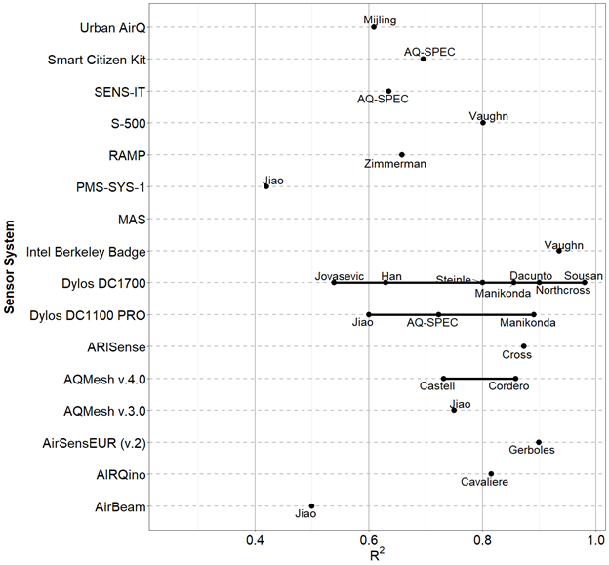

**Figure 3**. Mean R2 obtained from the calibration of sensor systems against reference measurements. The author name below each bullet gives the 1st author of the publication from which results were drawn.

Calibration of sensor data against a reference system was found to be carried out using input data at different time resolution. Therefore, in order to make a comparison of R2 obtained at the same time resolution data, we chose Records averaged over different time-scale of 1 hour (Figure A1) and 1 minute (Figure A2). Most of these Records were from OEMs (93) whereas only a limited number were from sensor systems (101). For the measurement of PM2.5, values of R2 ~ 1 were found for the sensors PMS1003 by Plantower [[74]](https://www.zotero.org/google-docs/?fkG2AM) at 1-hour resolution and for the the PMS3003 , Dylos DC1100 PRO and DC1700 by Dylos at a resolution of 1 minute [[14,40,80]](https://www.zotero.org/google-docs/?8vzFnb). The Plantower and Dylos sensors showed higher R2 when calibrated with 1 minute resolution reference data. Other sensors such as, the OPC-N2 by AlphaSense [[40]](https://www.zotero.org/google-docs/?7gCN1Y) reported values of R2 falling within the range of 0.7 - 1.0 at a resolution of 1 hour. The same OEM sensor OPC-N2, reported values of R2 just above 0.7 when measuring PM1 while it did not show a good performance when measuring PM10 [[40]](https://www.zotero.org/google-docs/?NtNn6L). We need to stress out that optical sensors, such as OPCs and nephelometers, are somewhat limited when detecting coarse particulate matter PM10 because of the low-efficiency of the sampling system when sampling large particles in ambient air.

Most of regression models used for the calibration of sensors detecting gaseous pollutants used a time-resolution of 1 hour. For the calibration of sensors measuring O3, the largest values of R2 was reported for the OEM sensors FIS SP-61 by FIS and O3-3E1F by CityTechnology, when using a time-resolution of 1 hour (Figure A1) [59]. On the other hand, when using a time-resolution of 1 minute, values of R2 ~ 1 were found for the sensor system AirSensEUR (V.2) by LiberaIntentio [[25]](https://www.zotero.org/google-docs/?2yI6MP) as well as for the OEM S-500 by Aeroqual [[40]](https://www.zotero.org/google-docs/?viGRiM) (Figure A2). The AirSensEUR uses a built-in OEM OX-A431. We want to point out that, most of the MLR models used for calibration ozone sensors foresees the use of reference NO2 because of the strong oxidizing effect of O3 on gas sensors with consequent formation of NO2. For the calibration of sensors measuring NO2 we found values of R2 within the range 0.7 - 1.0 for the OEM sensor NO2-B42F (by Alphasense [[31]](https://www.zotero.org/google-docs/?7KdpRq)), at a time resolution of 1 hour, and the sensor systems AirSensEUR (v.2) (by LiberaIntentio) [[25]](https://www.zotero.org/google-docs/?PqljiT)) and MAS [67] at a time resolution of 1 minute (Figure 3). We need to point out that for the measurement of NO2, the AirSensEUR (v.2) uses the OEM sensor NO2-B43F by AlphaSense.

Most of the Records about the calibration of sensor measuring CO showed high values of R2. As shown in Figure A1, the OEMs CO 3E300 by City Technology [[58]](https://www.zotero.org/google-docs/?WGOZOf) and CO-B4 by Alphasense [[31]](https://www.zotero.org/google-docs/?TDtTSV) reported R2 ~ 1 for time-resolution of 1 hour. High values of R2 were also reported for the sensor system AirSensEUR (v.2) when calibrating CO at a time-resolution of 1 minute (Figure A2) [[25]](https://www.zotero.org/google-docs/?TTS7qx). Other sensors reporting values of R2 within the range 0.7 - 1.0 where the MICS-4515 by and SGX Sensortech [[20]](https://www.zotero.org/google-docs/?8GJ3kt), the Smart Citizen Kit by Acrobotic [[40]](https://www.zotero.org/google-docs/?HTs3mu) and the RAMP [[32]](https://www.zotero.org/google-docs/?q0QaRU). All these sensors used 1 hour time-resolution data.

## 4.2 Comparison of calibrated low-cost sensors with reference measurements

We found about 1213 Records about the comparison of calibrated sensors against a reference instrument. All comparisons were carried out by using a linear regression model between calibrated and reference data. The performance of the regression was evaluated with the coefficient of determination R2 and the *slope* of the regression. As explained above, we need to stress out that not all the analyzed Records reported the Root Mean Square Error (RMSE) of the regression therefore, we decided to omit it in the present review.

In this work, Records gathered from the comparison of sensors with reference systems came from OEMs and sensor systems using a custom calibration or a built-in calibration directly setup by the manufacturer. As for the Records collected from the calibration of sensor, comparison with reference system was carried out at different time-resolutions. Here we only report comparisons performed at a time-resolution of 1 hour with 549 and 144 Records from sensor systems and OEMs, respectively. In Figure 4 we have reported the averaged R2 values for all reviewed sensor systems found from each reference works. As for the evaluation of the calibration of sensors, we have averaged values obtained from the same reference and for the same sensor systems. It was observed that, for the same sensor system, we could find different R2 value for the comparison with reference measurements. In the following we give a more detailed breakdown about the performances of each OEM / SS upon their comparison with reference measurements at different averaging-times.

Figure A3 and Figure A4 show the distribution of R2 values for sensors systems measuring PM10, PM2.5, PM1, O3, NO2, and CO against reference at 1-minute and 1-hour time-resolution. For the measurements of particulate matter, most of the comparisons were performed during field tests with the highest obtained from the sensor PA-II by PurpleAir [[40]](https://www.zotero.org/google-docs/?kuZ526) and PATS+ by Berkley Air [[71]](https://www.zotero.org/google-docs/?HhXczU). These sensors reported values of R2 between 0.8 and 1.0. Other sensors with R2 values falling in the range 0.7-1.0 were identified in the PMS-SYS-1 by Shinyei, the Dylos 1100 PRO by Dylos, the MicroPEM by RTI, the AirNUT by Moji China the Egg (2018) by Air Quality Egg, the AQT410 v.1.15 by Vaisala, the AirVeraCity by AirVeraCity the NPM2 by MetOne [[39]](https://www.zotero.org/google-docs/?zBCMSO) and, the Air Quality Station by AS LUNG [[40]](https://www.zotero.org/google-docs/?mZiK2A). Records from other sensors showed different values of R2 depending of the type of field test and for the averaging time chosen to process the time-series of data. We need to point out that the performance of sensor systems measuring PM10, on average, was very poor.

For gaseous pollutants, high R2 values were found for the sensor systems 2B Tech. (POM) by 2B Technologies (O3) [[40]](https://www.zotero.org/google-docs/?yvNYOj), the AirSensEUR (v.2) by LiberaIntentio [[25]](https://www.zotero.org/google-docs/?zOkNo5), the AirCasting by HabitatMap [[51]](https://www.zotero.org/google-docs/?kADTH4), the Spec, the AQMesh. These sensors reported values of R2 between 0.8 and 1.0. As shown in Figure A3 and Figure A4, we found a non-negligible number of Records for sensor systems whose R2 resulting from the comparison with reference systems was within the range 0.7 - 1.0 using 1-hour averaged data. We want to point out that, among all tested sensor systems, only the AirSensEUR (v.2) was the only one measuring multiple pollutants.

For the comparison of OEMs against reference systems over a time-scale of 1 hour, the OPC-N2, OPC-N3 [23,40,42,76,83] and the SDS011 by Nova Fitness [76] (Figure A5) showed R2 values within the range 0.7 - 1.0 for the measurement of PM. On the other hand, when the comparison was performed over a time-scale of 24 hour, we found R2 within the range 0.7 - 1.0 for the OPC-NO2 and the OPC-N3 sensors [[40]](https://www.zotero.org/google-docs/?cOhoVe) (Figure A6).

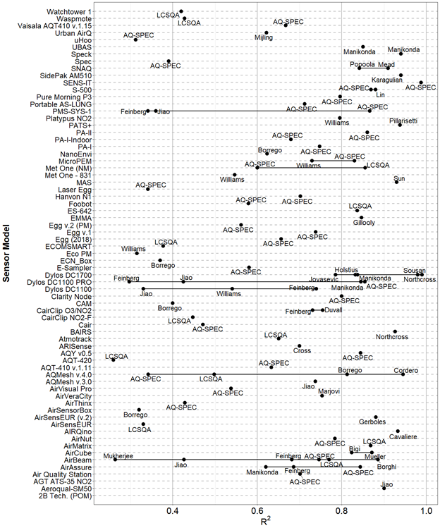

**Figure 4.** Mean R2 for obtained from the comparison of sensor systems against reference measurements. The author name below each bullet gives the 1st author of the publication from which results were drawn.

For the comparison of sensor systems against a reference system, the sensors PA-II, [[40]](https://www.zotero.org/google-docs/?RzOxgU) AirQUINO by CNR [[78]](https://www.zotero.org/google-docs/?VsadFO) reported values of R2 ~ 1 when measuring 24-hour averaged data of PM2.5, (Figure A7). On the other hand, for the evaluation of gaseous pollutants, we found very few OEMs with R2 within 0.7 - 1.0 when using data at time-resolution of 1 hour. These sensors included the CairClip O3/NO2 by CairPol [[16,22,30,61]](https://www.zotero.org/google-docs/?YspAqD), the Aeroqual Series 500 (and SM50) [[22]](https://www.zotero.org/google-docs/?mwUmCh), the O3-3E1F by CityTechnology [[16,22,58]](https://www.zotero.org/google-docs/?gD5bjA) and the NO2-B43F by Alphasense [[32,62]](https://www.zotero.org/google-docs/?uvgR3L) (Figure A1). On the other hand, we found very few Records for sensor systems using 24 hour data. As a general remark, we can see that the performance of OEMs sensors is enhanced when they are integrated inside a sensor system. It is also evident that most of the gathered Records from PM2.5 and gaseous pollutants O3, NO2, CO and NO, used 24 hours and 1 hour time-resolution data as required by the European Air Quality Directive.

To check the accuracy of a sensor, when compared to a reference system, we looked at the value of the slope obtained from the linear regression of the sensor measurements against a reference measurement. Most of comparisons were carried out during field tests, while only a limited number of laboratory tests were available. Ideally, only an R2 ~ 1.0 and a *slope* ~ 1.0 should be a good indicator of performance for a sensor. Therefore, we only selected Records with R2 > 0.7 and slope within the range 0.5-1.5.

Figure A8 shows sensor systems such as the AirSensEUR (v2), the AirVeracity and the S-500 have *slope* ~ 1 for most of measured gaseous pollutants when using 1 hour time-resolution data. On the other hand, only few Records from PM2.5 sensor systems showed *slope* ~ 1 for 1-hour (AirNut, AQY v0.5, Egg v.2 (PM), and the NPM2) and 24-hour (AIRQuino, AQY v0.5, Egg v.2 (PM) and the PA-I) time-averaged sensor systems (Figure A8, Figure A10).

Among OMEs showing *slope* ~ 1 when using 1-hour time-averaged data, we found the SM50, the CairClip O3/NO2, the S-500, (NO2, O3), the NO2-B4F (NO2) and the Nova Fitness SDS011 (PM2.5) (Figure A9). On the other hand, when using 24-hour time-averaged data, only the OPC-N2 by Alphasense and the DataRAM, showed slopes ~ 1 when measuring PM10 (Figure A11).

As a general remark, from the above analysis we could observe that for some OEMs and sensor systems, the width of the interquartile range IQR (H-spread) was very narrow. This is an indication of the reproducibility of the regression parameters used in their calibration. This becomes relevant when it comes to the development of a reliable sensor system that uses the same OEM sensor and the same calibration algorithms.

# 5 Cost of purchase

As preliminary outcome of the present analysis, we have started identifying sensors systems that are in good agreement with reference instruments commonly used to monitor pollutant concentrations. Although the sensor market constantly develops, we identified sensor systems that are commercially available or that can be assembled with commercially available OEM sensors.

Usually, the price of OEM sensors only represents a small fraction of the selling value of the entire sensor system. In the common understanding, a sensor for air quality is classified as low-cost when its price is less than 10000 EUR. In addition, if a low-cost sensor can measure multiple pollutants, potentially it could be used by local authorities as a complementary source of air quality data as substitute of reference instruments whose cost might rise up to one order of magnitude.

For the evaluation of the price of sensors, we considered all sensor systems manufactured by commercial companies as well as sensor systems built for laboratory testing by research groups. The latter ones are custom-built devices assembled around an OEM sensor. The price of sensors did not include the operating costs such as calibration, maintenance, deployment and data treatment.

We must stress out that, while for the detection of different sizes of particulate matter it is possible to use the same optical sensor for the detection of gaseous pollutant it is necessary to have a dedicated sensor for each pollutant. Therefore, among all the analyzed Records, we tried identifying sensor systems that can measure concentrations of particulate matter together with gaseous pollutants.

Figure 5 and Figure S13 show the commercial price of OEMs and sensor systems by model and number of pollutant measured by each sensor. There is a large number of sensor systems measuring single pollutants but few ones measuring multiple pollutants. This is an indication about the complexity to have a sensor system measuring multiple pollutants. Most OEMs are open source devices (Figure S13). This means that OEMs can be used to build sensor systems for data acquisition and therefore to calibrate the sensor. On the other hand, most of the sensor systems are black box (Figure 5). This means that most of the manufacturers of sensor systems does not commercialize sensors that can be re-calibrated according to the requirements of the user. Sensor systems are intended to be ready-to-use air quality monitors. When purchased by the end-user, a sensor system should estimate the concentration of pollutants with a close agreement to the traditional reference systems used to monitor air quality.

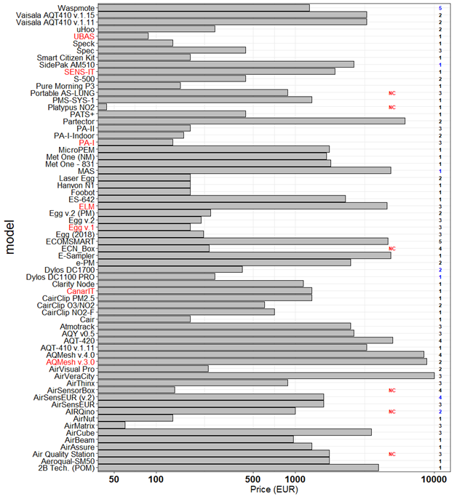

**Figure 5.** Prices of SS grouped by model. (Numbers in bold indicates the number of pollutant measured by each sensor. x-axis uses logarithmic scale). Numbers in bold indicate the number of open source (blue) and black box (black) Records. Names of ‘living’ and ‘updated’ and ‘non-living’ sensors are indicated in black and red color, respectively. indicates non commercially available sensor.

In Figure 6 we have shortlisted sensor systems according to their level of agreement to reference systems. For this purpose, we considered metrics obtained from 1 hour and 24 hour averaged data of sensor systems with R2 > 0.85 and 0.8 < *slope* < 1.2.

Among open source sensor systems we could identify the AirSensEUR (v.2) by LiberaIntentio and the AIRQuino by the CNR for the detection of NO2, CO, O3, NO and PM, respectively. The remaining shortlisted sensor systems were identified as black box. Table 4 and Table A4 report the mean value of and of the for the sensors systems shortlisted in Figure A13 for 1 hour and 24 hour averaged data. As we can see, the AirSensEUR (v.2) resulted in a mean R2 value of ~ 0.90 and a *slope* of ~ 0.94 while the AIRQuino resulted in a mean R2 value of ~ 0.91 and a *slope* of ~ 0.97. We need to point out that, at the date, the AIRQuino can measures up to five pollutants (PM2.5, PM10, NO2, O3, CO and NO ,CO2 and VOCs), however, only data for PM were available a the time of this review. On the other hand, the AirSensEUR (v2) is a complete sensor system that can also measure particulate matter beside gaseous pollutants including CO2 and Rn (radon). This sensor system is already operative and has undergone multiple calibrations and field tests where measurements of gaseous pollutants showing good agreement with reference measurements.

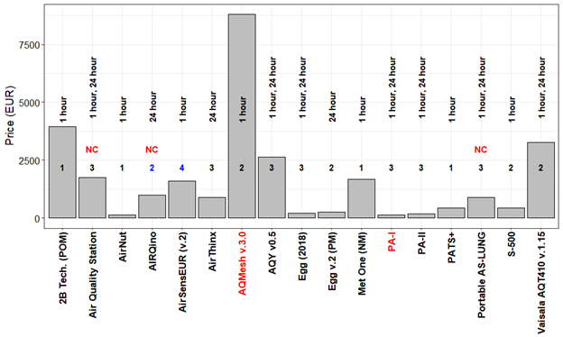

**Figure 6.** Price of low-cost sensor systems. Numbers in bold indicate the number of pollutant measured by open source (blue) and black box (black) sensors. Only Records with R2 > 0.85 and 0.8 < *slope* < 1.2 are shown. Names of ‘living’ & ‘updated’ and ‘non-living’ sensors are indicated in black and red, respectively. indicates non commercially available sensor. Labels reporting 1 hour / 24 hour indicate the averaging time of reviewed records.

As shown in Table 4, the price of sensor systems ranged from few hundreds of euros to about 10000 euros. We have investigated the possibility of having a relationship between the performance of the sensor (here expressed as R2) and the selling price of the sensor. For this purpose we have compared the mean R2 of all sensor models against their price.

**Table 4.** Shortlist of sensor systems showing good agreement with reference systems (R2 > 0.85; 0.8 < *slope* < 1.2) for 1 hour time averaged data.

**model**

|  |  |  |  |  |  |  |  |
| --- | --- | --- | --- | --- | --- | --- | --- |
| **model** | **pollutant** | **mean R²** | **mean slope** | **open/close** | **living** | **commercial** | **price (EUR)** |
| **AirNut** | PM2.5 | 0.8618 | 0.8838 | black box | Y | commercial | 132 |
| **PA-I** | PM1 | 0.9464 | 0.9234 | black box | N | commercial | 132 |
| **PA-II** | PM1 | 0.9874 | 0.823 | black box | Y | commercial | 176 |
| **Egg (2018)** | PM1 | 0.8736 | 0.8484 | black box | Y | commercial | 219 |
| **PATS+** | PM2.5 | 0.96 | 0.92 | black box | Y | commercial | 440 |
| **S-500** | NO2 ,O3 | 0.88 | 1.03 | black box | Y | commercial | 440 |
| **Portable AS-LUNG** | PM1 | 0.8858 | 0.8678 | black box | Y | non commercial | 880 |
| **AirSensEUR (v.2)** | NO2 ,O3 CO, NO | 0.8938 | 0.9425 | open source | Y | commercial | 1600 |
| **Met One (NM)** | PM2.5 | 0.8646 | 1.128 | black box | Y | commercial | 1672 |
| **Air Quality Station** | PM1 | 0.88 | 0.896 | black box | Y | non commercial | 1760 |
| **AQY v0.5** | PM2.5 | 0.8654 | 0.9673 | black box | updated | commercial | 2640 |
| **Vaisala AQT410 v.1.15** | CO | 0.8734 | 0.97 | black box | Y | commercial | 3256 |
| **2B Tech. (POM)** | O3 | 0.9972 | 1.007 | black box | Y | commercial | 3960 |
| **AQMesh v.3.0** | NO | 0.87 | 0.883 | black box | N | commercial | 8800 |

In Figure 7 we reported the relation between the mean R2 and the selling price of OEM/SS for field tests comparisons of sensors against reference systems using 1 hour averaged data. As shown in Figure 7, we did not find a significant relation between the commercial price of OEM sensors and the value of R2. On the other hand, we could observe a slight increase of the price of sensor systems together with R2. The regression equations indicated in Figure 7 have been calculated only considering “living” (or active) OEM/sensor when compared to reference measurements during field tests. For 24 hour averaged data from both OEMs and SS we did not show any relationship between mean R2 and selling price.

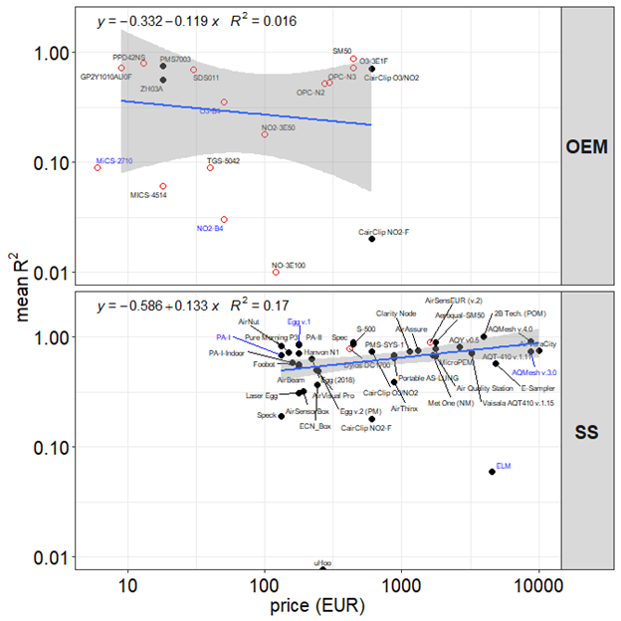

**Figure 7.** Relation between prices of OEMs/Sensor Systems (SS) and R2 for field test only. Logarithmic scale has been set for both axis. Open source and black box models are indicated with open and full circles, respectively. Names of ‘living’ and ‘non-living’ sensors are indicated in black and blue color, respectively. R2 refers to data averaged over 1 hour. Grey shade in the fit plots indicate a pointwise 95% confidence interval on the fitted values.

As shown in Figure 7, most of the reviewed sensor systems are “black box” systems. This means that the end-user cannot perform any further correction or re-calibration on the sensor system itself. The relationship observed between the coefficient of determination R2 and the price of the sensor system, it is an evidence that complexity of building a detector for air quality is somewhat linked to the choice of materials, multi-functionality and time-spent to develop a reliable sensor system

# 6 Discussion and conclusions

In order to target sensor systems in closer agreement and accuracy with reference systems, we displayed the distribution of SS models with R² > 0.75 and 0.5 < R² < 1.2. Figure 8 indicates the 2B Tech. (POM) by 2B Technologies, the AirSensEUR (v.2) by Liberantentio, the S-500 by Aeroqual, the Egg (v.2) by Air Quality Egg, the AQT410 v.1.15 by Vaisala and the AirVeraCity as the one having R² –> 1 and *mean slope* = 1. These sensor systems give indicative measurements of air pollutants when compared with the traditional reference monitoring systems over 1 hour averaging time. On the other hand, other sensors such as the PA-II by Purple Air, the AirNut, the AQMesh v.3.0 by AQMesh and, the AQY v0.5 by Aeroqual showed good agreement with reference systems but lower accuracy.

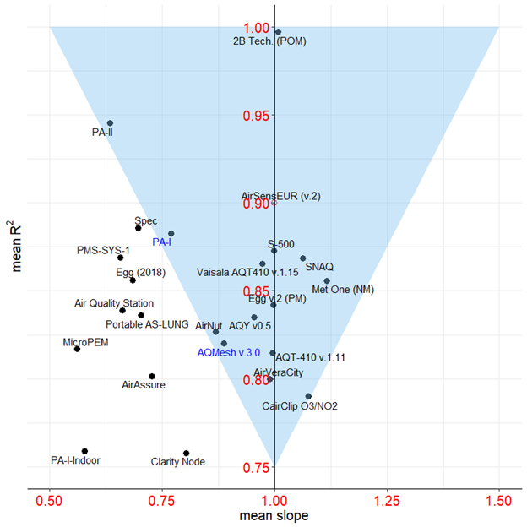

**Figure 8.** Correspondence between R2 and *slope* for sensor systems (SS). Only sensor models with R² > 0.75 and 0.5 < R2 < 1.2 are shown. Names of ‘living’ and ‘non-living’ sensors are indicated in black and blue color, respectively.

According to the European Air Quality Directive, a sensor system can be considered “Equivalent” when it meets the Data Quality Objectives (DQOs) set for data capture and uncertainty [[87]](https://www.zotero.org/google-docs/?Pwf2sH). In order for sensor system measurement to be incorporated into the legal framework set by the Air Quality Directive in Europe, they shall satisfy one of the data quality objectives (DQOs) of the Directive. DQOs, defined as the maximum allowed relative uncertainty, are defined either for reference and indicative measurements or for objective estimations. For inorganic gaseous pollutants, they correspond to 15, 25 to 30 and 75 %, respectively. Although, the objective of sensor systems is to provide the most accurate air pollution measurements, it is most likely that the DQO for reference measurements is out reach while it is believed that by improving the sensor calibration procedures the DQO of “Indicative Measurements” could be met at fixed monitoring sites [[88]](https://www.zotero.org/google-docs/?oPaMkj).

**Author Contributions:** conceptualization, Federico Karagulian and Michel Gerboles; methodology, Federico Karagulian and Michel Gerboles; software, Federico Karagulian; validation, Federico Karagulian and Michel Gerboles; formal analysis, Federico Karagulian and Michel Gerboles; investigation, Federico Karagulian and Michel Gerboles; resources, X.X.; data curation, Federico Karagulian, Michel Gerboles, Sabine Crunaire, Nathalie Redon and Laurent Spinelle, Caroline Marchand and Benoît Herbin; original draft preparation, Federico Karagulian; review and editing, Federico Karagulian, Michel Gerboles, Alex Kotsev, Laurent Spinelle and Annette Borowiak; visualization, Federico Karagulian; supervision, Michel Gerboles; project administration, Annette Borowiak.; funding acquisition, Annette Borowiak.

**Funding:**  This research was funded through the Administrative Arrangement called AQSens between the General Directorate for Environment of the EUROPEAN COMMISSION and the Joint Research Centre of the EUROPEAN COMMISSION. The french intercomparison exercise was funded by the French ministry of environment through the national reference laboratory for air quality monitoring (LCSQA).

**Acknowledgments:** In this section you can acknowledge any support given which is not covered by the author contribution or funding sections. This may include administrative and technical support, or donations in kind (e.g., materials used for experiments). Insert

**Conflicts of Interest:** The authors declare no conflict of interest. The funders had no role in the in the collection, analyses, or interpretation of data; in the writing of the manuscript, or in the decision to publish the results.

**Appendix A**

**Table A1.** Number of analyzed Records and sensor models by averaging time.

|  |  |  |
| --- | --- | --- |
| **Averaging time** | **n. Records** | **n. OEMs & SS** |
| 1 hour | 594 | 85 |
| 5 min | 253 | 40 |
| 24 hour | 248 | 42 |
| 1 min | 208 | 33 |

**Table A2.** Metrics used for comparing sensor data (Mi), and reference measurements (RMi).

|  |  |  |  |
| --- | --- | --- | --- |
| **Comparison metrics** | **Short name** | **Mathematical formulas** | **Characteristics** |
| Coefficient of determination | *R2* | where SSRES is the sum of squares of residuals and SSTOT is the total sum of squares | R2 measures the strength of relationship between Mi and RMi, of the percentage of total variance that is explained by a linear relationship |
| Slope of linear relationship | *slope* | where RMi and Mi are two measured values for the reference and the sensor system | the *slope* indicates the level  of accuracy |
| Intercept of the linear relationship | *intercept* |  | the *intercept* indicates the bias between the reference and the sensor data |
| Root Mean Square Error | *RMSE* |  | indicates the magnitude of the error and retains the variable’s unit; is sensitive to extreme values and outliers; tends to vary as a function of the standard deviation of the RM |
| Measurement uncertainty | *U* |  |  |
| Correlation Coefficient | *r* |  | measures the strength and direction of a linear relationship between two variables, and receives a value between -1 and 1; is independent of the difference in the variance (var) of M and RM, thus if r=1 and var(M)<var(RM), then variance correction may be required |

**Table A3.** Model of OEMs by pollutant, type, openness and price.

|  |  |  |  |  |  |  |
| --- | --- | --- | --- | --- | --- | --- |
| **model** | **pollutant** | **type** | **reference** | **open/close** | **living** | **price** |
| **CO-B4** | CO | electrochemical | Wei[[31]](https://www.zotero.org/google-docs/?dTP8xk) | open source | N | 50 |
| **CO 3E300** | CO | electrochemical | Gerboles[[58](https://www.zotero.org/google-docs/?Z21c6r)] | open source | Y | 100 |
| **DataRAM pDR-1200** | PM2.5 | nephelometer | Chakrabarti[[69]](https://www.zotero.org/google-docs/?EyCQbG) | black box | N | - |
| **DiscMini** | PM | OPC | Viana[[79]](https://www.zotero.org/google-docs/?JEEuuV) | open source | Y | 11000 |
| **DN7C3CA006** | PM2.5 | nephelometer | Sousan[[83]](https://www.zotero.org/google-docs/?q1S0sj) | open source | Y | 10 |
| **DSM501A** | PM2.5 | nephelometer | Wang[[67]](https://www.zotero.org/google-docs/?V7iCDB), Alvarado[[68]](https://www.zotero.org/google-docs/?SH7CUd) | open source | Y | 15 |
| **FIS SP-61** | O3 | MOs | Spinelle[[66]](https://www.zotero.org/google-docs/?2oye7A) | open source | Y | 50 |
| **GP2Y1010AU0F** | PM2.5, PM10 | nephelometer | Olivares[[70]](https://www.zotero.org/google-docs/?cBGmKF), Manikonda[[52]](https://www.zotero.org/google-docs/?tWQVVX), Sousan[[54](https://www.zotero.org/google-docs/?ajF3vA)], Alvarado[[68]](https://www.zotero.org/google-docs/?Fp7VL5), Wang[[67]](https://www.zotero.org/google-docs/?FJrp6b) | open source | Y | 10 |
| **MiCS-2710** | NO2 | MOs | Spinelle[[16]](https://www.zotero.org/google-docs/?5HqspD), Williams[[30]](https://www.zotero.org/google-docs/?c0QZUs) | open source | N | 7 |
| **MICS-4514** | CO, NO2 | MOs | Spinelle[63], Spinelle[[16]](https://www.zotero.org/google-docs/?CpNO5N) | open source | Y | 20 |
| **NO-3E100** | NO | electrochemical | Spinelle[64], Gerboles[[58](https://www.zotero.org/google-docs/?idqp9U)] | open source | Y | 120 |
| **NO-B4** | NO | electrochemical | Wei[[31]](https://www.zotero.org/google-docs/?Jhn4Go) | open source | Y | 50 |
| **NO2-3E50** | NO2 | electrochemical | Spinelle[[60]](https://www.zotero.org/google-docs/?xeFlyF), Gerboles[[58](https://www.zotero.org/google-docs/?TEqT9w)] | open source | Y | 100 |
| **NO2-A1** | NO2 | electrochemical | Williams[[30]](https://www.zotero.org/google-docs/?cXRoJw) | black box | Y | 50 |
| **NO2-B4** | NO2 | electrochemical | Spinelle[[60]](https://www.zotero.org/google-docs/?lTmyMn), Spinelle[[16]](https://www.zotero.org/google-docs/?WQr4oG) | open source | N | 50 |
| **NO2-B42F** | NO2 | electrochemical | Wei[[31]](https://www.zotero.org/google-docs/?n3mev0) | open source | N | 50 |
| **NO2-B43F** | NO2 | electrochemical | Sun[[62]](https://www.zotero.org/google-docs/?tqfH1b) | open source | Y | 50 |
| **O3-B4** | O3 | electrochemical | Spinelle[[60]](https://www.zotero.org/google-docs/?woOO8f), Spinelle[[16]](https://www.zotero.org/google-docs/?SuvHr4), Wei[[31]](https://www.zotero.org/google-docs/?rYnQCj) | open source | N | 50 |
| **O3-3E1F** | O3 | electrochemical | Spinelle[[60]](https://www.zotero.org/google-docs/?0VJp6h), Gerboles[[58](https://www.zotero.org/google-docs/?xI6XAM)] | open source | Y | 500 |
| **OPC-N2** | PM1, PM2.5, PM10 | OPC | AQ-SPEC[[40]](https://www.zotero.org/google-docs/?zI2ra0), Mukherjee[[77]](https://www.zotero.org/google-docs/?YW8wFs), Sousan[[83]](https://www.zotero.org/google-docs/?hcPBlt), Feinberg[[22]](https://www.zotero.org/google-docs/?4F0se9), Crilley[[84]](https://www.zotero.org/google-docs/?1GA54A), Badura[[76]](https://www.zotero.org/google-docs/?gzBDgT), Crunaire[[39]](https://www.zotero.org/google-docs/?lO8LQz) | open source, black box | N | 362 |
| **OPC-N3** | PM1, PM2.5, PM10 | OPC | AQ-SPEC[[40]](https://www.zotero.org/google-docs/?WJ9IjS) | open source | Y | 338 |
| **PMS1003** | PM2.5 | OPC | Kelly[[74]](https://www.zotero.org/google-docs/?ik2TtY) | black box | Y | 20 |
| **PMS3003** | PM2.5 | OPC | Zheng[[17]](https://www.zotero.org/google-docs/?P783h6), Kelly[[74]](https://www.zotero.org/google-docs/?a7mNj4) | open source, black box | Y | 30 |
| **PMS5003** | PM2.5 | OPC | Laquai[[34]](https://www.zotero.org/google-docs/?CTjROg) | black box | Y | 15 |
| **PMS7003** | PM2.5 | OPC | Badura[[76]](https://www.zotero.org/google-docs/?ZDcdx7) | black box | Y | 20 |
| **PPD42NS** | PM2.5, PM3, PM2 | nephelometer | Wang[[67]](https://www.zotero.org/google-docs/?uwwuCC), Holstius[[18]](https://www.zotero.org/google-docs/?dLPZI8), Austin[[72]](https://www.zotero.org/google-docs/?J7vA5W), Gao[[73]](https://www.zotero.org/google-docs/?aNmb7B),Kelly[[74]](https://www.zotero.org/google-docs/?Fne9Xv) | open source | Y | 15 |
| **SDS011** | PM2.5, PM10 | OPC | Budde[[10]](https://www.zotero.org/google-docs/?fAZwqO), Laquai[[34]](https://www.zotero.org/google-docs/?fr0Ves), Badura[[76]](https://www.zotero.org/google-docs/?HaZaQD), Liu[[19]](https://www.zotero.org/google-docs/?ECKmzY) | open source | Y | 30 |
| **SM50** | O3 | MOs | Feinberg[[22]](https://www.zotero.org/google-docs/?HGwZED) | open source | Y | 500 |
| **TGS-5042** | CO | MOs | Spinelle[[37]](https://www.zotero.org/google-docs/?TvUNX6) | open source | Y | 40 |
| **TZOA-PM Research Sensors** | PM | nephelometer | Feinberg[[22]](https://www.zotero.org/google-docs/?L2aMOy) | open source | Y | 90 |
| **ZH03A** | PM2.5 | nephelometer | Badura[[76]](https://www.zotero.org/google-docs/?6u6f2m) | black box | Y | 20 |

**Table A4**. Models of Sensor Systems by pollutant, type, openness and price.

|  |  |  |  |  |  |  |
| --- | --- | --- | --- | --- | --- | --- |
| **model** | **pollutant** | **type** | **reference** | **open/close** | **living** | **price** |
| **2B Tech. (POM)** | O3 | UV | AQ-SPEC[[40]](https://www.zotero.org/google-docs/?DJevKC) | black box | Y | 4500 |
| **Aeroqual-SM50** | O3 | MOs | Jiao[[44]](https://www.zotero.org/google-docs/?po863J) | black box | Y | 2000 |
| **AGT ATS-35 NO2** | NO2 | MOs | Williams[[30]](https://www.zotero.org/google-docs/?UyGaEQ) | black box | N | - |
| **Air Quality Station** | PM1, PM2.5, PM10 | OPC | AQ-SPEC[[40]](https://www.zotero.org/google-docs/?p4ecxw) | black box | Y | 2000 |
| **AirAssure** | PM2.5 | nephelometer | AQ-SPEC[[40]](https://www.zotero.org/google-docs/?4D3kND), Feinberg[[22]](https://www.zotero.org/google-docs/?kC9Vf1), Manikonda[[52]](https://www.zotero.org/google-docs/?GLNELM) | black box | Y | 1500 |
| **AirBeam** | PM2.5 | OPC, nephelometer | AQ-SPEC[[40]](https://www.zotero.org/google-docs/?2YLpX8), Mukherjee[[77]](https://www.zotero.org/google-docs/?Wen5T9), Feinberg[[22]](https://www.zotero.org/google-docs/?7kZ6Lk), Borghi[[41]](https://www.zotero.org/google-docs/?BUF4FF), Jiao[[44]](https://www.zotero.org/google-docs/?DHg3Im), Crunaire[[39]](https://www.zotero.org/google-docs/?M5e6Vh) | black box | Y | 200 |
| **AirCube** | NO2, O3, NO | electrochemical | Mueller[[28]](https://www.zotero.org/google-docs/?PbM5pL), Bigi[[59]](https://www.zotero.org/google-docs/?3g5jpu) | black box | Y | 3538 |
| **AirMatrix** | PM1, PM10, PM2.5 | nephelometer | Crunaire[[39]](https://www.zotero.org/google-docs/?MkgTCB) | black box | Y | 60 |
| **AirNut** | PM2.5 | nephelometer | AQ-SPEC[[40]](https://www.zotero.org/google-docs/?rO6GRL) | black box | Y | 150 |
| **AIRQino** | PM2.5, PM10 | OPC | Cavaliere[[78]](https://www.zotero.org/google-docs/?wwrUqN) | open source | Y | 1000 |
| **AirSensEUR (v.1)** | NO, NO2, O3 | electrochemical | Crunaire[[39]](https://www.zotero.org/google-docs/?lRInNM) | black box | Y | 1600 |
| **AirSensEUR (v.2)** | CO, NO, NO2, O3 | electrochemical | Gerboles[[25]](https://www.zotero.org/google-docs/?kTGGJA) | open source | Y | 1600 |
| **AirSensorBox** | NO2, CO, O3, PM10 | electrochemical, MOs, nephelometer | Borrego[[50]](https://www.zotero.org/google-docs/?HKOHwl) | black box | Y | 280 |
| **AirThinx** | PM1, PM2.5, PM10 | OPC | AQ-SPEC[[40]](https://www.zotero.org/google-docs/?1rlBst) | black box | Y | 1000 |
| **AirVeraCity** | CO, NO2, O3 | electrochemical, MOs | Marjovi[[57]](https://www.zotero.org/google-docs/?FoHBK0) | black box | Y | 10000 |
| **AirVisual Pro** | PM2.5, PM10 | nephelometer | AQ-SPEC[[40]](https://www.zotero.org/google-docs/?FZM7Nh) | black box | Y | 270 |
| **AQMesh v.3.0** | CO, NO | electrochemical | Jiao[[44]](https://www.zotero.org/google-docs/?MnAEPk) | black box | N | 10000 |
| **AQMesh v.4.0** | NO2, CO, NO, O3 | electrochemical | Cordero[[26]](https://www.zotero.org/google-docs/?oDX7Ox), AQ-SPEC[[40]](https://www.zotero.org/google-docs/?KLT9kd), Castell[[24]](https://www.zotero.org/google-docs/?nWS2Xp), Borrego[[50]](https://www.zotero.org/google-docs/?pucNFy), Crunaire[39] | black box | updated | 10000 |
| **AQT410 v.1.11** | O3 | electrochemical | AQ-SPEC[[40]](https://www.zotero.org/google-docs/?9yjfWt) | black box | Y | 3700 |
| **AQT-420** | NO2,O3, PM10, PM2.5 | electrochemical, OPC | Crunaire[[39]](https://www.zotero.org/google-docs/?y2S13t) | black box | Y | 3256 |
| **AQY v0.5** | PM2.5, NO2, O3 | OPC, electrochemical, MOs | AQ-SPEC[[40]](https://www.zotero.org/google-docs/?emQROJ) | black box | updated | 3000 |
| **ARISense** | NO2, CO, NO, O3 | electrochemical | Cross[[23]](https://www.zotero.org/google-docs/?XZYN7f) | black box | Y | - |
| **Atmotrack** | PM1, PM10, PM2.5 | nephelometer | Crunaire[[39]](https://www.zotero.org/google-docs/?ROt7x0) | black box | Y | 2500 |
| **BAIRS** | PM2.5-0.5 | OPC | Northcross[[86]](https://www.zotero.org/google-docs/?fbcgLs) | open source | N | 475 |
| **Cair** | PM2.5, PM10-2.5 | OPC | AQ-SPEC[[40]](https://www.zotero.org/google-docs/?lETqAY) | black box | Y | 200 |
| **CairClip O3/NO2** | O3, NO2 | electrochemical | Jiao[33], Spinelle[[60]](https://www.zotero.org/google-docs/?8vTPSv), Williams[[30]](https://www.zotero.org/google-docs/?K7Vg8Z), Duvall[[61]](https://www.zotero.org/google-docs/?S90mCp), Feinberg[[22]](https://www.zotero.org/google-docs/?0L1zjh) | black box | Y | 600 |
| **CairClip NO2-F** | NO2 | electrochemical | Spinelle[[60]](https://www.zotero.org/google-docs/?KxgApW), Duvall[[61]](https://www.zotero.org/google-docs/?1qeD2Z), Crunaire[[39]](https://www.zotero.org/google-docs/?znylnw) | black box | Y | 600 |
| **CairClip PM2.5** | PM2.5 | nephelometer | Williams[[51]](https://www.zotero.org/google-docs/?wBWXEO) | black box | Y | 1500 |
| **CAM** | PM10, PM2.5, NO2, CO, NO | OPC, electrochemical | Borrego[[50]](https://www.zotero.org/google-docs/?dk1t9z) | black box | Y | - |
| **CanarIT** | PM | nephelometer | Williams[[51]](https://www.zotero.org/google-docs/?lp2Vy0) | black box | N | 1500 |
| **Clarity Node** | PM2.5 | nephelometer | AQ-SPEC[[40]](https://www.zotero.org/google-docs/?lrCiNU) | black box | Y | 1300 |
| **Dylos DC1100** | PM2.5-0.5 | OPC | Jiao[[44]](https://www.zotero.org/google-docs/?ZwxVJJ), Williams[[51]](https://www.zotero.org/google-docs/?4PS9Fr), Feinberg[[22]](https://www.zotero.org/google-docs/?86TNHC) | black box, open source | Y | 300 |
| **Dylos DC1100 PRO** | PM2.5-0, PM10-2.5, PM10 | OPC | Jiao[[44]](https://www.zotero.org/google-docs/?XWaJi5), AQ-SPEC[[40]](https://www.zotero.org/google-docs/?nP9bsr), Feinberg[[22]](https://www.zotero.org/google-docs/?EAdTvc), Manikonda[[52]](https://www.zotero.org/google-docs/?ls5F1U) | black box, open source | Y | 300 |
| **Dylos DC1700** | PM2.5-0.5, PM10, PM10-2.5, PM3, PM2, PM2.5 | OPC | Manikonda[[52]](https://www.zotero.org/google-docs/?AKPNzB), Sousan[[83]](https://www.zotero.org/google-docs/?bMGmBN), Northcross[[86]](https://www.zotero.org/google-docs/?6J0ioq), Holstius[[18]](https://www.zotero.org/google-docs/?69xZAE), Steinle[[80]](https://www.zotero.org/google-docs/?w9nMe5), Han[[81]](https://www.zotero.org/google-docs/?WBpwNv), Jovasevic[[82]](https://www.zotero.org/google-docs/?dP2rjy), Dacunto[[55]](https://www.zotero.org/google-docs/?4Vu2MB) | open source | Y | 475 |
| **e-PM** | PM10, PM2.5 | nephelometer | Crunaire[[39]](https://www.zotero.org/google-docs/?29b8ch) | black box | Y | 2500 |
| **E-Sampler** | PM2.5 | OPC | AQ-SPEC[[40]](https://www.zotero.org/google-docs/?fSYOiJ) | black box | Y | 5500 |
| **ECN_Box** | PM10, PM2.5, NO2, O3 | nephelometer, electrochemical | Borrego[[50]](https://www.zotero.org/google-docs/?0uqkj5) | black box | Y | 274 |
| **Eco PM** | PM1 | OPC | Williams[[51]](https://www.zotero.org/google-docs/?3XJmq0) | black box | N |  |
| **ECOMSMART** | NO2, O3, PM1, PM10, PM2.5 | electrochemical, OPC | Crunaire[[39]](https://www.zotero.org/google-docs/?l6JTz8) | black box | Y | 4560 |
| **Egg (2018)** | PM1, PM2.5, PM10 | OPC | AQ-SPEC[[40]](https://www.zotero.org/google-docs/?d3hhVj) | black box | Y | 249 |
| **Egg v.1** | CO, NO2, O3 | MOs | AQ-SPEC[[40]](https://www.zotero.org/google-docs/?kZbFdt) | black box | N | 200 |
| **Egg v.2** | CO, NO2, O3 | electrochemical | AQ-SPEC[[40]](https://www.zotero.org/google-docs/?Mnm751) | black box | Y | 240 |
| **Egg v.2 (PM)** | PM2.5, PM10 | nephelometer | AQ-SPEC[[40]](https://www.zotero.org/google-docs/?shzzAN) | black box | Y | 280 |
| **ELM** | NO2, PM10, O3 | MOs, nephelometer | AQ-SPEC[[40]](https://www.zotero.org/google-docs/?a1e7r9), US-EPA[[65]](https://www.zotero.org/google-docs/?zvdBI8) | black box | N | 5200 |
| **EMMA** | PM2.5, CO, NO2, NO | OPC, electrochemical | Gillooly[[21]](https://www.zotero.org/google-docs/?8yjANT) | black box | Y | - |
| **ES-642** | PM2.5 | OPC | Crunaire[[39]](https://www.zotero.org/google-docs/?H1vbR7) | black box | Y | 2600 |
| **Foobot** | PM2.5 | OPC | AQ-SPEC[[40]](https://www.zotero.org/google-docs/?Xb64S1) | black box | Y | 200 |
| **Hanvon N1** | PM2.5 | nephelometer | AQ-SPEC[[40]](https://www.zotero.org/google-docs/?UwcImP) | black box | Y | 200 |
| **Intel Berkeley Badge** | NO2, O3 | electrochemical, MOs | Vaughn[[46]](https://www.zotero.org/google-docs/?4iQWKK) | open source | N | - |
| **ISAG** | NO2, O3 | MOs | Borrego[[50]](https://www.zotero.org/google-docs/?AezRmm) | black box | N | - |
| **Laser Egg** | PM2.5, PM10 | nephelometer | AQ-SPEC[[40]](https://www.zotero.org/google-docs/?8Ls9fK) | black box | Y | 200 |
| **M-POD** | CO, NO2 | MOs | Piedrahita[[20]](https://www.zotero.org/google-docs/?6rjJ9I) | black box | N |  |
| **MAS** | CO, NO2, O3 , PM2.5 | electrochemical, UV, nephelometer | Sun[[45]](https://www.zotero.org/google-docs/?GSaGfs) | black box, open source | N, Y | 5500 |
| **Met One - 831** | PM10 | OPC | Williams[[51]](https://www.zotero.org/google-docs/?vrSy3N) | black box | Y | 2050 |
| **Met One (NM)** | PM2.5 | OPC | AQ-SPEC[[40]](https://www.zotero.org/google-docs/?8F3VZg) | black box | Y | 1900 |
| **MicroPEM** | PM2.5 | nephelometer | AQ-SPEC[[40]](https://www.zotero.org/google-docs/?Wey3lw), Williams[[51]](https://www.zotero.org/google-docs/?eWtTac) | black box | Y | 2000 |
| **NanoEnvi** | NO2, O3, CO | electrochemical, MOs | Borrego[[50]](https://www.zotero.org/google-docs/?43bPBS) | black box | Y | - |
| **PA-I** | PM1, PM2.5, PM10 | OPC | AQ-SPEC[[40]](https://www.zotero.org/google-docs/?4ow8uj) | black box | N | 150 |
| **PA-I-Indoor** | PM2.5, PM10 | OPC | AQ-SPEC[[40]](https://www.zotero.org/google-docs/?qqinGj) | black box | Y | 180 |
| **PA-II** | PM1, PM2.5, PM10 | OPC | AQ-SPEC[[40]](https://www.zotero.org/google-docs/?2RB5OZ) | black box | Y | 200 |
| **Partector** | PM1, PM2.5 | Electrical | AQ-SPEC[[40]](https://www.zotero.org/google-docs/?xlgGhA) | black box | Y | 7000 |
| **PATS+** | PM2.5 | nephelometer | Pillarisetti[[71]](https://www.zotero.org/google-docs/?zcAC5b) | black box | Y | 500 |
| **Platypus NO2** | NO2 | MOs | Williams[[30]](https://www.zotero.org/google-docs/?IEWK3h) | black box | Y | 50 |
| **PMS-SYS-1** | PM2.5 | nephelometer | Jiao[[44]](https://www.zotero.org/google-docs/?LEYZbf), AQ-SPEC[[40]](https://www.zotero.org/google-docs/?W9I1KC), Williams[[51]](https://www.zotero.org/google-docs/?CA0B2Y), Feinberg[[22]](https://www.zotero.org/google-docs/?IX39VP) | black box | Y | 1000 |
| **Portable AS-LUNG** | PM1, PM2.5, PM10 | OPC | AQ-SPEC[[40]](https://www.zotero.org/google-docs/?56Q7ci) | black box | Y | 1000 |
| **Pure Morning P3** | PM2.5 | OPC | AQ-SPEC[[40]](https://www.zotero.org/google-docs/?AI2Ona) | black box | Y | 170 |
| **RAMP** | CO, NO2 | electrochemical | Zimmerman[[32]](https://www.zotero.org/google-docs/?NGzH1F) | open source | Y | - |
| **S-500** | NO2, O3 | MOs | Lin[[63]](https://www.zotero.org/google-docs/?JkVO3D), AQ-SPEC[[40]](https://www.zotero.org/google-docs/?DR1foV), Vaughn[[46]](https://www.zotero.org/google-docs/?H8iQIc) | black box | Y | 500 |
| **SENS-IT** | O3, CO, NO2 | MOs | AQ-SPEC[[40]](https://www.zotero.org/google-docs/?4nAEHX) | black box | N, Y | 2200 |
| **SidePak AM510** | PM2.5 | nephelometer | Karagulian[[75]](https://www.zotero.org/google-docs/?oZmdQK) | open source | Y | 3000 |
| **Smart Citizen Kit** | CO | MOs | AQ-SPEC[[40]](https://www.zotero.org/google-docs/?CqkH7R) | black box | Y | 200 |
| **SNAQ** | NO2, CO, NO | electrochemical | Mead[[47]](https://www.zotero.org/google-docs/?GWqtnw), Popoola[[48]](https://www.zotero.org/google-docs/?G6pk5T) | black box | Y | - |
| **Spec** | CO, NO2, O3 | electrochemical | AQ-SPEC[[40]](https://www.zotero.org/google-docs/?yGE0PY) | black box | Y | 500 |
| **Speck** | PM2.5 | nephelometer | Feinberg[[22]](https://www.zotero.org/google-docs/?Yc6IEK), US-EPA[[65]](https://www.zotero.org/google-docs/?OrZhFj), Williams[[51]](https://www.zotero.org/google-docs/?vhlcka), AQ-SPEC[[40]](https://www.zotero.org/google-docs/?YKpDc7), Manikonda[[52]](https://www.zotero.org/google-docs/?fWqwNR), Zikova[[53]](https://www.zotero.org/google-docs/?004Y19) | black box | Y | 150 |
| **UBAS** | PM2.5 | nephelometer | Manikonda[[52]](https://www.zotero.org/google-docs/?yCfdqI) | black box | N | 100 |
| **uHoo** | PM2.5, O3 | nephelometer, MOs | AQ-SPEC[[40]](https://www.zotero.org/google-docs/?zlbPTO) | black box | Y | 300 |
| **Urban AirQ** | NO2 | electrochemical | Mijling[[29]](https://www.zotero.org/google-docs/?VzPf4j) | open source | N | - |
| **Vaisala AQT410 v.1.11** | CO, NO2 | electrochemical | AQ-SPEC[[40]](https://www.zotero.org/google-docs/?t1dZQC) | black box | Y | 3700 |
| **Vaisala AQT410 v.1.15** | CO, NO2 | electrochemical | AQ-SPEC[[40]](https://www.zotero.org/google-docs/?YUsZqR) | black box | Y | 3700 |
| **Waspmote** | NO, NO2, PM1, PM10, PM2.5 | MOs, OPC | Crunaire[[39]](https://www.zotero.org/google-docs/?S2vCOR) | black box | Y | 1270 |
| **Watchtower 1** | NO2, PM1, PM10, PM2.5, O3 | electrochemical, OPC | Crunaire[[39]](https://www.zotero.org/google-docs/?VIhoi6) | black box | Y |  |

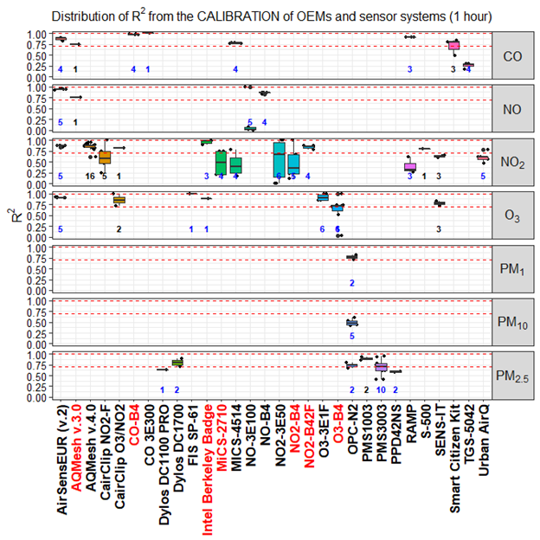

**Figure A1.** Distribution of R2 for OEMs and sensor systems against the reference for different pollutants. Records were averaged over a time-scale of 1 hour. Dashed lines indicate the value of 0.7 and 1.0. Numbers in bold indicate the number of open source (blue) and black box (black) Records. Names of ‘living’ and ‘non-living’ sensors are indicated in black and red color, respectively.

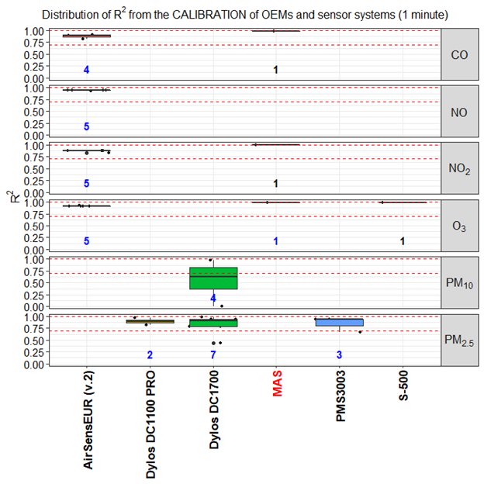

**Figure A2.** Distribution of R2 for OEMs and sensor systems against the reference for different pollutants. Records were averaged over a time-scale of 1 minute. Dashed lines indicate the value of 0.7 and 1.0. Numbers in bold indicate the number of open source (blue) and black box (black) Records. Names of ‘living’ and ‘non-living’ sensors are indicated in black and red color, respectively.

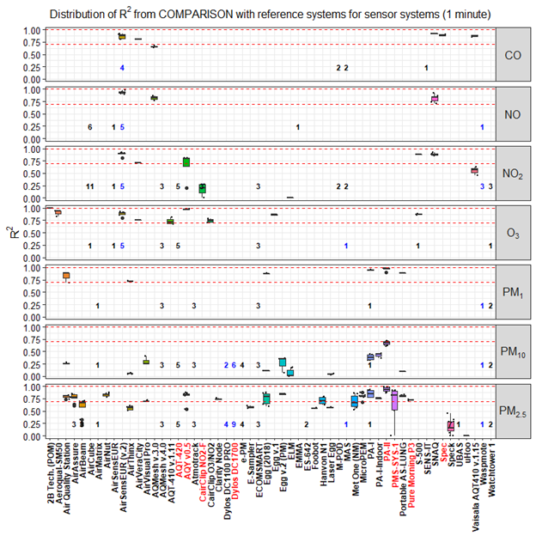

**Figure A3.** Distribution of R2 from the comparison of all sensor systems against reference systems. Records were averaged over a time-scale of 1 minute. Numbers in bold indicate the number of open source (blue) and black box (black) Records. Names of ‘living’ and ‘non-living’ sensors are indicated in black and red color, respectively.

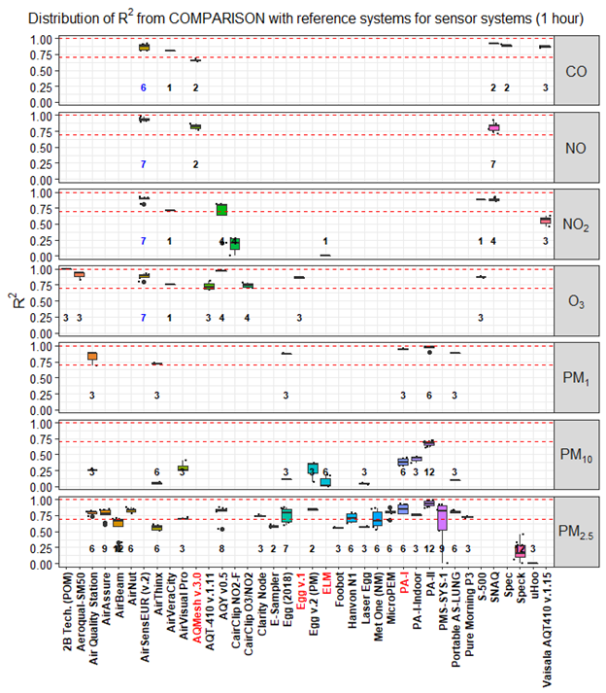

**Figure A4.** Distribution of R2 from the comparison of all sensor systems against reference systems. Records were averaged over a time-scale of 1 hour. Numbers in bold indicate the number of open source (blue) and black box (black) Records. Names of ‘living’ and ‘non-living’ sensors are indicated in black and red color, respectively.

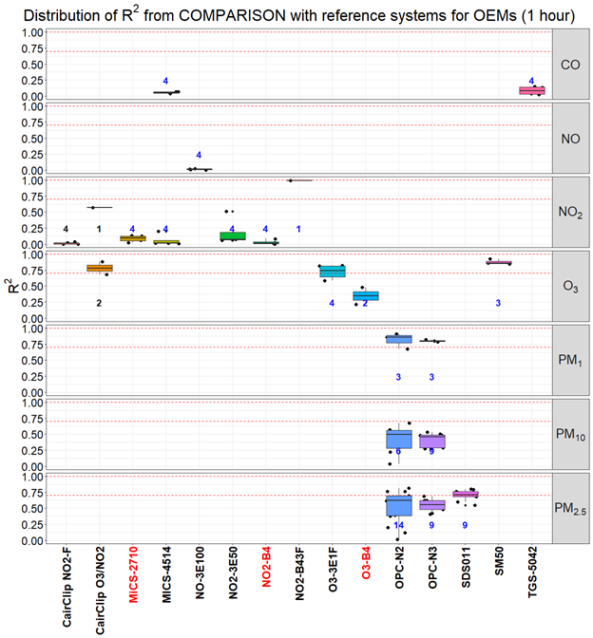

**Figure A5.** Distribution of R2 from the comparison of all OEMs against reference systems. Records were averaged over a time-scale of 1 hour. Numbers in bold indicate the number of open source (blue) and black box (black) Records. Names of ‘living’ and ‘non-living’ sensors are indicated in black and red color, respectively.

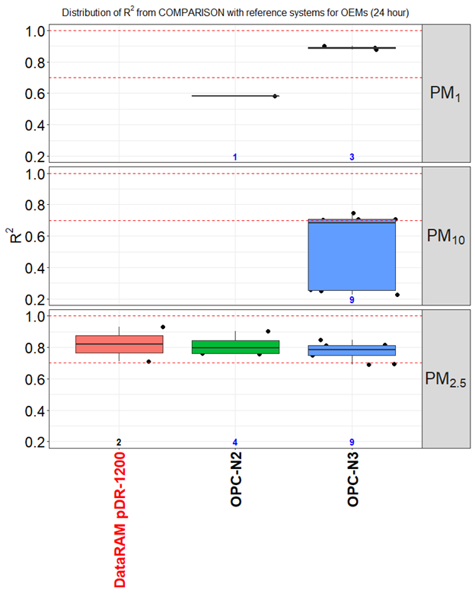

**Figure A6.** Distribution of R2 from the comparison of all OEMs against reference systems. Records were averaged over a time-scale of 24 hour. Numbers in bold indicate the number of open source (blue) and black box (black) Records. Names of ‘living’ and ‘non-living’ sensors are indicated in black and red color, respectively.

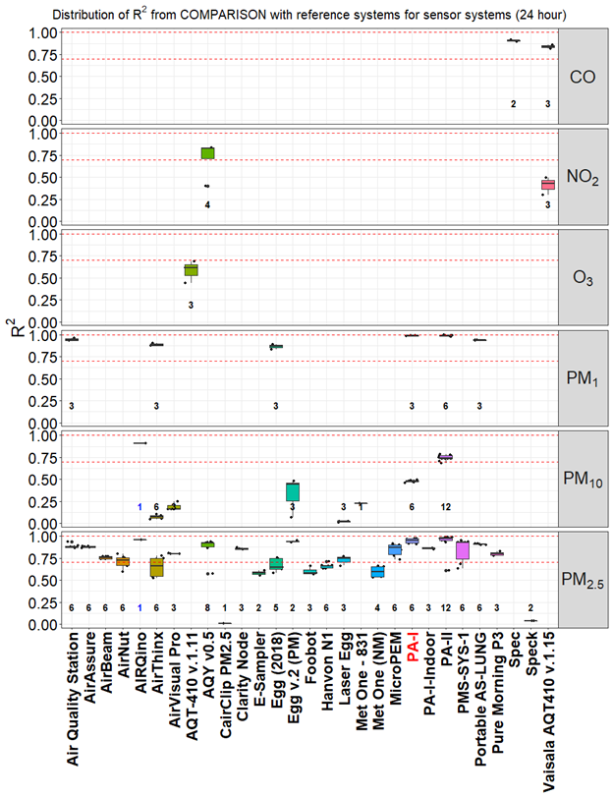

**Figure A7.** Distribution of R2 from the comparison of all sensor systems against reference systems. Records were averaged over a time-scale of 24 hour. Numbers in bold indicate the number of open source (blue) and black box (black) Records. Names of ‘living’ and ‘non-living’ sensors are indicated in black and red color, respectively.

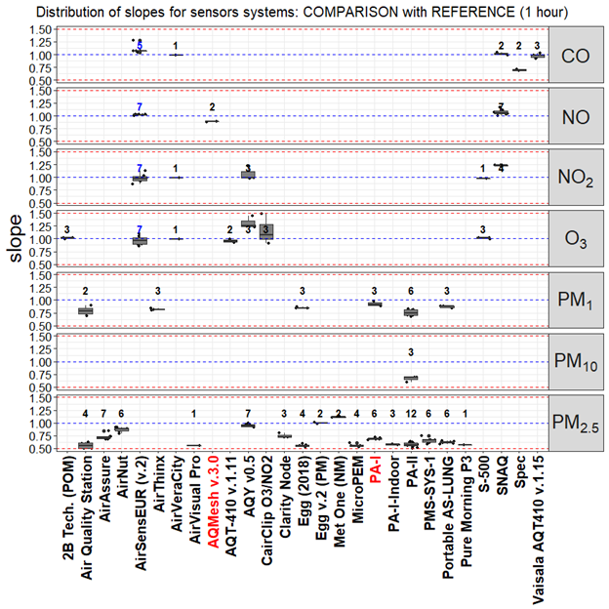

**Figure A8.** Distribution of slopes from the comparison of sensors systems against the reference. Only Records with R2 > 0.7 and 0.5 < slope < 1.5 are shown. Records were averaged over a time-scale of 1 hour. Numbers in bold indicate the number of open source (blue) and black box (black) Records. Names of ‘living’ and ‘non-living’ sensors are indicated in black and red color, respectively.

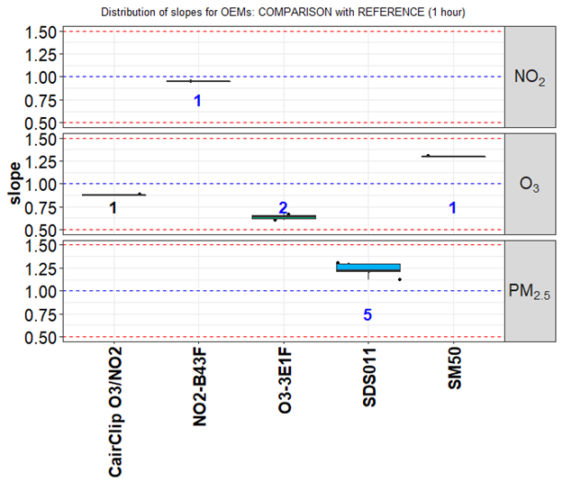

**Figure A9.** Distribution of slopes from the comparison of OEMs against the reference. Only Records with R2 > 0.7 and 0.5 < slope < 1.5 are shown. Records were averaged over a time-scale of 1 hour. Numbers in bold indicate the number of open source (blue) and black box (black) Records. Names of ‘living’ and ‘non-living’ sensors are indicated in black and red color, respectively.

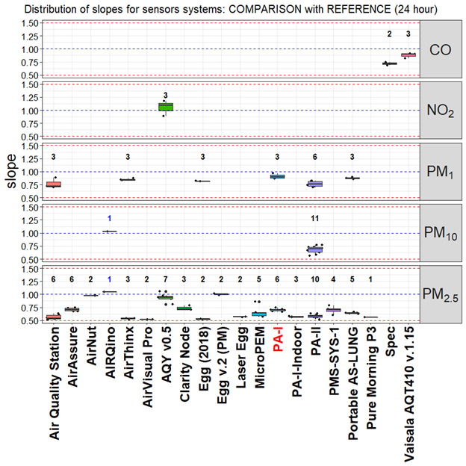

**Figure A10.** Distribution of slopes from the comparison of sensors systems against the reference. Only Records with R2 > 0.7 and 0.5 < slope < 1.5 are shown. Records were averaged over a time-scale of 24 hour. Numbers in bold indicate the number of open source (blue) and black box (black) Records. Names of ‘living’ and ‘non-living’ sensors are indicated in black and red color, respectively.

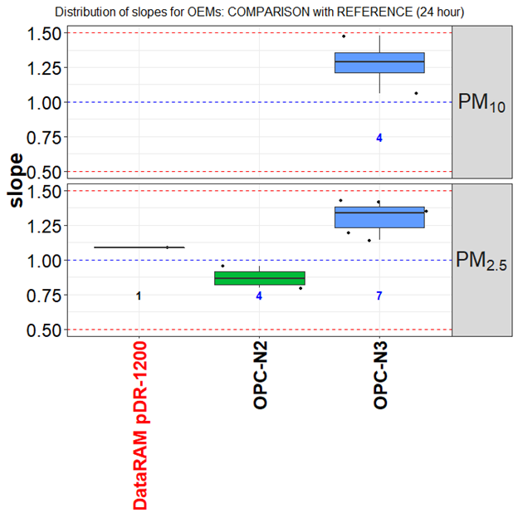

**Figure A11.** Distribution of slopes from the comparison of OEMs against the reference. Only Records with R2 > 0.7 and 0.5 < slope < 1.5 are shown. Records were averaged over a time-scale of 24 hour. Numbers in bold indicate the number of open source (blue) and black box (black) Records. Names of ‘living’ and ‘non-living’ sensors are indicated in black and red color, respectively.

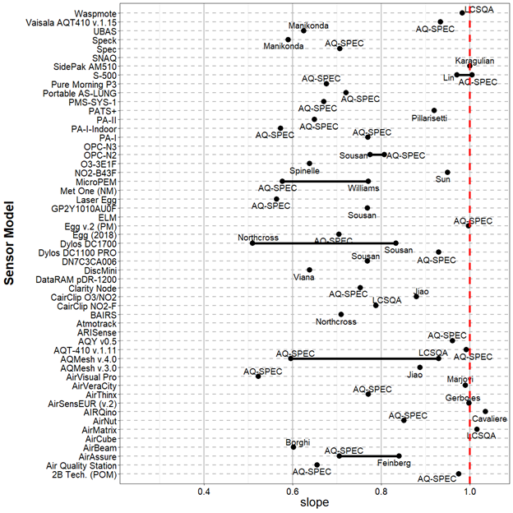

**Figure A12.** Mean for obtained from the comparison of OEMs and sensor systems against reference measurements.

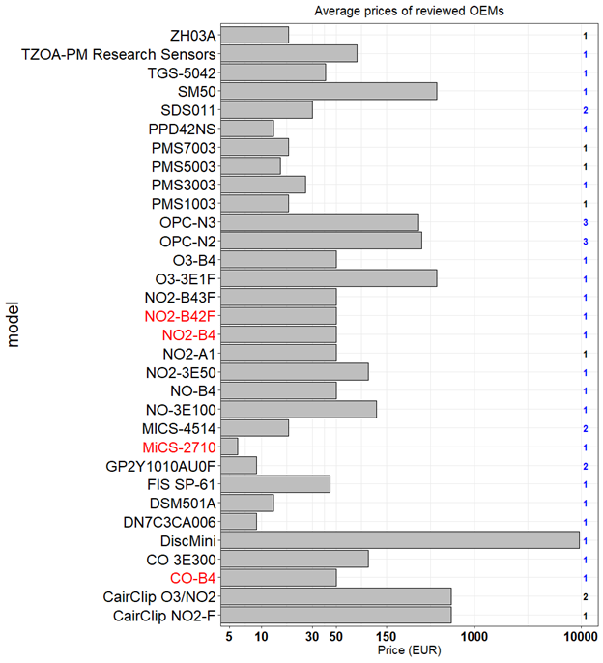

**Figure A13.** Prices of OEMs available on the market (Numbers in bold indicates the number of pollutant measured by each sensor. x-axis uses logarithmic scale). Numbers in bold indicate the number of open source (blue) and black box (black) Records. Names of ‘living’ and ‘non-living’ sensors are indicated in black and red color, respectively.

**Table A7.** Shortlist of sensor systems showing good agreement with reference systems ( > 0.85; 0.8 < slope < 1.2) for 24 hour time averaged data.

|  |  |  |  |  |  |  |  |
| --- | --- | --- | --- | --- | --- | --- | --- |
| **model** | **pollutant** | **mean** | **mean slope** | **open/close** | **living** | **commercial** | **price (EUR)** |
| **PA-I** | PM1 | 0.9867 | 0.9086 | black box | N | commercial | 132 |
| **PA-II** | PM1 | 0.9937 | 0.8252 | black box | Y | commercial | 176 |
| **Egg (2018)** | PM1 | 0.8776 | 0.8145 | black box | Y | commercial | 219 |
| **Egg v.2 (PM)** | PM2.5 | 0.9375 | 1.001 | black box | Y | commercial | 246 |
| **AirThinx** | PM1 | 0.8858 | 0.8483 | black box | Y | commercial | 880 |
| **Portable AS-LUNG** | PM1 | 0.9347 | 0.876 | black box | Y | non commercial | 880 |
| **AIRQino** | PM2.5,PM10 | 0.909 | 0.972 | open source | Y | non commercial | 1000 |
| **Air Quality Station** | PM1 | 0.94 | 0.89 | black box | Y | non commercial | 1760 |
| **AQY v0.5** | PM2.5 | 0.9092 | 0.9393 | black box | updated | commercial | 2640 |
| **Vaisala AQT410 v.1.15** | CO | 0.8612 | 0.9105 | black box | Y | commercial | 3256 |

References

[1. Kumar, P.; Morawska, L.; Martani, C.; Biskos, G.; Neophytou, M.; Di Sabatino, S.; Bell, M.; Norford, L.; Britter, R. The rise of low-cost sensing for managing air pollution in cities. *Environment International* **2015**, *75*, 199–205.](https://www.zotero.org/google-docs/?c1YQdG)

[2. 2008/50/EC: Directive of the European Parliament and of the Council of 21 May 2008 on ambient air quality and cleaner air for Europe Available online: http://eur-lex.europa.eu/Result.do?RechType=RECH_celex&lang=en&code=32008L0050 (accessed on Feb 15, 2011).](https://www.zotero.org/google-docs/?c1YQdG)

[3. CEN *Ambient air - Standard gravimetric measurement method for the determination of the PM10 or PM2,5 mass concentration of suspended particulate matter (EN 12341:2014). European Committee for Standardization.*; 2014;](https://www.zotero.org/google-docs/?c1YQdG)

[4. CEN *Ambient air - Standard method for the measurement of the concentration of carbon monoxide by non-dispersive infrared spectroscopy, (EN 14626:2012). European Committee for Standardization.*; 2012;](https://www.zotero.org/google-docs/?c1YQdG)

[5. CEN *Ambient air - Standard method for the measurement of the concentration of nitrogen dioxide and nitrogen monoxide by chemiluminescence (EN 14211:2012). European Committee for Standardization.*; 2012;](https://www.zotero.org/google-docs/?c1YQdG)

[6. CEN *Ambient air - Standard method for the measurement of the concentration of ozone by ultraviolet photometry,  (EN 14625:2012). European Committee for Standardization.*; 2012;](https://www.zotero.org/google-docs/?c1YQdG)

[7. CEN *Ambient air - Standard method for the measurement of the concentration of sulphur dioxide by ultraviolet fluorescence, (EN 14212:2012). European Committee for Standardization.*; 2012;](https://www.zotero.org/google-docs/?c1YQdG)

[8. Lewis, A.C.; von Schneidemesser, E.; Peltier, R. *Low-cost sensors for the measurement of atmospheric composition: overview of topic and future applications (World Meteorological Organization) WMO-No. 1215.*; 2018;](https://www.zotero.org/google-docs/?c1YQdG)

[9. Aleixandre, M.; Gerboles, M. Review of small commercial sensors for indicative monitoring of ambient gas. *Chemical Engineering Transactions* **2012**, *30*, 169–174.](https://www.zotero.org/google-docs/?c1YQdG)

[10. Budde, M.; Müller, T.; Laquai, B.; Streibl, N.; Schwarz, A.; Schindler, G.; Riedel, T.; Beigl, M.; Dittler, A. Suitability of the Low-Cost SDS011 Particle Sensor for Urban PM-Monitoring. **2018**.](https://www.zotero.org/google-docs/?c1YQdG)

[11. iScape *Summary of Air Quality sensors and recommendations for application. iScape project D1.5, February 2017*; 2017;](https://www.zotero.org/google-docs/?c1YQdG)

[12. Snyder, E.G.; Watkins, T.H.; Solomon, P.A.; Thoma, E.D.; Williams, R.W.; Hagler, G.S.W.; Shelow, D.; Hindin, D.A.; Kilaru, V.J.; Preuss, P.W. The changing paradigm of air pollution monitoring. *Environmental Science and Technology* **2013**, *47*, 11369–11377.](https://www.zotero.org/google-docs/?c1YQdG)

[13. White, R.M.; Paprotny, I.; Doering, F.; Cascio, W.E.; Solomon, P.A.; Gundel, L.A. Sensors and “apps” for community-based: Atmospheric monitoring. *EM: Air and Waste Management Association’s Magazine for Environmental Managers* **2012**, 36–40.](https://www.zotero.org/google-docs/?c1YQdG)

[14. Williams, R.; Kilaru, V.; Snyder, E.; Kaufman, A.; Dye, T.; Rutter, A.; Russell, A.; Hafner, H. *Air Sensor Guidebook, United States Environmental Protection Agency (US-EPA)*; 2014;](https://www.zotero.org/google-docs/?c1YQdG)

[15. Zhou, X.; Lee, S.; Xu, Z.; Yoon, J. Recent Progress on the Development of Chemosensors for Gases. *Chemical Reviews* **2015**, *115*, 7944–8000.](https://www.zotero.org/google-docs/?c1YQdG)

[16. Spinelle, L.; Gerboles, M.; Villani, M.G.; Aleixandre, M.; Bonavitacola, F. Field calibration of a cluster of low-cost available sensors for air quality monitoring. Part A: Ozone and nitrogen dioxide. *Sensors and Actuators B: Chemical* **2015**, *215*, 249–257.](https://www.zotero.org/google-docs/?c1YQdG)

[17. Zheng, T.; Bergin, M.H.; Johnson, K.K.; Tripathi, S.N.; Shirodkar, S.; Landis, M.S.; Sutaria, R.; Carlson, D.E. Field evaluation of low-cost particulate matter sensors in high and low concentration environments. *Atmospheric Measurement Techniques Discussions* **2018**, 1–40.](https://www.zotero.org/google-docs/?c1YQdG)

[18. Holstius, D.M.; Pillarisetti, A.; Smith, K.R.; Seto, E. Field calibrations of a low-cost aerosol sensor at a regulatory monitoring site in California. *Atmospheric Measurement Techniques* **2014**, *7*, 1121–1131.](https://www.zotero.org/google-docs/?c1YQdG)

[19. Liu, H.-Y.; Schneider, P.; Haugen, R.; Vogt, M. Performance Assessment of a Low-Cost PM2.5 Sensor for a near Four-Month Period in Oslo, Norway. *Atmosphere* **2019**, *10*, 41.](https://www.zotero.org/google-docs/?c1YQdG)

[20. Piedrahita, R.; Xiang, Y.; Masson, N.; Ortega, J.; Collier, A.; Jiang, Y.; Li, K.; Dick, R.P.; Lv, Q.; Hannigan, M.; et al. The next generation of low-cost personal air quality sensors for quantitative exposure monitoring. *Atmospheric Measurement Techniques* **2014**, *7*, 3325–3336.](https://www.zotero.org/google-docs/?c1YQdG)

[21. Gillooly, S.E.; Zhou, Y.; Vallarino, J.; Chu, M.T.; Michanowicz, D.R.; Levy, J.I.; Adamkiewicz, G. Development of an in-home, real-time air pollutant sensor platform and implications for community use. *Environmental Pollution* **2019**, *244*, 440–450.](https://www.zotero.org/google-docs/?c1YQdG)

[22. Feinberg, S.; Williams, R.; Hagler, G.S.W.; Rickard, J.; Brown, R.; Garver, D.; Harshfield, G.; Stauffer, P.; Mattson, E.; Judge, R.; et al. Long-term evaluation of air sensor technology under ambient conditions in Denver, Colorado. *Atmospheric Measurement Techniques* **2018**, *11*, 4605–4615.](https://www.zotero.org/google-docs/?c1YQdG)

[23. Cross, E.S.; Williams, L.R.; Lewis, D.K.; Magoon, G.R.; Onasch, T.B.; Kaminsky, M.L.; Worsnop, D.R.; Jayne, J.T. Use of electrochemical sensors for measurement of air pollution: correcting interference response and validating measurements. *Atmos. Meas. Tech.* **2017**, 14.](https://www.zotero.org/google-docs/?c1YQdG)

[24. Castell, N.; Dauge, F.R.; Schneider, P.; Vogt, M.; Lerner, U.; Fishbain, B.; Broday, D.; Bartonova, A. Can commercial low-cost sensor platforms contribute to air quality monitoring and exposure estimates? *Environment International* **2017**, *99*, 293–302.](https://www.zotero.org/google-docs/?c1YQdG)

[25. Gerboles, M. *Calibration of 5 AirSensEUR boxes in the Netherlands; proof of Concept AirSensEUR*; European Commission - Joint Research Centre: Ispra (ITALY), 2019;](https://www.zotero.org/google-docs/?c1YQdG)

[26. Cordero, J.M.; Borge, R.; Narros, A. Using statistical methods to carry out in field calibrations of low cost air quality sensors. *Sensors and Actuators B: Chemical* **2018**, *267*, 245–254.](https://www.zotero.org/google-docs/?c1YQdG)

[27. Bigi, A.; Mueller, M.; Grange, S.K.; Ghermandi, G.; Hueglin, C. Performance of NO, NO2; low cost sensors and three calibration approaches within a real world application. *Atmospheric Measurement Techniques Discussions* **2018**, 1–29.](https://www.zotero.org/google-docs/?c1YQdG)

[28. Mueller, M.; Meyer, J.; Hueglin, C. Design of an ozone and nitrogen dioxide sensor unit and its long-term operation within a sensor network in the city of Zurich. *Atmos. Meas. Tech.* **2017**, 17.](https://www.zotero.org/google-docs/?c1YQdG)

[29. Mijling, B.; Jiang, Q.; de Jonge, D.; Bocconi, S. Practical field calibration of electrochemical NO2 sensors for urban air quality applications. *Atmos. Meas. Tech. Discuss.* **2017**, *2017*, 1–25.](https://www.zotero.org/google-docs/?c1YQdG)

[30. Williams, R.; Long, R.; Beaver, M.; Kaufman, A.; Zeiger, F.; Heimbinder, M.; Acharya, B.R.; Grinwald, B.A.; Kupcho, K.A.; Tobinson, S.E. *Sensor Evaluation Report*; Office of Research and Development National Exposure Research Laboratory; 2014;](https://www.zotero.org/google-docs/?c1YQdG)

[31. Wei, P.; Ning, Z.; Ye, S.; Sun, L.; Yang, F.; Wong, K.; Westerdahl, D.; Louie, P. Impact Analysis of Temperature and Humidity Conditions on Electrochemical Sensor Response in Ambient Air Quality Monitoring. *Sensors* **2018**, *18*, 59.](https://www.zotero.org/google-docs/?c1YQdG)

[32. Zimmerman, N.; Presto, A.A.; Kumar, S.P.N.; Gu, J.; Hauryliuk, A.; Robinson, E.S.; Robinson, A.L.; R. Subramanian A machine learning calibration model using random forests to improve sensor performance for lower-cost air quality monitoring. *Atmos. Meas. Tech.* **2018**, *11*, 291–313.](https://www.zotero.org/google-docs/?c1YQdG)

[33. Spinelle, L.; Gerboles, M.; Aleixandre, M. Performance Evaluation of Amperometric Sensors for the Monitoring of O 3 and NO 2 in Ambient Air at ppb Level. *Procedia Engineering* **2015**, *120*, 480–483.](https://www.zotero.org/google-docs/?c1YQdG)

[34. Laquai, B. Particle Distribution Dependent Inaccuracy of the Plantower PMS5003 low-cost PM-sensor. **2017**.](https://www.zotero.org/google-docs/?c1YQdG)

[35. Liu, H.-Y.; Schneider, P.; Haugen, R.; Vogt, M. Performance Assessment of a Low-Cost PM2.5 Sensor for a near Four-Month Period in Oslo, Norway. *Atmosphere* **2019**, *10*, 41.](https://www.zotero.org/google-docs/?c1YQdG)

[36. EC Directive 2008/50/EC of the European Parliament and the Council of 21 May 2008 on ambient air quality and cleaner air for Europe 2008.](https://www.zotero.org/google-docs/?c1YQdG)

[37. Spinelle, L.; Gerboles, M.; Villani, M.G.; Aleixandre, M.; Bonavitacola, F. Field calibration of a cluster of low-cost commercially available sensors for air quality monitoring. Part B: NO, CO and CO2. *Sensors and Actuators B: Chemical* **2017**, *238*, 706–715.](https://www.zotero.org/google-docs/?c1YQdG)

[38. Lewis, A.; Edwards, P. Validate personal air-pollution sensors. *Nature News* **2016**, *535*, 29.](https://www.zotero.org/google-docs/?c1YQdG)

[39. Crunaire, S.; Redon, N.; Spinelle, L. *1ER ESSAI NATIONAL D’APTITUDE DES MICRO-CAPTEURS(EAμC) POUR LA SURVEILLANCE DE LA QUALITE DE L’AIR : SYNTHESE DES RESULTATS*; LCSQA, 2018; p. 38;.](https://www.zotero.org/google-docs/?c1YQdG)

[40. AQ-SPEC; South Coast Air Quality Management District; South Coast Air Quality Management District Air Quality Sensor Performance Evaluation Reports. Available online: http://www.aqmd.gov/aq-spec/evaluations#&MainContent_C001_Col00=2 (accessed on Dec 29, 2015).](https://www.zotero.org/google-docs/?c1YQdG)

[41. Borghi, F.; Spinazzè, A.; Campagnolo, D.; Rovelli, S.; Cattaneo, A.; Cavallo, D.M. Precision and Accuracy of a Direct-Reading Miniaturized Monitor in PM2.5 Exposure Assessment. *Sensors* **2018**, *18*, 3089.](https://www.zotero.org/google-docs/?c1YQdG)

[42. Mukherjee, A.; Stanton, L.G.; Graham, A.R.; Roberts, P.T. Assessing the Utility of Low-Cost Particulate Matter Sensors over a 12-Week Period in the Cuyama Valley of California. *Sensors* **2017**, *17*, 1805.](https://www.zotero.org/google-docs/?c1YQdG)

[43. Zikova, N.; Masiol, M.; Chalupa, D.C.; Rich, D.Q.; Ferro, A.R.; Hopke, P.K. Estimating Hourly Concentrations of PM2.5 across a Metropolitan Area Using Low-Cost Particle Monitors. *Sensors (Basel)* **2017**, *17*.](https://www.zotero.org/google-docs/?c1YQdG)

[44. Jiao, W.; Hagler, G.; Williams, R.; Sharpe, R.; Brown, R.; Garver, D.; Judge, R.; Caudill, M.; Rickard, J.; Davis, M.; et al. Community Air Sensor Network (CAIRSENSE) project: evaluation of low-cost sensor performance in a suburban environment in the southeastern United States. *Atmospheric Measurement Techniques* **2016**, *9*, 5281–5292.](https://www.zotero.org/google-docs/?c1YQdG)

[45. Sun, L.; Wong, K.C.; Wei, P.; Ye, S.; Huang, H.; Yang, F.; Westerdahl, D.; Louie, P.K.K.; Luk, C.W.Y.; Ning, Z. Development and Application of a Next Generation Air Sensor Network for the Hong Kong Marathon 2015 Air Quality Monitoring. *Sensors (Basel)* **2016**, *16*.](https://www.zotero.org/google-docs/?c1YQdG)

[46. Vaughn, D.L.; Dye, T.S.; Roberts, P.T.; Ray, A.E.; DeWinter, J.L. *Characterization of low-Cost NO2 Sensors*; U.S. Environmental Protection Agency Research Triangle Park, NC, 2010;](https://www.zotero.org/google-docs/?c1YQdG)

[47. Mead, M.I.; Popoola, O.A.M.; Stewart, G.B.; Landshoff, P.; Calleja, M.; Hayes, M.; Baldovi, J.J.; McLeod, M.W.; Hodgson, T.F.; Dicks, J.; et al. The use of electrochemical sensors for monitoring urban air quality in low-cost, high-density networks. *Atmospheric Environment* **2013**, *70*, 186–203.](https://www.zotero.org/google-docs/?c1YQdG)

[48. Popoola, O.A.M.; Stewart, G.B.; Mead, M.I.; Jones, R.L. Development of a baseline-temperature correction methodology for electrochemical sensors and its implications for long-term stability. *Atmospheric Environment* **2016**, *147*, 330–343.](https://www.zotero.org/google-docs/?c1YQdG)

[49. The World Air Quality Index *Sensing the Air Quality: Research on Air Quality Sensors. http://aqicn.org/sensor/.*; 2019;](https://www.zotero.org/google-docs/?c1YQdG)

[50. Borrego, C.; Costa, A.M.; Ginja, J.; Amorim, M.; Coutinho, M.; Karatzas, K.; Sioumis, T.; Katsifarakis, N.; Konstantinidis, K.; De Vito, S.; et al. Assessment of air quality microsensors versus reference methods: The EuNetAir joint exercise. *Atmospheric Environment* **2016**, *147*, 246–263.](https://www.zotero.org/google-docs/?c1YQdG)

[51. Williams, R.; Kaufman, A.; Hanley, T.; Rice, J.; Garvey, S. *Evaluation of Field-deployed Low Cost PM Sensors*; Office of Research and Development National Exposure Research Laboratory; 2014;](https://www.zotero.org/google-docs/?c1YQdG)

[52. Manikonda, A.; Zíková, N.; Hopke, P.K.; Ferro, A.R. Laboratory assessment of low-cost PM monitors. *Journal of Aerosol Science* **2016**, *102*, 29–40.](https://www.zotero.org/google-docs/?c1YQdG)

[53. Zikova, N.; Hopke, P.K.; Ferro, A.R. Evaluation of new low-cost particle monitors for PM2.5 concentrations measurements. *Journal of Aerosol Science* **2017**, *105*, 24–34.](https://www.zotero.org/google-docs/?c1YQdG)

[54. Sousan, S.; Koehler, K.; Hallett, L.; Peters, T.M. Evaluation of the Alphasense optical particle counter (OPC-N2) and the Grimm portable aerosol spectrometer (PAS-1.108). *Aerosol Science and Technology* **2016**, *50*, 1352–1365.](https://www.zotero.org/google-docs/?c1YQdG)

[55. Dacunto, P.J.; Klepeis, N.E.; Cheng, K.-C.; Acevedo-Bolton, V.; Jiang, R.-T.; Repace, J.L.; Ott, W.R.; Hildemann, L.M. Determining PM2.5 calibration curves for a low-cost particle monitor: common indoor residential aerosols. *Environmental Science: Processes & Impacts* **2015**, *17*, 1959–1966.](https://www.zotero.org/google-docs/?c1YQdG)

[56. Viana, M.; Rivas, I.; Reche, C.; Fonseca, A.S.; Pérez, N.; Querol, X.; Alastuey, A.; Álvarez-Pedrerol, M.; Sunyer, J. Field comparison of portable and stationary instruments for outdoor urban air exposure assessments. *Atmospheric Environment* **2015**, *123*, *Part A*, 220–228.](https://www.zotero.org/google-docs/?c1YQdG)

[57. Marjovi, A.; Arfire, A.; Martinoli, A. Extending Urban Air Quality Maps Beyond the Coverage of a Mobile Sensor Network: Data Sources, Methods, and Performance Evaluation. In Proceedings of the Proceedings of the 2017 International Conference on Embedded Wireless Systems and Networks; Junction Publishing: USA, 2017; pp. 12–23.](https://www.zotero.org/google-docs/?c1YQdG)

[58. Gerboles, M.; Spinelle, L.; Signorini, M. *AirSensEUR: an open data/software/hardware multi-sensor platform for air quality monitoring. Part A: sensor shield*; Publications Office of the European Union, 2015;](https://www.zotero.org/google-docs/?c1YQdG)

[59. Bigi, A.; Mueller, M.; Grange, S.K.; Ghermandi, G.; Hueglin, C. Performance of NO, NO2 low cost sensors and three calibration approaches within a real world application. *Atmospheric Measurement Techniques* **2018**, *11*, 3717–3735.](https://www.zotero.org/google-docs/?c1YQdG)

[60. Spinelle, L.; Gerboles, M.; Aleixandre, M.; Bonavitacola, F. Evaluation of metal oxides sensors for the monitoring of O3 in ambient air at ppb level. *Chemical Engineering Transactions* **2016**, 319–324.](https://www.zotero.org/google-docs/?c1YQdG)

[61. Duvall, R.M.; Long, R.W.; Beaver, M.R.; Kronmiller, K.G.; Wheeler, M.L.; Szykman, J.J. Performance Evaluation and Community Application of Low-Cost Sensors for Ozone and Nitrogen Dioxide. *Sensors* **2016**, *16*, 1698.](https://www.zotero.org/google-docs/?c1YQdG)

[62. Sun, L.; Westerdahl, D.; Ning, Z. Development and Evaluation of A Novel and Cost-Effective Approach for Low-Cost NO2 Sensor Drift Correction. *Sensors* **2017**, *17*, 1916.](https://www.zotero.org/google-docs/?c1YQdG)

[63. Lin, C.; Gillespie, J.; Schuder, M.D.; Duberstein, W.; Beverland, I.J.; Heal, M.R. Evaluation and calibration of Aeroqual series 500 portable gas sensors for accurate measurement of ambient ozone and nitrogen dioxide. *Atmospheric Environment* **2015**, *100*, 111–116.](https://www.zotero.org/google-docs/?c1YQdG)

[64. Vaughn, D.L.; Dye, T.S.; Roberts, L.; Ray, A.E.; DeWinter, J.L. *Characterization of Low-Cost NO2 Sensors*; U.S. Environmental Protection Agency Research Triangle Park, North Carolina: North Carolina, 2010; p. 10;.](https://www.zotero.org/google-docs/?c1YQdG)

[65. US-EPA Evaluation of Elm and Speck Sensors. **2015**, *EPA/600/R*-*15/314 | November 2015 | www.epa.gov/ord*.](https://www.zotero.org/google-docs/?c1YQdG)

[66. Spinelle, L.; Gerboles, M.; Kotsev, A.; Signorini, M. *Evaluation of low-cost sensors for air pollution monitoring: Effect of gaseous interfering compounds and meteorological conditions*; Publications Office of the European Union, 2017;](https://www.zotero.org/google-docs/?c1YQdG)

[67. Wang, Y.; Li, J.; Jing, H.; Zhang, Q.; Jiang, J.; Biswas, P. Laboratory Evaluation and Calibration of Three Low-Cost Particle Sensors for Particulate Matter Measurement. *Aerosol Science and Technology* **2015**, *49*, 1063–1077.](https://www.zotero.org/google-docs/?c1YQdG)

[68. Alvarado, M.; Gonzalez, F.; Fletcher, A.; Doshi, A.; Alvarado, M.; Gonzalez, F.; Fletcher, A.; Doshi, A. Towards the Development of a Low Cost Airborne Sensing System to Monitor Dust Particles after Blasting at Open-Pit Mine Sites. *Sensors* **2015**, *15*, 19667–19687.](https://www.zotero.org/google-docs/?c1YQdG)

[69. Chakrabarti, B.; Fine, P.M.; Delfino, R.; Sioutas, C. Performance evaluation of the active-flow personal DataRAM PM2.5 mass monitor (Thermo Anderson pDR-1200) designed for continuous personal exposure measurements. *Atmospheric Environment* **2004**, *38*, 3329–3340.](https://www.zotero.org/google-docs/?c1YQdG)

[70. Olivares, G.; Edwards, S. The Outdoor Dust Information Node (ODIN) – development and performance assessment of a low cost ambient dust sensor. *Atmospheric Measurement Techniques Discussions* **2015**, *8*, 7511–7533.](https://www.zotero.org/google-docs/?c1YQdG)

[71. Pillarisetti, A.; Allen, T.; Ruiz-Mercado, I.; Edwards, R.; Chowdhury, Z.; Garland, C.; Hill, L.D.; Johnson, M.; Litton, C.D.; Lam, N.L.; et al. Small, Smart, Fast, and Cheap: Microchip-Based Sensors to Estimate Air Pollution Exposures in Rural Households. *Sensors (Basel)* **2017**, *17*.](https://www.zotero.org/google-docs/?c1YQdG)

[72. Austin, E.; Novosselov, I.; Seto, E.; Yost, M.G. Laboratory Evaluation of the Shinyei PPD42NS Low-Cost Particulate Matter Sensor. *PLOS ONE* **2015**, *10*, e0137789.](https://www.zotero.org/google-docs/?c1YQdG)

[73. Gao, M.; Cao, J.; Seto, E. A distributed network of low-cost continuous reading sensors to measure spatiotemporal variations of PM2.5 in Xi’an, China. *Environmental Pollution* **2015**, *199*, 56–65.](https://www.zotero.org/google-docs/?c1YQdG)

[74. Kelly, K.E.; Whitaker, J.; Petty, A.; Widmer, C.; Dybwad, A.; Sleeth, D.; Martin, R.; Butterfield, A. Ambient and laboratory evaluation of a low-cost particulate matter sensor. *Environmental Pollution* **2017**, *221*, 491–500.](https://www.zotero.org/google-docs/?c1YQdG)

[75. Karagulian, F.; Belis, C.A.; Lagler, F.; Barbiere, M.; Gerboles, M. Evaluation of a portable nephelometer against the Tapered Element Oscillating Microbalance method for monitoring PM2.5. *J. Environ. Monit.* **2012**, *14*, 2145–2153.](https://www.zotero.org/google-docs/?c1YQdG)

[76. Badura, M.; Batog, P.; Drzeniecka-Osiadacz, A.; Modzel, P. Optical particulate matter sensors in PM2.5 measurements in atmospheric air. *E3S Web of Conferences* **2018**, *44*, 00006.](https://www.zotero.org/google-docs/?c1YQdG)

[77. Mukherjee, A.; Stanton, L.G.; Graham, A.R.; Roberts, P.T. Assessing the Utility of Low-Cost Particulate Matter Sensors over a 12-Week Period in the Cuyama Valley of California. *Sensors* **2017**, *17*, 1805.](https://www.zotero.org/google-docs/?c1YQdG)

[78. Cavaliere, A.; Carotenuto, F.; Di Gennaro, F.; Gioli, B.; Gualtieri, G.; Martelli, F.; Matese, A.; Toscano, P.; Vagnoli, C.; Zaldei, A. Development of Low-Cost Air Quality Stations for Next Generation Monitoring Networks: Calibration and Validation of PM2.5 and PM10 Sensors. *Sensors* **2018**, *18*, 2843.](https://www.zotero.org/google-docs/?c1YQdG)

[79. Viana, M.; Rivas, I.; Reche, C.; Fonseca, A.S.; Pérez, N.; Querol, X.; Alastuey, A.; Álvarez-Pedrerol, M.; Sunyer, J. Field comparison of portable and stationary instruments for outdoor urban air exposure assessments. *Atmospheric Environment* **2015**, *123*, *Part A*, 220–228.](https://www.zotero.org/google-docs/?c1YQdG)

[80. Steinle, S.; Reis, S.; Sabel, C.E.; Semple, S.; Twigg, M.M.; Braban, C.F.; Leeson, S.R.; Heal, M.R.; Harrison, D.; Lin, C.; et al. Personal exposure monitoring of PM 2.5 in indoor and outdoor microenvironments. *Science of The Total Environment* **2015**, *508*, 383–394.](https://www.zotero.org/google-docs/?c1YQdG)

[81. Han, I.; Symanski, E.; Stock, T.H. Feasibility of using low-cost portable particle monitors for measurement of fine and coarse particulate matter in urban ambient air. *Journal of the Air & Waste Management Association* **2017**, *67*, 330–340.](https://www.zotero.org/google-docs/?c1YQdG)

[82. Jovašević-Stojanović, M.; Bartonova, A.; Topalović, D.; Lazović, I.; Pokrić, B.; Ristovski, Z. On the use of small and cheaper sensors and devices for indicative citizen-based monitoring of respirable particulate matter. *Environmental Pollution* **2015**, *206*, 696–704.](https://www.zotero.org/google-docs/?c1YQdG)

[83. Sousan, S.; Koehler, K.; Thomas, G.; Park, J.H.; Hillman, M.; Halterman, A.; Peters, T.M. Inter-comparison of low-cost sensors for measuring the mass concentration of occupational aerosols. *Aerosol Science and Technology* **2016**, *50*, 462–473.](https://www.zotero.org/google-docs/?c1YQdG)

[84. Crilley, L.R.; Shaw, M.; Pound, R.; Kramer, L.J.; Price, R.; Young, S.; Lewis, A.C.; Pope, F.D. Evaluation of a low-cost optical particle counter (Alphasense OPC-N2) for ambient air monitoring. *Atmospheric Measurement Techniques* **2018**, *11*, 709–720.](https://www.zotero.org/google-docs/?c1YQdG)

[85. Barrett, J.P. The Coefficient of Determination—Some Limitations. *The American Statistician* **1974**, *28*, 19–20.](https://www.zotero.org/google-docs/?c1YQdG)

[86. Northcross, A.L.; Edwards, R.J.; Johnson, M.A.; Wang, Z.-M.; Zhu, K.; Allen, T.; Smith, K.R. A low-cost particle counter as a realtime fine-particle mass monitor. *Environ. Sci.: Processes Impacts* **2013**, *15*, 433–439.](https://www.zotero.org/google-docs/?c1YQdG)

[87. European Commission *Guide to the demonstration of equivalence of ambient air monitoring methods, Report by an EC Working, Group on Guidance*; European Commission, 2010;](https://www.zotero.org/google-docs/?c1YQdG)

[88. KEY-VOCs *Metrology for VOC indicators in air pollution and climate change. Revision of the testing protocol and procedure for calibration based on laboratory validation, final report. ENV56 KEY-VOCs.*; 2017;](https://www.zotero.org/google-docs/?c1YQdG)

|  |  |
| --- | --- |
|  | © 2019 by the authors. Submitted for possible open access publication under the terms and conditions of the Creative Commons Attribution (CC BY) license (http://creativecommons.org/licenses/by/4.0/). |