Maze Game

Goal:

Control your character around the cave. Solve the maze. You have to collect all the diamonds to be able to exit the maze. To open the door, you have to collect the key. You have to make sure to get out of the maze before your time runs out

Controls:

Use the arrow buttons to move your character around the maze.

CRC Cards:

**-------------------------------------------------------------------------------------------------------------------------------**

**MazeGame**

**-------------------------------------------------------------------------------------------------------------------------------**

Display MazePanel

**-------------------------------------------------------------------------------------------------------------------------------**

**MazePanel**

**-------------------------------------------------------------------------------------------------------------------------------**

Control Maze MazeGame

Draw Block

Update Player

Start/End

Control Keyboard Input

Manage Collectibles

Keep track of time

**-------------------------------------------------------------------------------------------------------------------------------**

**Block**

**-------------------------------------------------------------------------------------------------------------------------------**

Draw MazePanel

**-------------------------------------------------------------------------------------------------------------------------------**

**Player**

**-------------------------------------------------------------------------------------------------------------------------------**

Draw MazePanel

Move

Check Colision

UML Diagram:

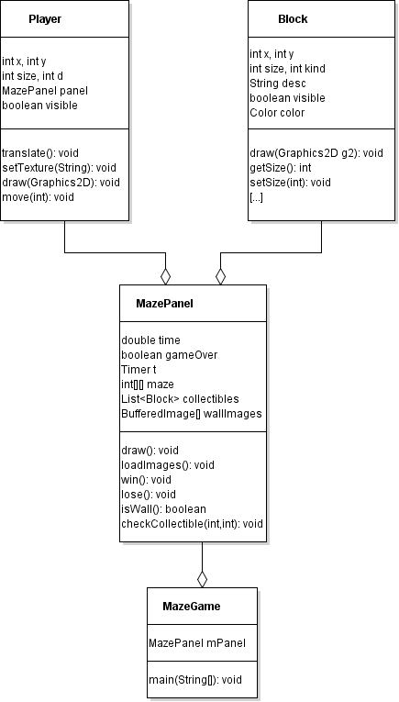

Additional Feautures:

* Changing Textures of player depending on the direction of movement
* Maze texture flashes purple when there is a little time left (15 seconds)
* Door/Key feature
* Randomized diamond position
* Updated textures