Supplementary Information
Correct use of HGVS nomenclature in clinical variant reporting and literature, 2010–2026: a meta-analysis of published audits and an interrupted time-series analysis of nomenclature changes
Alper Karagöl^{1,†,*}, Taner Karagöl^{1,¶,*}
¹ Istanbul University, Istanbul Medical Faculty, Istanbul, Turkey
† Present address: Broad Institute of MIT and Harvard, Cambridge, MA, USA; Department of Mechanical Engineering, Massachusetts Institute of Technology, Cambridge, MA, USA
¶ Present address: McGovern Institute for Brain Research, Massachusetts Institute of Technology, Cambridge, MA, USA
* To whom correspondence should be addressed: Alper Karagöl (akaragol@mit.edu; ORCID 0009-0001-7864-0732); Taner Karagöl (karagolt@mit.edu; ORCID 0009-0005-1011-7661)
Prepared 22 October 2026. Companion files: Supplementary_Data.xlsx (every count used, one sheet per dataset) and analysis code (analysis.py, analysis_supplementary.py).

Contents
- Supplementary Methods: S1 search and selection; S2 extraction and scoring; S3 statistical models
- Supplementary Figures S1–S9
- Supplementary Tables S1–S13
- Supplementary References

Supplementary Methods

S1. Search strategy and study selection
Searches were run on 20 October 2026 with a general web search engine over the terms "HGVS nomenclature compliance", "HGVS external quality assessment", "variant nomenclature errors manuscripts", "Mutalyzer literature variant descriptions", "annotation discordance HGVS ClinVar", and the titles of papers cited by each retrieved study (citation chasing in both directions). PubMed, Europe PMC, Crossref and OpenAlex could not be queried from the analysis environment, so no database search with controlled vocabulary was possible and the search is not exhaustive; this is the principal limitation of the evidence base.
Inclusion: peer-reviewed publication (2010–2026) that scored variant descriptions against the HGVS recommendations current at the time and reported, or allowed recovery of, the number scored and the number compliant for a defined corpus (journal manuscripts, clinical reports, checker submissions, database or annotation-tool output). Exclusion: commentaries without counts; tool papers without usage audits; studies on gene-symbol nomenclature only.
Fourteen records were retrieved and read in full where the publisher page could be fetched; nine met the inclusion criteria (Table 2 of the main text), six of which report counts that enter Figure 1. Three records (Tack et al. 2016; Deans et al. 2016; Berwouts et al. 2011) could not be fetched from the publisher and are represented through the figures reported in Keppens et al. 2020; Hart et al. 2024 is represented through its abstract record and the official HGVS version pages. The HGVS version history was taken from hgvs-nomenclature.org (versions pages for the 21.0 and 21.1 series and the older-versions page) on 20 October 2026.

S2. Extraction and scoring
A description was counted as fully compliant only when the audit scored it as complete and correct under the recommendations current at the time: a versioned reference sequence; the DNA level with its c. or g. prefix; the protein level with the p. prefix and, where the audit required it, parentheses around predicted changes; the 3′ rule; and the del, dup, ins and delins conventions. Legacy protein-only names (T790M, ΔF508) were non-compliant in every audit. Where a paper reports a percentage and a denominator but not the count, the count was recovered as round(percentage × n / 100); these cells are marked "back-computed" in Supplementary Data. Element-level outcomes (reference sequence given; version given; c. level; p. level; g. level; genome build) were extracted separately and never pooled with full-compliance outcomes.
Corpus strata, pooled only within a stratum: journal manuscripts and articles; clinical reports scored in external quality assessment (EQA) schemes; descriptions submitted to a nomenclature checker; database or annotation-tool outputs. The unit of analysis differs between strata (manuscript, report, variant entry, submitted string, variant) and is stated with every estimate.

S3. Statistical models
Proportions. Wilson score 95% confidence intervals for every proportion. Random-effects pooling on the logit scale with DerSimonian–Laird τ²; zero cells received a continuity correction of 0.5 (sensitivity: 0.1 and 1.0, and a Freeman–Tukey double-arcsine transform with harmonic-mean back-transformation). Heterogeneity as Cochran Q and I². Hartung–Knapp confidence intervals and a 95% prediction interval (t distribution with k − 2 degrees of freedom) were computed for the main pooled estimate; leave-one-out estimates omit each study in turn.
Interrupted time series. For the annual EQA series (Keppens et al. 2020, Table 3, "Total" column; 2012–2018; 1,712 scored entries) a segmented binomial regression with logit link was fitted with the proportion compliant as outcome and the number of entries as variance weight: logit(p_t) = β0 + β1·t + β2·post_t + β3·(t − 2016)·post_t, where t = year − 2012 and post_t indicates 2016 or later; β2 is the level change and β3 the change in slope. Over-dispersion was allowed by a quasi-binomial scale (Pearson χ²/df). The counterfactual is the pre-break model projected forward. Autocorrelation was checked with the Durbin–Watson statistic on deviance residuals. Sensitivity: the break moved to each year 2014–2018 (the 2018 model has no post-break slope term); a control series (the share of reports citing a current-version LRG or RefSeq reference sequence, an element whose rules the 2016 update did not change) fitted identically; and a panel of the four provider–indication sub-series with scheme fixed effects and a common break, plus a model with scheme-specific level changes.
Other comparisons. Risk ratios and odds ratios with Wald 95% CIs; χ² or Fisher exact tests for 2 × 2 tables; a weighted logistic trend for compliance by number of EQA participations; a Mantel–Haenszel odds ratio stratified by variant for the nine variants distributed both before and after 2016, with the Breslow–Day test for homogeneity and an exact sign test on the direction of change. All computation in Python 3 with numpy, pandas, scipy and statsmodels 0.15; the scripts reproduce every number in the main text and this supplement.

Supplementary Figures
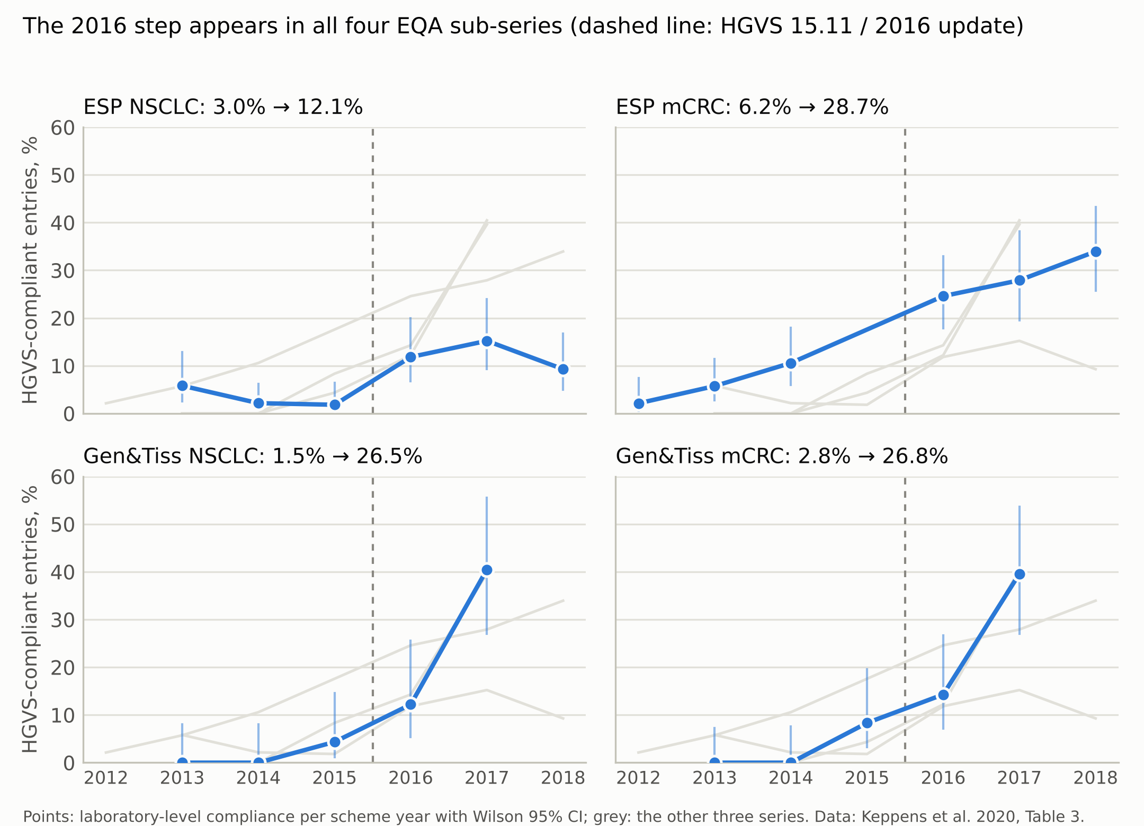
Supplementary Figure S1. Replication of the 2016 step in each EQA sub-series. Laboratory-level HGVS compliance per scheme year in the European Society of Pathology (ESP) and Gen&Tiss schemes for non-small-cell lung cancer (NSCLC) and metastatic colorectal cancer (mCRC), with Wilson 95% CIs; grey lines show the other three series. Pooled rates before and after 2016: ESP NSCLC 3.0% → 12.1% (RR 4.04, 2.03–8.03); ESP mCRC 6.3% → 28.7% (RR 4.59, 2.90–7.26); Gen&Tiss NSCLC 1.5% → 26.5% (RR 17.76, 4.29–73.58); Gen&Tiss mCRC 2.8% → 26.8% (RR 9.65, 3.48–26.78). Data: Keppens et al. 2020, Table 3.

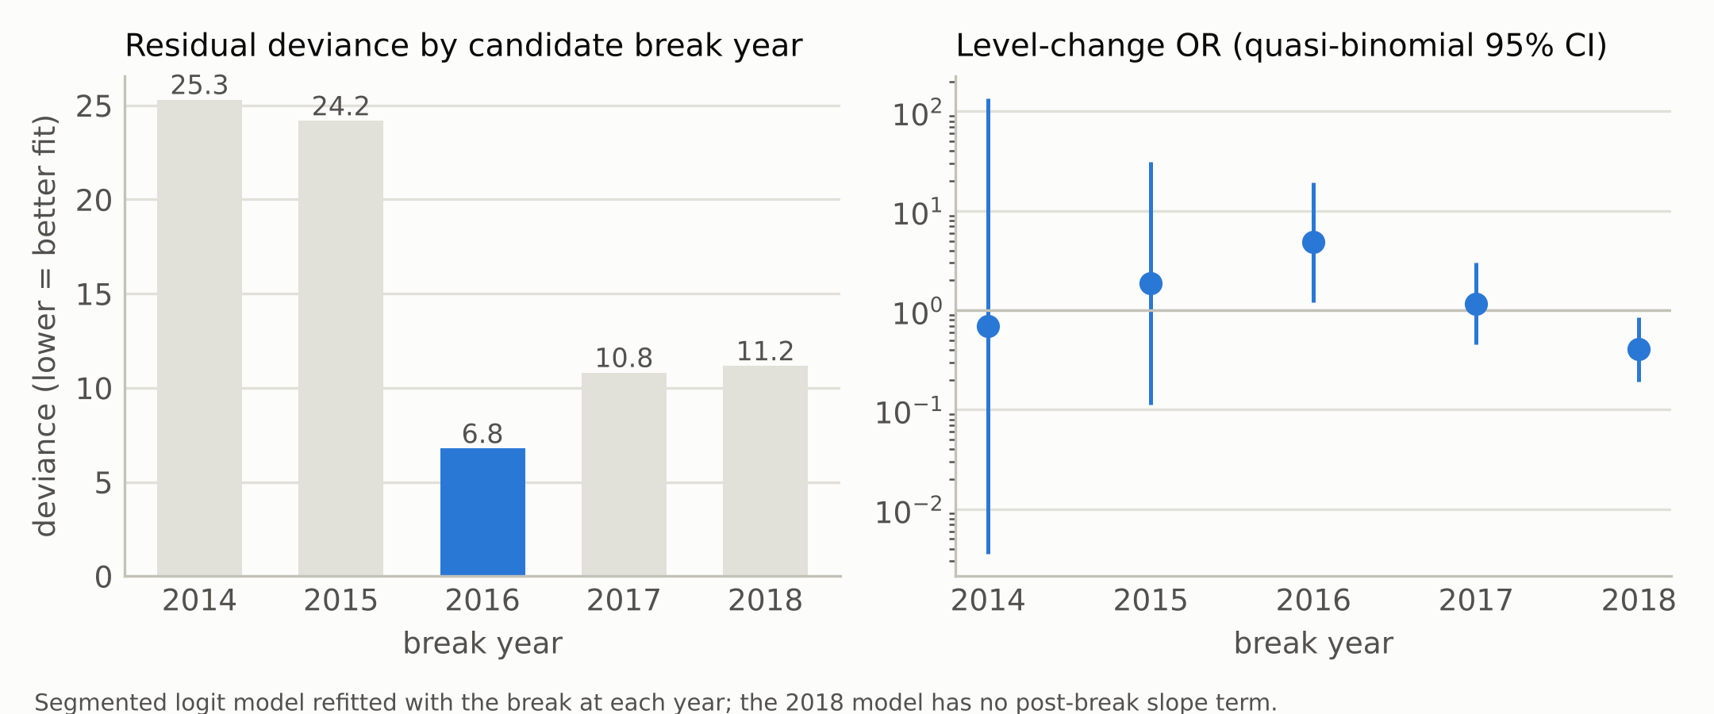
Supplementary Figure S2. Interruption-year sensitivity. The segmented logit model for the total EQA series refitted with the break placed at each year 2014–2018. Left: residual deviance (2014: 25.3; 2015: 24.2; 2016: 6.8; 2017: 10.8; 2018: 11.2); right: level-change odds ratio with quasi-binomial 95% CI. The 2016 break fits best; the 2018 model has no post-break slope term.

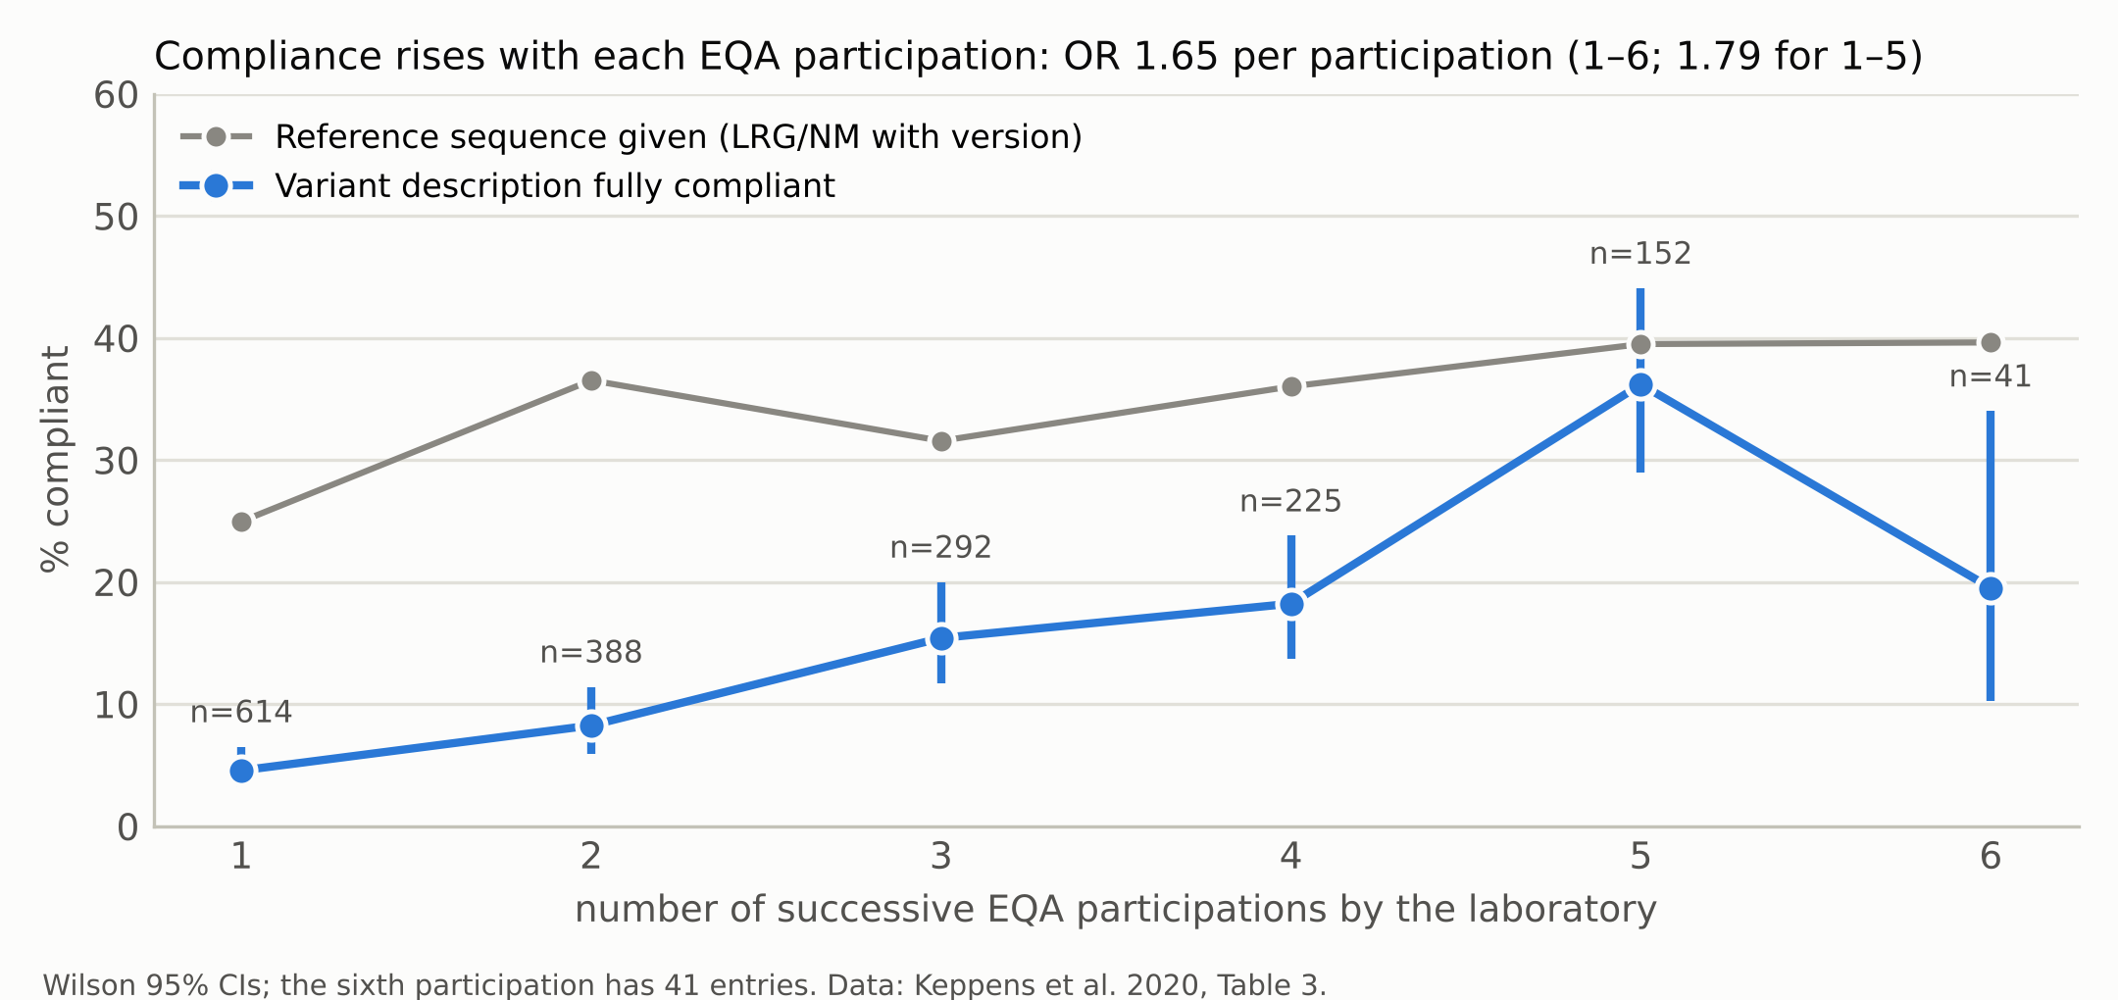
Supplementary Figure S3. Feedback dose–response. Compliance by the number of successive EQA participations by a laboratory (1–6), with Wilson 95% CIs and the number of entries; grey: reference sequence given in LRG/NM format with version. Weighted logistic trend: OR 1.65 (1.38–1.98) per participation over 1–6 and 1.79 (1.60–2.01) over 1–5; reference sequence OR 1.15 (1.03–1.28). Data: Keppens et al. 2020, Table 3.

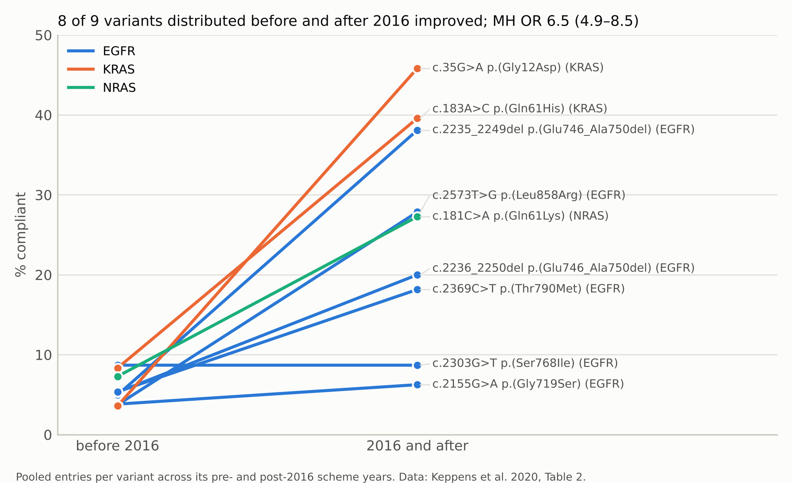
Supplementary Figure S4. Within-variant change for the nine variants distributed in EQA schemes both before and after 2016. Entries pooled per variant across its pre- and post-2016 scheme years. 8 of 9 improved (sign test p = 0.039); Mantel–Haenszel OR 6.46 (4.88–8.54), risk ratio 5.09; Breslow–Day homogeneity p = 0.004. Data: Keppens et al. 2020, Table 2.

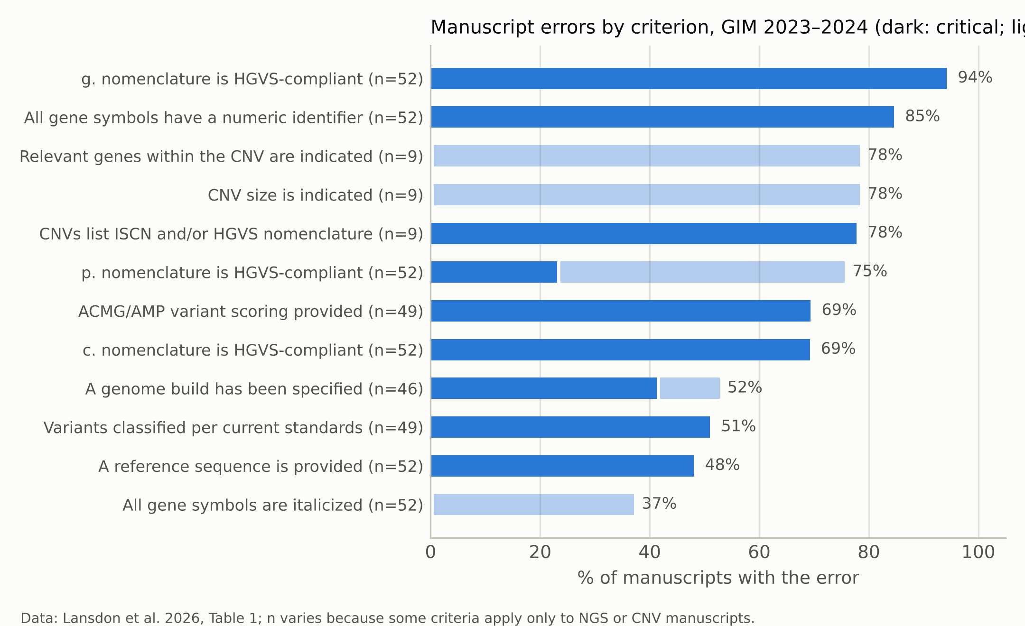
Supplementary Figure S5. Manuscript-level errors by rubric criterion in 52 manuscripts submitted to Genetics in Medicine and Genetics in Medicine Open in 2023–2024 (dark: critical error; light: small error); n varies because genome-build criteria apply only to the 46 NGS manuscripts and CNV criteria to the 9 CNV manuscripts. Data: Lansdon et al. 2026, Table 1.

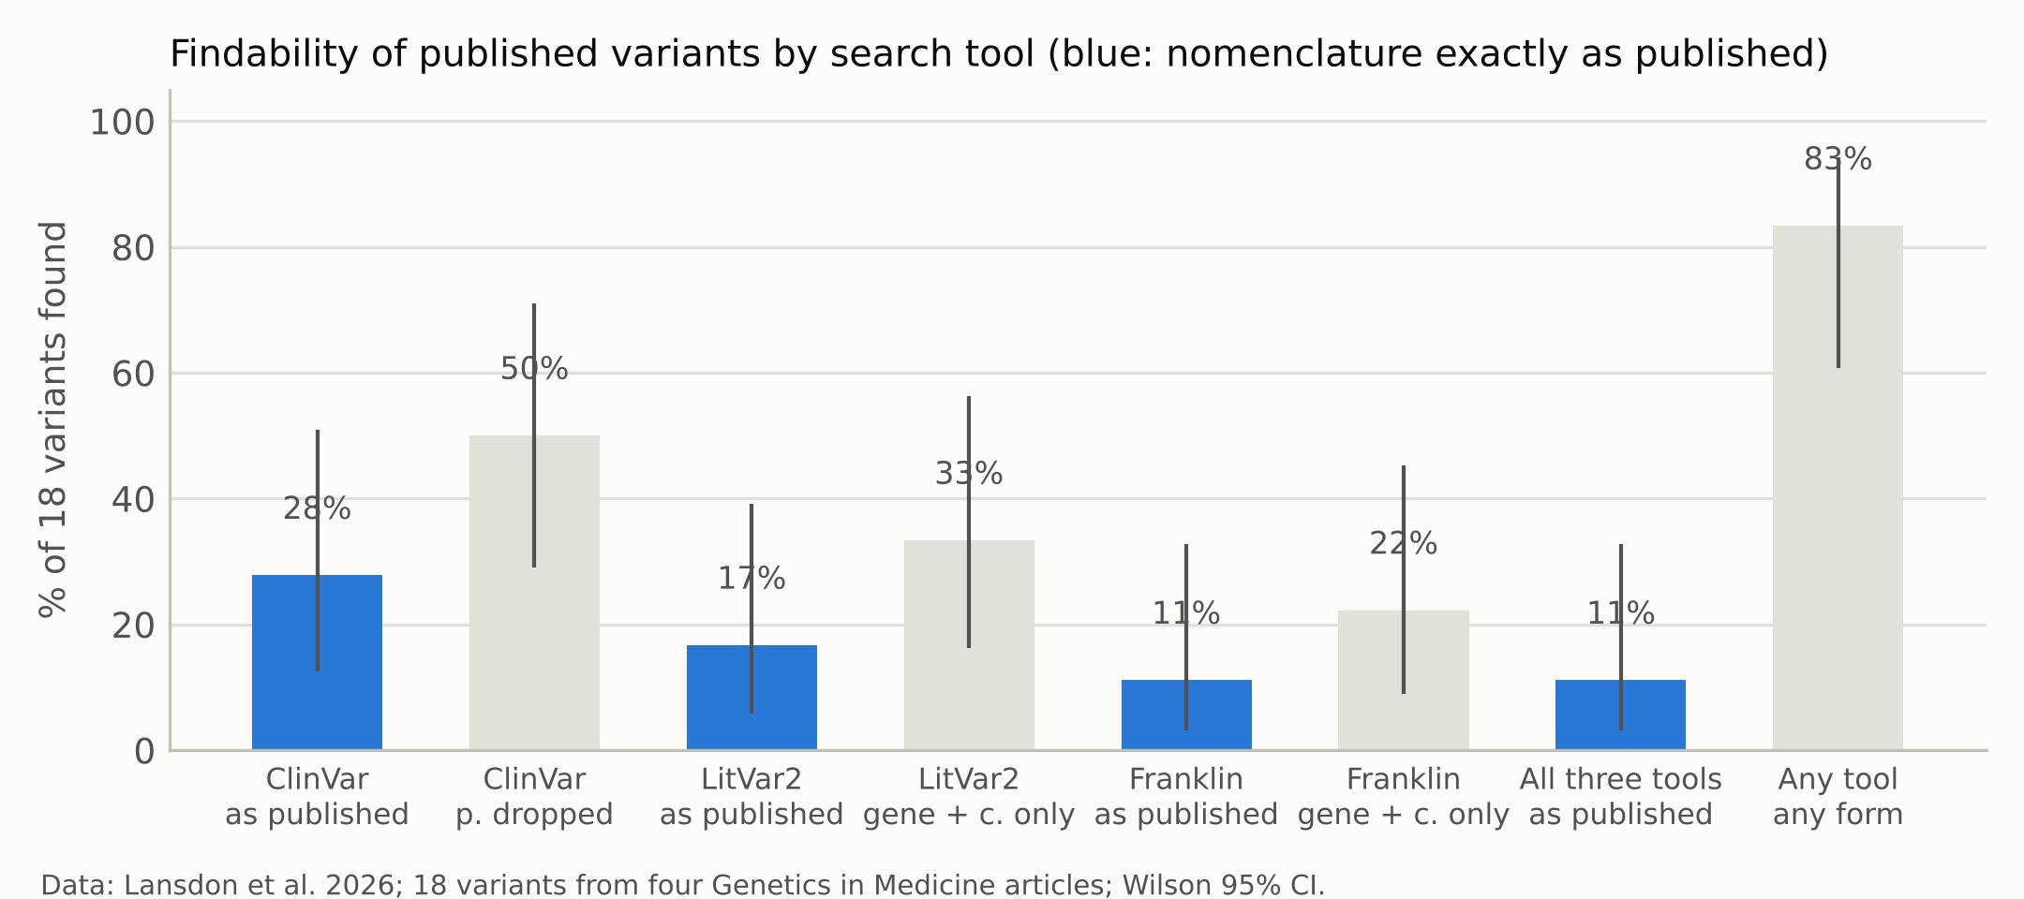
Supplementary Figure S6. Findability of 18 published variants from four Genetics in Medicine articles in ClinVar, LitVar2 and Franklin when searched with the nomenclature exactly as published (blue) or with a modified string (grey); Wilson 95% CIs. Data: Lansdon et al. 2026.

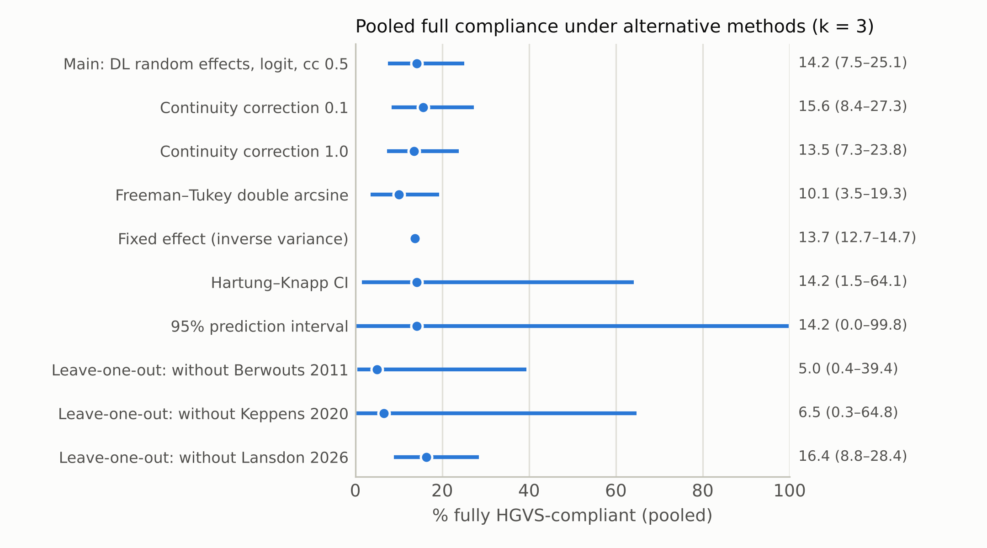
Supplementary Figure S7. Sensitivity of the pooled full-compliance estimate (k = 3 document-level audits) to the pooling model, transform, continuity correction, confidence-interval method and leave-one-out exclusion. Main estimate 14.2% (7.5–25.1); I² = 95.9%.

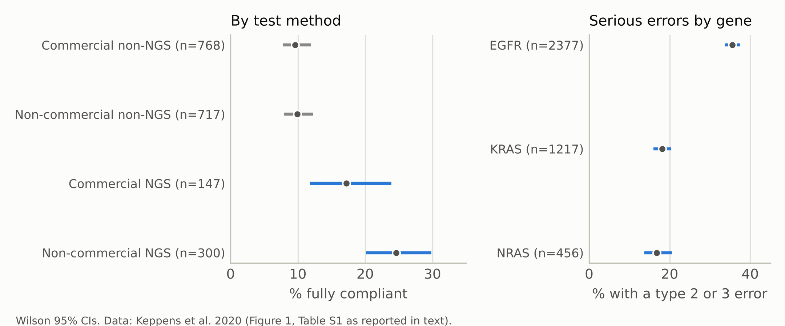
Supplementary Figure S8. Full compliance by test method (left) and share of entries with a type 2 or 3 error (potential therapeutic impact) by gene (right), with Wilson 95% CIs. NGS vs non-NGS methods: OR 2.43 (1.82–3.23); compliance did not differ between genes (χ² p = 0.932) but serious errors did (p < 0.001; EGFR vs KRAS RR 1.97, 1.73–2.24). Data: Keppens et al. 2020.

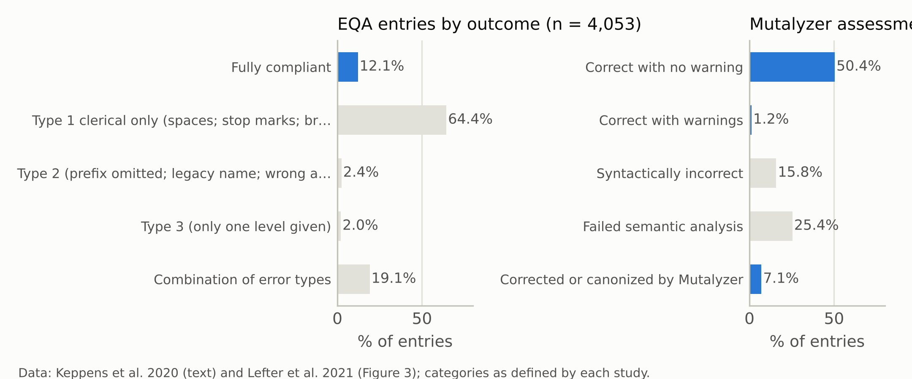
Supplementary Figure S9. Composition of outcomes in the EQA audit (left; Keppens et al. 2020: type 1 = clerical, type 2 = prefix omitted, legacy name or wrong amino-acid code, type 3 = one level only) and of Mutalyzer Name Checker assessments of 26 million unique submitted descriptions, September 2014 to October 2019 (right; Lefter et al. 2021, Figure 3).

Supplementary Tables
Supplementary Table S1. Complete HGVS Nomenclature release log, 2000–2026, newest first (hgvs-nomenclature.org version pages, accessed 20 October 2026; den Dunnen et al. 2016 for version 15.11).
Date | Version | Type | Change
2026-09-17 | 21.1.5 | patch | No rule change listed
2026-05-11 | 21.1.4 | patch | Repeat lengths divisible by three only within CDS; SVD-WG011 added; ISCN documentation improved
2025-06-13 | 21.1.3 | patch | X for unknown amino acid replaced by Xaa; negative examples highlighted
2025-03-10 | 21.1.2 | patch | SVD-WG010 rejected; history updated
2025-01-03 | 21.1.1 | patch | Reference sequence wording clarified on substitution page
2024-11-16 | 21.1.0 | minor | Fusion (adjoined transcript) recommendations organized; spaces not permitted; LOVD syntax checker listed
2024-08-15 | 21.0.4 | patch | Coding/non-coding identity handling changed; MIT licence
2024-07-19 | 21.0.3 | patch | Numbering diagram; supernumerary chromosome description fixed
2024-03-15 | 21.0.2 | patch | syntax.yaml updated
2024-02-22 | 21.0.1 | patch | indel removed except where listed as not to be used
2024-01 | 21.0.0 | major | Semantic versioning; new site hgvs-nomenclature.org; HVNC under HUGO; formal grammar; syntax summary; fusion rules aligned with VICC/HGNC/ISCN
2020-05 | 20.05 | dated | Adjoined transcripts for gene fusions (SVD-WG007); acceptable reference sequences (SVD-WG008)
2019-01 | 19.01 | dated | Circular DNA (SVD-WG006); methylation gom/lom (SVD-WG005); ISCN named extension (SVD-WG004)
2015-11 | 15.11 | dated | First YY.MM version; '=' for no change (SVD-WG001); n. coordinates (SVD-WG002); published as the 2016 update (Hum Mutat 37:564)
2012-11-01 | 2.121101 | dated | Stop-loss with no new stop (ext?); frameshift with unknown stop (fs*?)
2012-08-31 | 2.120831 | dated | Parentheses may be omitted with experimental evidence; upstream start codon p.Met1ext-5
2000 | 1 | publication | den Dunnen & Antonarakis 2000 (Hum Mutat 15:7)
Supplementary Table S2. Study-level estimates entering Figure 1 (Wilson 95% CIs; counts back-computed from published percentages where the paper reports no count) and the HUGO journal pilot (Higgins et al. 2021).
Estimate | Stratum | Outcome | Period | Events / n | % (95% CI)
Berwouts 2011 | Clinical reports (EQA) | Fully HGVS-compliant nomenclature | CF EQA scheme reports (scheme years not stated by the citing source) | 139 / 631 | 22.0 (19.0–25.4)
Keppens 2020 | Clinical reports (EQA) | Fully HGVS-compliant nomenclature | ESP + Gen&Tiss EQA 2012-2018 | 490 / 4,053 | 12.1 (11.1–13.1)
Lansdon 2026 | Journal manuscripts | No critical nomenclature error | GIM/GIMO submissions 2023-2024 | 0 / 52 | 0.0 (0.0–6.9)
Lansdon 2026 (c.) | Journal manuscripts (element) | c. descriptions HGVS-compliant | GIM/GIMO submissions 2023-2024 | 16 / 52 | 30.8 (19.9–44.3)
Lansdon 2026 (p.) | Journal manuscripts (element) | p. descriptions without any error | GIM/GIMO submissions 2023-2024 | 13 / 52 | 25.0 (15.2–38.2)
Lansdon 2026 (ref seq) | Journal manuscripts (element) | Reference sequence provided | GIM/GIMO submissions 2023-2024 | 27 / 52 | 51.9 (38.7–64.9)
Keppens 2020 (ref seq) | Clinical reports (element) | Any reference sequence provided | ESP + Gen&Tiss EQA 2012-2018 | 1,007 / 1,792 | 56.2 (53.9–58.5)
Keppens 2020 (ref seq current) | Clinical reports (element) | LRG/NM reference with current version | ESP + Gen&Tiss EQA 2012-2018 | 572 / 1,792 | 31.9 (29.8–34.1)
Lefter 2021 (Mutalyzer logs) | Checker submissions | Correct input (no error or warning) | Checker submissions Sep 2014-Oct 2019 | 13,104,000 / 26,000,000 | 50.4 (50.4–50.4)
Yen 2017 (c.) | Annotation tools | SnpEff-VEP exact c. match | Ground-truth set, tools 2016 | 100 / 108 | 92.6 (86.1–96.2)
Yen 2017 (p.) | Annotation tools | SnpEff-VEP exact p. match | Ground-truth set, tools 2016 | 81 / 108 | 75.0 (66.1–82.2)
Chen 2025 (c.) | Annotation tools | HGVSc identical across 3 tools (ClinVar transcript) | ClinVar Jan 2024; 3 tools | 96,294 / 164,549 | 58.5 (58.3–58.8)
Chen 2025 (p.) | Annotation tools | HGVSp identical across 3 tools (ClinVar transcript) | ClinVar Jan 2024; 3 tools | 138,287 / 164,549 | 84.0 (83.9–84.2)

Journal (HUGO pilot) | Stage | Period | Manuscripts with variants | With validation file (% , 95% CI) | Returned for errors
Human Mutation | initial submission | 6 months from April 2019 | 349 | 208 (59.6; 54.4–64.6) | —
Human Mutation | revision | 6 months from April 2019 | 187 | 162 (86.6; 81.0–90.8) | —
Genetics in Medicine | revision | 3 months from April 2019 | 35 | 35 (100.0; 90.1–100.0) | 4
Supplementary Table S3. Interrupted time-series model outputs for the total EQA series (odds ratios with 95% CIs). Main model: break 2016, residual deviance 6.8 on 3 df, over-dispersion φ = 2.28, Durbin–Watson 2.95; pre-period rate 3.9% (n = 933), post-period 22.2% (n = 779), risk ratio 5.76 (4.07–8.14); level change +14.8 percentage points in 2016 and a gap of 19.8 points by 2018 against the projected pre-2016 trend.
Model | Term | OR (95% CI) | p
Variant description, break 2016, quasi-binomial | Pre-break slope (per year) | 1.11 (0.64–1.92) | 0.715
Variant description, break 2016, quasi-binomial | Level change at break | 4.82 (1.21–19.18) | 0.025
Variant description, break 2016, quasi-binomial | Change in slope after break (per year) | 1.07 (0.57–2.03) | 0.828
Variant description, break 2016, binomial | Pre-break slope (per year) | 1.11 (0.77–1.59) | 0.581
Variant description, break 2016, binomial | Level change at break | 4.82 (1.93–12.02) | < 0.001
Variant description, break 2016, binomial | Change in slope after break (per year) | 1.07 (0.70–1.63) | 0.742
Variant description, break 2017, quasi-binomial | Pre-break slope (per year) | 1.85 (1.30–2.65) | < 0.001
Variant description, break 2017, quasi-binomial | Level change at break | 1.17 (0.46–2.99) | 0.741
Variant description, break 2017, quasi-binomial | Change in slope after break (per year) | 0.41 (0.18–0.95) | 0.037
Current-version reference sequence cited (control), break 2016, quasi-binomial | Pre-break slope (per year) | 1.18 (0.89–1.57) | 0.238
Current-version reference sequence cited (control), break 2016, quasi-binomial | Level change at break | 0.84 (0.38–1.87) | 0.673
Current-version reference sequence cited (control), break 2016, quasi-binomial | Change in slope after break (per year) | 0.82 (0.53–1.29) | 0.395

Year | Compliant / n | Observed % | Fitted % (break 2016) | Projected % (no break)
2012 | 2 / 94 | 2.1 | 3.3 | 3.3
2013 | 12 / 301 | 4.0 | 3.6 | 3.6
2014 | 14 / 334 | 4.2 | 4.0 | 4.0
2015 | 8 / 204 | 3.9 | 4.4 | 4.4
2016 | 53 / 305 | 17.4 | 19.6 | 4.8
2017 | 74 / 268 | 27.6 | 22.5 | 5.3
2018 | 46 / 206 | 22.3 | 25.7 | 5.9
Supplementary Table S4. Per-scheme replication (Figure S1). Pooled compliance before (2012–2015) and after (2016–2018) the break in each provider–indication sub-series, with risk ratios and Fisher exact p; scheme-specific level-change odds ratios from the interaction model; and the common-break panel model with scheme fixed effects (15 residual df, deviance 44.0, φ = 2.76).
Sub-series | Years | Before: compliant / n (%) | After: compliant / n (%) | RR (95% CI) | Fisher p | Scheme-specific level OR (95% CI)
ESP NSCLC | 2013-2018 | 10 / 335 (3.0) | 34 / 282 (12.1) | 4.04 (2.03–8.03) | < 0.001 | 1.30 (0.22–7.77)
ESP mCRC | 2012-2018 | 20 / 320 (6.3) | 91 / 317 (28.7) | 4.59 (2.90–7.26) | < 0.001 | 1.04 (0.11–9.78)
Gen&Tiss NSCLC | 2013-2017 | 2 / 134 (1.5) | 22 / 83 (26.5) | 17.76 (4.29–73.58) | < 0.001 | 7.93 (0.50–126.34)
Gen&Tiss mCRC | 2013-2017 | 4 / 144 (2.8) | 26 / 97 (26.8) | 9.65 (3.48–26.78) | < 0.001 | 4.23 (0.46–39.17)

Panel model term (common break, scheme intercepts) | OR (95% CI) | p
Pre-break slope (per year) | 1.34 (0.72–2.49) | 0.359
Level change at break | 3.00 (0.63–14.25) | 0.166
Change in slope after break (per year) | 0.93 (0.45–1.93) | 0.842
Supplementary Table S5. Interruption-year sweep for the total EQA series (Figure S2): fit statistics and level-change estimate with the break placed at each candidate year.
Break year | Residual deviance | AIC | Residual df | Level OR (95% CI, quasi-binomial) | p
2014 | 25.30 | 825.0 | 3 | 0.70 (0.00–134.72) | 0.892
2015 | 24.17 | 823.9 | 3 | 1.87 (0.11–31.26) | 0.664
2016 | 6.78 | 806.5 | 3 | 4.82 (1.21–19.18) | 0.025
2017 | 10.80 | 810.5 | 3 | 1.17 (0.46–2.99) | 0.741
2018 | 11.16 | 808.9 | 4 | 0.41 (0.19–0.86) | 0.018
Supplementary Table S6. Feedback dose–response (Figure S3) and transitions between successive schemes. Transitions: a laboratory correct in the previous scheme was compliant in 51/88 cases vs 102/876 after an error (RR 4.98, 3.86–6.42; OR 10.46, 6.53–16.75); for reference sequences 221/346 vs 166/683 (RR 2.63, 2.25–3.07). First vs fifth participation RR 7.93 (5.22–12.06); unsegmented calendar trend OR 1.65 per year (1.33–2.04).
Participations | Compliant / n | % (95% CI) | Reference sequence: compliant / n | %
1 | 28 / 614 | 4.6 (3.2–6.5) | 159 / 637 | 25.0
2 | 32 / 388 | 8.2 (5.9–11.4) | 149 / 408 | 36.5
3 | 45 / 292 | 15.4 (11.7–20.0) | 95 / 301 | 31.6
4 | 41 / 225 | 18.2 (13.7–23.8) | 85 / 236 | 36.0
5 | 55 / 152 | 36.2 (29.0–44.1) | 62 / 157 | 39.5
6 | 8 / 41 | 19.5 (10.2–34.0) | 21 / 53 | 39.6
Supplementary Table S7. Returning variants (Figure S4): entries pooled before and after 2016 for each variant distributed in both periods. Mantel–Haenszel OR 6.46 (4.88–8.54); Breslow–Day p = 0.004.
Gene | Variant | Before: compliant / n (%) | After: compliant / n (%)
EGFR | c.2155G>A p.(Gly719Ser) | 5 / 131 (3.8) | 2 / 32 (6.3)
EGFR | c.2235_2249del p.(Glu746_Ala750del) | 6 / 121 (5.0) | 24 / 63 (38.1)
EGFR | c.2236_2250del p.(Glu746_Ala750del) | 6 / 113 (5.3) | 19 / 95 (20.0)
EGFR | c.2303G>T p.(Ser768Ile) | 4 / 46 (8.7) | 2 / 23 (8.7)
EGFR | c.2369C>T p.(Thr790Met) | 14 / 261 (5.4) | 67 / 369 (18.2)
EGFR | c.2573T>G p.(Leu858Arg) | 15 / 403 (3.7) | 100 / 359 (27.9)
KRAS | c.35G>A p.(Gly12Asp) | 6 / 167 (3.6) | 22 / 48 (45.8)
KRAS | c.183A>C p.(Gln61His) | 4 / 48 (8.3) | 19 / 48 (39.6)
NRAS | c.181C>A p.(Gln61Lys) | 15 / 206 (7.3) | 21 / 77 (27.3)
Supplementary Table S8. Meta-analytic sensitivity for the pooled full-compliance estimate (Figure S7). Main model: DerSimonian–Laird random effects on the logit scale with a 0.5 continuity correction for the zero cell (Lansdon 2026, 0/52).
Method | Pooled % (95% CI) | τ² (logit) | I² (%)
Main: random effects, logit, cc 0.5 | 14.2 (7.5–25.1) | 0.27 | 95.9
Random effects, logit, cc 0.1 | 15.6 (8.4–27.3) | 0.26 | 95.7
Random effects, logit, cc 1.0 | 13.5 (7.3–23.8) | 0.27 | 95.9
Random effects, Freeman–Tukey double arcsine | 10.1 (3.5–19.3) | 0.01 | 96.6
Fixed effect (inverse variance), logit | 13.7 (12.7–14.7) | — | —
Main estimate with Hartung–Knapp CI | 14.2 (1.5–64.1) | — | —
Main estimate, 95% prediction interval | 14.2 (0.0–99.8) | — | —
Leave-one-out: without Berwouts 2011 | 5.0 (0.4–39.4) | 2.55 | 71.6
Leave-one-out: without Keppens 2020 | 6.5 (0.3–64.8) | 4.73 | 82.4
Leave-one-out: without Lansdon 2026 | 16.4 (8.8–28.4) | 0.25 | 97.8
Supplementary Table S9. Element-level and subgroup comparisons: version omission among descriptions that cite a reference sequence (EQA reports vs manuscripts), test-method and gene effects.
Comparison | Group 1 | Group 2 | Effect (95% CI) | p
Reference cited without a version | EQA reports: 179 / 1007 (17.8; 15.5–20.3) | Manuscripts: 5 / 27 (18.5; 8.2–36.7) | pooled 17.8% (15.6–20.2), I² = 0.0% | Fisher 1.000
Full compliance, NGS vs non-NGS methods | NGS 93/447 | non-NGS 145/1485 | OR 2.43 (1.82–3.23) | < 0.001
Full compliance, non-commercial vs commercial NGS panels | 24.6% (n = 300) | 17.2% (n = 147) | OR 1.60 (0.97–2.65) | —
Full compliance, non-commercial vs commercial non-NGS methods | 9.9% (n = 717) | 9.6% (n = 768) | OR 1.03 (0.73–1.45) | —
Full compliance by gene | EGFR 12.0% (2,377); KRAS 12.4% (1,217) | NRAS 11.9% (459) | — | χ² 0.932
Type 2/3 (serious) errors by gene | EGFR 35.6% (2,377) | KRAS 18.1% (1,217); NRAS 16.8% (456) | EGFR vs KRAS RR 1.97 (1.73–2.24) | χ² < 0.001
Supplementary Table S10. Manuscript rubric results, Genetics in Medicine and GIM Open submissions 2023–2024 (Lansdon et al. 2026, Table 1), with Wilson 95% CIs for any error.
Criterion | Critical | Small | No error | n | Any error % (95% CI)
All gene symbols are italicized | 0 | 19 | 33 | 52 | 36.5 (24.8–50.1)
All gene symbols have a numeric identifier | 44 | 0 | 8 | 52 | 84.6 (72.5–92.0)
g. nomenclature is HGVS-compliant | 49 | 0 | 3 | 52 | 94.2 (84.4–98.0)
A reference sequence is provided | 25 | 0 | 27 | 52 | 48.1 (35.1–61.3)
c. nomenclature is HGVS-compliant | 36 | 0 | 16 | 52 | 69.2 (55.7–80.1)
p. nomenclature is HGVS-compliant | 12 | 27 | 13 | 52 | 75.0 (61.8–84.8)
A genome build has been specified | 19 | 5 | 22 | 46 | 52.2 (38.1–65.9)
ACMG/AMP variant scoring provided | 34 | 0 | 15 | 49 | 69.4 (55.5–80.5)
Variants classified per current standards | 25 | 0 | 24 | 49 | 51.0 (37.5–64.4)
CNVs list ISCN and/or HGVS nomenclature | 7 | 0 | 2 | 9 | 77.8 (45.3–93.7)
CNV size is indicated | 0 | 7 | 2 | 9 | 77.8 (45.3–93.7)
Relevant genes within the CNV are indicated | 0 | 7 | 2 | 9 | 77.8 (45.3–93.7)
Supplementary Table S11. Findability of 18 published variants by tool and search string (Lansdon et al. 2026).
Tool | Search string | Found / 18 | % (95% CI)
ClinVar | exact nomenclature as published | 5 | 27.8 (12.5–50.9)
ClinVar | published nomenclature with p. dropped | 9 | 50.0 (29.0–71.0)
LitVar2 | exact nomenclature as published | 3 | 16.7 (5.8–39.2)
LitVar2 | gene symbol + c. only | 6 | 33.3 (16.3–56.3)
Franklin | exact nomenclature as published | 2 | 11.1 (3.1–32.8)
Franklin | gene symbol + c. only | 4 | 22.2 (9.0–45.2)
All three tools | exact nomenclature as published | 2 | 11.1 (3.1–32.8)
Any tool | any search form | 15 | 83.3 (60.8–94.2)
Supplementary Table S12. Agreement of HGVS descriptions between annotation tools and with ClinVar (Yen et al. 2017; Chen et al. 2025). Chen et al. counts are back-computed from reported match fractions on 164,549 ClinVar variants. In Yen et al., c. agreement exceeded p. agreement (χ² p = < 0.001).
Study | Comparison | Level | Agree / n | % (95% CI)
Yen 2017 | SnpEff vs VEP (ground-truth set) | c. | 100 / 108 | 92.6 (86.1–96.2)
Yen 2017 | SnpEff vs VEP (ground-truth set) | p. | 81 / 108 | 75.0 (66.1–82.2)
Chen 2025 | ANNOVAR vs SnpEff vs VEP (ClinVar transcript) | c. | 96,294 / 164,549 | 58.5 (58.3–58.8)
Chen 2025 | ANNOVAR vs SnpEff vs VEP (ClinVar transcript) | p. | 138,287 / 164,549 | 84.0 (83.9–84.2)
Chen 2025 | ANNOVAR match to ClinVar HGVSc | c. | 123,905 / 164,549 | 75.3 (75.1–75.5)
Chen 2025 | SnpEff match to ClinVar HGVSc | c. | 162,574 / 164,549 | 98.8 (98.7–98.9)
Chen 2025 | VEP match to ClinVar HGVSc | c. | 160,764 / 164,549 | 97.7 (97.6–97.8)
Chen 2025 | ANNOVAR match to ClinVar HGVSp | p. | 161,423 / 164,549 | 98.1 (98.0–98.2)
Chen 2025 | SnpEff match to ClinVar HGVSp | p. | 162,245 / 164,549 | 98.6 (98.5–98.7)
Chen 2025 | VEP match to ClinVar HGVSp | p. | 163,068 / 164,549 | 99.1 (99.1–99.1)
Supplementary Table S13. Error-type composition of the 4,053 scored EQA entries (Keppens et al. 2020) and of 26 million unique Mutalyzer submissions (Lefter et al. 2021), as plotted in Figure S9.
Source | Category | %
EQA entries (n = 4,053) | Fully compliant | 12.1
EQA entries (n = 4,053) | Type 1 clerical only (spaces; stop marks; brackets) | 64.4
EQA entries (n = 4,053) | Type 2 (prefix omitted; legacy name; wrong amino-acid code) | 2.4
EQA entries (n = 4,053) | Type 3 (only one level given) | 2.0
EQA entries (n = 4,053) | Combination of error types | 19.1
Mutalyzer Name Checker | Correct with no warning | 50.4
Mutalyzer Name Checker | Correct with warnings | 1.2
Mutalyzer Name Checker | Syntactically incorrect | 15.8
Mutalyzer Name Checker | Failed semantic analysis | 25.4
Mutalyzer Name Checker | Corrected or canonized by Mutalyzer | 7.1

Supplementary References
1. Lansdon LA, Porath B, Mori M, Miller DT, Drexler DD, Wattenberg C, et al. Universal presence of gene/variant nomenclature errors in journal manuscript submissions. Clin Chem. 2026;72(6):652-661. doi:10.1093/clinchem/hvag010
2. Keppens C, Tack V, Dufraing K, Rouleau E, Ligtenberg MJL, Schuuring E, et al. Variation in nomenclature of somatic variants for selection of oncological therapies: can we reach a consensus soon? Hum Mutat. 2020;41(1):7-16. doi:10.1002/humu.23926
3. Higgins J, Dalgleish R, den Dunnen JT, Barsh G, Freeman PJ, Cooper DN, et al. Verifying nomenclature of DNA variants in submitted manuscripts: guidance for journals. Hum Mutat. 2021;42(1):3-7. doi:10.1002/humu.24144
4. Freeman PJ, Wagstaff JF, Fokkema IFAC, Cutting GR, Rehm HL, Davies AC, et al. Standardizing variant naming in literature with VariantValidator to increase diagnostic rates. Nat Genet. 2024;56(11):2284-2286. doi:10.1038/s41588-024-01938-w
5. Lefter M, Vis JK, Vermaat M, den Dunnen JT, Taschner PEM, Laros JFJ. Mutalyzer 2: next generation HGVS nomenclature checker. Bioinformatics. 2021;37(18):2811-2817. doi:10.1093/bioinformatics/btab051
6. Wei CH, Allot A, Riehle K, Milosavljevic A, Lu Z. tmVar 3.0: an improved variant concept recognition and normalization tool. Bioinformatics. 2022;38(18):4449-4451. doi:10.1093/bioinformatics/btac537
7. Yen JL, Garcia S, Montana A, Harris J, Chervitz S, Morra M, et al. A variant by any name: quantifying annotation discordance across tools and clinical databases. Genome Med. 2017;9:7. doi:10.1186/s13073-016-0396-7
8. Chen YA, Yuan TH, Huang JH, Wang YB, Hung TM, Chen CY, et al. Toward streamline variant classification: discrepancies in variant nomenclature and syntax for ClinVar pathogenic variants across annotation tools. Hum Genomics. 2025;19:70. doi:10.1186/s40246-025-00778-x
9. Conlin LK, Landrum MJ, Freimuth RR, Funke B. Standardization of genomic nomenclature across a diverse ecosystem of stakeholders: evolution and challenges. Clin Chem. 2025;71(1):45-53. doi:10.1093/clinchem/hvae195
10. Berwouts S, Morris MA, Girodon E, Schwarz M, Stuhrmann M, Dequeker E. Mutation nomenclature in practice: findings and recommendations from the cystic fibrosis external quality assessment scheme. Hum Mutat. 2011;32(11):1197-1203. doi:10.1002/humu.21569 (Figures as reported by Keppens et al. 2020.)
11. Tack V, Deans ZC, Wolstenholme N, Patton S, Dequeker EMC. What's in a name? A coordinated approach toward the correct use of a uniform nomenclature to improve patient reports and databases. Hum Mutat. 2016;37(6):570-575. doi:10.1002/humu.22975 (As reported by Keppens et al. 2020.)
12. Deans ZC, Fairley JA, den Dunnen JT, Clark C. HGVS nomenclature in practice: an example from the United Kingdom National External Quality Assessment Scheme. Hum Mutat. 2016;37(6):576-578. doi:10.1002/humu.22978 (As reported by Keppens et al. 2020.)
13. den Dunnen JT, Dalgleish R, Maglott DR, Hart RK, Greenblatt MS, McGowan-Jordan J, et al. HGVS recommendations for the description of sequence variants: 2016 update. Hum Mutat. 2016;37(6):564-569. doi:10.1002/humu.22981
14. Hart RK, Fokkema IFAC, DiStefano M, Hastings R, Laros JFJ, Taylor R, et al. HGVS Nomenclature 2024: improvements to community engagement, usability, and computability. Genome Med. 2024;16(1):149. doi:10.1186/s13073-024-01421-5
15. Richards S, Aziz N, Bale S, Bick D, Das S, Gastier-Foster J, et al. Standards and guidelines for the interpretation of sequence variants: a joint consensus recommendation of the American College of Medical Genetics and Genomics and the Association for Molecular Pathology. Genet Med. 2015;17(5):405-424. doi:10.1038/gim.2015.30
16. HGVS Variant Nomenclature Committee. HGVS Nomenclature: versions (21.1 series, 21.0 series, older versions). https://hgvs-nomenclature.org/stable/versions/ (accessed 20 October 2026).
17. EMQN CIC. EMQN CIC policy on variant nomenclature (DOC2702), version 13. Manchester: EMQN CIC; 2024. https://www.emqn.org/wp-content/uploads/2024/06/DOC2702-EMQN-Variant-Nomenclature-Policy.pdf (accessed 20 October 2026).

