

**Import market orders by csv files help document**

Import market orders using the **Upload file** button to select the Csv file. The first line of the Csv file to be inserted is the second (2) line as show on the picture below.

The columns must be as below

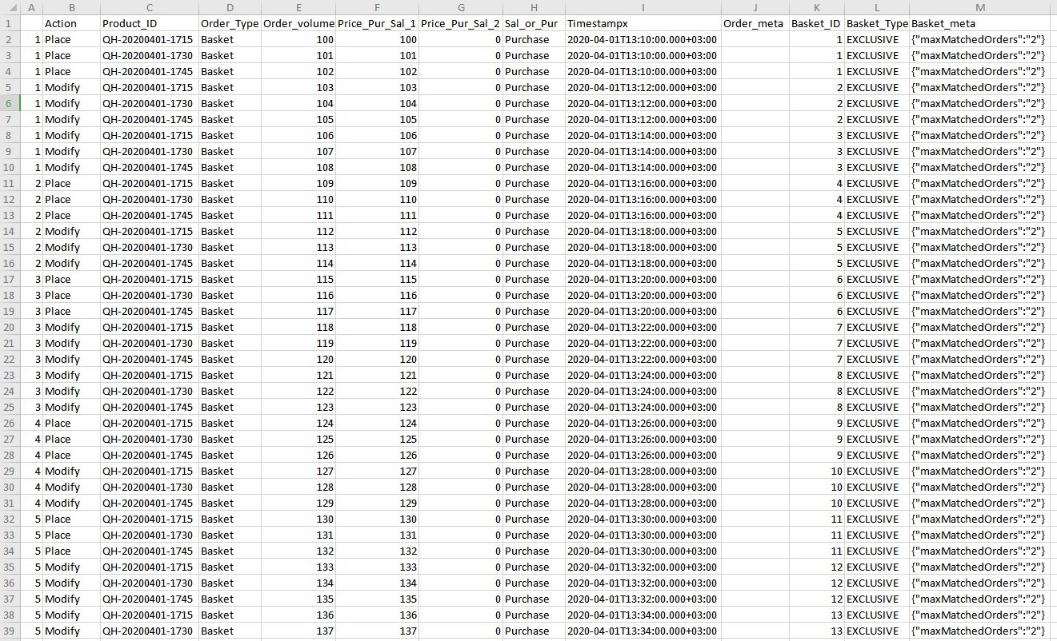

* *Column 1* - Order_ID, Type: Integer

The order id is a number that identifies the current order. It can be the same, repeated on multiple rows, since an order can be placed on one row, but also tha same order can be modified on next rows for a specific future timestamp.

* *Column 2* - Action, Type: String

This column can contain the value ‘Place’ or ‘Modify’ that identifies if that order will be a new order being placed on the market or modification of an existing order.

* *Column 3* - Product_ID, Type: String

This Is the product name that this order refers to. Ex. ‘1H-20200227-2300’

* *Column 4* - Order_volume, Type: Double

The quantity of the order

* *Column 5* - Price_Pur_Sal_1, Type: Double

The price of the order if the order is a Purchase

* *Column 6* - Price_Pur_Sal_2, Type: Double

The price of the order if the order is a Sate

* *Column 7* - Sal_or_Pur, Type: String

This column can contain the value ‘Sale’ or ‘Purchase’.

*Column 8* - Timestampx, Type: DateTime, Format: **yyyy-MM-ddTHH:mm:ss.SSSXXXXXX (Example:2018-07-17T09:59:51.312+03:00)**

You can navigate to the inserted orders through the equivalent section, inspect their execution condition & delete the any import order by clicking on the **Delete all** button or by clicking the delete icon on of the data rows that deleted multiple rows by their Group id.

