

**Import weather csv files help document**

Import the weather data using the **Upload file** button to select the Csv file. The first line of the Csv file to be inserted is the first (1) line as show on the picture below.

The columns must be as below

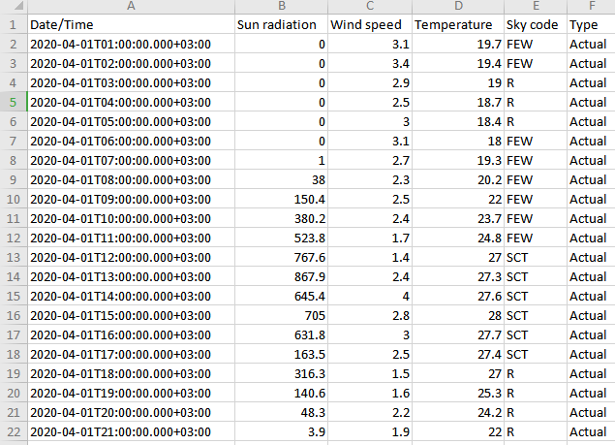

* *Column 1* - Date/Time, Type: DateTime, Format: **yyyy-MM-ddTHH:mm:ss.SSSXXXXXX (Example:2018-07-17T09:59:51.312+01:00)**
* *Column 2* - Sun radiation, Type: Double
* *Column 3* - Wind speed, Type: Double
* *Column 4* - Temperature, Type: Double
* *Column 5* - Sky code, Type: String
* *Column 6* - Type, Type: String (Values:‘Actual’and ‘Prediction’ )

|  |  |
| --- | --- |
| **Sky code accepted values** | |
| CLR | clear |
| SCT | scattered clouds |
| FEW | few clouds |
| BKN | broken clouds |
| OVC | overcast cloudy |
| FOG | fog |
| S | snow |
| I | ice |
| R | rain |
| SI | snow and ice |
| SR | snow and rain |
| IR | ice and rain |
| T | thunder storm |
| MIX | rain,snow and ice |

You can navigate through the inserted weather data using the **Show on period** button & delete the data by clicking on the **Delete all Selected** button and the delete icon on of the data rows.

