1. 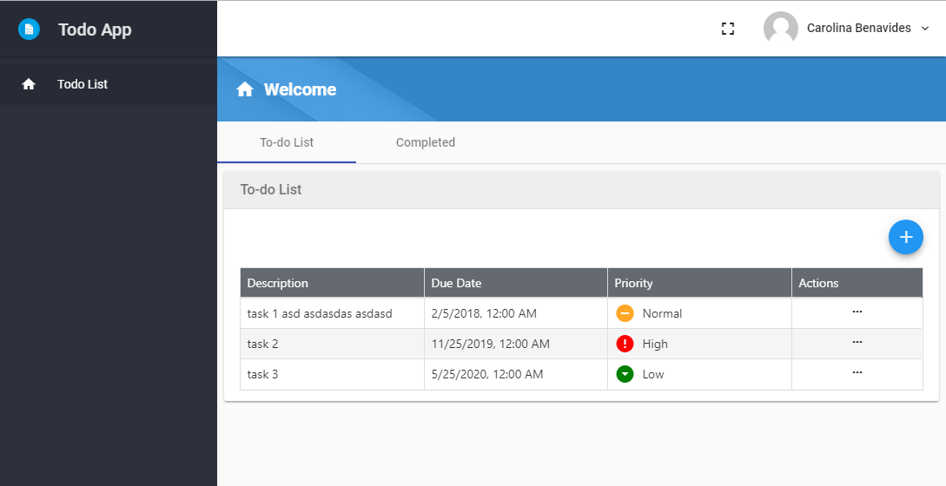Users can view their todo list.
2. Users can add, remove, modify and delete todo entries.

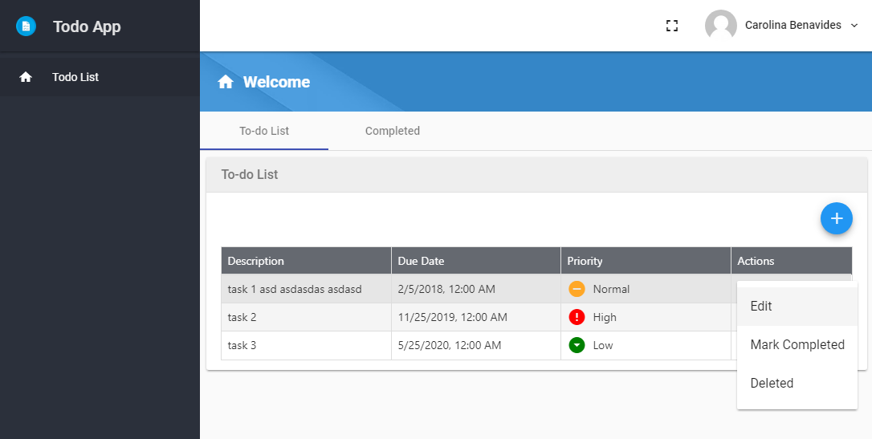

1. Each todo entry includes a single line of text, due date and priority.
2. 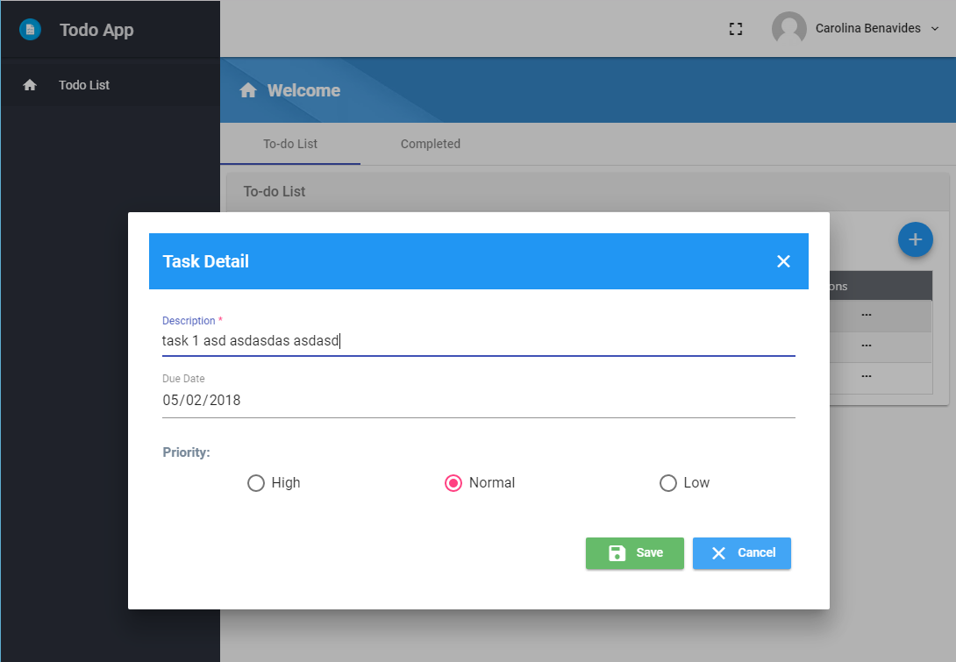Users can assign priorities and due dates to the entries.
3. 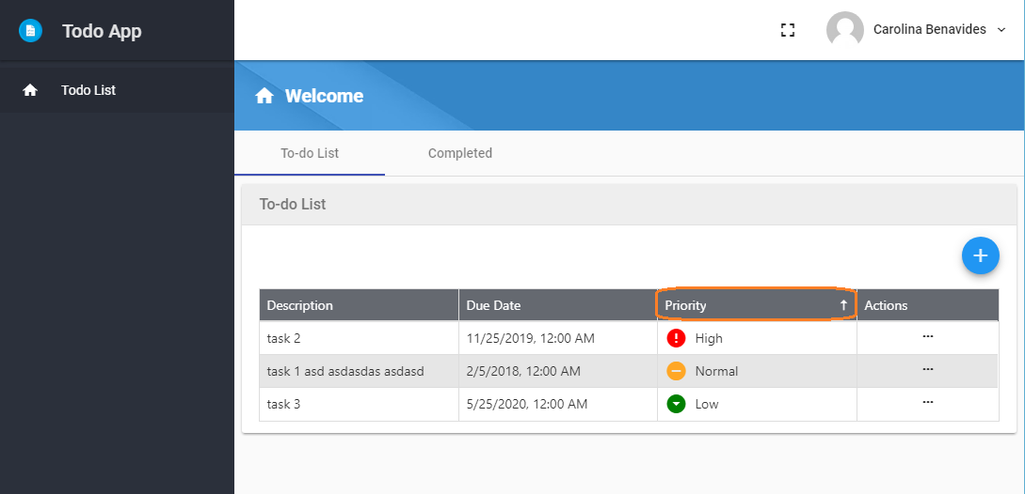Users can sort todo lists using due date and priority
4. Users can mark an entry as completed.

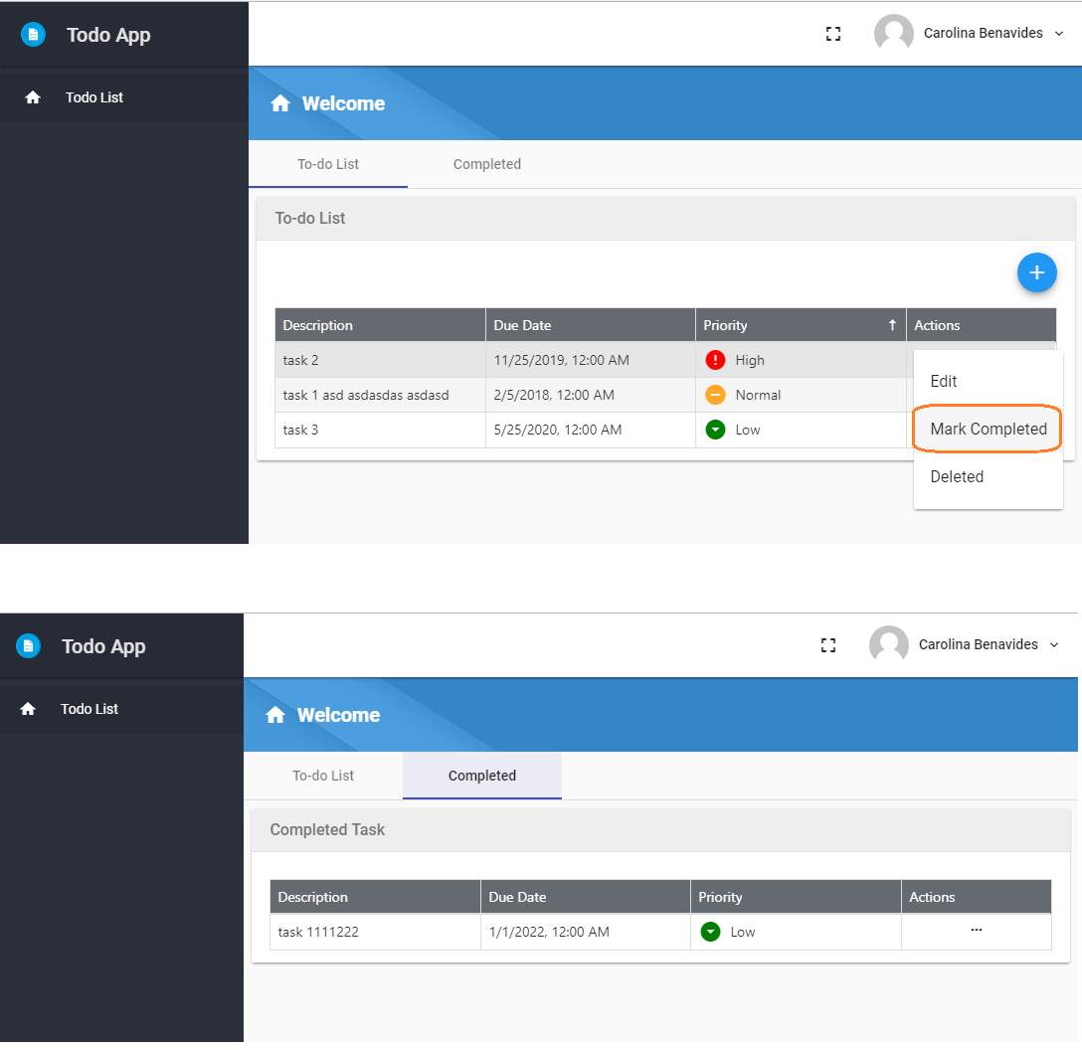

**OPTIONAL**:

* Provide authentication and authorization service for both the app and the API

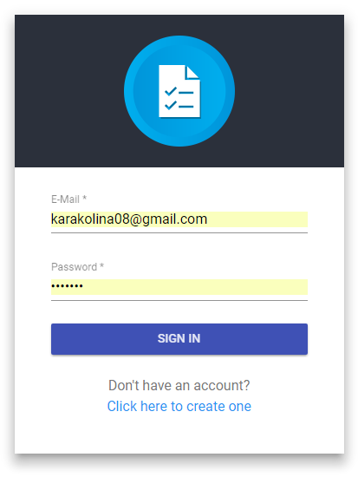

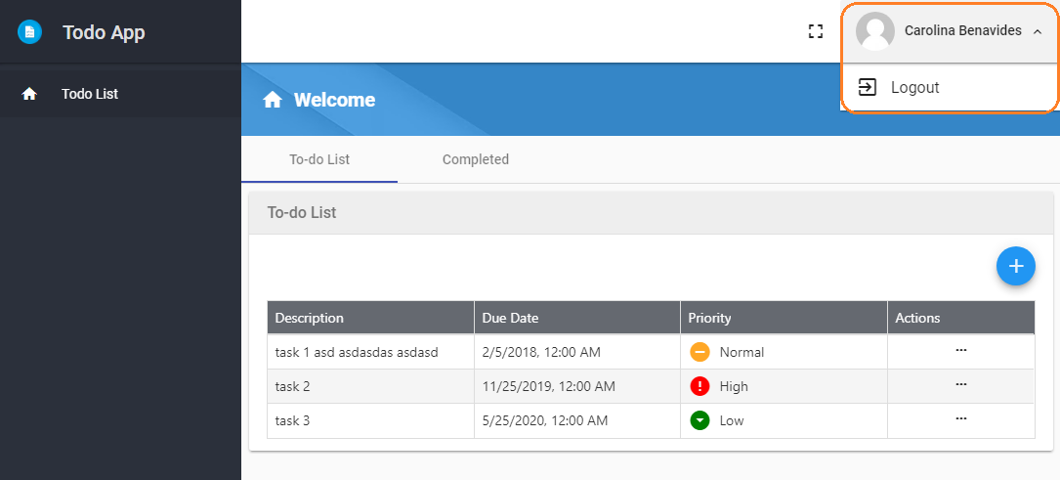

* As complementary to the last item, one should be able to create users in the system via an interface, probably a signup/register screen.

