Analysis of the Band 40 flight-test anomaly
My main conclusion is that the 9.75 dB difference between FVD1 and FVD2 on the new-diplexer, idle, outgoing flight is a genuine anomaly that needs explaining, but the available results do not yet establish whether it is caused by the RF hardware, the UE measurement behaviour, or a change in the radio conditions during that flight.
The most useful evidence is the contrast between the outgoing and return legs:
- Old combiner/splitter, idle: FVD1 and FVD2 track almost identically, with a mean point-to-point difference of just 0.076 dB.
- New diplexer, idle: the difference increases to 9.75 dB, even though both devices are flying the same leg.
- New diplexer, active calls: the difference reduces to 1.8 dB, with correlated RSRP variations.
- Old configuration, active calls: FVD1 and FVD2 again track closely, with a mean difference of about 0.075 dB.
That pattern is important. It suggests the anomaly is associated with the new RF configuration under the particular conditions of the outgoing idle leg, rather than a consistent difference between the two FVDs or a general problem with the flight path.
There is, however, one important distinction: the active-call and idle results are from different legs, flown in opposite directions. The return leg therefore does not isolate the effect of making a call. Direction, time, serving-cell conditions and propagation can also differ.
1. What the plots add to the analysis
The FVD1-versus-FVD2 plots support the interpretation of the tables.
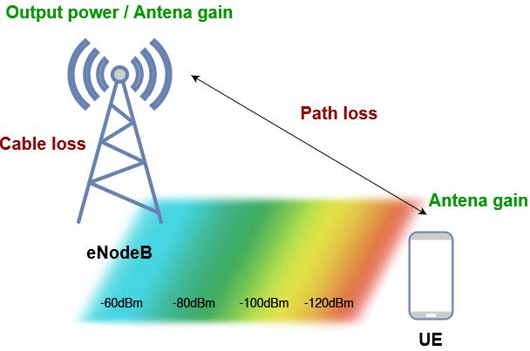
RSRP versus distance
The old-configuration traces are closely aligned. On the new configuration, the two idle traces are substantially separated, whereas the active-call traces are much closer together. This looks like a difference in received signal level between the two measurement chains, not simply random scatter.
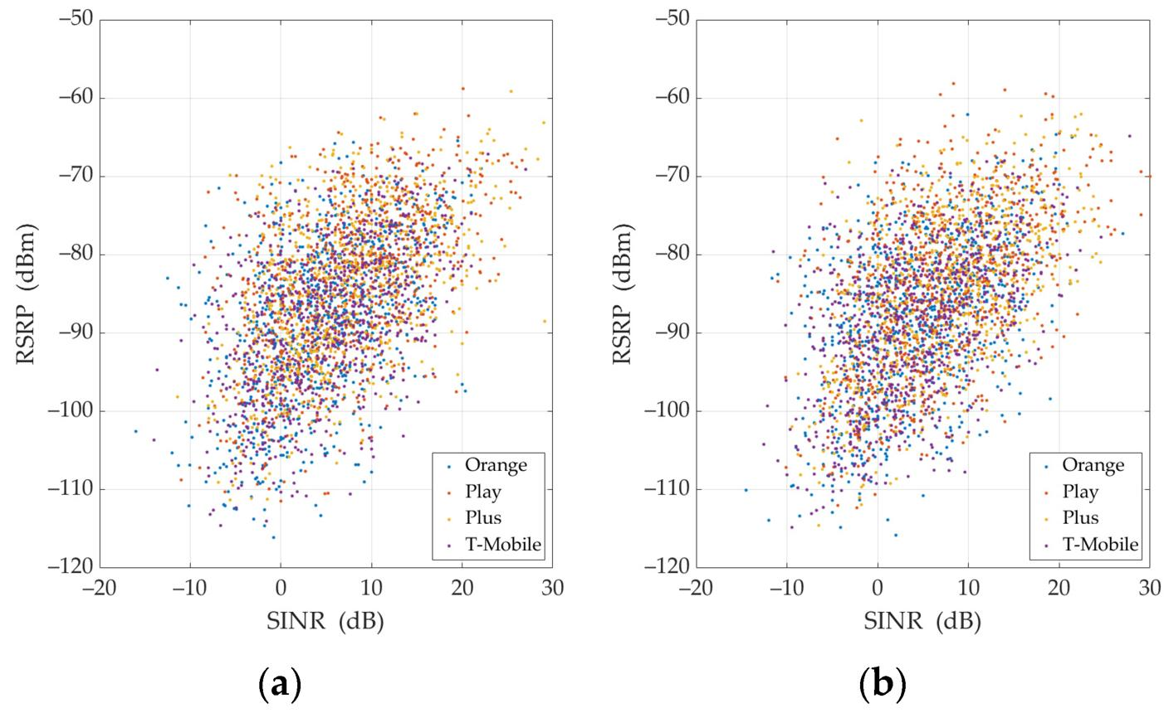
SINR versus distance and FVD1 versus FVD2
The new-diplexer idle results also show a separation in SINR. That matters because the weaker RSRP measurement is accompanied by poorer reported signal quality. However, this does not prove that the RF path itself is reducing SINR: SINR also depends on interference, receiver behaviour and measurement conditions.
The most informative feature is that the old configuration produces closely aligned measurements, while the new configuration produces a large separation specifically in the idle outgoing leg.
One qualification: the correlation coefficients alone do not tell us whether the devices agree in absolute value. Two devices can have a high correlation while maintaining a substantial constant offset. The mean point-to-point difference and the distribution of that difference are therefore more useful here.
2. Why might Band 40 be more sensitive?
There are several plausible explanations, but they are not equally supported by the evidence.
A. A difference in the complete RF paths
This remains a leading possibility.
The individual diplexers have only 0.08–0.3 dB attenuation, and the measured cable losses are broadly similar. That makes ordinary insertion-loss differences an unlikely explanation for a 9.75 dB discrepancy.
However, individual component measurements do not fully characterise the assembled system. The complete path includes the antenna, cable, connectors, diplexer and their impedance interactions. A mismatch at one interface can affect the response of the assembled network even when the components look acceptable individually.
The important question is whether the complete path to FVD1 has a different response from the complete path to FVD2 at the actual Band 40 frequency.
There is also a useful clue in your results: the difference is much smaller in the return leg. If the two paths simply had a fixed 9.75 dB difference in insertion loss, we would expect a broadly similar offset on the return leg, assuming comparable conditions. The 1.8 dB difference therefore argues against a simple, constant passive-loss difference as the entire explanation.
It does not completely rule out a hardware issue: antenna mismatch, orientation, coupling or frequency-dependent interactions could behave differently in the two situations.
B. Antenna behaviour and the aircraft installation
Band 40 uses a different antenna from Bands 3 and 20, so its behaviour cannot be assumed to match theirs.
The aircraft installation could introduce differences through:
- Antenna radiation patterns and polarisation.
- The aircraft body and other nearby conductive structures.
- Coupling between antennas and RF paths.
- Changes in antenna impedance caused by the installed environment.
- Different responses to the elevation and azimuth of the serving base station.
The anechoic-chamber coupling measurements deserve attention, but the suggestion that the antennas were in the Fresnel region is not, by itself, an explanation for the in-flight discrepancy. It is a possible explanation for why the chamber coupling measurements differed from a simple free-space estimate.
Also, a Fresnel-region effect in the chamber cannot directly explain a 9.75 dB difference observed during flight. It would only be relevant if it helped identify an antenna interaction or installation characteristic that also exists on the aircraft.
C. Receiver measurement behaviour
The FVDs may not report RSRP and SINR identically under every condition. Differences in receiver implementation, filtering, measurement timing or how the modem handles weak or changing signals could contribute.
However, the old configuration gives very close FVD1/FVD2 results. That is good evidence against a permanent 10 dB difference between the devices themselves.
It does not exclude an interaction between a receiver and its particular RF path. That is why swapping the complete paths between the two FVDs would be a useful controlled diagnostic if the initial measurements do not resolve the issue.
3. Why is the difference much larger in idle mode?
This is probably the most interesting part of the results.
Band 40 uses TDD, so uplink and downlink share the same frequency band but use different time slots. During an active call, the FVDs may transmit uplink bursts; in idle mode, they generally do not transmit user-plane uplink traffic, although control signalling can still occur.
If the concern were simply that an FVD's uplink transmission was desensitising the other receiver through the aircraft's shared RF environment, we might expect the problem to be more pronounced during active calls. Your measurements show the opposite.
That makes uplink-transmission coupling alone an unlikely explanation for the large idle-mode discrepancy.
There is an important caveat: the idle and active results were recorded on opposite flight legs, so we cannot attribute the difference solely to the operating mode. To establish that, you would need to compare idle and active operation under otherwise equivalent conditions.
I would also avoid assuming that the TDD mechanism itself causes the anomaly. TDD explains the timing of uplink and downlink transmissions; it does not inherently explain a 9.75 dB difference between two receiving paths.
4. What I would investigate next
I would prioritise the following tests.
Test 1 — Swap the complete RF paths between FVD1 and FVD2
Keep the antennas, cables and diplexer paths in place, but exchange which FVD connects to each complete path. Repeat a static Band 40 test first, in idle mode.
- If the large difference follows the physical RF path, investigate that path and its interfaces.
- If it follows the FVD, investigate the receiver, configuration and measurement behaviour.
- If the difference disappears or changes unpredictably, investigate connection repeatability and the test conditions.
This is now a useful diagnostic because the component measurements have not explained the field results.
Test 2 — Measure both complete RF paths at Band 40
Measure the assembled paths, including the installed antennas, cables, connectors and diplexers. Compare insertion loss and return loss at the actual Band 40 operating frequency.
Where possible, measure at the FVD connection points and retain the results separately for the two paths. If practical, repeat with the antennas installed on the aircraft.
This would establish whether the assembled RF system has a difference that was not visible in the individual component measurements.
Test 3 — Repeat the idle/active comparison on equivalent flight legs
Fly the same radial in the same direction at the same altitude, preferably with repeated passes. Compare both FVDs in idle mode, then repeat with calls active.
Record serving PCI, EARFCN, distance, timestamp and both FVDs' RSRP/SINR. Check for changes in serving cell and compare only equivalent sections of the route.
This would help separate the effect of operating mode from differences between the outgoing and return flights.
5. One additional check: confirm the exact measurement configuration
Before interpreting the 9.75 dB difference as a physical RF loss, I would confirm that both FVDs were measuring the same serving cell on the same frequency throughout the relevant section.
Your tables identify Band 40 PCI 216, but if either device changed cell or its measurement conditions differed during the leg, the comparison could be misleading. The point-to-point difference should ideally be calculated using time- or position-aligned samples from the same cell and frequency.
I would also check whether the two devices' individual RSRP distributions are stable over repeated passes. The green trace in your plot appears noisier at its upper end, so it is worth checking whether the 9.75 dB mean difference represents a consistent offset or is strongly influenced by a particular section of the flight.
Overall conclusion
The results point to a specific issue: the new diplexer configuration produces a large FVD1/FVD2 RSRP difference on the Band 40 idle outgoing leg, despite the old configuration showing excellent agreement. The individual diplexer and cable measurements do not explain that difference.
I would not yet conclude that the diplexers are faulty, nor that Band 40 TDD is the cause. The most useful next step is to swap the complete RF paths between the FVDs and repeat a controlled Band 40 idle test, followed by a measurement of the complete assembled RF paths. That should help distinguish a path-dependent problem from receiver behaviour before more flight testing is undertaken.
*************************************************************************
The point-to-point difference are calculated using time- and position-aligned samples from the same cell (PCI 216) and frequency. The only thing I forgot to mention is that 3 of the 4 antennas (two B3/B20 antennas and one B40 antenna) were mounted on a V-plate on the belly of the aircraft, whereas the fourth antenna B40 was mounted on the empenage of the aircraft, i.e. the tail which has some inclination.
That is an important detail. It introduces a plausible explanation for why the Band 40 results might differ between the outgoing and return legs, even though you have aligned the samples by time and position and confirmed the same PCI 216 and frequency.
The tail-mounted B40 antenna could behave differently from the belly-mounted B40 antenna because of its mounting angle and the aircraft structure around it. However, whether this explains the 9.75 dB difference depends on which antenna feeds FVD1 and which feeds FVD2.
1. Why the antenna positions matter
You have three antennas on the belly V-plate and one B40 antenna on the inclined empennage.

Belly-mounted antennas
Their radiation patterns can be affected by the fuselage, the V-plate and nearby antennas. The effects depend on antenna orientation, spacing and the aircraft structure.
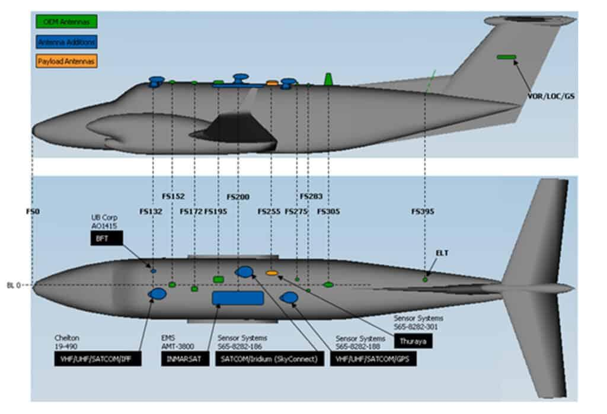
Tail-mounted B40 antenna
The inclined mounting surface changes the antenna's orientation relative to the ground station. The tail structure can also affect the radiation pattern and impedance. As the aircraft changes heading between outgoing and return legs, the antenna's effective orientation relative to the eNB changes.
The aircraft's heading changes by approximately 180° between the two legs. Consequently, the belly- and tail-mounted antennas may not see the same effective radiation pattern or aircraft-body shadowing in the two directions.
This could help explain why the difference is large on the outgoing leg but much smaller on the return leg.
However, the mounting difference alone does not explain why the old configuration gives almost identical FVD measurements. The new configuration may interact differently with the antenna feeds, or the two configurations may route the antenna signals differently. We need to establish that before attributing the anomaly to the mounting position.
2. The key question: which B40 antenna feeds each FVD?
This is now the most important detail to clarify.
- Does the belly-mounted B40 antenna feed FVD1 and the tail-mounted B40 antenna feed FVD2?
- Or are the two antenna feeds distributed differently between the FVDs?
If one FVD is connected to the belly antenna and the other to the tail antenna, the 9.75 dB difference could be a combination of antenna-pattern differences and RF-path differences.
If both FVDs receive the same antenna signals through the diplexer network, the antenna mounting positions alone are less likely to explain such a large difference between their reported RSRP values.
3. How this changes the interpretation of your flight results
The evidence can now be interpreted as follows:
Observation | What it suggests
Old configuration: approximately 0.08 dB difference on both legs | The old RF distribution arrangement gives excellent agreement.
New configuration: 9.75 dB difference on outgoing idle leg | A substantial discrepancy appears under one specific combination of configuration and flight conditions.
New configuration: 1.8 dB difference on return active-call leg | The discrepancy is not a simple, constant offset between the two measurement chains.
Same PCI, frequency, position-aligned samples | Cell changes and sample misalignment are unlikely explanations.
Belly and tail antennas mounted differently | Antenna pattern, aircraft shadowing and orientation are now credible contributing factors.
The strongest conclusion is still that the new configuration exhibits a condition-dependent discrepancy. The antenna installation provides a possible explanation for the directional dependence, but it does not yet identify the cause.
4. The test I would run next
Before changing the antenna installation, I would repeat the Band 40 test with the aircraft stationary, if practical, and compare the two FVDs in idle mode with the aircraft oriented in different headings relative to the eNB.
If the difference changes significantly with heading, that would support an antenna-pattern or aircraft-shadowing contribution. If the difference remains tied to one RF path regardless of heading, that would point more strongly towards the RF distribution path or receiver.
First, can you confirm which B40 antenna—the belly-mounted one or the tail-mounted one—is connected to FVD1 and which is connected to FVD2? That will determine how directly the mounting geometry can explain the observed difference.
******************************************************************************
Unfortunately, it is not possible to fly again or recreate this same configuration. I will confirm on Monday, but according to the diagrams, the empenage antenna (tail) is the B40 antenna connected to FVD2.

That makes the antenna mounting a much more interesting lead. If the diagrams are correct and FVD2 is connected to the tail-mounted B40 antenna, the 9.75 dB anomaly may be partly explained by the difference between the belly and tail installations. We cannot confirm that retrospectively, but we can assess whether the existing evidence supports it.
1. What the antenna location could explain
Your results show:
Band 40 configuration | FVD1–FVD2 mean RSRP difference
Old splitter, idle | +0.076 dB
Old splitter, active calls | −0.075 dB
New diplexer, idle, outgoing | −9.75 dB
New diplexer, active calls, return | +1.8 dB
The signs depend on the subtraction convention, but the key point is the magnitude: the new idle leg has a much larger discrepancy.
Assuming the difference is calculated as FVD1 minus FVD2, the −9.75 dB result means FVD2, connected to the tail antenna, received a signal approximately 9.75 dB stronger than FVD1.
That is not the result I would automatically expect from the tail mounting, but it is entirely possible. An inclined antenna can have a different gain towards the eNB, and the aircraft structure can change the radiation pattern. The tail antenna might even have a more favourable orientation towards the eNB on the outgoing leg.
On the return leg, the aircraft heading changes, potentially changing the relative antenna gains and reducing the difference to 1.8 dB.
However, this interpretation assumes that the two FVDs are indeed connected to their respective antennas in the way shown in the diagrams.
2. Why the old configuration is still important
The old configuration provides strong evidence that the two FVDs do not inherently differ by anything like 10 dB.
But it does not completely rule out the antenna explanation. The old and new architectures may distribute the antenna signals differently, so the same antenna-pattern differences may not translate into the same receiver-level differences in both configurations.
The key unresolved question is whether the new configuration exposes an existing difference between the two antenna installations or introduces an additional difference through the RF paths.
The individual diplexer and cable measurements suggest that ordinary component insertion loss is unlikely to account for the discrepancy. They do not, however, establish the complete installed path response.
3. What you can still establish without another flight
I would not try to recreate the original flight. Instead, I would use the evidence already available and make a few targeted checks.
1. Confirm the antenna-to-FVD mapping. On Monday, verify that the tail antenna feeds FVD2 and the belly antenna feeds FVD1, including the complete routing through the diplexers.
2. Review the antenna patterns and installation geometry. Compare the B40 antenna's radiation pattern in the relevant direction, taking account of the tail mounting angle and aircraft structure. An anechoic-chamber pattern for the antenna alone may not represent the installed aircraft pattern.
3. Review the existing flight traces. Since the samples are aligned by position, time, PCI and frequency, compare the FVD1–FVD2 RSRP difference along the outgoing and return legs. If the difference changes progressively with distance or position, that may help distinguish a direction-dependent antenna effect from a relatively constant path loss. It will not prove the cause, but it can provide useful evidence.
4. Use the existing lab measurements to assess the complete RF paths. If possible, measure the installed or assembled path responses at the actual Band 40 frequency. This can establish whether the two paths differ electrically, although it cannot reconstruct the antenna patterns during the original flight.
My current assessment
The tail-mounted antenna is now a credible explanation for at least part of the directional difference. I would not yet conclude that it explains the entire 9.75 dB discrepancy, especially because the old configuration showed almost perfect agreement.
The most defensible conclusion for your report would be:
The large FVD1/FVD2 RSRP difference observed during the Band 40 outgoing idle leg may be influenced by the different antenna installations, as FVD2 is believed to be connected to the tail-mounted antenna while FVD1 is connected to the belly-mounted antenna. The different mounting positions and orientations could produce different antenna gains towards the serving eNB, with the effect changing between flight directions. However, the available measurements do not establish whether this accounts for the full discrepancy or whether an additional difference in the new RF paths contributes. The antenna mapping and complete installed RF paths should therefore be verified before attributing the anomaly to the diplexer configuration alone.
One final nuance: because the return leg was flown in active-call mode, the existing data cannot separate the effects of flight direction and antenna orientation from those of idle versus active operation. That limitation should be stated explicitly rather than implying that idle mode itself caused the discrepancy.
***************************************************************************
the difference is indeed calculated as FVD1 minus FVD2. Along the outgoing idle leg, FVD1 (blue in the plot) is 9.75dB weaker than FVD2 in sage green. Along the return leg, FVD1 is 1.8dB stronger than FVD2. I will confirm on Monday the mapping between Band 40 antennas and FVDs. You said that "That is not the result you would automatically expect from the tail mounting". Isn't it possible that the tail mounted antenna captures the strong signal along the outgoing radial (i.e. tail is facing the eNodeB), but the effect gets reversed and the delta between the two devices reduced, when the nose is facing the eNodeB?
Yes — absolutely. Your explanation is physically plausible, and I should have been clearer about that in my previous answer.
The tail-mounted antenna could have a stronger response towards the eNodeB when the aircraft is flying away from it, while the belly-mounted antenna or its installation could have a more favourable response when the aircraft is flying back towards it. That could produce exactly the directional change you observe.
How it could explain your results
Assuming the tail antenna is connected to FVD2 and the belly antenna to FVD1:
1. Outgoing leg — aircraft nose pointing away from the eNodeB

Conceptual illustration of the geometry, not your aircraft installation.
If the tail-mounted antenna has a more favourable radiation pattern towards the eNodeB in this orientation, FVD2 could receive the stronger signal.
- FVD1 (belly antenna): weaker
- FVD2 (tail antenna): stronger
- Measured FVD1 − FVD2: −9.75 dB
2. Return leg — aircraft nose pointing towards the eNodeB

Conceptual illustration of the geometry, not your aircraft installation.
When the aircraft reverses heading, the relative orientation of the antennas and aircraft structure changes. The tail antenna may become less favourably oriented, while the belly antenna may have a more favourable response.
- FVD1 (belly antenna): slightly stronger
- FVD2 (tail antenna): slightly weaker
- Measured FVD1 − FVD2: +1.8 dB
The key point is that the relative difference changes from −9.75 dB to +1.8 dB — a 11.55 dB change in the FVD1–FVD2 difference between the two legs.
An orientation-dependent difference in antenna gain and aircraft-body effects could, in principle, account for such a change. Whether it can account for the full 11.55 dB depends on the actual antenna patterns and installed geometry.
Does this explain why the old configuration showed almost no difference?
Not necessarily, and this is the main caveat.
If the old combiner/splitter and new diplexer configurations use the same physical antennas, the same antenna orientations and equivalent RF paths, the antenna-pattern difference should still exist in both configurations.
The old configuration's near-zero difference therefore suggests at least one of the following:
- The old and new configurations distribute the antenna signals differently.
- The old arrangement makes the two receiver inputs behave differently from the new arrangement.
- The old and new flight measurements were affected by different conditions, despite the broadly similar flight paths.
- The new configuration introduces an additional path-dependent effect that combines with the antenna-pattern difference.
So the antenna orientation is a plausible explanation for the change between flight directions, but it does not, on its own, explain why the anomaly appears with the new configuration and not the old one.
What I would conclude for now
I would keep two hypotheses open:
- Orientation-dependent antenna response: the belly and tail antennas have different installed radiation patterns, and reversing the aircraft changes their relative received levels.
- An interaction with the new RF configuration: the new diplexer paths introduce an additional difference that becomes particularly apparent in the outgoing idle leg.
Confirming the antenna-to-FVD mapping on Monday is important. After that, the existing flight traces and the installed antenna-pattern information should help assess the first hypothesis without requiring another flight.
I would not describe the tail mounting as an unlikely explanation. It is a credible possibility — just not yet a complete explanation of all the results.
**********************************************************************************
I think with the old configuration both FVDs receive a signal from each of the antennas, and internally it takes the strongest or best via maximum ratio combining
That is a very important point, and it could explain why the old configuration showed almost identical RSRP on both FVDs while the new configuration did not.
However, I would distinguish between both FVDs receiving signals from both antennas and the FVDs using maximum-ratio combining (MRC). The first depends on your RF wiring; the second depends on how the modem implements receive diversity.
1. How the old configuration could mask antenna differences
If the old combiner/splitter network combines the signals from the belly-mounted and tail-mounted B40 antennas and distributes the combined signal to both FVDs, the arrangement would look conceptually like this:
B40 belly antenna + B40 tail antenna
Old combiner and splitter network
FVD1
Combined RF signal
FVD2
Combined RF signal
In that arrangement, both FVDs receive a version of the same combined RF signal. Although the two antennas may have very different radiation patterns, their contributions are present at both FVDs. This would naturally help explain why their RSRP measurements track each other so closely.
There is one qualification: combining two antenna signals does not necessarily improve the received signal. Depending on their relative phase, amplitude and the combiner's characteristics, the signals can reinforce or partially cancel one another. Nevertheless, if both FVDs receive the same combined signal through well-matched splitter outputs, their measurements should be similar.
2. What changes with the new diplexer configuration?
If the new configuration routes the belly antenna to FVD1 and the tail antenna to FVD2, the situation is fundamentally different:
- FVD1 primarily measures the belly antenna's received signal.
- FVD2 primarily measures the tail antenna's received signal.
The two FVDs are no longer necessarily observing the same combined RF signal.
This would make your flight results much easier to understand qualitatively:
Flight leg | Possible outcome
Outgoing, aircraft nose away from eNodeB | Tail antenna has the stronger response; FVD2 is stronger by 9.75 dB.
Return, aircraft nose towards eNodeB | Relative antenna responses change; FVD1 becomes stronger by 1.8 dB.
Old configuration | Both FVDs receive the combined antenna signals, so their RSRP measurements remain closely aligned.
This is a plausible explanation for the directional reversal, and it provides a potentially important explanation for why the anomaly appears in the new architecture but not the old one.
3. Would maximum-ratio combining explain it?
Possibly, but I would not assume that the FVDs use MRC without checking their modem documentation.
MRC normally combines multiple receiver branches using their signal quality and phase information to maximise the resulting signal-to-noise ratio. It is not simply a rule that selects whichever antenna has the highest RSRP.
In LTE, the modem's use of multiple receive antennas depends on its RF architecture, supported receiver configuration and the relevant reference signals. The RSRP reported by XCAL may also be based on a particular reference-signal measurement and antenna-port configuration rather than a single, general-purpose MRC result.
Therefore, the more important question is whether the old RF network physically combines both antenna signals and distributes that combination to both FVDs. If it does, you don't need to rely on an assumption about MRC to explain why the FVD measurements agree.
4. The crucial point to verify on Monday
I would check the old and new RF diagrams side by side and establish:
- Whether both B40 antennas contributed to the signal delivered to each FVD in the old configuration.
- Whether the new configuration separates the belly and tail antenna signals between the FVDs.
- Whether the H and V branches follow the same routing arrangement.
If that is indeed how the systems are wired, I would revise the leading hypothesis: the anomaly may primarily reflect the change from a shared, combined antenna signal to separate antenna feeds, rather than an intrinsic problem with the diplexers.
The diplexers could still contribute through path mismatch, but the large directional change would then have a credible antenna-pattern explanation.

