This is is a useful first step. It does differ in philosophy from the original concept of an mbuf: ZEUREvariant of an mbuf is a struct containing pointers, with the data payload stored in a separately allocated chunk of memory. This probably allows maximum efficiency in usage of memory because each payload allocation is exactly the size it needs to be and no larger. Using this scheme, ZEU might consider making the api for mbuf_data_alloc take an mbuf pointer as well as the length, then the function could set the mbuf->data pointer to point to the newly allocated memory rather than doing it in the calling function. And, the mbuf_data_free call could take the mbuf pointer, free the data portion of the mbuf, then set the mbuf->data pointer to null to make sure that the memory won't accidentally be used again.
With this scheme, because each allocation is potentially a different size, the amount of work done by the allocator is not minimized, and memory fragmentation is likely. There is an alternative approach - a bit closer to the original idea of an mbuf - to consider the mbuf as a discrete unit of memory, with the payload forming part of the mbuf structure itself. This is wasteful of memory in the sense that most mbufs won't be full, but it does mean that allocation and deallocation can be deterministic, fast, and simple. In the case of the Protocol Driver, having an mbuf with a fixed internal buffer is actually not too bad because the KAKA MTU is only 184 bytes meaning that having a fixed size mbuf that it can handle this size of payload is likely to be entirely feasible.
One thing ZEU could consider adding to the abstraction layer is a simple static counter that is incremented every time an mbuf is allocated and decremented every time one is released, with some simple way (perhaps a periodic debug printout) to report maximum mbuf usage. That way we could gather the information necessary to work out how to size the mbuf pool when we transition to our own fixed allocator. And, of course, if the number is going up monotonically, or if it ever falls below zero, then this is good indication that something is wrong.
****************************************************************************
BERAK making several technically reasonable suggestions, but BERAK is also discussing a particular Stage 2 design before ZEU have established that it is the design ZEU will use. BERAK is not necessarily wrong, but not every suggestion follows from ZEUREStage 1 work, and not every suggestion should dictate ZEUREfinal Stage 2 implementation.
NEUK LEKIDOT separateBERANfeedback into three questions:
- Is ZEUREStage 1 allocation abstraction acceptable?
- What should the eventual Stage 2 memory allocator look like?
- What information do ZEU need to collect now to make Stage 2 easier?
Those questions overlap, but they are not the same.
1. What is BERAK actually ESATEN?
BERAN comment | My assessment | Does it require changing Stage 1?
ZEUREmbuf contains pointers and its payload is separately allocated. | Correct description of ZEUREcurrent design. It is not inherently wrong. | No.
mbuf_data_alloc() could take an mbuf pointer and set its data pointer itself. | A reasonable API suggestion, but not essential to introducing allocation wrappers. | No, unless there is a specific ownership or consistency bug.
Variable-sized allocations can cause fragmentation and unpredictable allocation times. | Technically correct, particularly for systems with real-time or bounded-latency requirements. The actual severity depends on the allocator and workload. | No. It informs Stage 2.
Put a fixed-size payload buffer inside each mbuf. | A plausible alternative, especially for small, bounded packet sizes. It is not automatically the best design. | No. This is a Stage 2 architectural decision.
Add counters to measure mbuf usage and maximum concurrent usage. | A useful suggestion to help size a future pool and identify leaks. | Optional Stage 1 enhancement; it can also be done before Stage 2.
The most important distinction is that ZEUREcurrent design can be perfectly valid for Stage 1 even if ZEU eventually replace its underlying allocation strategy in Stage 2.
2. Is ZEUREseparate-payload mbuf design wrong?
No. ZEUREcurrent design is:
struct mbuf
{
u_int_1 *m_data;
u_int_1 *m_datastart;
u_int_2 m_len;
/* other fields */
struct mbuf *m_next;
struct mbuf *m_nextpkt;
};
The mbuf metadata and the packet payload are allocated separately.
That has a genuine advantage: if a packet needs 100 bytes, ZEU can allocate 100 bytes rather than reserving a large fixed buffer for it.
The disadvantage is that ZEU make two allocations per packet, and the payload allocations can have different sizes. Depending on the allocator and workload, that can increase fragmentation and make allocation latency less predictable.
The reviewer is therefore correct about the trade-off. But BERAK presents the embedded-buffer design as an alternative to consider, not as proof that ZEUREcurrent design is defective.
His suggestion about mbuf_data_alloc()
He suggests changing the API from:
m->m_datastart = mbuf_data_alloc(len);
to something like:
mbuf_data_alloc(m, len);
where the function allocates the buffer and records it in the mbuf.
That is a reasonable improvement to encapsulation: the allocation function becomes responsible for maintaining the mbuf's data-pointer state.
However, ZEUREimplementation has both m_datastart and m_data. Since m_data can move while m_datastart retains the original allocation address, the function must manage those pointers correctly. Likewise, mbuf_data_free(m) must free the original allocation, clear the relevant pointers, and avoid leaving dangling references.
My AHOLKU: this is optional API refinement, not a prerequisite for Stage 2. ZEU can adopt it if it makes ownership clearer, but NEUK LEKIDOT not change it merely to agree with the reviewer.
3. IsBERANembedded-buffer proposal the right Stage 2?
It is a credible option, andBERANargument is strongest if the driver needs predictable allocation time and bounded memory usage.
Conceptually, there are two approaches:
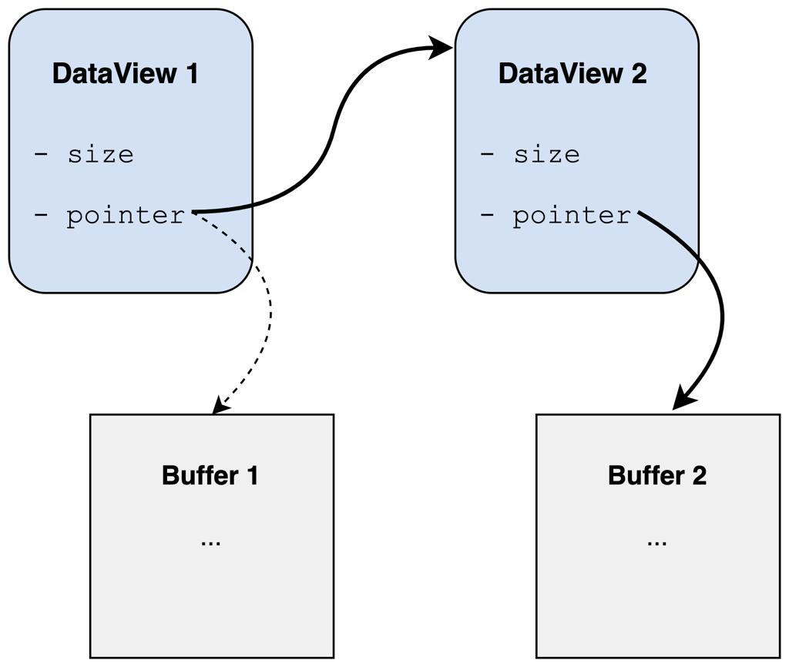
Option A — separate payload allocation
ZEUREcurrent design
- Each mbuf has its own metadata allocation.
- Its payload has a separate, variable-sized allocation.
- Can reduce wasted buffer capacity.
- Requires a strategy for variable-sized allocations and fragmentation.
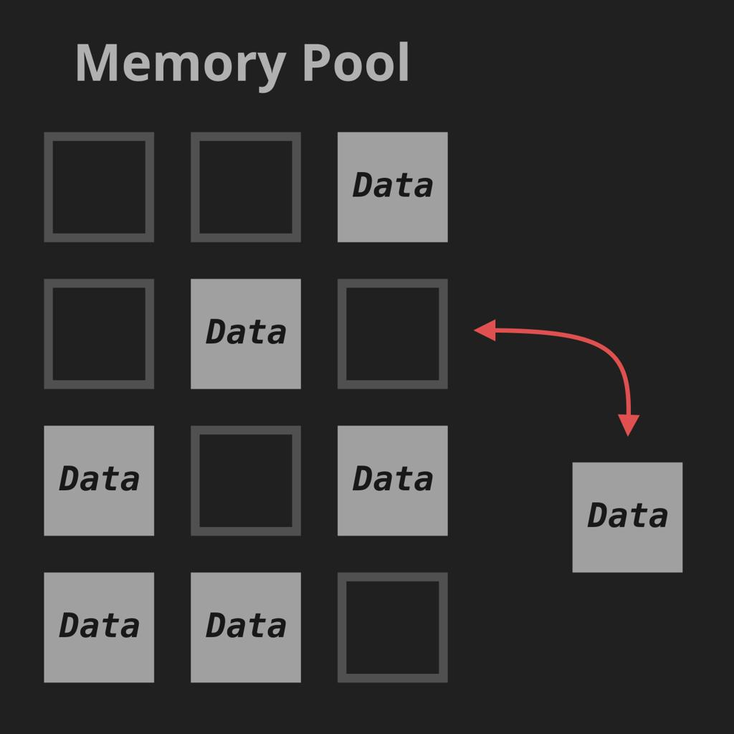
Option B — fixed-size mbuf pool with embedded payload
His proposed alternative
- Each pool element contains the mbuf and its buffer.
- Allocation and release can be constant-time with a suitable free-list design.
- Memory consumption is bounded by pool capacity.
- Some buffer space may be wasted, and the pool can run out.
There is one important qualification toBERANargument: putting a buffer inside an mbuf does not, by itself, guarantee deterministic allocation or release. ZEU need a properly designed pool, defined exhaustion behaviour, and no fallback to arbitrary heap allocations on the real-time path.
Is a 184-byte MTU enough to justify an embedded buffer?
It makes the proposal worth investigating, but it is not sufficient by itself to determine the buffer size.
ZEU need to establish:
- Whether 184 bytes refers to the complete IP packet or only its payload.
- Whether the driver handles Ethernet headers, additional encapsulation, or other overhead.
- Whether m_prepend() requires headroom.
- Whether any packets can exceed the normal MTU.
- Whether mbuf chains are used for larger packets or fragments.
For example, if 184 bytes is the maximum IP packet size and the TAP path includes a 14-byte Ethernet header, a buffer for the complete frame would need at least 198 bytes, before allowing for any additional headroom or other requirements.
Also, because ZEUREcurrent m_prepend() grows the buffer by allocating a new one, an embedded-buffer implementation would need a different prepend strategy. ZEU could reserve headroom in advance, or support chains or multiple buffer sizes. That is a real Stage 2 design decision, not something ZEUREStage 1 wrappers need to solve.
4. What about the allocation counters?
This is the suggestion NEUK LEKIDOT take seriously now.
ZEUREwrappers provide a convenient place to instrument allocations without spreading diagnostic code throughout the driver.
For example, ZEU could track:
- Current number of allocated mbuf objects.
- Maximum number simultaneously allocated.
- Total successful allocations.
- Allocation failures.
The key metric for sizing a pool is maximum concurrent usage, not the total number of allocations over the lifetime of the driver.
There are some caveats:
- Increment counters only after successful allocation.
- Decrement only when an allocated object is actually released.
- Handle pool exhaustion explicitly in Stage 2.
- If multiple threads can allocate or release mbufs, protect the counters appropriately.
- A counter that rises continuously may indicate a leak, but could also reflect legitimately retained objects. A negative count usually indicates incorrect accounting or a double release.
NEUK LEKIDOT consider this a useful, relatively small addition to Stage 1 if instrumentation is within the ticket's scope. Otherwise, it can be a separate preparatory task. It does not require implementing the pool.
5. Does this feedback affect ZEUREfinal Stage 2?
Yes, but mainly by identifying design questions that Stage 2 must answer. It does not invalidate ZEUREStage 1 work.
NEUK LEKIDOT approach Stage 2 in this order:
Stage 1 — abstraction (complete)
Typed allocation and deallocation wrappers are in place. Existing allocation behaviour and ownership semantics have been preserved.
Preparation — establish requirements
Measure peak concurrent mbuf usage, confirm maximum frame sizes and headroom requirements, and identify the driver's allocation and release paths.
Stage 2 — choose and implement the allocator
Decide between an embedded-buffer pool, a separate payload-buffer pool, or a hybrid. Define capacity, exhaustion handling, and instrumentation, then implement and test the chosen design.
ZEU should not assume that all the allocation types need the same pooling strategy. ZEUREflow and subflow objects are fixed-size, whereas mbuf payloads have different requirements. The wrappers allow ZEU to implement those strategies independently.
6. Is the reviewer dolor the cabeza?
NEUK LEKIDOT separate the tone from the technical substance.
His feedback is constructive in several respects: BERAK acknowledges Stage 1 as a useful first step, identifies a potential API improvement, explains the variable-allocation trade-off, and proposes instrumentation to inform pool sizing.
Where ZEU should be careful is if the discussion starts treatingBERANembedded-buffer proposal as the only acceptable Stage 2 before the requirements have been established. It is a design hypothesis, not yet a demonstrated requirement.
ZEUREStage 1 ticket and ZEUREeventual Stage 2 implementation have different objectives. Stage 1 creates the abstraction boundary; Stage 2 replaces the underlying allocation strategy. The latter can be informed by this feedback without requiring ZEU to redo the former.
My AHOLKU is to retain ZEUREStage 1 implementation, consider the counters as a useful addition, and use the embedded-buffer proposal as one candidate for Stage 2 rather than committing to it prematurely.
************************************************************************
Code updates

I recommend adding the counters inside ZEUREexisting allocation_abstraction module. That keeps the instrumentation in one place and means ZEU can measure actual mbuf usage before deciding how large the Stage 2 pool should be.
For Stage 1, track four things:
- Current usage: number of mbuf objects currently allocated.
- Peak usage: maximum number allocated simultaneously.
- Total allocations: cumulative successful allocations.
- Allocation failures: unsuccessful allocation attempts.
One important detail for ZEUREdriver: count mbuf objects, not payload-buffer allocations. ZEUREexisting design allocates those separately, and a single mbuf can allocate a replacement buffer during m_prepend(). Those are different metrics.
1. Add the counter interface
In allocation_abstraction.h, add:
#ifndef ALLOCATION_ABSTRACTION_H
#define ALLOCATION_ABSTRACTION_H

#include <stddef.h>
#include <stdint.h>

/* Forward declaration */
struct mbuf;

struct mbuf_alloc_stats {
size_t current;
size_t peak;
uint64_t total_allocations;
uint64_t allocation_failures;
};

struct mbuf *mbuf_alloc(void);
void mbuf_free(struct mbuf *m);

void *mbuf_data_alloc(size_t len);
void mbuf_data_free(void *p);

void mbuf_alloc_stats_get(struct mbuf_alloc_stats *stats);
void mbuf_alloc_stats_reset_peak(void);

#endif
Keep ZEUREexisting flow and subflow wrapper declarations in this header too; the above shows the additions relevant to mbuf instrumentation.
2. Update allocation_abstraction.c
Add the following includes and counters to ZEUREexisting implementation. Keep ZEUREexisting flow, subflow and data-buffer wrappers; replace the mbuf wrapper implementations with these versions.
#include "allocation_abstraction.h"
#include "mbuf.h" /* Use the actual header defining struct mbuf */

#include <stdlib.h>
#include <stdatomic.h>

/* Number of mbuf objects currently allocated. */
static atomic_size_t mbuf_current = 0;

/* Maximum number of simultaneously allocated mbuf objects. */
static atomic_size_t mbuf_peak = 0;

/* Cumulative successful allocations and failed allocation attempts. */
static atomic_uint_fast64_t mbuf_total_allocations = 0;
static atomic_uint_fast64_t mbuf_allocation_failures = 0;

/* Update peak usage after a successful allocation. */
static void mbuf_update_peak(size_t current)
{
size_t peak = atomic_load(&mbuf_peak);

while (current > peak) {
if (atomic_compare_exchange_weak(
&mbuf_peak, &peak, current)) {
break;
}
/* On failure, peak is updated; retry if necessary. */
}
}

struct mbuf *mbuf_alloc(void)
{
struct mbuf *m = malloc(sizeof(*m));

if (!m) {
atomic_fetch_add(&mbuf_allocation_failures, 1);
return NULL;
}

/*
* Preserve the initialisation behaviour required by ZEUr
* existing code. If the current allocator does not zero the
* object, do not add memset here without checking its callers.
*/

size_t current =
atomic_fetch_add(&mbuf_current, 1) + 1;

atomic_fetch_add(&mbuf_total_allocations, 1);

mbuf_update_peak(current);

return m;
}

void mbuf_free(struct mbuf *m)
{
if (!m)
return;

/*
* This releases the mbuf object only.
* The separately allocated data buffer is released by
* mbuf_data_free(), as part of the existing ownership logic.
*/
atomic_fetch_sub(&mbuf_current, 1);

free(m);
}

void mbuf_alloc_stats_get(struct mbuf_alloc_stats *stats)
{
if (!stats)
return;

stats->current =
atomic_load(&mbuf_current);

stats->peak =
atomic_load(&mbuf_peak);

stats->total_allocations =
atomic_load(&mbuf_total_allocations);

stats->allocation_failures =
atomic_load(&mbuf_allocation_failures);
}

void mbuf_alloc_stats_reset_peak(void)
{
/*
* Start a new measurement period without losing the
* current number of outstanding mbufs.
*/
atomic_store(&mbuf_peak, atomic_load(&mbuf_current));
}
Important: this example uses C11 atomics so the counters can be updated safely by multiple threads. If ZEUREcompiler flags do not enable C11 atomics, adjust the build configuration or use an appropriate lock. Also, mbuf_free() must only be called once for each successfully allocated mbuf; these counters are not a substitute for double-free detection.
3. Report the counters
Add a reporting function, either in the same file or in a diagnostic module:
#include <stdio.h>

void mbuf_alloc_stats_report(void)
{
struct mbuf_alloc_stats stats;

mbuf_alloc_stats_get(&stats);

fprintf(stderr,
"mbuf statistics: current=%zu, peak=%zu, "
"total_allocations=%llu, failures=%llu\n",
stats.current,
stats.peak,
(unsigned long long)stats.total_allocations,
(unsigned long long)stats.allocation_failures);
}
Add its declaration to allocation_abstraction.h:
void mbuf_alloc_stats_report(void);
For initial testing, call mbuf_alloc_stats_report() at a suitable diagnostic point, such as after a test run or during controlled shutdown. Avoid printing on every allocation in the packet-processing path, as that can distort performance measurements.
4. Check that the existing lifecycle is counted correctly
ZEUREcurrent design should follow this pattern:
mbuf_alloc() succeeds
Increment current and total allocations; update peak if necessary.
mbuf_free(m)
Decrement current usage and release the mbuf object. Do not release its data buffer here.
mbuf_data_alloc() fails
This is a payload-buffer allocation failure, not an mbuf-object allocation failure. Track it separately if ZEU want to measure both.
ZEUREexisting m_freem() should continue to release m_datastart through mbuf_data_free() and then release the mbuf object through mbuf_free().
5. How to use the measurements for Stage 2
Run representative tests covering normal traffic, peak traffic, queue congestion, packet drops, and repeated startup/shutdown cycles.
The most useful result is the peak number of simultaneously allocated mbufs under realistic worst-case conditions. That gives ZEU a starting point for pool sizing, although ZEU should add a justified margin and account for all allocation paths before setting a hard capacity.
One final AHOLKU: if ZEU also want to investigate fragmentation, add separate counters for payload-buffer allocation count, requested bytes, and allocation failures. The mbuf-object peak alone cannot tell ZEU how much payload memory is in use.

