# Python Web Basics Exam Evaluation

## Exam in the Judge System

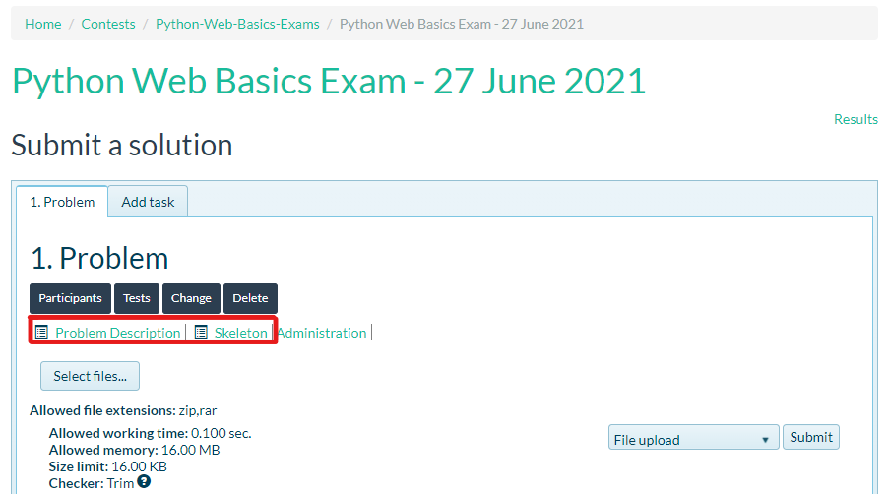You will be given a **link** to the **contest** in the judge system. In the contest, you will find only **one problem**. It will contain the **problem description** and a **skeleton**.

### Problem Description

There will be separate **sections** in the problem description, as shown in the picture below. It is recommended to use **PostgreSQL** as a database.

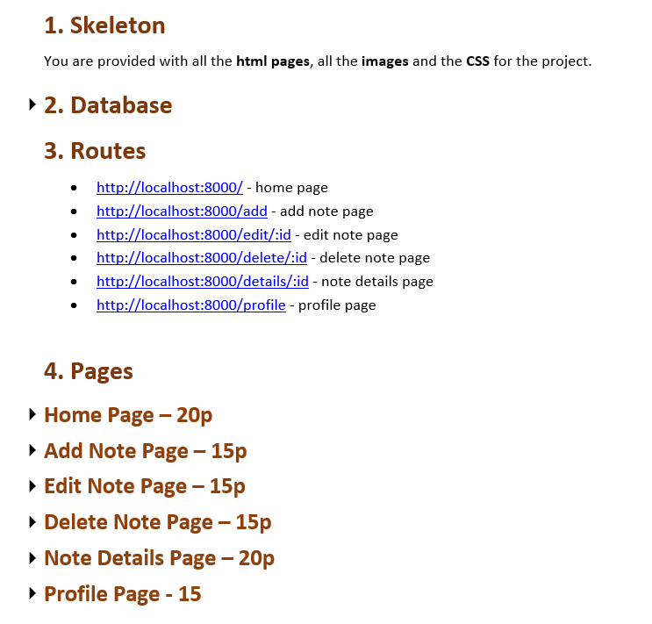

Each **page** will give you **points** which you will see in the title of each section. The points depend on how you display the pages (if **all the** **data** is **displayed correctly** with the **correct information**).

### Skeleton

The skeleton will include all the **HTML pages** that you will have to split into templates and the **CSS/images** you will need.

## Judge Upload

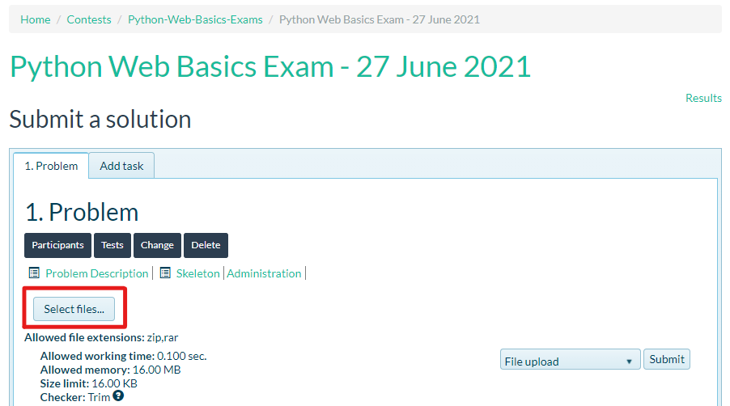Once you have completed the project, you must **archive it** (zip format) and **upload** it to the contest. You do not need to include in the zip file your **venv**, **.idea**, **pycache**, and **__MACOSX** (for Mac users), so you do not exceed the **maximum allowed size** of **19.53 MB**.

You do not need to **export your database either**. The person evaluating your project will make sure that they create the database **before** running your project.

## Evaluation

When you submit your project in Judge, you will not see any point as usual.Instead, **you will see the message "Compile time error"**. It is because the evaluation is **NOT automated**. It will be evaluated **manually**. The results will be available **10-13 workdays** after the day of the exam. The evaluation will be done based on the **functionality** of the application (you are allowed to use any **additional Django tools** that you know).

## Support

In case of any **unclarities** or **questions**, the team will be available in the **sli.do** channel (**#python-web**) **during the exam**.