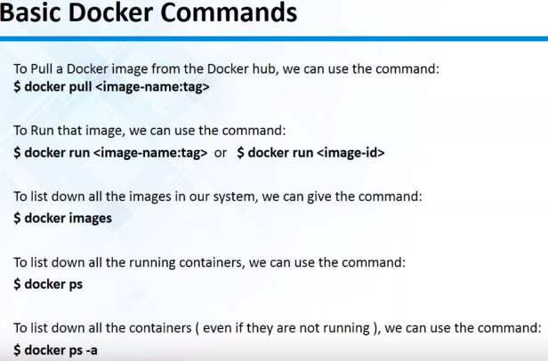>docker pull

>docker run

>docker images

>docker ps

>docker ps –a

# Creating a docker file

## Docker file example:

## Start/Stop containers

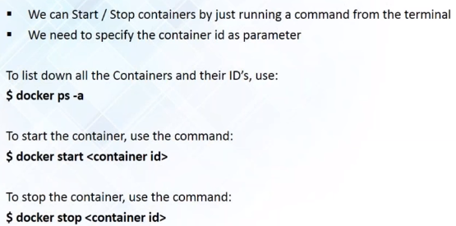

## Delete container/image

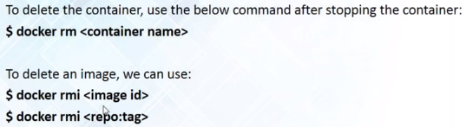

# Docker terminology

# Kubernetes

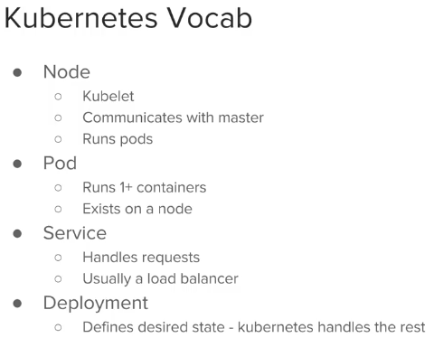

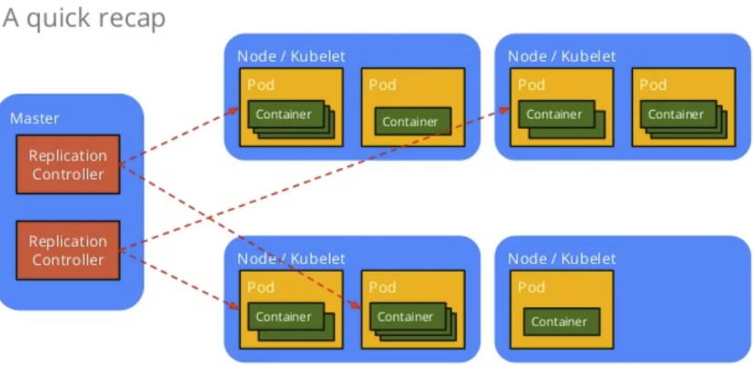

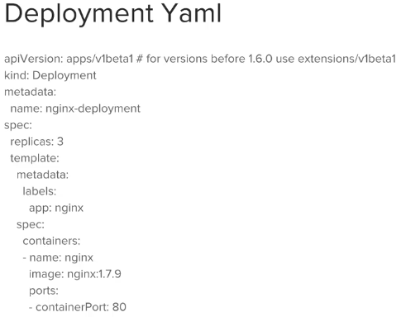

## Start kubernetes

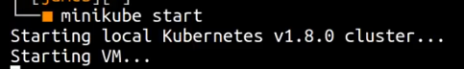

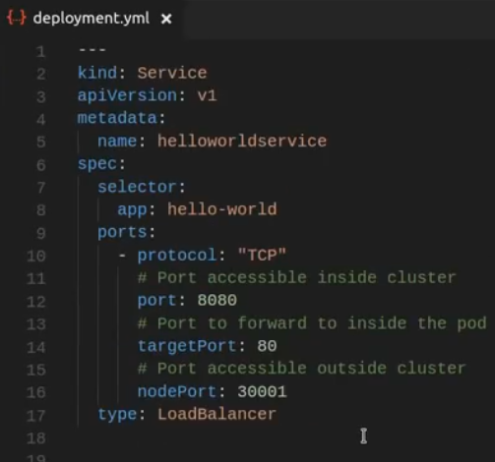

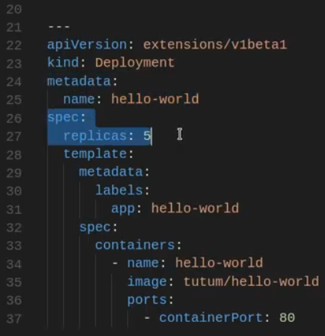

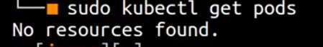





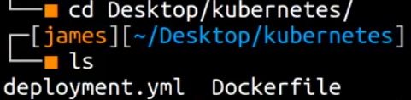

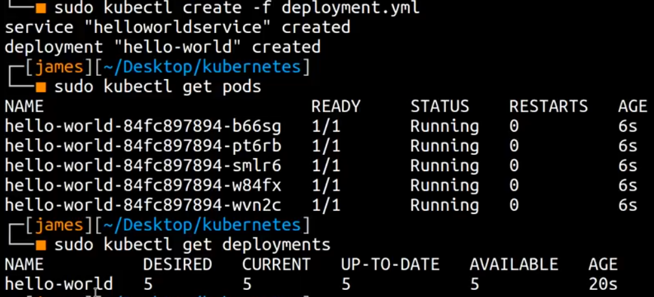



# NODE JS web application:

<https://nodejs.org/en/docs/guides/nodejs-docker-webapp/>

## **Create the Node.js app**

First, create a new directory where all the files would live. In this directory create a package.json file that describes your app and its dependencies:

{

"name": "docker_web_app",

"version": "1.0.0",

"description": "Node.js on Docker",

"author": "First Last <first.last@example.com>",

"main": "index.js",

"scripts": {

"start": "node index.js"

},

"dependencies": {

"express": "^4.16.1"

}

}

With your new package.json file, run npm install. If you are using npm version 5 or later, this will generate a package-lock.json file which will be copied to your Docker image.

Then, create a index.js file that defines a web app using the [Express.js](https://expressjs.com/) framework:

'use strict';

const express = require('express');

// Constants

const PORT = 8080;

const HOST = '0.0.0.0';

// App

const app = express();

app.get('/', (req, res) => {

res.send('Hello world\n');

});

app.listen(PORT, HOST);

console.log(`Running on http://${HOST}:${PORT}`);

In the next steps, we'll look at how you can run this app inside a Docker container using the official Docker image. First, you'll need to build a Docker image of your app.

## Dockerfile with comments:

#base image, from Docker hub (hub.docker.com)

FROM node:carbon

#work directory inside the container

WORKDIR /usr/src/app

#for npm ver >5 we need also file package-lock

COPY package.json .

COPY package-lock.json .

#install packages using json files above using node.js installer npm inside the container

RUN npm install

#copy all generated files

COPY . .

#internal listening port

EXPOSE 8080

#command to be executed. It will run command npm start, and npm start according to the package.json will run command node index.js

CMD [“npm”,”start”]